**Studies lexical material of English**

**Contents**

Chapter I. How is Vocabulary learned?

1.1 How important is vocabulary

1.2 How are words selected

1.3 Conveying the meaning

Chapter II. How to present vocabulary

2.1 Presenting vocabulary

2.2 How to illustrate meaning

2.3 How to explain meaning

Chapter III. How to put words to work

3.1 Decision - making tasks

3.1.1 Identifying words

3.1.2 Selecting tasks

3.1.3 Matching task

3.1.4 Sorting activities

3.1.5 Ranking and sequencing

3.2 Games

Chapter IV. Teaching word parts word chunks

4.1 Teaching word formation and word combination

4.2 A lexical approach

4.3 Teaching lexical chunks

4.4 Teaching phrasal verbs

4.5 Teaching idioms

Conclusions

Bibliography

**Chapter I. How is Vocabulary learned?**

**1.1 How important is vocabulary**

Teaching English vocabulary is an important area worthy of effort and investigation. Recently methodologists and linguists emphasize and recommend teaching vocabulary because of its importance in language teaching. Vocabulary is needed for expressing meaning and in using the receptive (listening and reading) and the productive (speaking and writing) skills. "If language structures make up the skeleton of language, then it is vocabulary that provides the vital organs and the flesh" (Harmer)

Vocabulary is not a syllabus, i.e., a list of words that teachers prepare for their learners to memorize and learn by heart. Memorizing may be good and useful as a temporary technique for tests, but not for learning a foreign language. Language students need to learn vocabulary of the target language in another way. If we are really to teach students what words mean and how they are used, we need to show them being used together in context. Words do not just exist on their own; they live together and they depend upon each other. Therefore, teaching vocabulary correctly is a very important element in language learning. Correct vocabulary instruction involves vocabulary selection, word knowledge and techniques.

**1.2 How are words selected**

In the past, teachers used to select and present vocabulary from concrete to abstract. Words like 'door', 'window', 'desk', etc., which are concrete, used to be taught at beginning levels. However, words like 'honesty', 'beauty' etc., which are abstract words, used to be taught at advanced levels because they are not "physically represented" in the learning/teaching environment and are very difficult to explain.

Nowadays methodologists and linguists suggest that teachers can decide and select the words to be taught on the basis of how frequently they are used by speakers of the language. That is, the most commonly used words should be taught first (Harmer).

We can get information about which words will be most useful for learners of English by looking at frequency counts of vocabulary. Usually a vocabulary count is done by making a list of the words in a particular text or group of texts and counting how often and where they occur. Some of the more recent counts have used computers to list the words and count their frequency (Nation).

Besides that, teachers can decide which words are useful and should be taught to their learners on the basis of semantics. This means, that the word is more useful if it covers more things than if it only has one very specific meaning. For example, the word 'book', which is taught at beginning levels, has wider usage than the words 'notebook', 'textbook', etc. Furthermore, Nation says that frequency and coverage are not enough to be used when teachers select and prepare a word list for learners of English. So he suggests other criteria, such as language needs, availability and familiarity, regularity and ease of learning or learning burden.

Teachers can help their learners enrich and increase their vocabulary. They can also help the learners to build a new store of words to select from when they want to express themselves. If any learner can handle grammar correctly, that does not mean that he can express himself fluently unless he has a store of words to select from. Therefore, teachers are a very important factor in selecting and teaching English vocabulary, and they have to design vocabulary syllabi according to their learners' needs. As a result, “teachers vocabulary work can be directed toward useful words and can give learners practice in useful skills".

The selection of words which are to be taught to the students is a very important procedure in the language learning process. However, the word selection process doesn't mean that the students will be fluent in expressing themselves in English upon learning that list, i.e., what students need to know regarding vocabulary is the word meaning, the word use, the word formation and the word grammar.

**1.3 Conveying the meaning**

When conveying the meaning to the students, teachers should teach their students that a word may have more than one meaning when used in meaning, different contexts. For example, the word "book" has at least twelve different meanings when used in context. It has eight meanings as a noun, two meanings as a verb and three different meanings when used with prepositions as phrasal verbs. One may say "I booked my ticket three days ago"; another "I booked him for speeding" and so on (Harmer).Teachers should make the teaching learning vocabulary process clear and easy for their students when conveying any meaning; otherwise the student may feel bored and become fed up with learning vocabulary.

The meaning of words can be communicated in many different ways. Nation suggests that teachers can convey meaning to their students by demonstration or pictures (using an object, using a cut out figure, using gesture, performing and action, photographs, blackboard drawings or diagrams and pictures from books) and by verbal explanation (analytical definition, putting the new word in a defining context, and translating into another language). Besides that, teachers should involve their students in discovering the words' meanings by themselves and let them make efforts to understand words' meanings. When the students are involved in discovering meaning, they will never forget those meanings and they will be able to express themselves fluently.

When a single word has various meanings, the teacher should decide which meanings are to be taught first, i.e., the teacher must decide which meanings occur most frequently and which meanings the learners need most. As a result, the students will be motivated, and gradually they will build their own store of words which will be a basis for communication at any time.

Teaching vocabulary is not just conveying the meaning to the students and asking them to learn those words by heart. If teachers believe that the words are worth explaining and learning, then it is important that they should do this efficiently. Teachers should use different techniques and activities in teaching English vocabulary to motivate the learners, enrich their vocabulary and enable them to speak English properly.

**Chapter II. How to present vocabulary**

**2.1 Presenting vocabulary**

We looked at possible sources of vocabulary input, including vocabulary books, readers, dictionaries and corpora. A motivated and self-directed learner might be able to acquire a large vocabulary simply by using these resources. However, many learners sign up for language courses in the expectation that, at least some of the time, they will be presented with language, rather than having to go out and find it for themselves. By presentation, we mean those pre-planned lesson stages in which learners are taught pre-selected vocabulary items. Of course, incidental vocabulary teaching can occur at other times of the lesson, as when a text or a discussion throws up unfamiliar vocabulary. In this chapter, however, we will be mainly concerned with ways vocabulary can be formally presented in the classroom. But many of the issues are relevant to the informal teaching of vocabulary as well.

At the very least learners need to learn both the meaning and the form of a new word. We shall deal with each of these components in turn. But it's worth pointing out that both these aspects of a word should be presented in close conjunction in order to ensure a tight meaning-and-form fit. The greater the gap between the presentation of a word's form and its meaning, the less likely that the learner will make a mental connection between the two.

Let's say the teacher has decided to teach a related set of words - for example, items of clothing: shirt, trousers, jacket, socks, dress, jeans. The teacher has a number of options available. First, there is the question of how many words to present. This will depend on the following factors:

* the level of the learners (whether beginners, intermediate, or advanced);
* the learners' likely familiarity with the words (learners may have met the words before even though they are not part of their active vocabulary);
* the difficulty of the items - whether, for example, they express abstract meanings.

Consider how you would present each of the following six sets of words. What do you think would be the most appropriate means of presenting them? (E.g. visual aids, a situation, real objects, etc.)

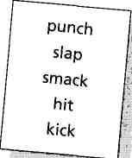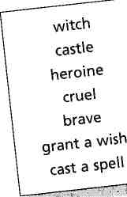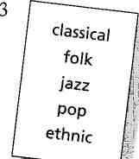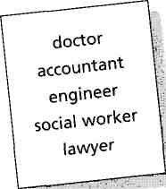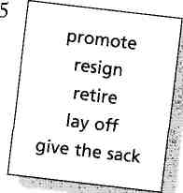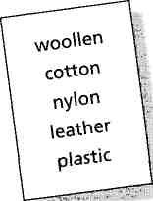

**2.2 How to illustrate meaning**

An alternative to translation – and an obvious choice if presenting a set of concrete objects such as clothes items – is to somehow illustrate or demonstrate them. This can be done either by using real objects (called realia) or pictures or mime. The use of realia, pictures and demonstration was a defining technique of the Direct Method. The Direct Method, in rejecting the use of translation, developed as a reaction to such highly intellectual approaches to language learning as Grammar-Translation. Here, for example, is advice for teachers from a popular Direct Method course of the 1940s:

HOW TO TEACH THE NAMES OF OBJECTS

The usual procedure is as follows.

The teacher first selects a number of objects, in batches of say from 10 to 20. [...] The objects may be:

(a) those that are usually found in the place where the lesson is given, e.g. door, window, knife, match, book; or parts of the body or articles of clothing;

(b) those collected specially for the purposes of the lesson, e.g. a stick, a stone, a nail, a piece of wire, a piece of string etc;

(c) those represented by pictures, such as those printed on picture cards or wall charts, or by rough drawings on the blackboard.

The teacher shows or points to each object in turn and names it. He says the name clearly (but naturally) three or four times. [...] When the pupils have had sufficient opportunity to hear the words and sentences (and to grasp their meaning) they are called upon to say them. In the first instance they may repeat them after the teacher ...

(from Palmer H, The Teaching of Oral English, Longman)

Visual aids take many forms: flashcards (published and home-made), wall charts, transparencies projected on to the board or wall using the overhead projector, and board drawings. Many teachers collect their own sets of flashcards from magazines, calendars, etc. Especially useful are pictures of items belonging to the following sets: food and drink, clothing, house interiors and furniture, landscapes/exteriors, forms of transport plus a wide selection of pictures of people, sub-divided into sets such as jobs, nationalities, sports, activities, and appearance (tall, strong, sad, healthy, old, etc).

**2.3 How to explain meaning**

Of course, reliance on real objects, illustration, or demonstration, is limited. It is one thing to mime a chicken, but quite another to physically represent the meaning of a word like intuition or become or trustworthy. Also, words frequently come up incidentally, words for which the teacher won't have visual aids or realia at hand. An alternative way of conveying the meaning of a new word is simply to use words – other words. This is the principle behind dictionary definitions. Non-visual, verbal means of clarifying meaning include:

* providing an example situation;
* giving several example sentences;
* giving synonyms, antonyms, or super ordinate terms;
* giving a full definition.

All of the above procedures can be used in conjunction, and also in combination with visual means such as board drawings or mime. Although a verbal explanation may take a little longer than using translation, or visuals or mime, the advantages are that the learners are getting extra “free” listening practice, and, by being made to work a little harder to get to the meaning of a word, they may, be more cognitively engaged.

**Chapter III. How to put words to work**

**3.1 Decision - making tasks**

There are many different kinds of tasks that teachers can set learners in order to help move words into long-term memory. Some of these tasks will require more brain work than others. That is to say, they will be more cognitively demanding. Tasks in which learners make decisions about words can be divided into the following types, roughly arranged in an order from least cognitively demanding to most demanding:

• identifying

• selecting

• matching

• sorting

• ranking and sequencing

The more of these task types that can be performed on a set of words the better. In other words, an identification task could be followed by a matching task, which in turn could be followed by a ranking task.

**3.1.1 Identifying words**

Identifying words simply means finding them where they may otherwise be “hidden”, such as in texts.

Here, for example, are some identification tasks relating to the text Fear of Flying. Give the learners the text and ask them to:

• Count the number of times plane(s) and train(s) occur in the text.

• Find four words connected with, flying in the text.

• Find five phrasal verbs in the text.

• Find eight comparative adjectives in the text.

• Underline all the words ending in -ing in the text.

Ask them to read the text, then turn it over, and then ask:

• “Did the following words occur in the text?”

busy crowded fast dangerous uncomfortable dirty convenient inconvenient noisy

• “Now check the text to see if you were right.”

Identification is also the process learners apply in tasks in which they have to unscramble anagrams (such as utis, snaje, eti — for suit, jeans, tie), or when they have to search for words in a 'word soup', such as the following (also from Language in Use):

1 What are these clothes in English? The answers are all in the word square.

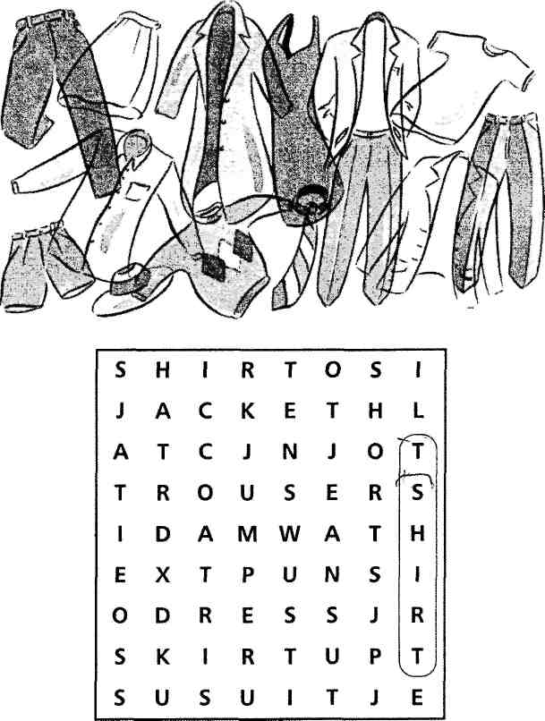

**3.1.2 Selecting tasks**

Selecting tasks are cognitively more complex than identification tasks, since they involve both recognising words and making choices amongst them. This may take the form of choosing the “odd one out”, as in this task (again, based on the lexical set of clothes).

**Choose the odd one out in each group**

|  |  |  |  |  |
| --- | --- | --- | --- | --- |
| 1  2  3 | trousers  blouse  T-shirt etc. | socks  skirt  suit | jeans  tie  shorts | T-shirt  dress  trainers |

Note that with this kind of activity, there is no “righ” answer necessarily. What is important is that learners are able to justify their choice, whatever their answer. It is the cognitive work that counts – not getting the right answer.

**Here is another open-ended selection task, with a personalised element**

|  |  |
| --- | --- |
| 1. Work in pairs. Choose five words to describe yourself. Use a dictionary if necessary.  careful interesting clever cold confident fit funny imaginative intelligent kind lazy nervous  optimistic patent pessimistic  polite quiet calm rude sad sensitive nice serious tidy thoughtful  Think of other words you can  use.  honest, friendly...  Discuss your choice of words with your partner.  I think I'm usually optimistic.  And I'm always polite!  Does he/she agree with you? | 2.Think of three people you admire very much. They can be politicians, musicians, sports personalities etc. or people you know personally. Choose the person you admire most and think of three adjectives to describe this person.  Then choose the second and third person you admire and think of three more adjectives for each person to explain why. |

from Greenall S, Reward Pre-Intermediate, Macmillan Heinemann

**3.1.3 Matching task**

A matching task involves first recognising words and then pairing them with – for example – a visual representation, a translation, a synonym, an antonym, a definition, or a collocate. As an example of this last type, here is a verb-noun matching task.

Here is a vocabulary activity from a beginners' course (Mohamed S and Acklam R, The Beginners' Choice, Longman), consisting of two stages. Devise at least three further stages which would require learners to 'put the words to work' – both receptively and productively.

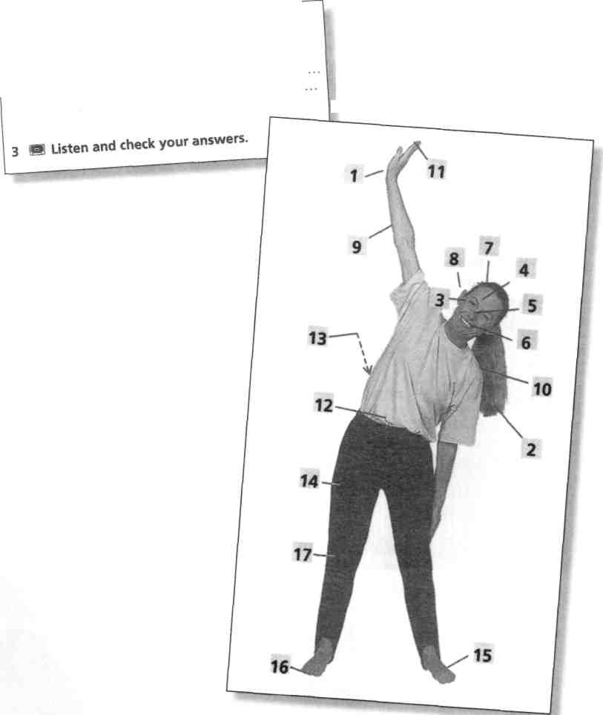

Look at the picture below and number the parts of the body.

hair 2. head ... foot ... nose ... eye ... leg ... knee ... finger ... mouth ... hand toe ... shoulder ... face ... arm ... back ear ... stomach ...

**3.1.4 Sorting activities**

Sorting activities require learners to sort words into different categories. The categories can either be given, or guessed. Here is an example of the former (from Thornbury S, Highlight Pre-Intermediate, Heinemann).

Word field: characteristics

**Put these adjectives into two groups – positive and negative**

|  |  |  |  |
| --- | --- | --- | --- |
| emotional  confident  offensive | friendly  ambitious  kind | good-humoured  rude  selfish | outgoing  self-centred  nice |

Here is an activity in which learners (at a fairly advanced level) decide the categories themselves:

Put these words into four groups of three words each. Then, think of a title for each group.

goal net piece club racket shoot board green

court hole pitch referee check serve tee move

Now, can you add extra words to each group?

**3.1.5 Ranking and sequencing**

Ranking and sequencing activities require learners to put the words into some kind of order. This may involve arranging the words on a cline: for example, adverbs of frequency {always, sometimes, never, occasionally, often, etc). Or learners may be asked to rank items according to preference:

Imagine you have just moved into a completely empty flat. You can afford to buy one piece of furniture a week. Put the following items in the order in which you would buy them:

fridge bed desk dining table sofa

wardrobe chair dishwasher bookcase cooker

washing machine chest of drawers

Now, compare your list with another student and explain your order. If you were sharing the flat together, would you agree? If not, make a new list that you both agree about.

Any sequence of activities – from starting a car to buying a home – lends itself to the same treatment. Here, for example, is a task that focuses on the language of air travel (from Garton-Sprenger J and Greenall S, Flying Colours 2, Heinemann):

Work in pairs. Think about what people do when they travel by plane. Put the actions below in the correct column.

|  |  |
| --- | --- |
| before the flight | after the flight |
| check in  leave the plane  land  unfasten your seatbelt  go into the departure lounge  go to the departure gate  fasten your seatbelt  go through passport control | Leave the plane  check in  collect your baggage  go through passport control  listen to the safety instructions  go through customs  board the plane  go into the arrivals hall |
| Number the actions in the order people do them. | |

**3.2 Games**

While the tide of this chapter is “How to put words to work”, it would be wrong to suggest that vocabulary learning has to be all work and no play. Language play, including word games, has a long history. Children of all cultures seem to enjoy games of the “I spy ...” or “Hangman” type, and there is a long tradition of adult word games, a number of which have been adapted for television. Most first-language word games transfer comfortably to the second-language classroom.

Word clap: Students stand or sit in a circle, and, following the teacher's lead, maintain a four-beat rhythm, clapping their hands on their thighs three times (one-two-three ...) and then both hands together (four!). The game should start slowly, but the pace of the clapping can gradually increase. The idea is to take turns, clockwise, to shout out a different word from a pre-selected lexical set (for example, fruit and vegetables) on every fourth beat. Players who either repeat a word already used, or break the rhythm – or say nothing – are “out” and the game resumes without them, until only one player is left. The teacher can change the lexical set by shouting out the name of a new set at strategic points: Furniture! Nationalities! Jobs! etc.

Categories: Learners work in pairs or small groups. On a piece of paper, they draw up a number of columns, according to a model on the board, each column labelled with the name of a lexical set: e.g. fruit, transport, clothes, animals, sports. The teacher calls out a letter of the alphabet (e.g. B!), and to a time limit (e.g. three minutes), students write down as many words as they can beginning with that letter in the separate columns {banana, berry; bus; bikini, blouse; bear, bat; baseball, basketball...). The group with the most (correct) words wins.

Noughts and crosses: Draw two noughts and crosses grids on the board:

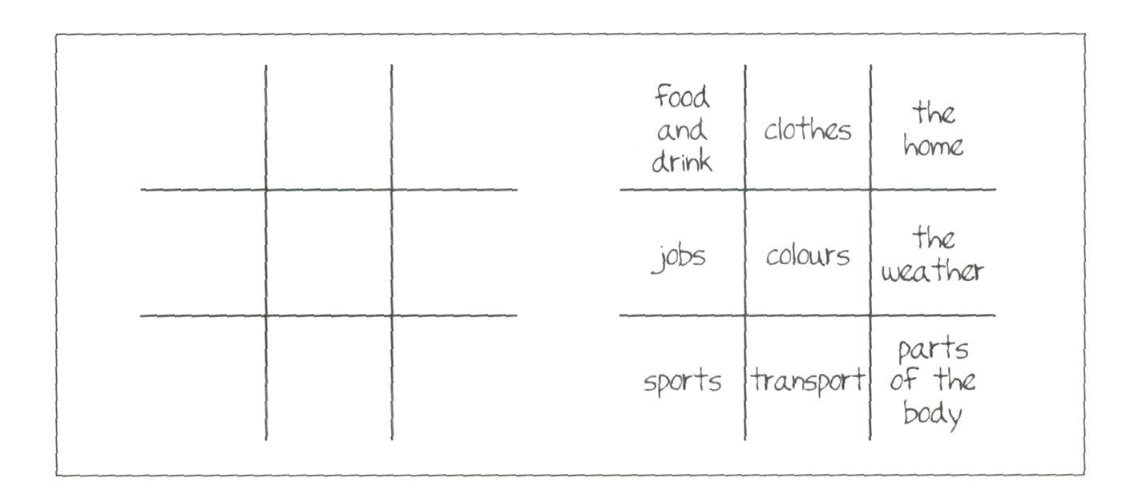

One is blank. In the other each square is labelled with a category, or with nine different phrasal verb particles {up, on, off, in, back, etc), or nine different affixes {un-, non-, -less, -tion, etc). Prepare a number of questions relating to each category. For example (if the class is monolingual): How do you say “tamburo” in English? Or, What is the opposite of “shy”? Divide the class into two teams: noughts and crosses. The object is to take turns choosing a category and answering a question in this category correctly so as to earn the right to place their team's symbol in the corresponding position in the blank grid. The winning team is the first to create a line of three (noughts or crosses), either vertically, horizontally, or diagonally.

Coffeepot: This is a guessing game. One learner answers yes/no questions from the rest of the class (or group) about a verb that she has thought of, or that the teacher has whispered to her. In the questions the word coffeepot is used in place of the mystery verb. So, for example, students might ask Do you coffeepot indoors or outdoors? Is coffee potting easy or difficult? Can you coffeepot with your hands? etc. If the verb that the student has selected is yawn the answers would be: Both indoors and outdoors; It's easy; No, you can't, but you might use your hands ... To make the game easier a list of, say, twenty verbs can be put on the board and the person who is 'it' chooses one of them. This can also be played in pairs.

Back to board: This is another guessing game, but this time the student who is 'it' has to guess a word by asking the rest of the class questions. The student sits facing the class, back to the board; the teacher writes a recently studied word or phrase or idiom on the board, out of sight of the student. The student asks different students yes/no or either/or questions in order to guess the word. For example: Helga, is it a verb or a noun? (A verb.) Dittmer, is it an action? (No.) Karl-Heinz, is it something you do with your mind? (Yes.) ... etc. To make the game easier, the words chosen can be limited in some way – e.g. all phrasal verbs; all character adjectives, and so on.

**Chapter IV. Teaching word parts word chunks**

**4.1 Teaching word formation and word combination**

We looked at some of the principles of word formation in English. We noted that words can be formed by the addition of prefixes and suffixes – a process called affixation. (The word affixation is itself an example of the result of adding affixes to the root fix.) We also saw how, by compounding, two or more words can join up to make one. Thus: black + board = blackboard. Or, new words can be created by a process called conversion, when a word that in one context is one part of speech (such as a noun), in another context can be enlisted to serve a different function (such as a verb). Hence, you may have heard the relatively recent term to board as in The teacher boarded the new words and the students wrote them down.

Then again words can cluster (but not join up) to form multi-word units – loosely called chunks – that behave as if they were single words. For example, alongside black, the Longman Dictionary of Contemporary English lists: black and white, black and blue, black sheep, in the black and to black out. (This last is an example of a phrasal verb.) Many chunks have an idiomatic meaning – that is to say the meaning of the chunk as a whole is not directly inferrable from the individual words: He's the black sheep of the family; you've introduced a red herring, etc.

The way bits of words combine, and the way words themselves can be combined, is a constant source of difficulty for learners. Errors of the following types are common:

Affixation errors

There are uncountless ways to bring happiness to my life thanks to the internet.

After finishing the paragraph and reading it again, I felt unsatisfy. I think that my real and only knowledgements are in the vocabulary.

Compounding errors

In London I took a two floor bus and of course crossed the city in the highest floor.

I saw my dog died in a box's shoes.

Errors of multi-word units

We have also a buses network.

Sometimes dog isn't the best man's friend.

Collocation errors

I don't like when I do mistakes.

Some teachers are strict they put us a lot of homework and exams.

Phrasal verb errors

She used to go to school with her maid, and a maid was picking up her from school.

There are some days that the better it's stay in bed and don't get up you.

Idiom errors

I have no more money. So most of time I just watch shops' window.

I don't like to blow my own horn, but my grammar knowledge and my vocabulary are quite good.

In responding to these kinds of problems, there are two possible approaches.

You can either

* + teach rules, or
  + expose learners to lots of correct examples

A rule-based approach starts by isolating and highlighting any relevant patterns or regularities. Take word formation, for example. In a rule-based approach, words can be grouped and presented according to the manner of formation (affixation, compounding, conversion, etc). Within these categories finer distinctions can be made. So, of the words formed by affixation we can select those formed by the addition of prefixes, and this group can be narrowed down further to those that have a negative meaning. The way these words are formed can then be described in general terms in the form of a rule – or 'rule of thumb'. Here is an example of such an explicit rule statement (from Gude K and Duckworth M, Proficiency Masterclass, OUP):

|  |
| --- |
| B Negative prefixes. The prefixes mis-, dis-, ig-, and un- can all be used to give a word a rather negative meaning. The prefix may help you to guess the meaning of the word.  mis- = 'wrongly, badly' or 'not done' (mismanage)  dis- = 'away from, the opposite of, lack of' (distaste)  ig- = 'not, lacking in' (ignorant)  un- = 'not, lack of, the opposite, reversal or removal of' (undo)  Here is some advice to help you choose the correct prefix.  dis- can be used to form verbs, eg dissatisfy, adjectives, eg dishonest; and nouns, eg disability.  The prefix ig- appears only before the letter n. |

Here, on the other hand, is a table which suggests – but doesn't explicitly state – a rule about noun and verb endings:

|  |  |  |  |  |  |  |  |  |  |  |  |  |  |  |  |  |  |  |  |  |  |  |
| --- | --- | --- | --- | --- | --- | --- | --- | --- | --- | --- | --- | --- | --- | --- | --- | --- | --- | --- | --- | --- | --- | --- |
| 1 Now you can strengthen the thin green line.  Strengthen is a verb which is formed from the adjective strong. Work in pairs and complete this table. | |  |  |  | | --- | --- | --- | | ADJECTIVE | NOUN | VERB | | wide |  |  | | strong |  |  | | deep |  |  | | weak |  |  | | short |  |  | | high | |  | |

from Naunton J, Think First Certificate, Longman

A similar approach is used with word collocations, wherever a general tendency can be identified. Here, for example, is a coursebook extract that focuses on the difference between make and do combinations:

VOCABULARY

Make or do?

1 Read the following sentences carefully.

Last night I tried to do my homework. However, I kept making mistakes because the man upstairs was doing his exercises and making a noise.

Make usually means to create, bring into existence, or produce a result.

Do usually means to perform an action. However, there are exceptions to this 'rule', as you will see in Exercise 3.

from Bell J and Gower R, Intermediate Matters, Longman

One problem with a rule-based approach is that the scope of the rule is not always clear. How many, and which, adjectives can be turned into verbs by the addition of -en, for example? Sweet and fresh — yes, but wet and dry? There is the added problem of the lack of one-to-one match between forms and categories. For example, in- and un- both express negation (uncertain, inactive), but in- can also be used with the meaning of in, or within (as in inclusive). And when do we use in-, as opposed to un- or non- or dis-, to convey negation? How, for example, does the learner know whether to use unsatisfied, dissatisfied, insatisfied or nonsatisfied ?

Other pattern-highlighting techniques involve the use of texts and include the following:

* + learners are given a text and asked to search for and underline all compound nouns, negative prefixes, multi-word units, etc.
  + learners find words in a text that are derivations. For example, 'Find three words in the text that are derived from sense ...'
  + learners classify these derivations according to which part of speech they are
  + learners categorise underlined words in a text according to a common affix, or according to the word formation principle they exemplify (compounding, conversion, etc.)

The more of these kinds of operations the learner does the better, since (as we saw in the last chapter) the more decisions the learner makes about a word the greater the depth of processing.

A great advantage of working from texts is that the words that are to be focused on are already in context, hence their meanings may be clearer than if presented as isolated words in a list. Also, and perhaps more importantly, the shared context will bring words together that are commonly associated. In the following text, for example, there are a number of words associated with time, crime and the law.

An approach to focusing on these features might be:

• Ask students to read the text and to answer comprehension questions to gauge level of understanding. For example:

1. The maximum time you can be detained without charge is:

a 24 hours b 36 hours c 60 hours

1. You can be detained for 36 hours only if:
   1. a a serious arrestable offence has been committed,
   2. b a magistrate gives permission,
   3. c further questioning is necessary.

• Ask learners (working together and using dictionaries) to underline all words relating to legal processes, and to categorise these according to a) people, b) processes.

• Ask them to use dictionaries to make verbs for these nouns: limit, detention, charge, offence, questioning, suspect, and to make nouns of these verbs: arrest, detain, commit, extend, secure, preserve. Which of the verb forms can take -able to form an adjective?

• Ask them to circle all time expressions with numbers and note the prepositions used in each case.

• Ask learners to identify the verbs that fill these slots: ______a person

without charge; _________an offence; __________a suspect in custody;

_______a suspect before a magistrate; ___________a time limit.

• Ask learners to rewrite the passage in 'plain English', e.g. as if they were explaining it to a friend. Alternatively, ask them to translate it into their own language.

• Learners then use the rewritten (or translated) passage as a basis for reconstructing the original text. They then compare the reconstruction with the original.

• A follow-up activity might be to ask learners to research and summarise this aspect of the legal system in their own country (respecting, of course, their cultural sensitivities).

Note that this text, although short, is difficult and the tasks would be achievable only by quite advanced learners. Nevertheless, the same tasks could be adapted to much easier texts, and used at lower levels.

To summarise, then: the teaching of the grammar of word formation and word combination can be approached from two directions: early instruction in the rules, or the learning of a quantity of vocabulary items from which these rules are slowly distilled. We have looked at the case for a midway position that recognises the need for early exposure but at the same time accepts that consciousness-raising through focused attention can speed up the process of 'getting a feel for it'. Plentiful exposure plus consciousness- raising is a key principle underlying what has come to be known as a lexical approach.

**4.2 A lexical approach**

A lexical approach to language teaching foregrounds vocabulary learning, both in the form of individual, high frequency words, and in the form of word combinations (or chunks). The impetus for a lexical approach to language teaching derives from the following principles:

• a syllabus should be organised around meanings

• the most frequent words encode the most frequent meanings and

• words typically co-occur with other words

• these co-occurrences (or chunks) are an aid to fluency

A syllabus organised around meanings rather than forms (such as grammar structures) is called a semantic syllabus. A number of theorists have suggested that a syllabus of meanings – especially those meanings that learners are likely to need to express – would be more useful than a syllabus of structures. For example, most learners will at some time need to express such categories of meaning (or notions) as possession or frequency or regret or manner. Simply teaching learners a variety of structures, such as the present simple or the second conditional, is no guarantee that their communicative needs will be met. The present simple, for example, supports a wide range of meanings (present habit, future itinerary, past narrative, etc), some of which may be less useful than others. Wouldn't it be better to start with the more useful meanings themselves, rather than the structure?

A semantic syllabus – i.e. one based around meanings – is likely to have a strong lexical focus. The following sentences, for example, all involve the present simple, but they express different notions. These notional meanings are signalled by certain key words (underlined):

Does this towel belong to you? (possession)

How often do you go to London? (frequency)

I wish I'd done French, (regret)

Exercise is the best way of losing weight, (manner)

Words like belong, often, wish and way carry the lion's share of the meaning in these sentences: the grammar is largely padding. A lexical approach argues that meaning is encoded primarily in words. This view motivated two coursebook writers, Dave and Jane Willis, to propose that a lexical syllabus might be the best way of organising a course. The Willises believed that a syllabus based around the most frequent words in the language would cover the most frequent meanings in the language. Accordingly, they based their beginners' course around the 700 most frequent words in English. They used corpus data (i.e. computer banks of naturally occurring text – see page 68) to find out how these words 'behaved' – that is, the kinds of words and structures that were associated with these high frequency words.

For example, an extremely common word in English is way. According to COBUILD corpus data, it is in fact the third most common noun in English (after time and people). An analysis of corpus data shows that way is used to express a variety of meanings:

|  |  |
| --- | --- |
| 1. method or means 2. manner, style, behaviour 3. what happens, what is the case 4. degree, extent, respect 5. location, movement, direction, space | It's a useful way of raising revenue. The cheapest way is to hire a van.  He smiles in a superior way. Play soccer Jack Charlton's way.  That's the way it goes.  We were so pleased with the way  things were going.  She's very kind and sweet in lots of  ways.  In no way am I a politically effective person.  A man asked me the way to St Paul's. Get out of the way. |

(after Willis D, The Lexical Syllabus, Collins)

Using corpus data, they then studied what kinds of grammatical structures way was typically found with – i.e. its syntactic environment. For example, the first use of way in the table above (meaning 'method or means') is commonly found in association with this pattern:

way + of + -ing a useful way of raising revenue the different ways of cooking fish

The next step was to devise teaching materials that illustrated these meanings and patterns, bearing in mind that the starting point was not the pattern itself, but the meaning (method, means), and its frequency, as evidenced in the high frequency of the word way.

**4.3 Teaching lexical chunks**

So far we have been talking about lexical chunks as if they were a single al chunks undifferentiated category. But there are different types of chunks and different degrees of 'chunkiness'. Of the different types, the following are the most important for teaching purposes:

* + collocations – such as widely travelled; rich and famous; make do with; set the table
  + phrasal verbs – such as get up; log on; run out of; go on about
  + idioms, catchphrases and sayings – such as hell for leather; get cold feet; as old as the hills; mind your own business; takes one to know one
  + sentence frames – such as would you mind if... ?; the thing is ...; I'd... if I were you; what really gets me is ...
  + social formulae – such as see you later; have a nice day; yours sincerely
  + discourse markers – such as frankly speaking; on the other hand; I take your point; once upon a time; to cut a long story short...

Within these categories further distinctions can be made in terms of fixedness and idiomaticity. Fixed chunks are those that don't allow any variation: you can say over the moon (to mean ecstatic) but not under the moon (to mean not ecstatic). Nor over the full moon, over the sun, etc. Many chunks are semi-fixed, in that they allow some degree of variation. Nice to see you is semi-fixed in that it allows lovely, good, wonderful, etc. in the nice slot, and meet, talk to, hear from, etc. in the see slot.

Some chunks are transparent in that the meaning of the whole is clear from their parts, as in the case of as old as the hills and to knock down. Others are much more idiomatic: to spill the beans and to knock off (meaning to steal). Neither fixedness nor idiomaticity are absolute values, however. Rather there is a cline from very fixed to very free, and from very idiomatic to very transparent. Phrasal verbs are a case in point. Some phrasal verbs are syntactically flexible: I'll bring up the paper or I'll bring the paper up. Others are not: I can't tell the twins apart but not I can't tell apart the twins. Moreover, the combination bring up has a range of meanings, some literal (I'll bring up the paper), some semi-idiomatic (Don't bring that subject up again) and some very idiomatic (They brought their children up to speak Italian).

The ability to deploy a wide range of lexical chunks both accurately and appropriately is probably what most distinguishes advanced learners from intermediate ones. How is this capacity developed? Probably not by learning rules – as we saw with word formation, the rules (if there are any) are difficult to learn and apply. A lexical approach is based on the belief that lexical competence comes simply from:

* + frequent exposure, and
  + consciousness-raising

To which we could perhaps add a third factor:

* + memorising

Classroom language provides plentiful opportunities for exposure to lexical chunks. Many learners are familiar with expressions like I don't understand and I don't know long before they have been presented with the 'rules' of present simple negation. By increasing the stock of classroom phrases, teachers can exploit the capacity of chunks to provide the raw material for the later acquisition of grammar. Many teachers cover their classroom walls with useful phrases and insist on their use whenever an appropriate opportunity arises. A sampling of phrases I have noticed on classroom walls includes:

What does X mean?

How do you say X?

What's the (past/plural/opposite, etc.) of X?

Can you say that again?

Can you write it up?

How do you spell it?

I'm not sure.

I've forgotten.

I left it at home.

I haven't finished yet.

It's (your/my/his) turn.

You go first.

Here you are.

Pass me the ...

Let's have a break.

etc.

The repetitive nature of classroom activity ensures plentiful exposure to these chunks. This is vital, because occasional and random exposure is insufficient. Many learners simply aren't aware if a combination is one that occurs frequently (and is therefore a chunk) or if it is a one-off. Nevertheless, there is more chance of encountering instances of chunking in authentic text than in text that has been 'doctored' for teaching purposes.

This is yet another argument for using authentic texts in the classroom, despite the difficulties often associated with them.

Here, for example, is an extract from a fairly well-known authentic text:

Yo, I'll tell you what I want what I really really want,

So tell me what you want what you really really want

I'll tell you what I want what I really really want,

So tell me what you want what you really really want

I wanna I wanna I wanna I wanna I wanna really really really wanna

zigazig ha

If you want my future, forget my past,

If you wanna get with me, better make it fast

Now don't go wasting my precious time

Get your act together we could be just fine ...

If you wannabe my lover, you gotta get with my friends

Make it last forever, Friendship never ends

If you wannabe my lover, you have got to give,

Taking is too easy but that's the way it is.

What d'ya think about that? Now you know how I feel.

Say you can handle my love, are you for real?

I won't be hasty, I'll give you a try

If you really bug me then I'll say goodbye

(from Wannabe by the Spice Girls)

Like many pop songs, the lyrics of this song are rich in lexical chunks, including sentence frames (I'll tell you what I...; what I really [really] want [is ...]; If you wanna ... better ...; If you really, then I'll ...), collocations (wasting my precious time; last forever; taking it... easy; give you a try), and catchphrases (better make it fast; get your act together; that's the way it is; are you for real?).

How could you use the above song text? Essentially, the approach need not be very different from the approach to the legal English text on page 110. That is:

* + check understanding of text (for example, by eliciting a paraphrase or translation of the text)
  + using transcript, set tasks focusing on features of words in combination

Examples of such tasks might be:

• Underline all contractions. Decontract them (i.e. wanna = want to)

• Find examples of these sentence patterns in the song:

... tell... what...

If you ... imperative ...

If you ... you have got to ...

If you ... then I'll...

• Write some more examples, using these patterns, that would fit the theme of the song.

• Use examples from the song to show the difference between tell and say.

Here are some more ideas for teaching collocation:

Learners sort words on cards into their collocational pairs (e.g. warm + welcome, slim + chance, golden + opportunity, lucky + break, mixed + reception, etc). Use the same cards to play pelmanism. Or they sort them into binomial pairs (pairs of words that follow a fixed sequence and often have idiomatic meaning such as hot and cold, to and fro, out and about, sick and tired). Or into groups, according to whether they collocate with particular 'headwords': e.g. trip (business, day, round, return, boat), holiday (summer, family, public, one month, working) and weekend (long, every, last, next, holiday). Follow up by asking learners to write sentences using these combinations.

Read out a list of words: learners in groups think of as many collocations or related expressions as they can. The group with the most collocations wins a point. Good words for this include parts of the body (face, head, back, foot, hand), colours (red, green, blue, black, etc.) and opposites, such as weak/strong, narrow/wide, safe/dangerous, old/young, etc.

Fill in a collocational grid, using dictionaries, to show common collocations. For example, here's a very simple (and completed) one for wide and broad.

|  |  |  |
| --- | --- | --- |
| wide | broad |  |
| • |  | door |
| • | • | street |
| • | • | river |
|  | • | smile |
|  | • | shoulders |
|  | • | nose |
| • |  | gaP |
|  | • | accent |
| • |  | world |
| • | • | range |
| • |  | variety |
| • |  | apart |
| • |  | awake |

Ask learners to prepare 'collocation maps' of high frequency words and their collocates. Words like have, take, give, make and get lend themselves to this kind of treatment. They are often used in combination with nouns to form an expression which has a meaning of its own, as in have a look, take a break, give advice, make an appointment, so that the verb itself has little or no independent meaning. For this reason, they are called delexical verbs. Here, for example, is a collocation map for have, which shows its range of collocations organised into meaning categories:

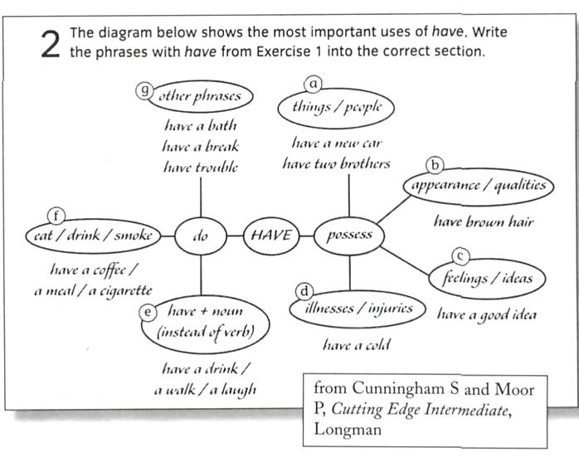

Learners can either create their own maps using dictionaries or add to an existing map, as this task (also from Cutting Edge Intermediate) suggests:

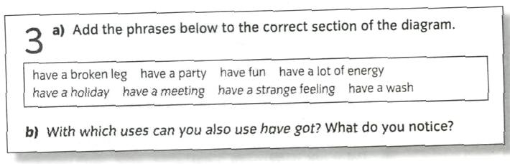

Because of the two-part nature of collocations, any matching activities lend themselves to work on them. Similarly, odd one out tasks are useful. For example:

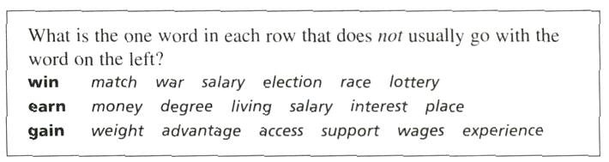

Finally, as a general approach to the teaching of lexical phrases and collocation, the following advice is sound:

* + Become more aware of phrases and collocations yourself.
  + Make your students aware of phrases and collocations.
  + Keep an eye on usefulness and be aware of overloading students.
  + Feed in phrases on a 'little but often' basis.
  + Introduce phrases in context, but drill them as short chunks.
  + Point out patterns in phrases.
  + Be ready to answer students' questions briefly.
  + Keep written records of phrases as phrases.
  + Reinforce and recycle the phrases as much as you can.

(from Cutting Edge Intermediate Teachers' Book, Longman)

**4.4 Teaching phrasal verbs**

Phrasal verbs are another instance of the fuzziness at the boundary between words and grammar. They are particularly problematic for learners both because of their lexical meanings (which are often idiomatic) and their grammatical form. Here is how phrasal verbs are often grouped, according to their grammar:

2 There are four types of phrasal verb.

Type 1: intransitive e.g. come to (recover consciousness) These don't take an object.

Type 2: transitive inseparable e.g. look into (investigate) These must take an object which always comes after the verb.

Type 3: transitive separable e.g. put off (postpone) The object can either come between the verb and the particle or after the verb. If we use a pronoun then it must go between.

Type 4: three-part, e.g. put up with (endure) These are always transitive inseparable.

from Naunton J, Think Ahead to First Certificate, Longman

Traditional approaches to the teaching of phrasal verbs have tended to focus on these rules. Hence, when phrasal verbs are presented they are categorised according to whether they are Type 1, Type 2, etc. They are also often grouped according to their lexical verb (that is, the word that carries the major share of the meaning): get up, get back, get off, get over, etc, and exercises are designed to test the learner's knowledge of the difference. For example:

Use phrasal verbs with get to complete these sentences:

1. 1 I can't ________ how much Julia has changed: it's amazing!
2. Excuse me, I want to ________ at the next stop.
3. The concert was cancelled so I'm going to see if I can ___________ my money ___________.

Typical exercise types used in the teaching of phrasal verbs include:

* + sentence gap-fills (as the example above)
  + re-phrasing: e.g. changing the verb in the sentence (e.g. depart) to a phrasal verb that has a similar meaning (e.g. set off)
  + matching: e.g. matching the phrasal verb with its synonym

More recently, exercise types have focused on the meanings of the particles – a particle being the adverb or preposition component of the phrasal verb (in, back, off, around, etc). A focus on particles aims to sensitise learners to the shared meanings of a group such as carry on, drive on, hang on, go on and come on. Here, for example, is an exercise sequence that deals with the particle down:

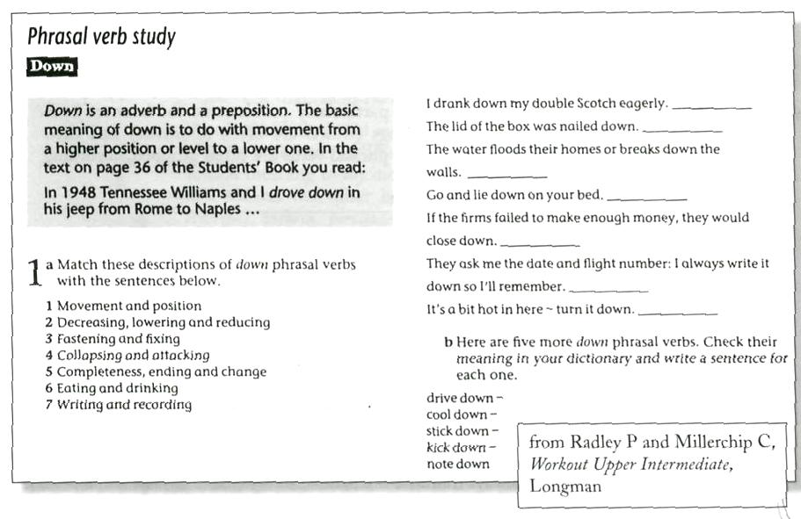

**4.5 Teaching idioms**

We've seen that many phrasal verbs are idiomatic – in that their meanings are not easily unpacked from their component parts. Knowing the meaning of put and up allows us to interpret the sentence I put up a shelf in the kitchen. But this knowledge is not much help in unpacking either I put Luke up for the weekend or I put up with Luke for the weekend. Both these last examples are idiomatic. Idiomaticity exists at both the single word and multi-word level. Individual words can be used figuratively, as in This plan doesn't grab me; The kitchen is a pigsty; I can't unpack the meaning of this idiom. More typically, idioms are formed from collocations, and vary from being both very fixed and very idiomatic (smell a rat; the coast is clear) to being both less fixed and less idiomatic (explode a myth/theory, etc; run a business/theatre, etc).

Idioms present problems in both understanding and in production. They are difficult to understand because they are not easily unpacked, and they are difficult to produce because they often allow no variation. Few errors sound more comical than an even slightly muddled idiom (e.g. I don't want to blow my own horn, instead of I don't want to blow my own trumpet). Moreover, many idioms have a very narrow register range, being used only in certain contexts and for certain effects. They therefore need to be approached with a great deal of caution, and most teaching guides recommend teaching them for recognition only.

Traditional teaching approaches tend to group idioms together according to some category, and present them in sets. But, as with phrasal verbs, teaching a set of idioms that are notionally related – such as idioms associated with parts of the body (down at heel, put your feet up, foot the bill, toe the line, etc.) – would seem to be a sure recipe for confusion. It's not difficult to imagine what could go wrong: put your heels up, toe the bill, etc. More typically, idioms are grouped by theme. For example, the expressions under the weather, off colour, run down and out of sorts are all synonymous with ill. But again, if these are being taught for production, the potential for confusion is high.

As with phrasal verbs, a more effective and less perilous approach might be simply to teach them as they arise, and in their contexts of use. That is, to treat them as individual lexical items in their own right, without making a song and dance about them. Since idioms tend to cluster together, certain text types are often very rich in them. In this extract (from Sugar) idioms (including idiomatic phrasal verbs) are underlined.

Eastenders

Martin gets a big wake-up call this month when Mark is taken seriously ill. How will he cope knowing his big bro's days could be numbered and will Nicky stick by him through thick and thin?

Home and Away

Tom offers to pay for Justine's courses in the city with the money 1 earned from acting in the commercial. What a sweetie, eh? However, Justine isn't that impressed, and feels that Tom's cramping her style. Ho can she let him down gently?

Coronation Street

The Mike, Mark and Linda triangle's still going strong, and sparks are beginning to fly between Linda and Mark's new girlie, Claire. Eeek! Things aren't too good over at the Platt's either.

Emmerdale

Mark is annoyed when neither of his parents make it to the parent evening ... how embarrassing! Richie lends Sarah a shoulder to cry on after yet another bust-up with Jack. Will those two ever get on?

To use a text like this in class, learners could be set the task of working 01 the underlined idioms from either their form or their context. For example, going strong is easily unpacked from its components. Sparks are beginning to fly is less obvious, but its negative connotation can be deduced from what follows (Eeek! Things aren't too good...). Showing learners how to work on idiomatic meaning from these kinds of clues can not only contribute t passive vocabulary knowledge but can improve reading skills as well.

Conclusions

There is more to words than simply 'words'. In this chapter we have seen:

* + how parts of words combine in systematic ways to form whole words
  + how whole words combine in systematic ways to form chunks

But, the fact that these combinations are systematic does not mean that the teaching of word formation or of word combination should necessarily be rule-based. The systems may be too complicated or too irregular to be of much use to learners, either for receptive or productive purposes.

Instead, an approach that combines frequent and contextualised exposure with consciousness-raising may work best. This is recommended for the teaching of:

* + composite words
  + collocations
  + phrasal verbs
  + idioms

**Conclusions**

In this term paper we have looked the implications of findings for the teaching of vocabulary:

* Learners need tasks and strategies to help them organize their mental lexicon by building networks of associations – the more the better;
* Teachers need to accept that the learning of new words involves a period of “initial fuzziness”;
* Learners need to wean themselves off a reliance on direct translation from their mother tongue;
* Words need to be presented in their typical contexts so that learners can get a feel for their meaning, their register, their collocations and their syntactic environment;
* Teaching should direct attention to the sound of new words, particularly the way they are stressed.

In this work we have looked the ways the teacher can make the presentation of vocabulary maximally effective, both in terms of word form and word meaning. Some of the conclusions reached include the following:

* establishing the meaning of a new word first and when presenting its form is a standard approach;
* translation is an economical way of presenting meaning but may not be the most memorable;
* illustrating meaning is effective but is limited to certain kinds of words;
* explaining meaning verbally is time-consuming but can be effective if explanations are kept clear and simple;
* the spoken form can be highlighted through the giving of clear models, the use of phonemic script, and repetition;
* the written form should not be withheld too long;
* learners should be actively involved in the presentation.

**Bibliography**

1. A.S.Hornby. Oxford Student's dictionary of current English. Oxford. oxford University press, 1984. – 770 p.
2. Методика викладання іноземних мов в середніх навчальних закладах. Підручник для студентів вищих закладів освіти. – К. Лен світ, 2002. – 328 с.
3. Scott Thornbury. How to teach vocabulary. – Longman. 2002. – 185 p.