**HARATYAN, DMITRY VADIMOVICH**

**(р. 1960), Russian film actor.**

**Almalyk the Tashkent region was born in.**

**(Uzbekistan) on January, 21 1960.**

Debuted at cinema still the schoolboy in film Draw (1976, реж. V.Menshov). Having played the romantic boy with Igor Grushko's guitar, young Haratyan began one of the most popular actors of the country. The second screen work - Volodja Yemelyanov from a television movie the Photo on a wall (1978, реж. A.Vasiljev) - has woken serious interest to an actor's trade. Харатьян has acted{arrived} in Theatrical school him{it}. M.S.ShChepkina (M.I.Tsareva's rate). The student continued to act in film.

Has played, in particular, small, but sharp, socially and psychologically exact role of Bone Стрижака in film Hunting for foxes (1980, реж. V.Abdrashitov) - one of the few in the creative biography of negative roles.

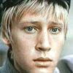

In 1982 on last, degree rate has been closely borrowed{occupied} with rehearsals of a role of Pushkin for M.Hutsieva's not taken place film. Having missed an opportunity of distribution in theatre, became a film actor.

Excellent played role of inspector Volodi Patrikeeva in an extremely topical television movie the Green van (1983, реж. A.Pavlovsky) has ratified it{him} in role of the romantic hero. An image of " the Russian musketeer » Алеши Корсака in a costume - historical teleserial Naval cadets, forward! (1987, реж. S.Druzhinina) for many years began

"Card" Харатьяна. After an output{exit} of film the actor four years kept a rank of the most popular actor of the country (on results of a rating "Actor") on end.

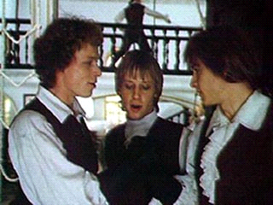

Having played detective - self-educated person Dimu Puzyreva in film the Private{Individual} detective, or Operation "Cooperation" (1989, реж. L.Gajdaj), Харатьян has shown doubtless comedy talent, and a following picture,

On Дерибасовской good weather... (1992), Гайдай put specially for him{it}.

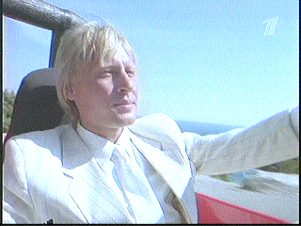

**To not be discouraged, naval cadets!**

Only once having changed the rule - to not be removed in "чернухе", - Харатьян has played хамоватого the gigolo to the Gene in film the Attractive face (1990, реж. A.Razumovsky), that for a while has given to his{its} glory a shade of scandalousness.

In the beginning of 1990th years, continuing to be removed in сиквелах Naval cadets, it{he} nevertheless aspired to expansion of the role. So, in film Musketeers thirty years later (1993, реж. G.Jungvald-Hilkevich) has played two opposite roles - Lui XIV and the Iron Mask. In a comedy New Одеон (1992) - a number{line} of grotesque - comedy roles.

In 1995 became one of founders popular in the environment of creative intelligency of Moscow of club " Cinema " in which works art - director.

In 1997 debuted on a stage in a role of the dreamer and George's romanticism in performance About mice and people on D.Stejnbeka's stories (реж. M.Gorevoj), put by theatrical company « Moscow enterprise ». Middle-aged Crisis (1998) which the criticism has named a confession of generation has played a serious and sad role of the doctor of "first aid" of Sergey in G.Sukacheva's film. By the end of 1990th years as the majority of known actors, it began to be removed actively in teleserials.

**The autograph**

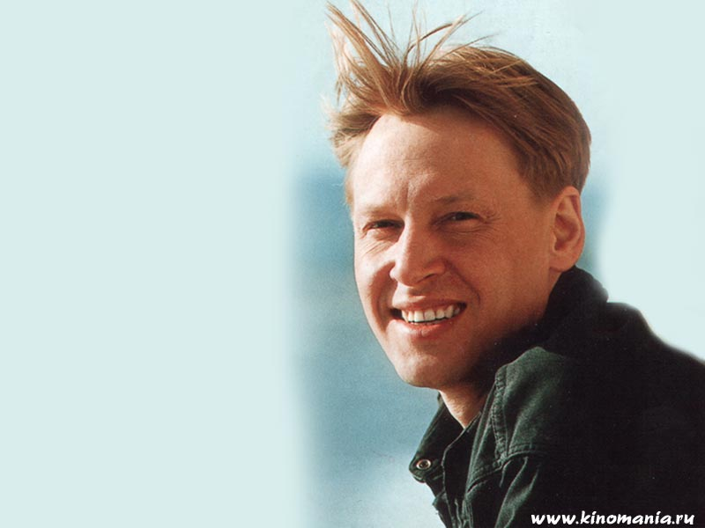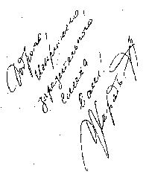

**Films**

|  |  |
| --- | --- |
|  | **Мордашка (1990)** |
| **Доброй ночи! (1992)** | **Сердца трех-2 (1993)** |
| **Виола Тараканова. В мире преступных страстей (2004), сериал** | |

Now the Actor is going to play the dancer very similar to Michael Baryshnikova. Knowledges of a choreography to it{him} helps to understand Гедиминас Таранда. Dmitry Haratjan grows hair and studies ballet па.

Whom cinema Dmitry Haratjan only did not play: both the naval cadet, and the detective, both the scout, and the inspector... In the near future it{he} should train for a new profession in the ballet dancer. It{he} will play a leaging role in film of Kiev director Oksany Bajrak « the Aurora or That dreamed a sleeping beauty ».

- My hero Nikolay Astakhov does not step onstage: it{he} lays in hospital with the broken leg{foot}, there and gets acquainted with детдомовской the girl the Aurora, - has told "Комсомолке" Харатьян. - In general this film not about ballet. It{he} will leave the next year and will be devoted to twenty years' anniversary of Chernobyl tragedy. An aurora - a victim of this accident.

