МИНИСТЕРСТВО ОБРАЗОВАНИЯ РЕСПУБЛИКИ БЕЛАРУСЬ

Учреждение образования

"Гомельский государственный университет

имени Франциска Скорины"

Факультет иностранных языков

Кафедра теории и практики английского языка

French Borrowings in the Modern English Language

Курсовая работа

Исполнитель:

студент группы Векшин П.А.

Научный руководитель: Лобанкова Т.А.

Гомель 2006

Contents

Introduction

French borrowings in the modern english language

Conclusion

Biblography

## Introduction

A foreign language is not just a

subject learnt in the classroom…

it is something which is used for

communication by real people

in real situations.

We live in Belarus and our native language is Belarusian. Almost all the words are native in our language. But some of them are borrowed from other languages, though they got their meanings, spelling, according to the Belarusian language. I have been learning English since the first form, so English is the third language in which I can communicate a little. Since the sixth form I began to study German, comparing pronunciations of the words, grammar rules, spelling it became easier for me to learn these languages. And I am sure that it is easier to learn several languages comparing them.

Last year I took part in the research work and I got a deeper knowledge of borrowings in English language. And this year I decided to deepen my knowledge in this theme too. So today we would like to present you more information about borrowings in English language. This theme sounds interesting for us and we guess you will be interested in it too.

An international vocabulary in any language changes due to the development of economy, science, education etc. Everything depends on time. The same is in English.

The purpose of our research work is to study French borrowings in the modern English language.

The purpose has defined the following tasks:

try to highlight the oldest words borrowed from French;

compare unique domination of widespread languages in a certain epoch;

show that English is now the most widespread of the word's languages;

discern the influence of the French language in the early modern period;

compare the sound of "Norman English" of the middle ages and the modern variant.

## French borrowings in the modern english language

**English** is a **Germanic** Language of the Indo-European Family. It is the **second** most spoken language in the world.

It is estimated that there are 300 million native speakers and 300 million who use English as a second language and a further 100 million use it as a foreign language. It is the language of science, aviation, computing, diplomacy, and tourism. It is listed as the official or co-official language of over 45 countries and is spoken extensively in other countries where it has no official status.

This domination is unique in history. English is on its way to becoming the world's unofficial international language. Mandarin (Chinese) is spoken by more people, but English is now the most widespread of the world's languages.

Half of all business deals are conducted in English. Two thirds of all scientific papers are written in English. Over 70% of all post / mail is written and addressed in English. Most international tourism, aviation and diplomacy are conducted in English.

English contains many words from Norman French, brought to England during the 11th century Norman Conquest.

In 1066 the Normans conquered Britain. **French** became the language of the Norman aristocracy and added more vocabulary to English. More pairs of similar words arose.

Table 1. French-English bilinguism

|  |  |
| --- | --- |
| French | English |
| close | shut |
| reply | answer |
| odour | smell |
| annual | yearly |
| demand | ask |
| chamber | room |
| desire | wish |
| power | might |
| ire | wrath / anger |

Because the English underclass cooked for the Norman upper class, the words for most domestic animals are English (*ox, cow, calf, sheep, swine, deer*) while the words for the meats derived from them are French (beef, veal, mutton, pork, bacon, venison).

The Germanic form of plurals (*house, housen; shoe, shoen*) was eventually displaced by the French method of making plurals: adding an *s* (*house, houses; shoe, shoes*). Only a few words have retained their Germanic plurals: *men, oxen, feet, teeth, children.*

It wasn't till the 14th Century that English became dominant in Britain again. In 1399, King Henry IV became the first king of England since the Norman Conquest whose mother tongue was English. By the end of the 14th Century, the dialect of London had emerged as the standard dialect of what we now call **Middle English**. Chaucer wrote in this language.

**Modern English** began around the 16th Century and, like all languages, is still changing. One change occurred when the suffix of some verb forms became *s (loveth, loves; hath, has*). Auxiliary verbs also changed (*he is risen, he has risen*).

**Norman French** is the 11th century language of **France** and **England**. It is an **Indo-European** language.

In 1066, the **Norman** king, **William the Conqueror**, invaded **England**. Many **Norman French** words entered the language after this. In general, the **Normans** were the nobility, while the native **English** were their servants. The names of domestic animals and their meats show this relationship. The animal name is **English** (*"cow", "sheep", "pig")* while the names of the meats derived from these animals is **French** (*"beef", "mutton", "pork").*

Table 2. English - A Historical Summary

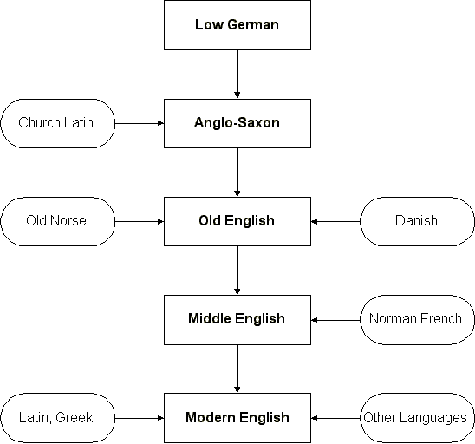

Many words have been borrowed from **Norman French**. These can be grouped into several types:

legal terms ("adultery", "slander"),

military words ("surrender", "occupy"),

names of meats ("bacon", "venison"),

words from the royal court ("chivalry", "majesty").

the non-metric unit of volume (the "gallon") is **Norman French**. There are many other words.

The **Normans** introduced the **QU** spelling for words containing **KW** (*"question").*

Table 3. French borrowings

|  |  |  |
| --- | --- | --- |
| Word | Meaning | Notes |
| accuse |  | One of many legal words from Norman French. |
| adultery |  |  |
| archer |  | One of several military words from Norman French. |
| arson |  | Crime of deliberate burning. |
| assault |  |  |
| asset | enough |  |
| bacon |  | Cured pig's meat. One of many names for meats from Norman French. |
| bail | to take charge | Security for a prisoner's appearance. |
| bailiff | carrier | Officer who executes writs. |
| beef |  | Meat of ox or cow. |
| butcher | seller of goat flesh | A dealer in meat. |
| button |  |  |
| chivalry | horseman | One of many words used in royal life from Norman French. |
| comfort | strengthen |  |
| courtesy |  |  |
| cricket |  | A ball game played in the UK, Caribbean, parts of Africa and Asia, Australia, New Zealand. |
| crime | judgment |  |
| curfew | cover fire | Period to be off the streets. |
| custard |  | Baked mixture of eggs and milk. |
| defeat |  |  |
| dungeon |  | Underground prison. |
| duty |  |  |
| eagle |  | Large bird of prey. |
| elope | run away |  |
| embezzle | ravage |  |
| enemy | non friend |  |
| error |  |  |
| evidence |  |  |
| exchequer |  | A national treasury. |
| fashion | make |  |
| felony |  | A serious crime. |
| fraud |  |  |
| gallon | jug | A unit of liquid volume (= 4.546 Ч 10-3 m3 in UK; = 3.785 Ч 10-3 m3 in USA) |
| goblin |  |  |
| gourd |  |  |
| grammar | art of letters |  |
| grease | fat |  |
| grief |  |  |
| grocer |  | Food dealer. Originally "one who deals in the gross". |
| gutter | drop | Track for water. |
| haddock |  | A type of fish. |
| havoc |  |  |
| hogmanay |  | Now a Scottish festival at New Year. |
| honour |  |  |
| injury | wrong | Wrongful action or damage. |
| jettison | throw overboard |  |
| joy |  |  |
| judge | right speaking |  |
| jury | swear |  |
| justice |  |  |
| larceny |  | The crime of theft. |
| lavender |  | Perfumed shrub. |
| launch | hurl |  |
| lease | leave |  |
| leisure | allowed | Free time. |
| lever | to raise |  |
| liable | may be bound |  |
| libel | little book |  |
| liberty | free |  |
| liquorice | sweet root | Originally from a Greek root, "glico riza". |
| mackerel |  | A type of fish. |
| majesty |  |  |
| mangle |  |  |
| manor | remain |  |
| marriage |  |  |
| matrimony |  | From the same root as "matriarch" (mother). |
| mayhem |  |  |
| mutton |  | Meat of sheep. |
| noble |  |  |
| noun | name |  |
| nurse | nourish |  |
| occupy | seize |  |
| odour | smell |  |
| parliament | speaking | Ruling council in countries like UK. |
| pedigree | crane's foot | From "pe de gru". Because bird's feet marks resemble a family tree. |
| penthouse |  |  |
| perjury |  | False statement under oath. |
| pinch |  | As in "grip tightly". |
| platter | big plate |  |
| pleasure |  |  |
| pocket | small bag |  |
| pork |  | The meat of the pig. |
| prison | lay hold of |  |
| profound | deep |  |
| purloin | put away |  |
| purveyor |  | Supplier of food. |
| push |  |  |
| quarter |  | The Normans introduced the QU spelling for the KW sound. |
| question |  |  |
| quiet |  |  |
| quiver |  | The arrow case. |
| rape | take by force |  |
| reason |  |  |
| rebuke |  | Originally "to cut down wood". |
| rebut |  |  |
| recover |  |  |
| remedy | to heal |  |
| renown | to make famous |  |
| rent |  | The same root as "render". |
| repeal |  |  |
| reprieve | send back |  |
| reprisal |  |  |
| retail | piece cut off |  |
| reward |  |  |
| river |  |  |
| robe |  |  |
| royal |  |  |
| rummage |  |  |
| salary | salt | Soldiers used to be paid with salt. |
| salmon |  | A type of fish. |
| scavenger | tax collector |  |
| scullery | maker of dishes |  |
| search |  |  |
| sermon |  |  |
| sewer |  | Originally a channel to carry off overflow from a fishpond. |
| share |  |  |
| shop | cobbler's stall |  |
| sir |  | From "sire". |
| slander |  |  |
| soil |  |  |
| sovereign |  |  |
| spawn |  |  |
| spy |  |  |
| squirrel | little shadow tail |  |
| stubble | grain stalks |  |
| subsidy | support |  |
| suitor |  |  |
| surname |  | Family name. |
| surplus |  |  |
| surrender |  |  |
| survey |  |  |
| survive | over live |  |
| syllable |  |  |
| tally | mark on a stick | Tally sticks were used to record financial transactions. |
| tax | to charge |  |
| toil | stir |  |
| treason |  |  |
| treaty |  |  |
| uncle |  |  |
| usher | door keeper |  |
| valley |  |  |
| veal |  |  |
| veil |  |  |
| venison | to hunt | Deer meat |
| vicar | assistant |  |
| vice |  |  |
| view |  |  |
| virgin |  |  |
| vulture |  | Large bird of prey. |
| wafer |  |  |
| waive |  |  |
| warden |  | Same root as "guardian". |
| wicket | gate | Wooden sticks used in the game of cricket. |
| wreck |  |  |

The French Language in England

1066-1200

Norman French is the native language of the nobility.

Probably not a great deal of bilingualism

Small numbers of French loans enter English: legal, administrative and military terms.

1200-1300

1204 Loss of Normandy.

French is the cultivated, prestige language.

There is a diagnostic situation, with French the high-prestige, English the low-prestige variety.

Norman French has lost its status, and Parisian French as the preferred norm.

Large numbers of French loans enter English.

State of English 1300

1300-1400

English becomes the dominant language, but French remains dominant in literature and at the court.

Increasing evidence of imperfect knowledge of French

Table 4. Norman French chronology

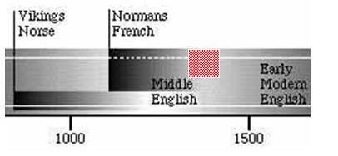

· 1334-1453 The Hundred Years' War with France.

· 1348-9 The Black Death.30% mortality. Labour shortage, wage rises, increasing importance of the English-speaking classes

· 1386 English accepted in the courts ('Statute of Pleading')

· Two major English poets at the end of the 14th century:

Gower writes mostly in French (but composes one long work *Confessio amantis*, in English)

· Chaucer writes almost entirely in English.

· Evidence of private letters:

· 1350: French is the rule.

· After 1400: English becomes common.

· After 1450: English is the rule.

· Use of English in schools.

The influence of French on English in the early modern period

Influence on English phrasing

Aside from borrowing and word formation, French considerably influenced English phrasing. The loan translations range from polite turns of speech, such as *at your service, do me the favour, to engage somebody in a quarrel, to make (*later: *pay*) *a visit,* to idiomatic phrases like *by occasion, in detail, in favour of, in the last resort, in particular, to the contrary.*

ME pronounciation

The English language of the middle ages is different from the modern one. Here are two extracts from Geoffrey Chaucer's Canterbury Tales to compare:

From the *General Prologue* Whan that April with his showres soote The droughte of March hath perced to the roote, And bathed every veine in swich licour, Of which vertu engendred is the flowr;

Whan Zephyrus eek with his sweete breeth Inspired hath in every holt and heeth The tendre croppes, and the yonge sonne Hath in the Ram his halve cours yronne, And smale fowles maken melodye That sleepen al the night with open yл - (So priketh hem Nature in hir corages) - Thanne longen folk to goon on pilgrimages, And palmeres for to seken straunge strondes To ferne halwes, couthe in sondry londes;

And specially from every shires ende Of Engelond to Canterbury they wende, The holy blisful martyr for to seeke, That hem hath holpen whan that they were seke.

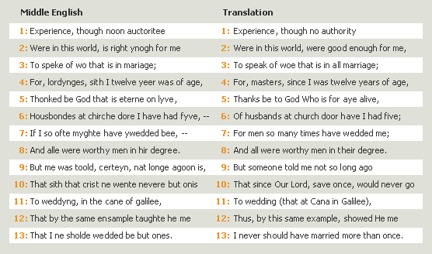

The Wife of Baths Prologue and Tale from The Canterbury Tales, by Geoffrey Chaucer, performed by Elizabeth Salter, from Geoffrey Chaucer: The Wife of Prologue and Tale (Cambridge University Press ISBN 0521635306) (p) 1976, 1998 Cambridge University Press. All Rights Reserved. /© Microsoft Corporation. All Rights Reserved.

## Conclusion

Language belongs to each of us. Everyone uses words. What is there in a language that makes people so curious? The answer is that there is almost nothing in our life that is not touched by language. We all speak and we all listen so we are all interested in the origin of words, in how they appear and die. Nowadays 750 million people all over the world use English. It has become the language of the planet.

Most of words are the same, but there are some differences. For example in Middle English *ynogh* is *enough* in modern English; *longe* is *long*; *agoon* is *ago* and so on, but they are a little bit similar in writing, so it is not very difficult to understand them.

Though the number of French loans in the modern period is relatively minor in comparison to Middle English, the contribution is most important. The French Loans were primarily borrowed to provide richness to the language. Whilst it was arguable during the Restoration whether the loans were corrupting or enriching the language, today there is no doubt or disputable grounds to argue that the loans did nothing but enrich the English language.

The borrowing of vocabulary is rapprochement of nations on the ground of economic, political and cultural connections. The bright example of it can be numerous French borrowings to English language.

Attempts to continue borrowings in 20th century did not have special success because language became more independent.

In my opinion we managed to study the problems of French borrowings in the English language. We understood possible ways of penetrating French words in the English language, we have seen difference ways of difference types of borrowings.

In spite of arrival of the words from different languages into the English vocabulary, the English Language did not suffer from large flow of foreign elements.

On the contrary its vocabulary has been enriched due to the taken foreign elements.

## Biblography

1. Иванова И.П., Чахоян Л.П., Беляева Т.М. История английского языка. - СПб.: Лань, 1999.
2. Иванова И.П., Чахоян Л.П., Беляева Т.М. Практикум по истории английского языка. - СПб.: Лань, 1999.
3. Смирницкий А.И. Древнеанглийский язык. - М., 1955.
4. Советский энциклопедический словарь. - М.: Советская энциклопедия, 1980.
5. Encyclopaedia Britannica 2004 Ultimate Reference CD-ROM
6. Encarta Encyclopedia Deluxe 2005
7. McCrum R. The Story of English. - New-York, 1987.
8. Whitelock D. The Beginning of English Society. - Harmondsworth Middlesex, 1952.
9. New Webster’s Dictionary, 1998.