Ministry of education and science of Republic Kazakhstan

University of International Business

Management Department

TERM PAPER

THEME: Unemployment: reasons and main forms

prepared by: Kulusheva Anar 117 group

scientific Adviser: Tulegenov S. V.

Almaty, 2008

Plan:

Introduction

Chapter 1. All about Unemployment

1.1 What is unemployment?

1.2 How is unemployment measured?

1.3 Why are there always some people unemployed?

1.4 Working resources and its classification

Chapter 2. Unemployment in practical

2.1 Unemployment Insurance

2.2 Types of unemployment

2.3 Distribution of manpower

Conclusion

List of used literature

Introduction

Why I choose this theme?

We all are living in globalization epoch. So, slight changing in economy some countries in the one side of earth, are prove a big influence for economy all countries in the entire world.

Due to , that economy all world’s countries connected with each other and measures undertaken by this countries about getting down this problem must be coordination.

Nowadays mortgage crisis in USA influenced for many countries economy and for Kazakhstan’s economy too. And afterwards of any economy crisis is unemployment. Today this theme is very topical.

All countries need to find measure for saving economy in their country from crisis and find method to limit quantity of unemployed, because increase quantity of unemployed is aggravate crisis in all country’s economical branches.

Losing a job can be the most distressing economic event in a person’s life. Most people rely on their standard of living, and many people get from their work not only income but also a sense of personal accomplishment. A job loss means a lower living standard in the present, anxiety about the future and reduced self-esteem. It is not surprising, therefore, that politicians campaigning for office often speak about how their proposed policies will help create jobs.

A country that saves and invests a high fraction of its income, for instance, enjoys more rapid growth in its capital stock and its GDP than similar country that saves and invests less. An even more obvious determinant of a country’s standard of living is the amount of unemployment it typically experiences. People who would like to work but cannot find a job are not contributing to the economy’s production of goods and services. Although some degree of unemployment is inevitable in a complex economy with thousands of firms and millions of workers, the amount of unemployment varies substantially over time and across countries. When a country keeps its workers as fully employed as possible, it achieves a higher level of GDP than it would if it left many of its workers standing idle.

The problem of unemployment is usefully divided into two categories – the long-run problem and the short-run problem. The economy’s natural rate of unemployment refers to the amount of unemployment that the economy normally experience.

Chapter 1. All about unemployment

* 1. What is unemployment?

The answer to this question may seem obvious: an unemployed person is someone who does not have a job. But as economists we need to be precise and careful in our definition of economic categories. If you are in full-time education, for example, you do not have a full-time job in the usual sense of the word – i.e. you are not in full-time paid employment. And there is good reason: you are studying. Hence you are not available for work. What if you were not a student but were suffering from some long-term illness that meant that you were unfit for work. Again, although you would not have a job, we would not say that you were unemployed because you would not be available for work. From these two examples, it seems clear that we need to qualify our original definition of an unemployed person as ‘someone who does not have a job’ to ‘someone who does not have a job and who is available for work’.

But we still need to be clear as to what we mean by ‘available for work’. Suppose you were not in full-time employment and were looking for a job and I offered you a job as my research assistant for 50 pence a day. Would you take it? If we ignore for a moment the complication that economic research is so interesting that it is its own reward, you would probably not take the job because the wage rate offered is so low. At another extreme, suppose you won so much money on the National Lottery that you decided you would leave university and live off your winnings for the rest of your life. Would you be unemployed? No, because you would still be unavailable for work, no matter what wage rate you were offered. Thus, being unemployed also depends upon whether you are willing to work (whether you are ‘available for work’) at going wage rates.

We are now in a position to give a more precise definition of what it means to be unemployed: the number unemployed in an economy is the number of people of working age who are able and available for work at current wage rates and who do not have a job.

Normally, economists find it more convenient to speak of the unemployment rate. This expresses the number unemployed as a percentage of the labor force, which in turn can be defined as the total number of people who could possibly be employed in the economy at any given point in time. If you think about it, this must be equal to the total number of people who are employed plus the total number of people who are unemployed.

* 1. How Is unemployment Measured?

The claimant Count. One simple way is to count the number of people who, on any given day, are claiming unemployment benefit payments from the government – the so-called claimant count. Since a government agency is paying out the benefits, it will be easy to gather data on the number of claimants. The government also has a good idea of the total labour force in employment, since it is receiving income tax payments from them. Adding to this the number of unemployment benefit claimants is a measure of the total labour force, and expressing the claimant count as a proportion of the labour force is a measure of the unemployment rate.

Since the government already has all the data necessary to compute the unemployment rate based on the claimant count, is it is relatively cheap and easy to do. Unfortunately, there are a number of important drawbacks with the claimant count method.

One obvious problem is that it is subject to changes in the rules the government applies for eligibility to unemployment benefit. Suppose the government gets tougher and changes the rules so that few people are now entitled to unemployment benefit. The claimant count will go down and so will the measured unemployment rate, even though there has been no change in the number of people with or without work! The opposite would happen if the government became more lenient and relaxed the rules so that more people became eligible.

As it happens, governments do often change the rules on unemployment benefit eligibility. In the UK, for example, there have been about 30 changes to the eligibility rules over the past 25 years, all but one of which have reduced the claimant count and so reduced the measured unemployment rate based on this measure. The following are examples of categories of people who are excluded from the UK claimant count: people over the age of 55 who are without a job; those on government training programmes (largely school-leavers who have not find a job); anyone looking for part-time work; and people who have left the workforce for a while and now wish to return to employment (for example women who have raised a family). Many – if not all – of the people in these categories would be people who do not have a job, are of working age and are able and available for work at current wage rates; yet they would be excluded from measured unemployment in the UK using the claimant count method.

Labour Force Surveys. The second, and probably more reliable method of measuring unemployment is through the use of surveys – in other words, going out and asking people questions – based on an accepted definition of unemployment. Questions then arise as to whom to speak to, how often (since surveys use up resources and are costly) and what definition of unemployment to use. Although the definition of unemployment that we developed earlier seems reasonable enough, the term ’available for work at current wage rates’ may be too loose for this purpose. In the UK and many other countries, the government carries out Labour Force Surveys based on the standardized definition of unemployment from the International Labour Office, or ILO. The ILO definition of an unemployed person is someone who is without a job and who is willing to start work within the next two weeks and either has been looking for work within the past four weeks or was waiting to start a job.

The Labour Force Survey is carried out quarterly in the UK and is based on a sample of about 60,000 households. Based on the answer to survey questions, the government places each adult (aged 16 and older) in each surveyed household into one of three categories:

* employed
* unemployed
* not in the labour force (or ’economically inactive’).

A person is considered employed if he or she spent some of the previous week working at a paid job. A person is unemployed if he or she fits the ILO definition of an unemployed person. A person who fits neither of the first two categories, such as a full-time student, homemaker or retiree, is not in the labour force (or, to use ILO terminology, economically inactive). Figure 1 shows this breakdown for the UK in the autumn of 2004.

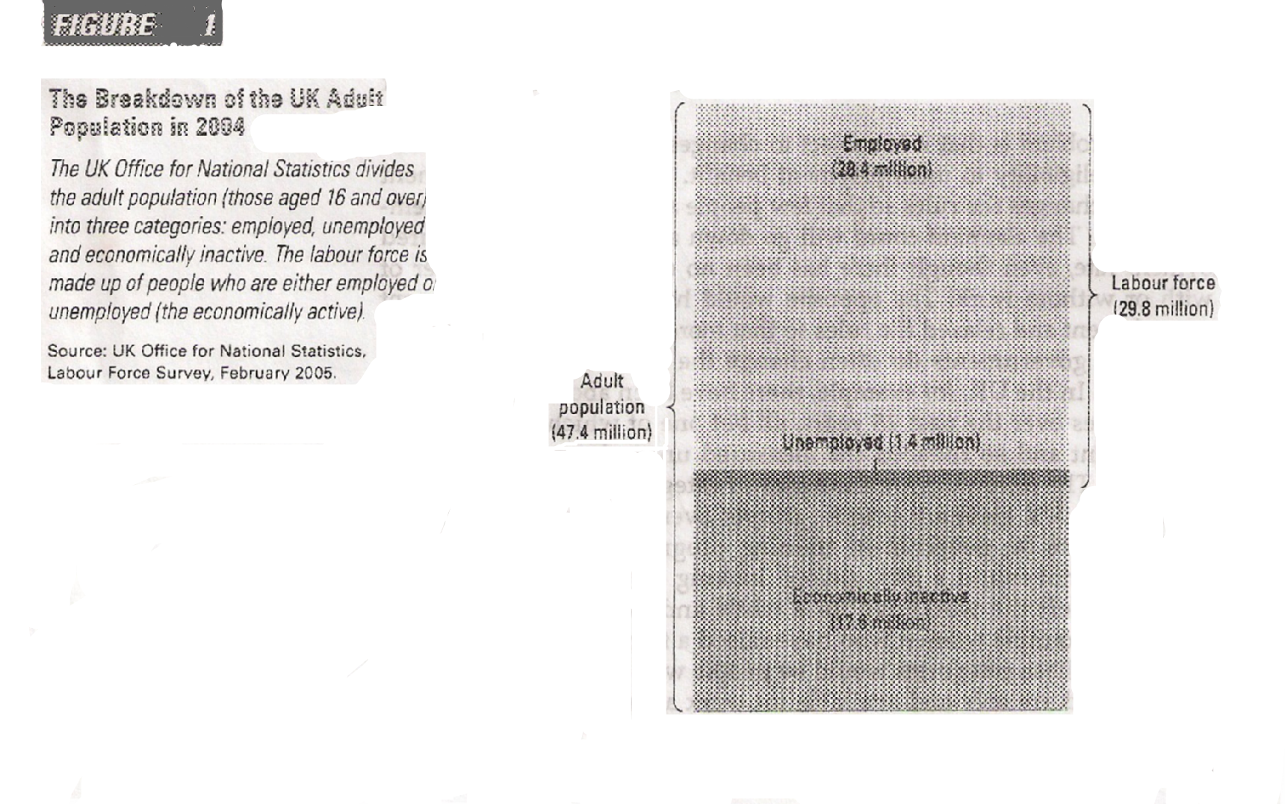

Once the government has placed all the individuals covered by the survey in a category, it computes various statistics to summarize the state of the labour market. The labour force is defined as the sum of the employed and the unemployed:

Labour force = Number of employed + Number of unemployed

Then the unemployment rate can be measured as the percentage of the labour force that is unemployed:

Unemployment rate = (Number of unemployed/Labour force) х 100

The government computes unemployment rates for the entire adult population and for more narrowly defined groups – men, women, youths and so on.

The same survey results are used to produce data on labour force participation. The labour force participation rate measures the percentage of the total adult population of the country that is in the labour force:

Labour force participation rate = (Labour force/Adult population) х 100

This statistic tells us the fraction of the population that has chosen to participate in the labour market. The labour force participation rate, like the unemployment rate, is computed both for the entire adult population and for more specific groups.

To see how these data are computed, consider the UK figures for autumn 2004. According to the Labour Force Survey, 28.4 million people were employed and 1.4 million people were unemployed. The labour force was:

Labour force = 28.4 + 1.4 = 29.8 million

The unemployment rate was:

Unemployment rate = (1.4/29.8) х 100 = 4.7 per cent

Because the adult population (the number of people aged 16 and over) was 47.4 million, the labour force participation rate was:

Labour force participation rate = (29.8/47.4) х 100 = 62.9 per cent

Hence, in autumn 2004, nearly two-thirds of the UK adult population were participating in the labor market, and 4.7 per cent of those labour market participants were without work.

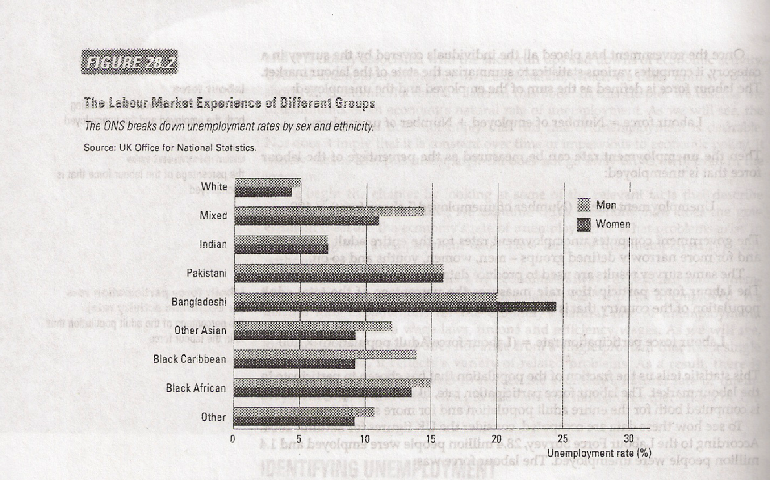

Figure 2 shows some statistics on UK unemployment for various groups within the population, broken down by ethnicity and sex, also collected by the ONS. A number of points are worth noting. First – and perhaps most striking – unemployment rates for people from non-white ethnic groups were higher than those for white people, for both men and women. Secondly, unemployment rates among ethnic groups vary widely. In 2001-02, among men, Bangladeshis had a highest unemployment rate in the UK at 20 per cent – four times that for white British men. The unemployment rate among Indian men was only slightly higher than that for white British men, 7 per cent compared with 5 per cent. Unemployment rates for all other non-white men were between two and three times higher than those for white British men.

The picture for women was similar to that for men, although the levels of unemployment were generally lower. Bangladeshi women had the highest unemployment rate of all at 24 per cent, six times greater than that for white British women (4 per cent). The rate for Indian women was slightly higher than for white women at 7 per cent.

Data on the labour market also allow economists and policymakers to monitor changes in the economy over time. Figure 3 shows the unemployment rate in the UK since 1971, calculated using the claimant count. Claimant count figures are less reliable than the Labour Force Survey figures.

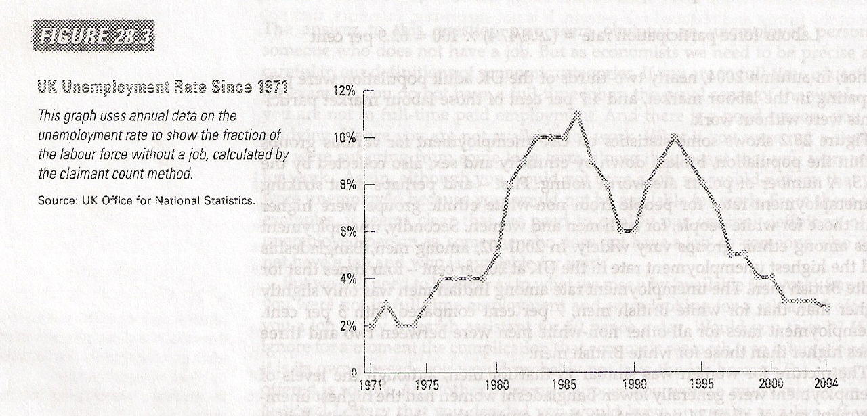

Nevertheless, the figure is useful in demonstrating that the economy always has some unemployment and that the amount changes – often considerably – from year to year.

* 1. Why Are There Always some people Unemployed?

The unemployment reasons. In the western economic literature of the reason of unemployment are investigated mainly on the basis of purely economic approach. Thus unemployment is considered as a macroeconomic problem of not enough full use of a cumulative labour. Often reasons of unemployment speak imbalance of a labour market or adverse changes this market.

The most known theory explaining the reasons of unemployment, the theory of J is. M. Keynes which has replaced in the mid-thirties the theory of classics-economists (A. Smit, A. Marshall), explaining the unemployment reason high level of wages. On Keynes, unemployment is inverse function of cumulative demand. « Employment volume, - Keynes wrote, - by absolutely certain image is connected with volume of effective demand ». The insufficient volume of effective demand causes slackness of investment process and, hence, impossibility of maintenance of employment that conducts to I grow unemployment. An exit from this situation Keynes saw in increase of a role of the state in formation of cumulative demand at the expense of increase in the State expenditure, first of all – on the investment goods. Keynes's critics, representatives of neoclassical school, see the unemployment reasons just in that state policy which the developed countries spent« under recipes» Keynes. So, for example, F. Hajek considered that unemployment « is direct result of a short-sighted full employment policy which you spent to a current of last twenty five years ». Growth of the State expenditure, on F. Hajeka's opinions, inevitably conducts to inflation which, having reached a critical point, itself becomes the reason of the increased unemployment. An exit from this closed circle one – to stop an inflationary full employment policy. Certainly, at the first stage it will lead to sharp jump of unemployment, but it, on Hayek's idea, will give the chance to reveal all defects in work placing, to develop and carry out not inflationary methods the program of maintenance of a high and stable occupation level. Monetarists led by M. Fridmenom have put forward the concept of "natural" unemployment. To which they carry so-called frictional unemployment. Frictional unemployment covers the workers changing for those or other reasons a place of work, for example, in search of higher earnings or work with большей by prestigious ness, more favorable working conditions, or migrating in connection with necessity of change of a residence. To natural unemployment carry also structural, caused by changes in structure of public manufacture under the influence of scientific and technical progress and perfection of the organization of productions. This type of unemployment also is time (though also more long, than frictional unemployment) as disappearances of one manufactures (branches) it is accompanied by rapid growth of others. Problem only in that, how fast the unemployed can adapt to the changed conditions on a labour market. The concept of "natural unemployment» is supported by almost all economists, including Neokeynesians. Disputes go only that causes growth of unemployment above natural level, - insufficiency of an aggregate demand or the regulating policy of the state infringing the "natural" mechanism of formation of employment and a wages in the market of work. Thus, the western economists recognize that unemployment – the integral attribute of market system of an economy, it is inevitable, and in the "natural" variant even is useful to maintenance of necessary flexibility of a labour market. But till now not one economic doctrine is not indisputable from a point of sight of an explanation of the reasons of unemployment and employment. All present sights at the unemployment reasons can be grouped in the next image.

First, rather redundant population, "superfluous" in comparison with the reached level of national production can become the unemployment reason. This factor of unemployment especially hardly affects in the developing countries.

Secondly, unemployment can be result of changes in economy structure, including – in technologies (structural unemployment). This unemployment is time as on change to old branches and productions (technologies) the new come.

Thirdly, unemployment can was temporary to increase because of natural desires of people to find work "to liking" and with the best working conditions and payments (frictional unemployment). Fourthly, especially strong increase in a rate of unemployment results from cyclic recession in economy (cyclical unemployment). This kind of unemployment is the most dangerous as there is a vicious circle: Production falling – unemployment – reduction of the general level of incomes – aggregate demand decrease – production falling – unemployment etc. Fifthly, in certain cases the unemployment generator can become active interference of the state and trade unions in relations between the hired worker and the employer that leads to market inflexibility of wages and forces businessmen to solve a problem of achievement of the maximum profit by employment reduction. All these reasons of unemployment represent without delay the factors influencing for the size and dynamics of unemployment. The basic sources of unemployment are not market proportions and the conditions developing on a labour market since a labour market only reflects proportions existing at present between demand and the labour offer, but direct sharing in their formation does not accept. These proportions depend on the processes which are outside of the market of work. The market only finds out them, shows unemployment, and does its visible for company.

* 1. Working resources and its classification

Statistics of manpower. Manpower is persons of both sexes who potentially could participate in production of the goods and services. They are significant in the conditions of market economy as integrate such categories, as the economically active population including of taken both unemployed persons, and economically inactive population at able-bodied age. Number of manpower is advanced proceeding from number of able-bodied population at able-bodied age and working persons outside of able-bodied age. The person of work possesses a main role in economic activities development, perfection of its organization and management for the purpose receptions of the greatest return from the creative work. People invent and make instruments of labour and production assets, will organise rational division and labour co-operation at various levels of productive activity, beginning from a job and finishing the organization within the limits of all national economy. The labour as set of physical and spiritual abilities of the person is main productive force of company and constitutes manpower of all enterprises and the establishments belonging to various branches of a national economy. Manpower of each made unit is represented by a part distributed on branches of a national economy of manpower. The statistical characteristic of availability of a manpower of the enterprise, establishment, association, an industry, agriculture, building or transport separately or all economic complex, is the list volume of employment in them workers. The statistics of each branch of a national economy studies the following questions connected with application of a living labour:

1. Statistics of manpower and their use.

2. Statistics of labour efficiency.

3. Statistics of wages.

The statistics of manpower is divided in turn on two parts:

1. To the statistican of a labour – the primary goals is studying of number and structure of workers, studying of change of number of workers; an estimation of security of the enterprise a manpower; studying of job management and use of workers on corresponding qualification; labour discipline studying.

2. To the statistican of working hours - problems is definition of a combined value of fulfilled time; studying of use of working hours, and revealing of losses of working hours

Statistics of structure of manpower. In force of distinction manpower the structure of workers at the enterprise is studied in following directions:

1) on a branch accessory;

2) on work plots;

3) on the functions executed in the course of production.

Depending on a branch accessory of division of the enterprises the staff of primary activity or industrial and production staff and staff of the nonindustrial organizations allocate. On executed functions workers of industrial and production staff are subdivided into six categories: workers, pupils, engineering employees, employees, junior attendants and workers of protection. The most numerous and basic part of structure of workers are workers. To workers, directly linked with production, and also the persons taken by repair and care by the equipment, material delivery persons concern jobs etc. The persons trained on production of this or that trade of workers and receiving wages concern pupils. Engineering employees constitute that part of the enterprise which carry out the organisation and a management industrial and engineering procedure. The workers performing administrative and managerial and economic functions concern employees. To junior attendants carry the workers dealing with service of industrial and non-productive premises. Depending on a role in the course of production discriminate the basic and auxiliary workers. To the cores carry the workers, directly taken by production manufacturing, leading to action machinery and plant. The workers taken by service of the basic workers concern the auxiliary, the equipment, on automation of their work. Working the basic and auxiliary are in turn characterised by degree of mechanisation and automation of their work.

The major statistics of number of workers of the enterprise is the size of average list number of workers. Average list number of workers of the enterprise or the shop, accepted for the partial working day, is estimated so: total number of the man-hours fulfilled by these workers for month, is divided into the established duration of the working day and the number of the fulfilled man-days received thus, divide into number of the working days in a month on a calendar.

For example, for a month in which on a calendar 22 working days, are fulfilled by workers of 12500 man-hours. Then at five-day working week the number of the fulfilled man-days will constitute 1524, as private from division 12500 on 8,2; т.е.12500:8,2. Average list number of the workers accepted for the partial working day (1524:22=69 the people) Will constitute 69 persons. Thus, average list number of the workers accepted for partial working week, advance as the relation of the man-days fulfilled by these Workers to number of the working days in the taken away month on a calendar. And the average list number of workers working full-time is calculated as average arithmetic simple during a certain interval of time (month, quarter, year). We will assume that for the first half of the year average list number of industrial and production staff has constituted 730 persons, and for July - 710, August 700. Average list number of industrial and production staff for January - August (8 months) Will equal: (736х6+710х1+700х1):8=5826:8=728 the economic statistics gives the Basic attention to that part of a manpower which participates in social work. Not less important problem there is a definition of the taken workers on national economy branch. Two groups of a manpower are allocated: taken by physical work and taken by intellectual labour.

Despite the fact that what the labour productivity level increased all over the world over the last 10 years, there are big ruptures in the data on industrial and to developing countries. Though the states of Southern and East Asia, and also the Central and Southeast Europe already catch up with EU and the USA on this indicator, as a whole the situation looks not in the best way. A poverty principal cause in the world the International job management (SQUANDERER) named inefficient use of a potential production of workers.

From the report containing key indicators of a labour market, published on September, 2nd the SQUANDERER it is visible that the USA still is the leader on productivity on one worker following the results of 2006. It is necessary to note essential growth of this indicator for the past of 10 years in East Asia where productivity has increased in 2 times.

Furthermore rupture in productivity between the USA where an added value on one worker (the highest in the world) has constituted $63,885, and other developed economy following States continues to increase: Ireland ($55,986), Luxembourg ($55,641), Belgium ($55,235), France ($54,609).

However Americans work more hours per year, than citizens of other developed countries. If to look at the cost added to one workers in an hour the best labour efficiency in Norway ($37,99), it follow the USA ($35,63) and France ($35,08).

The labour efficiency increase generally grows out more of an effective utilisation of a combination (combination) of work, the capital and technology. Insufficient investments in human and a fixed capital along with application of old technologies can lead to partial use of labour potential in the world. «Huge rupture between productivity and riches is at the bottom for anxiety, — the general director SQUANDERER Juan Somavija has declared. — the Increase in labour efficiency of workers with low yields in the poor countries leads to reduction of essential deficiency of a labour in the world».

In East Asia where the highest growth of a performance level is recorded, the output having on one worker, has grown with 1/8 to 1/5 from level of the industrial countries. In the report it is said also that in South East Asia and in Oceania this indicator in 7, and in Southern Asia in 8 times more low in comparison with the developed states. In Central Asia, Latin and Central America the added value having on one worker, in 3 times is less, than in the EU countries and the USA, and in the countries of the Central and Southeast Europe, in the CIS this indicator in 3,5 times more low. The biggest rupture in comparison with the states with industrial economy is observed in the Central Africa where the performance level in 12 times is less.

Thus, the next publication «Key indicators of a labour market» gives wider submission that in the SQUANDERER name «comprehensible deficiency of jobs» in the world. « Worthy »work ensures necessary productivity to the employer who in turn supports safety precautions, grants fair payment and social protection by worker and to their families, thereby promoting a normal life of company.

Hundred millions men and women work, applying all forces, however conditions in which they work, do not allow them to ensure own families to the most necessary. People continue to live below the poverty line, every day falling all below this line. The general director the SQUANDERER Mr. Somavija has declared necessity of increase in labour efficiency for the poor countries that would help people to earn more.

By data the SQUANDERER of 1,5 billion people in the world — or third of able-bodied population — not completely use the working potential. The problem consists that people in the poor countries want, but has no possibility to work. The income on one member of the family there does not exceed $2, it is catastrophically low figure. More than half of all taken are subject to threat to remain below the breadline. The majority of such people works in shadow economy and does not get practically under any protection. In the Central Africa and Southern Asia of 70 % taken are in similar position.

Besides, in the report the situation which has developed on labour markets is reflected. So, about half of able-bodied population all over the world does not leave on labour markets of the countries. Over the last 10 years the passive behavior on labour markets was more often fixed at women, rather than at men. Only 2 from 10 men do not show any activity while at women such position meets in half of cases.

«Key indicators of a labour market» into which have entered 20 various indicators reflecting a situation which have developed on a labour market with its productivity, working conditions, wages and indemnifications, represent a real picture of that as a whole occurs to a labour in the world.

Chapter 2. Unemployment in practical

* 1. Unemployment Insurance

One government policy that increases the amount of frictional unemployment, without intending to do so, is unemployment insurance (or, as it is called in the UK, national insurance). This policy is designed to offer workers partial protection against job loss. The unemployed who quit their job, were fired for just cause or who have just entered the labour force and not eligible. Benefits are paid only to the unemployed who were laid off because their previous employers no longer needed their skills.

While unemployed insurance reduces the hardship of unemployment, it also increases the amount of unemployment. The explanation is based on one of the Ten Principles of Economics. Because unemployment benefits stop when a worker takes a new job, the unemployed devote less effort to job search and are more likely to tern down unattractive job offers. In addition, because unemployment insurance makes unemployment less onerous, workers are less likely to seek guarantees of job security when they negotiate with employers over the terms of employment.

Many studies by labour economists have examined the incentive effects of unemployment insurance. In one US study, when unemployed workers applied to collect unemployment insurance benefits, some of them were randomly selected and offered each a $500 bonus if they found new jobs within 11 weeks. This group was then compared to a control group not offered the incentive. The average spell of unemployment for the group offered the bonus was 7 per cent shorter than the average spell for the control group. This experiment shows that the design of the unemployment insurance system influences the effort that the unemployed devote to job search.

Several other studies examined search effort by following a group of workers over time. Unemployment insurance benefits, rather than lasting forever, usually run out after six month or a year. These studies found that when the unemployed become ineligible for benefits, the probability of their finding a new job rises markedly. Thus, receiving unemployment insurance benefits does reduce the search effort of the unemployed.

Even though unemployment insurance reduces search effort and raises unemployment, we should not necessarily conclude that the policy is a bad one. The policy does achieve its primary goal of reducing the income uncertainty that workers face. In addition, when workers turn down unattractive job offers, they have the opportunity to look for jobs that better suit their tastes and skills. Some economists have argued that unemployment insurance improves the ability of the economy to match each worker with the most appropriate job.

The study of unemployment insurance shows that the unemployment rate is an imperfect measure of a nation’s overall level of economic well-being. Most economists agree that eliminating unemployment insurance would reduce the amount of unemployment in the economy well-being would be enhanced or diminished by this change in policy.

* 1. Types of unemployment

There are various kinds of unemployment, each of which is generated by the reasons. Today economists prefer to speak not about unemployment in general, and to allocate its specific kinds:

* frictional
* structural
* cyclic
* seasonal
* voluntary

Frictional unemployment exists even in the countries enduring rough economic blossoming. Its reason consists that to the worker who dismissed from the enterprise or has left it of the own free will, some time to find a new workplace is required. It should suit it both by the nature of activity, and on payment level. Even if in the work market such places to eat, find them it is possible usually not at once. One people feel capable to perform more difficult and highly paid work and search for it, others are convinced that do not correspond to requirements of the workplace and should look for work with payment more low. In a free market society always there is a certain quantity of people which for various reasons search for itself for more suitable work Besides, on a labour market always there are unemployed who search for work for the first time (youth, the women who have grown up children, etc.). Such people also are considered at definition of level of frictional unemployment. These processes promote increase of efficiency of use of labour resources, their more rational distribution. The economic science considers frictional unemployment as the phenomenon normal and not causing alarm. Moreover frictional unemployment is simply inevitable in normally organised economy. Growth of frictional unemployment can cause a number of the reasons:

1) lack of information of people on possibility to find work on the speciality and with arranging level of payment in concrete firms;

2) the factors objectively reducing mobility of a labour. For example, the person has not found work in the city, but cannot move in other city where such work is, because of backwardness of the market of habitation or absence of a residence permit. Such situation is characteristic for Russia that is unprofitable distinguishes a domestic labour market from a labour market of the western countries.

3) Features of national character and a way of life. Frictional unemployment above in those countries which citizens prefer to live all life in the same settlement, that is differ the lowered mobility. At such way of life (characteristic and for many Russians) labour overflows between regions are reduced.

Structural unemployment. The manufacture structure cannot remain invariable. As a result of scientific and technical progress, technological changes, the labour demand structure varies also. The requirement for one kinds of trades is reduced, and other specialities disappear at all. But there is a demand for new trades. Earlier not existing. Such unemployment already where is more painful for people, than frictional.

Occurrence of structural unemployment means that many people should master new trades, to avoid structural unemployment it is impossible. It is connected by that technical progress all time gives rise to the new goods, technologies and even the whole branches (manufacture of personal computers, laser disks and fiber optics, for example, concerns them). As a result the labour demand structure strongly varies. And people with trades unnecessary more in former quantity appear out of work, recruiting of ranks of the unemployed. For example, import to Russia considerable number of personal computers has led to refusal of use of the big COMPUTERS which service needed a considerable quantity of programmers. Together with computers new "generation" of the software products, allowing to communicate with car without the intermediary – the programmer from abroad has come. To keep or get a job, programmers of old school had to be retrained, seize urgently modern languages of programming and new software packages. Changes in demand structure appear today more and more essential. The American experts, making the forecast of development of a labour market in the USA till the end of a century, have found out inevitability of serious changes on it. It has appeared that to 2000г. The number of farmers in the country will be reduced to 900 thousand persons, and the share occupied in the industry will fall from 18 % in 1990г. To 9,7 % to the XXI-st century beginning. The overwhelming part of hired workers will work in any branches of services, including 43 % - in computer science sphere. The number of workplaces for the people owning following specialties will fastest grow:

1) the bookkeeper or the auditor

2) the mechanical engineer

3) the staff nurse

4) the expert in communications of the companies with the public

5) the programmer for personal computers and the computer techniques

6) the therapist specializing on occupational diseases

7) technician on service of medical equipment.

Structural unemployment, at all morbidity, also can not excite the country, but only in the event that total number of empty seats does not concede to number of the people searching for work, though and having other specialities. If in general it is less than workplaces, it means. That in the country there was a third, most unpleasant form of unemployment - cyclic.

Cyclic unemployment is inherent in the countries enduring the general economic recession. In this case the crisis phenomena arise not on separate, and practically in all commodity markets. Difficulties are endured by the majority of firms of the country that is why mass lay-offs begin almost simultaneously and everywhere. As a result total number of free workplaces in the country appears less numbers of the unemployed. In revival and lifting phases there are new working places, and unemployment resolves. Sometimes to a category of the unemployed carry (though and it is not quite lawful) seasonal workers. They remain without work of that some kinds of activity can be carried out only during the certain periods of year. The most typical example is the agricultural workers occupied during the period of harvesting, and in the rest of the time interrupted casual earnings.

Voluntary unemployment is caused by that in any society there is a layer of people which on the mental warehouse or for other reasons do not wish to work. Also it arises in those cases when the worker leaves on own desires if it is dissatisfied with level of payment of its work, working conditions, or any other circumstances. Studying unemployment problems, the economic science has come to a conclusion: frictional and structural unemployment – the phenomena normal and do not represent threat for country development. Moreover, without them development is simply impossible. After all if all workers are occupied how to create new firms or to expand manufacture of the goods which use in the market the raised demand except that, unemployment presence forces people to be afraid of loss of the workplace and induces them to work more производительно and is qualitative. From these positions it is quite possible to name unemployment stimulus to the best work. That is why as full employment in the majority of the developed countries of the world understands absence of cyclic unemployment at existence of unemployment frictional and structural. I.e. when unemployment in the country corresponds to the natural norm. Accordingly, the full employment level is defined by the equation: the Full employment = labour Х (1 natural norm of unemployment). For each country natural norm of unemployment develops in own way, and uniform value for it does not exist. For example, in the mid-seventies the American economists considered that for their country this norm makes an order of 4 %. Today this level has risen to 5-6 % that is connected with change of demographic structure of a labour and институциональными changes. The today's information on the unemployment scales, given by Goskomstat, underestimates an original rate of unemployment approximately in 5 times that creates additional alarm and without that to astable economy of Russia. But level understating, in the majority cases, occurs because of discrepancies in the course of gathering of the information on the unemployed.

The international organization of work (SQUANDERER) had been developed a technique reducing to a minimum of such discrepancy. It consists in the following: data gathering on the basis of monthly interrogations, about 50 thousand casually chosen family economies is made. Questions concern following problems: whether that or other individual had work last week; whether he tried to find work; what is the time it has already spent for employment; it undertook what actions with that end in view. Proceeding their answers to questions, to the unemployed carrying persons is more senior 16 years, which during the considered period: had no work (profitable employment); were engaged active in work searches; were ready to start to work. Not occupied in a social production and not aspiring to get a job persons do not consider at definition of a number of labour (that is economically active population). Many people from this category can work, but do not do it owing to those or other reasons. They are students of day branches, pensioners, housewives. Children aged till 16 years and the prisoners enduring punishment in prison are automatically excluded from a category of economically active population. The special category is represented by military men. The number of the persons consisting on the valid military service, is included into size of a cumulative labour, and at definition of the number of labour occupied in civil sector of economy, this category of economically active population is not considered. That affects in calculation of the general norm of unemployment and norm of unemployment for civil sector. These indicators reflect relative density the unemployed in number of a cumulative labour and a number of labour of the given sector accordingly.

The divergence between sizes constitutes about the tenth share of percent, and in publications there is a last indicator more often. Nevertheless the methodology of the International job management cannot overcome some discrepancies connected with measurement of level unemployment in connection with what official definition of norm of unemployment can be criticized both for reduction of real numbers of the unemployed, and for its exaggeration. One of ways avoidance of ambiguities is comparison official definition of the unemployed with concepts "idle" and "incapable to find work".

"The Unemployed and "idle". In definition practice безработного and taken essentially differ from concepts" working "and" idle ". On the one hand, many working do not get in category taken, for example, housewives. They are considered as taken only when they receive for the work monetary compensation. Besides, the number occupied does not join working children till 16 years irrespective of, whether they receive wages for work or work free of charge. On the other hand, at all each "idle" gets in a category the unemployed. It is possible to carry many people who are not doing anything to them to find to itself new work. Those who are absent during the given moment on a job because of illness or bad weather, and also so named "partially taken" (working incomplete the working days etc. are not considered as the unemployed).

"Unemployed" and "incapable to find work". These similar concepts actually also are only approximate. For example, the people temporarily dismissed from a place of service, and also the works which have found a place get to number of the unemployed and assuming to start to work within a month. Hardly it is possible to tell also about "inability to find work" at those who has left a former place in searches of the best variant.

2.3 Distribution of manpower

Manpower - a part of the population of the country, having physical development, mental faculties and the knowledge necessary for employment by socially useful work. The sizes of manpower depend on a population, a mode of its reproduction, structure on a floor and age. The basic part of manpower of the country is constituted by its population at able-bodied age, and also teenagers and persons of the pension age, capable to work Allocate still other category - the people really participating in production of goods or non-productive sphere, - economically active population. It is important to consider and a parity between an able-bodied part of the population, on the one hand, and idle (children and old men) - with other. It name demographic load. On the average in the world of 100 able-bodied people ensure the earnings of 70 children and pensioners. In developing countries such indicator frequently constitutes 100 on 100, whereas in Japan - 100 on 41. In Russia, Belarus, in Ukraine, in the Baltic States demographic load is approximately equal world average.

The crisis which has begun as bank, by degrees gets into all spheres of economy. Experts of the personnel market notice that the first wave of reductions has already begun. First of all, send in no-charge holidays so-called support staff, differently – the experts attending very wasteful for companies at present to projects with the delayed date received of profit. Reduction cost cutting also has begun, many projects were freezed.

Conclusion

As the major indicator – the indicator of is social-demographic safety the rate of unemployment acts. Unemployment occurrence is connected with development of market relations and, first of all, a labour market. As the material precondition of unemployment slump in production and structural transformations in economy act. Unemployment scales are evaluated on a number of criteria: unemployment registration in an employment service; незанятость and an active search of work irrespective of the registration fact (on methodology the SQUANDERER); absence of work, irrespective of availability of the official status of employment (in case of holidays and the partial working day at the initiative of the employer).

Obviously, the more operative and short-term character is carried by this or that problem of employment, the above probability of use of direct administrative influence. Main strategic targets of regulation of employment should be increase of economic and social efficiency of employment at the expense of change of its structure, forms, creation of conditions for development of a human capital of the country, perfection of economic relations of employment. For this purpose it is necessary to reduce level of redundant employment at the enterprises, flexibly to redistribute liberated workers in other branches and employment kinds.

The care of the state of achievement in the country of the most complete and effective employment as important social warranty for economically active population is the major aspect of state regulation of the labour market which mechanism of formation will be constantly improved with reference to new conditions of development of market economy, structural reorganization of production, formation of effective social policy.

List of used literature

* 1. Economics N. Gregory Mankiw and Mark P. Taylor
  2. Economical mentality Heine. P 2002
  3. Aleksey Vojlukov, it is published in «the Business journal Online», on September, 10th, 2007.