Kazakh Yurt

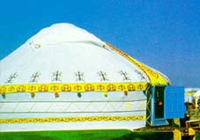A YURTAIS transportable collapsible dwelling that came to us from ancient times.
It consists of wooden framework, covered with felt. The framework ("kerege") forms walls of the dwelling made of latticed wooden poles; "uyuk" - long wooden poles serve as a cover for the upper spherical portion of the yurt; "shanrak" is the top most open part of the yurt, serving as an outlet for the smoke raising from the hearth, for purposes of ventilation and scanty lighting of the yurt’s interior. Depending on the air temperature the yurt is covered with two if not more layers of felt. The outermost layer is coated with flat for it to be impenetrable for rain or snow.
The yurt’s area ranges from 6-7 m. to 30-40 m. Spherical form makes it an exceedingly heat-consuming dwelling. They would enter the yurt through folding carved doors made of pine or birch-tree. They were a sort of touchstone testifying to aesthetic taste, social status and well being of its master. In real fact, fretwork motifs reflected Kazakhstan’s flora and fauna.
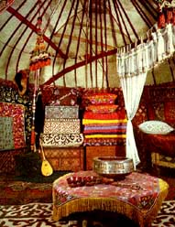Right in the center of the yurt one finds a hearth with a cauldron ("kazan") suspended there above. The place at the hearth is regarded as that of honor meant for particularly respectable, distinguished guests.
The main decoration of the yurt is no doubt carpets ("tekemets") made mostly of felt.
Besides the interior looks quite bright owing to a multitude of colorful carpet-strips and ribbons manufactured of wool (by filling), of felt (by in-laying), of such other materials by weaving, embroidery, wicker-work and all.
Every little corner in the yurt has a purpose of its own - a part for men, a respective portion of the area - for women, for clothes. Besides there is enough room for a "shop" where they repair harness, accomplish other works, room for preparing meals, for bed, for horse's gear, for children, for the son and the daughter-in-law.
Simplicity and feasibility of manufacture, easy and quick assembly, use of natural materials and high transportability turned yurt into an ideal dwelling of a nomad. Even now you may encounter a yurt in the steppe.
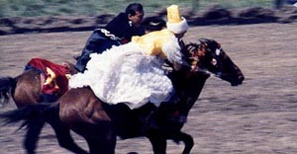
Kazakh National Games

KYZ KUU ("Overtake the girl") - young boys and girls are participants in this game. The girl on the horse does her best to gallop from the young man but as soon as the latter tries to overtake (approach) her she lashes him with a whip. If - up to a certain place - the young boy fails to overtake her she would "reward" him with whipping again. If he is a success he earns a kiss.

AUDARYSPAK ("Wrestling on horseback") - this kind of national sports requires skills both in hand-to-hand fighting and in trick riding. In fact two men fight while on horseback. Wins the one that brings his adversary down of his horse.
KUMIS ALU ("Pick up the coin"). The essence of the game is that while galloping at full speed a young man should pick up a silver ingot off the ground - such had been condition of the game in old days. Nowadays a handkerchief replaces the ingot. This contest particularly impressed Alexander the Great when he visited Central Asia. According to historians' evidence on watching kumis alu he exclaimed "That's a sort of training worthy of a warrior on horseback".
KOKPAR ("Fighting for a goat's carcass"). A most popular game. It stems from an ancient custom according to which one, who wants to get rid of all evil, should sacrifice a goat. Not infrequently taking part in the game is up to 1,000 horsemen. The game unfolds on an almost infinite steppe range. On the opposite ends of an immense field they arrange goals of teams - adversaries. It is into them that the symbolic carcass of the goat should be thrown, while the throw proper is preceded by a desperate flight between the teams to get hold of the carcass.
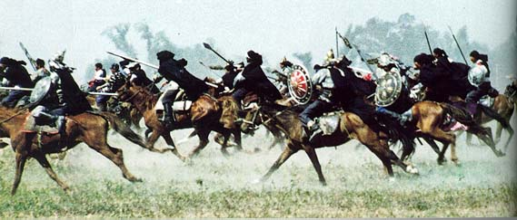

Traditional Holidays and Entertainments

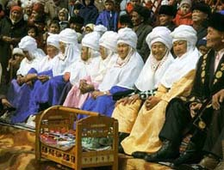NAURYZ - a holiday of spring, it is the most momentous and ancient festivity of Oriental nations.
In fact, it is a New Year's eve according to the ancient Oriental calendar. It has yet another name "Ulys Kuni"("The first day of the New Year") or "Ulystyn uly kuni" («The great day of the people").
They say that the more you are in celebrating the Nauryz holiday, the greater success will attend you throughout the year. Hence abundance of festive rites and attributes.
When the holiday comes, Kazakhs would put on festive clothes, pay visits to each other, exchange congratulations, best wishes of well-being and good luck in the coming year.
Universal merry-making, games, traditional horse races, and various amusements accompany festivities.
Traditionally they cook and roast and make all sorts of tasty meals during the holidays, for they should symbolize well-being and abundance in the coming year. The feast is usually timed to the noon; it is preceded and followed by a prayer in honor of the forefathers read by the mullah. In conclusion the eldest of those present gives his blessings (bata) so that year in year out prosperity be part and parcel of the family.
When Kazakhs celebrate Nauryz, presence of the figure of "7" is indispensable - it embodies 7 days of the week - time units of universal eternity: in front of aksakals ("white beards» or old men) they would put 7 bowls with the drink of "Nauryz-kozhe", prepared of 7 grades of 7 types of cereals.
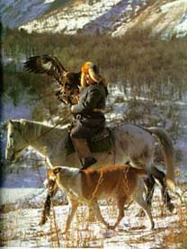BERKUTCHI - hunting with a golden eagle.
A tradition that has already been practiced for ten centuries.
They say that presenting a youngster with a fledgling of a hunting bird is tantamount to wishing him to be brave and strong young fellow.
Virtually training of a golden eagle is a rare and painstaking art. The bird just caught is being slowly trained to its master (a berkutchi). For the purpose the man doesn't get a wink of sleep for several nights with the bird being subjected to similar discomfort. The bird must take food (pieces of raw meat) from its master's hand only. When the eagles has got used to the hunter, its horse and its dog, it undergoes training: first it "hunts" stuffed foxes and only then proceeds with real hunting.

Dastarkhan

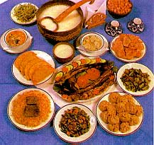Kazakh dastarkhan has a long story of its own, its own traditions, and its specifics inherent to Kazakh nation only, known for a quite particular manner of receiving and serving guests.
The part tea plays in the Kazakh dastarkhan is altogether remarkable. In fact any Kazakh feast invariably starts with a minutely itemized process of tea drinking. The host welcomes his guests, invites them to the table. Incidentally, it is only up to girls and young women to pour the tea. And they do this wonderfully though it is far from easy. For one should see to it that the guests' drinking bowls be always full, there must be no confusing them, there must be no tea leafs remains on the edge of the bowls. Even if the guest gives to understand that he has already quenched his thirst he must not be left unattended - the hostess must offer him a so-called "sui-ayak" - a tea bowl of honor. Tea is normally accompanied with cream, butter, jam, dried and fresh fruit, nuts, cakes, other sweetmeats.
Tea is but an introduction, an invitation to a capital meal - a festive feast. 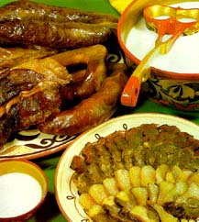

First they serve all sorts of appetizers, mostly meat ones - prepared of horse flesh and mutton. They are quite plentiful and their diversity is just as great, all made of smoked, semi-smoked and boiled meat. Added thereto are flat cakes and such milk tonics as koumyss, shubat and katyk... They are followed with vegetable titbits with invariable flat cakes. Next the guests are treated with a kuyrdak - hot rich roast meat prepared of mutton by - products mostly of liver, kidneys, heart, lungs and tail's fat.

After a small break the guests are treated with all sorts of patties: "samsa"- with meat, "puktermet"- with by- products, "belyashes", "kausyrma" and all...
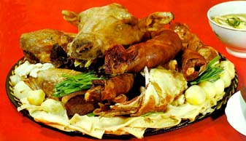Finally there comes the capital treat - besbarmak. First they cover a large round or oval dish with small round flat pieces of boiled paste followed by small bars of boiled horse-meat or mutton, then comes onion cut in rings and scalded with hot broth, all this strewn with a green mixture of fennel, parsley and kinza...
The most honored guest is usually offered a koy-bas (a boiled sheep's head). The guest is to dress it and distribute among the other participants to the dastarkhan. One should mind that each part of the head is attached particular significance and meaning: young men are treated with ears for them to be attentive, girls - with a palate (it is believed that this would make them more diligent). The head having been divided the host proceeds with cutting meat on the main dish and shares it with his guests.
Here too one has to mind certain habits and superstitions. For instance, hipbones and crust are offered to most honored guests while the breastbone goes to the son-in-law or daughter-in-law, cervical vertebra - to marries women, pregnant ones first and foremost.
Certain bans are also to be observed. Thus even the most honored guest may not be treated with a "koy-bas" if his father is present at the table.
Children may not be offered brains (they might become weak-willed), just as an elbow bone - to a young girl (she might be "left on the shelf")...
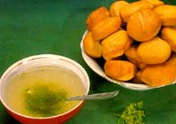The meat is usually accomplished with flat cakes with onion (ak nan). A rich broth (sorpa) is poured in separate bowls.

However in many areas of Kazakhstan besbarmak on the dastarkhan is replaced with "kespe", Kazakh noodle soup: in a drinking bowl or a soup-plate they put warmed up noodles and pour tuzdyk on them, a gravy consisting of meat, black radish, sweet pepper, onions, 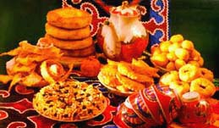tomatoes and green kinza.

The feast is finalized with a dessert abounding in all sorts of sweetmeats.

Kazakh National University named al-Farabi
Faculty of economics and business

The paper:

«Culture of Kazakhstan».
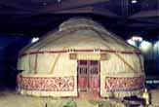

Done by: student of 1 course

BU I A 02r2

Safronova Olga
Checked by: Serikbaeva S.Z.

Almaty, 2003.

