**Fuselage**

The word fuselage is based on the French word fuseler, which means "to streamline." The fuselage must be strong and streamlined since it must withstand the forces that are created in flight. It houses the flight crew, passengers, and cargo. Fuselages are classified according to the arrangement of their force-resisting structure. The types of fuselages we will study are the truss and the semi-monocoque. Five types of stress act on an aircraft in flight: tension, compression, bending, shear, and torsion.

Tension: Tension is the stress which tends to pull things apart.

When you try to break a length of rope, you exert a type of stress which is called tension.

Compression: Compression is the opposite of tension. It is the stress which tends to push materials together. When you grasp a football at both ends and push, the ball is subject to compression. The landing gear struts of an aircraft are also subject to compression.

Bending: This type of stress combines tension and compression. You put a bending stress on a bar when you grasp it with both hands and push the ends together or when you bend a paper clip. The wing spars (interior structural members) are subjected to bending while the aircraft is in flight. The lower side of the spar is subjected to tension, while the upper side is subjected to compression. Obviously, some materials will break before they bend and often are unacceptable for aircraft construction.

Shear stress: Shear stress is caused by forces tending to slip or slide one part of a material in respect to another part. This is the stress that is placed on a piece of wood clamped in a vise and you chip away at it with a hammer and chisel. This type of stress is also exerted when two pieces of metal, bolted together, are pulled apart by sliding one over the other or when you sharpen a pencil with a knife. The rivets in an aircraft are intended to carry only shear. Bolts, as a rule, carry only shear, but sometimes they carry both shear and tension.

Torsion: Torsion is the stress which tends to distort by twisting. You produce a torsional force when you tighten a nut on a bolt. The aircraft engine exerts a torsional force on the crankshaft or turbine axis. All the members (or major portions) of an aircraft are subjected to one or more of these stresses mentioned in the paragraphs. Sometimes a member has alternate stresses, such as compression one instant and tension the next. Some members can carry only one type of stress. Wire and cables, for example, normally carry only tension.

Since any member is stronger in compression or tension than in bending, members carry end loads better than side loads. In order to do this, designers arrange the members in the form of a truss, or rigid framework. In order for a truss to be rigid, it must be composed entirely of triangles. When the load on a truss acts in one direction, every alternate member carries tension while the other members carry compression. When the load is reversed, the members which were carrying compression now are subjected to tension and those which were carrying tension are under compression. The truss itself consists of a welded tubular steel structure with longerons (horizontal members) and diagonal braces. These features make it rigid, strong, and light. The truss is covered with a metal or fabric cover so that less drag will be generated. To produce a smooth surface, the fabric cover is put on fairing strips, which are thin flat strips of wood or metal. These fairing strips run the length of the fuselage in line with the direction of flight.

The semi-monocoque is the most often used construction for modern, high-performance aircraft. Semi-monocoque literally means half a single shell. Here, internal braces as well as the skin itself carry the stress .The internal braces include longitudinal (lengthwise) members called stringers and vertical bulkhead. The semi-monocoque structure is easier to streamline than the truss structure. Since the skin of the semi-monocoque structure must carry much of the fuselage's strength, it will be thicker in some places than at other places. In other words, it will be thicker at those points where the stress on it is the greatest.

**Unit II. FUSELAGE**

Dialogue

T. Now, we shall consider the fuselage construction. Look at the picture (Fig.II.1.)-

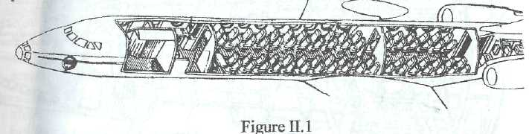

T. This is the fuselage. The fuselage is the largest element of the airplane. The fuselage is the rigid framework. ‘Rigid framework’ is ‘жорсткий каркас’. The rigid framework is built of tubular steel and metal rings. ‘Tubular steel’ means ‘трубчата сталь. So, what is it built of?

S. The fuselage is the rigid framework built of tubular steel and metal rings.

T. Quite right. The framework is covered with a skin. ‘Skin’ means ‘обшивка’. The skin should be thin-walled. ‘A thin-walled skin’ is ‘тонкостінна обшивка’. I am sure that you know what material the skin may be made of.

S. The skin may be made of fabric, metal, glass or other material.

T. You are right. The framework itself consists of longitudinal and transversal members. The longitudinal members are stringers.

T. Look at this picture (Fig.II.2).

T. These are longitudinal members. They are stringers. Stringers serve to stiffen the skin. ‘To stiffen’ means ‘надавати жорсткості’

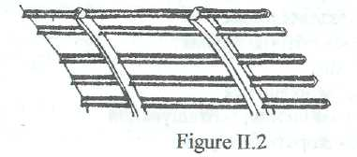

T. Look at this picture (Fig.II.3).

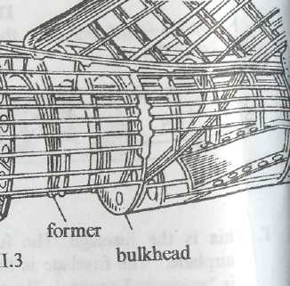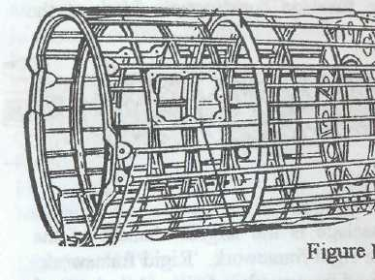

T. You can see transversal members. Transversal members are formers and bulkheads. ‘Former’ means ‘шпангоут’. ‘Bulkhead’ is ‘переборка’. Formers and bulkheads are used to maintain the circular cross section of the fuselage. ‘Circular cross section’ is ‘круглий профіль’. The formers serve as a support for stringers and skin. Longitudinal and transversal members will make the contour of the fuselage.

Exercise 1. Remember the pronunciation end meanings of the following words:

extend - простягатися

machine - машина; механізм;літак

in outline - у загальних рисах

streamlined shape - обтічна форма

drag - лобовий опір

vary - мінятися; змінюватися

arrangement - розміщення; розташування

rigid framework - жорсткий каркас

tubular steel - трубчата сталь

ring - кільце

thin-walled skin - тонкостінна обшивка

longitudinal - повздовжній

transversal - поперечний

stringer - стрінгер; повздовжня балка

former - шпангоут

bulkhead - перегородка

monocoque - монокок (тип конструкції фюзеляжу з працюючою обшивкою)

semimonocoque - напівмонокок; напівмонококовий, балочно-стрингерний

shell – оболонка

hollow – пустотілий

eliminate – усувати

bracing - розтяжка; кріплення

rivet - заклепка; клепати; з'єднати заклепками

reinforce – підсилювати

hold apart - утримувати на відстані

weld – зварювати

cockpit or flight deck - кабіна екіпажу

canopy - ліхтар (кабіни екіпажу)

hatch- люк

pressurized - герметичний; герметизований

**FUSELAGE**

The fuselage is the central body of the aeroplane and the largest element of it. The fuselage extends from the nose to the tail of the machine. All fuselages are round structures. The fuselage serves several purposes: it carries the crew, equipment, passenger cabins, baggage compartments and other accommodations. It may also contain the power plant, if the aeroplane has only one engine, fuel and oil tanks. Besides, the fuselage serves as a support for the tail unit and may carry the land­ing gear.

The fuselage is a rigid framework built of tubular steel and metal rings. The framework is covered with a thin-walled skin. The skin may be made of fabric, metal, glass or other material .The framework consists of longitudinal members (stringers and longerons or spars) and transversal members (formers).These longitudinal and transversal members make the contour or frame of the fuselage.

The fuselage must be strong enough to withstand different loads acting on it and has a streamlined shape to reduce the drag. Stringers and longerons or spars are loaded with axial forces (tensile and compressive forces). Stringers also serve to stiffen the skin. Formers are used to maintain the circular cross-section of the fuselage. They also serve as a support for stringers and skin, and they take local aerodynamic loads. Strong formers transmit local concentrated forces to the skin.

There are two main types of fuselage construction: monocoque design and semimonocoque. In the monocoque design the skin provides its own structural strength eliminating the need for internal bracing.

The airplane necessarily requires heavy-loaded material towithstand the forces acting in flight and landings. The main advantage of the monocoque design is to provide additional space available for cargo and passengers because of the hollow construction. The reinforced monocoque design uses a complete metal former, normally of welded tu­bular steel, covered with a metal skin.

A lighter material can be used comparing with full-monocoque design. The skin thus contributes to the overall strength of the structure. The most popular design in modern production is the semimonocoque design, which enhances the strength of the shell by using internal stiffeners: stringers –long, light, thin pieces of metal and bulkheads, giving strength to the total structure. This design meets the greatest range of needs since it permits the use of lighter materials while providing strength. Today the trend is to make fuselages of fail–safe design. Any cabin of fuselage may be pressurized & unpressurized. Pressurized cabins are used in modern aircraft. They are used to provide life conditions for the crew & passengers at high altitudes of flight. The portion of the airplane occupied by pilots is the pilot cockpit. Here all controls & navigation instruments are installed in.