**History of runes**

Fulfilled by the second year student of Rostov State Pedagogical University Translation Department Neustroev Cyril

Rostov-on-Don

2001

From ancient times mankind was appealed by unknown writings: half-forgotten antique languages, Egypt hieroglyphs, Indian inscriptions… The fate of runes was much happy – their sense wasn’t lost in the course of time, even when Latin alphabet became dominating one in Europe. For instance, runes were used in calendars till the end of the 18-th c.

Modern linguists think that runes posses another kind of meaning, which we cannot find in ideograms, hieroglyphs or in modern exotic alphabets – this meaning exists in subconsciousness level. Runes were the personification of the surrounding world, essence of outlook. With the help of special links between runes a man could express nearly everything, compiling them (so called combined runes). In different times runes could change their meaning, so we can say this adjusting system created dozens of meanings of one and the same symbol. (Linguists find confirmation of this theory in the following example – every rune in different languages had separate and original meaning, which didn’t fully coincide with another one in the second language.

Like all others components of language, runes endured numerous changes: in form, style of writing, system of sounds and letters, which expressed them. We can say, that these alphabets took wide spreading not only among Scandinavian and German tribes, but we can also trace its penetration in Celtic and Slavonic languages. Now runes keep their main original meaning - in the beginning they were the symbols of fortunetelling lore with sacred sense and mystic signs (The general matter why they didn’t get wide diffusion before AD). Even the word “rune” corresponds as “secret” (compare old Celtic “run”, middle welsh “rown”, modern German “raunen”). The last 1000 years in Iceland runes have been used for divination. In Anglo-Saxon England the hours of king council were called “runes”.

The most important sources about runic history are ancient texts of Scandinavian pagan religion – Old Edda by Brynolf Swesson and Lesser Edda by Snorri Sturlusson. They were two missionaries who discovered these manuscripts in the time of Christian expansion. Another documents containing the information about runes origin are Northern king sagas “Red leather” and Icelandic kin chronicles. Tombstones, altars, pagan pillars called “runic stones” played quite catholic role in scientific researches - usually they are found dappled with miscellaneous writings (Gothland, Upland, Norway). The most famous is Cilwer stone, which dates from the 5-th c. So we can find a lot of writings on jewels and weapon, for barbarians believed things had to posses their own names (breakteats).

German and Slavonic runic writing was the letter system of peculiar look, accounted by the writing technique on bone, wood and metal. Nowadays we have the main runic alphabet, consisting of 24 signs, may be more, but another ones are regarded as variants or combined runes. Letters of any language can have several sources of origin, for a taste Greek language, which gave the birth to North Italian writing, had a good many of meaning for every sign. This tradition was inherited by Etruscan alphabet and later by runic one. However, Christian chronicles of 9-12c, known as «songs», revealed information about rune names and their meanings. Every rune in it conforms to one strophe, which begins with this rune and its name. In its turn, the name begins with its sound. The whole system is divided into 2 parts – futarks (arises from the first symbols – F, U, Th, A, R, K: Old futark (runes of Old German origin – o.f.) and Late futark (modifications of o.f. in Northumbrian, Frisian and Anglo-Saxon alphabets). 24 signs traditionally gradate into 3 groups of 8 symbols called atts (“part of land “ or “kin” compare Scot. "airt”, Ireland “aird).

Late futark Norway runes

Anglo Saxon runes Northumbrian futark

Old futark old Norway German runes

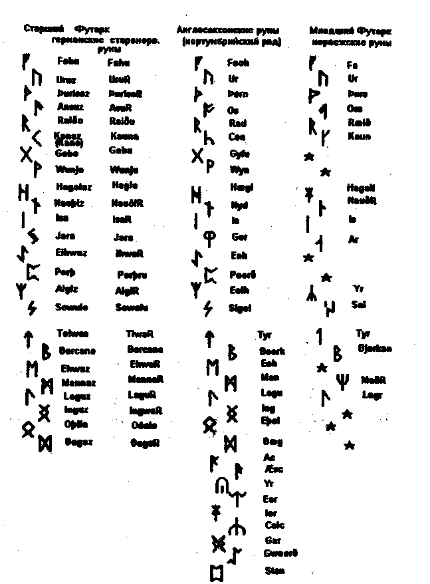

Comparing scheme of different futarks and their development

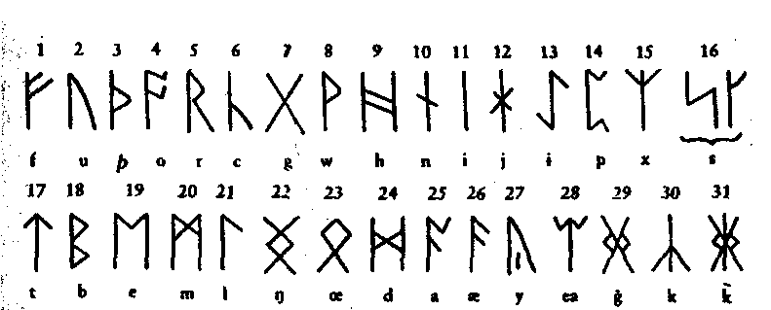

**Anglo-Saxon futark**

The origin of futark remains the matter of severe debates between historians, linguists and philologists. There are two main theories: 1) Runic writing appeared on the basis of Latin alphabet; 2) cradles of these signs are in transalpine and North Italian scripts. Scientists have a lot of historical facts, approving that Etruscan merchants used this system. Probably they brought it to the North (6-th c. B.C.). However some researchers think that runes cropped up in German tribes from ancient Rome Latin writing. Comparing 3 letter types we have: 10 runic letters in Etruscan language, which absolutely coincide each other; 5 coinciding runic letters and 8 resembling ones in Latin. Latin, Etruscan and some symbols from Greek originate from Akhiram alphabet (10c. B.C.). But the construction of runic alphabet (RA) different from others – for example, order of the first letters. The main period of development is one, when occult signs, used in Alpine region and in the North, became combine sole system. Many runic symbols were used as icons, showing various things and animals. Some runologists suppose that even in the most developed variant they are close to pictures: rune “Fehu” f symbolizes cattle, Thurisaz q l, – thorn, Wunjo w – weathercock, Algiz z – elk, Zin xxs– lightning, Yr u – bow, Edhwaz m – horse.

The top of development and complete formation of RA system was in 1-2 c. AD.

The number of runes in alphabet varied in the course of time. 28 sings appeared in the middle of the 6-th c. In Britain where German runes penetrated in the 5-th c. with Anglo-Saxon invasion, Frisian futark was improved by the some additions and changes (mostly combined runes) and numbered 29 units. In Northumberland 33 rune system existed already, with the mixture of Celtic runes. Whilst on the Continent o.f. went through the number of another changes. In the middle of the 7-th c. the tendency to simplification appeared – some runes changed in inscription, some were lost. To the middle of the 10-th c. the number of runes decreased to 16 units and late futark formed. It was purely writing system, which wasn’t used for fortune telling. It got wide spreading not only on the territory of German Empire, but in the North too, for example in Denmark and Swiss. The difference between them was in writing technology – Swiss ones were simpler, with short branches. Apparently it can be explained that it gained everyday using. This system, if not take notice of its disadvantages, was in circulation till 12-th c.

The next step in development of RA took place in the middle of the 12-th c. by adding dots to 16 sign system (dotted alphabet). It was used along with Latin one till the 16-th c. We can find its variants in Slavonic manuscripts. Hipped and branchy RA weren’t alike to dotted one.

Combined (constrained) runes. They attract attention by their unusual form – it is too difficult to regard it as ordinary symbol. Their use is quite miscellaneous: in amulets, braketeats, and everywhere when difficult magic formulas were necessary. Runes are bind on the strength of common line .

We cannot leave unnoticed such important stage of RA development as Ulfila`s Gothic alphabet. It has got nothing in common with “gothic” variants of Romanticism period. The real Gothic writing system was used by the Goths on Gothland Island and later on the territory of Poland, Lithuania and even North Black Sea coast. In the 6-th c. gothic bishop Ulfila invented parallel variant of gothic alphabet. Creating it, Ulfila took the range of common Greek letters and perfected some runic sings, which existed already, with the aim to paint them with brush. During 5 following centuries it was used by west Goths in Spain and in the South of France. But in 1018 Toledian counsel decreed to prohibit all runic alphabets as vane and pagan ones. It is clear from letter names and their order that UA is younger than other RA. So we can trace Greek and Latin influence in the system. For example, futark structure was changed by adding 2 symbols to the first att. So UA contains 12 signs, which do not have analogs in Old Gothic: Q, D, A, B, G, E, X, K, L, N, P, T.

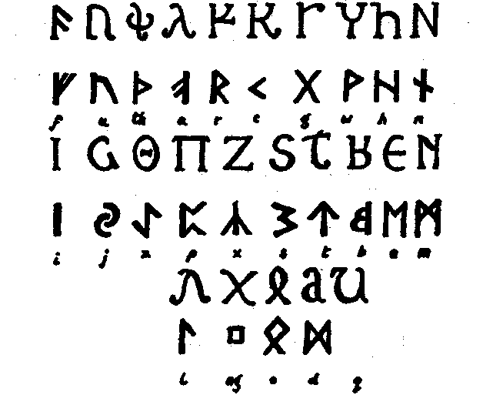

Comparing scheme of Gothic alphabet (upper rows) and Gothic runes (lower rows).

But, knowing all these peculiarities, we still can’t answer to the question, from where runes came. So, a few scientists suppose that German and Slavonic RA had the same roots and originated from a same proto-language, for Etruscan theory is rather imperfect – Scandinavians couldn’t borrow it, because Etruscan writings were used too far away from the North and in quite small territory. The following theory is closely connected with national migrations and mythology. One of the legendary Scandinavian tribes – vanes or veneds – came to the North from the East, where they set up Slavonic tribe – Vyatichi. We haven’t got any historical confirmations, that Slavonic people didn’t have writing systems before Cyril and Mefodius coming, so hypothetically we can believe that such system existed. Moreover, archeological researches showed that there were some traces of RA on the territory of ancient Russia. It differs from Scandinavian ones and looks like as Latin and Greek letters:

but in common it coincides with o.f. So we can say that when Slavonic tribes divided into non-relative kins, RA went through changes of different kind. In the end of the 1-st millennium BC veneds were vanished by Germanic barbarian hordes and proto runic system spread rapidly on the territory from the Black sea to Gaul. As it is follow from archeological discoveries RA can be found on the Slavonic jewels dated from 10-th c. AD, but it is difficult to say if they were originally Russian or Scandinavian ones – perhaps, runes on the jewelries were regarded as the part of design and in was copied blindly.

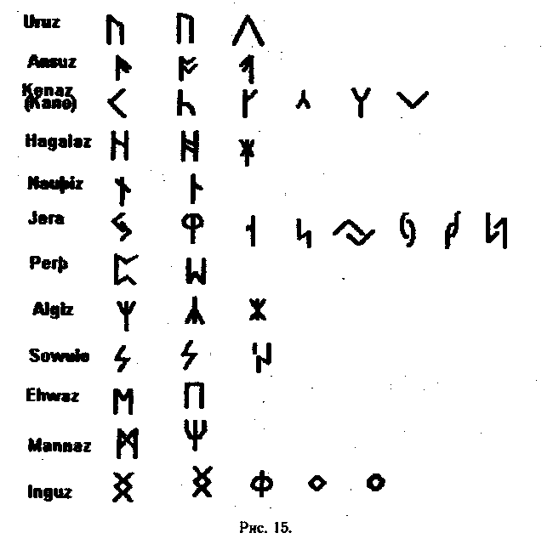

Different Slavonic variants of Scandinavian runes