**Educational institution**

**Summary**

Subject: Lithium

He performed the: .

Checked: .

City: 20 г.

**Content**

1 Introduction

2 Characteristics

2.1 Physical

2.2 Chemical

2.3 Lithium compounds

2.4 Isotopes

3 History and etymology

4 Occurrence

5 Production

6 Applications

6.1 Medical use

6.2 Other uses

7 Precautions

7.1 Regulation

8 Conclusion

9 References

**1. Introduction**

Lithium (pronounced /ˈlɪθiəm/, LITH-ee-əm) is a soft, silver-white metal that belongs to the alkali metal group of chemical elements. It is represented by the symbol Li, and it has the atomic number three. Under standard conditions it is the lightest metal and the least dense solid element. Like all alkali metals, lithium is highly reactive, corroding quickly in moist air to form a black tarnish. For this reason, lithium metal is typically stored under the cover of petroleum. When cut open, lithium exhibits a metallic luster, but contact with oxygen quickly turns it back to a dull silvery gray color. Lithium in its elemental state is highly flammable.

According to theory, lithium was one of the few elements synthesized in the Big Bang. Since its current estimated abundance in the universe is vastly less than that predicted by physical theories, the processes by which new lithium is created and destroyed, and the true value of its abundance,[1] continue to be active matters of study in astronomy.[2][3][4] The nuclei of lithium are relatively fragile: the two stable lithium isotopes found in nature have lower binding energies per nucleon than any other stable compound nuclides, save deuterium, and helium-3 (3He).[5] Though very light in atomic weight, lithium is less common in the solar system than 25 of the first 32 chemical elements.[6]

Due to its high reactivity it only appears naturally in the form of compounds. Lithium occurs in a number of pegmatitic minerals, but is also commonly obtained from brines and clays. On a commercial scale, lithium metal is isolated electrolytically from a mixture of lithium chloride and potassium chloride.

Trace amounts of lithium are present in the oceans and in some organisms, though the element serves no apparent vital biological function in humans, though the lithium ion Li+ administered as any of several lithium salts has proved to be useful as a mood stabilizing drug due to neurological effects of the ion in the human body.[7] Lithium and its compounds have several industrial applications, including heat-resistant glass and ceramics, high strength-to-weight alloys used in aircraft, and lithium batteries. Lithium also has important links to nuclear physics. The transmutation of lithium atoms to tritium was the first man-made form of a nuclear fusion reaction, and lithium deuteride serves as a fusion fuel in staged thermonuclear weapons.

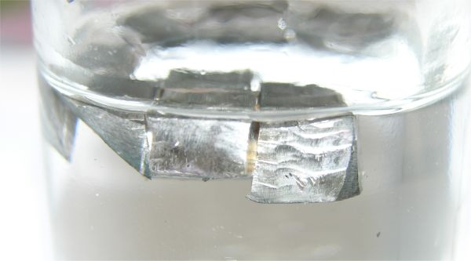

Figure. 0. Silvery white (seen here in oil)

**2. Characteristics**

**2.1 Physical**

Like the other alkali metals, lithium has a single valence electron that is easily given up to form a cation.[8] Because of this, it is a good conductor of both heat and electricity and highly reactive, though it is the least reactive of the alkali metals due to the proximity of its valence electron to its nucleus.[8]

Lithium is soft enough to be cut with a knife, and it is the lightest of the metals of the periodic table. When cut, it possesses a silvery-white color that quickly changes to gray due to oxidation.[8] It also has a low density (approximately 0.534 g/cm3) and thus will float on water, with which it reacts easily. This reaction is energetic, forming hydrogen gas and lithium hydroxide in aqueous solution.[8] Due to its reactivity with water, lithium is usually stored in mineral oil or kerosene.[8]

Lithium possesses a low coefficient of thermal expansion and the highest specific heat capacity of any solid element. Lithium is superconductive below 400 μK at standard pressure[9] and at higher temperatures (more than 9 kelvin) at very high pressures (over 200,000 atmospheres)[10] At cryogenic temperatures, lithium, like sodium, undergoes diffusionless phase change transformations. At 4.2K it has a rhombohedral crystal system (with a nine-layer repeat spacing)[11]; at higher temperatures it transforms to face-centered cubic and then body-centered cubic. At liquid-helium temperatures (4 K) the rhombohedral structure is the most prevalent.

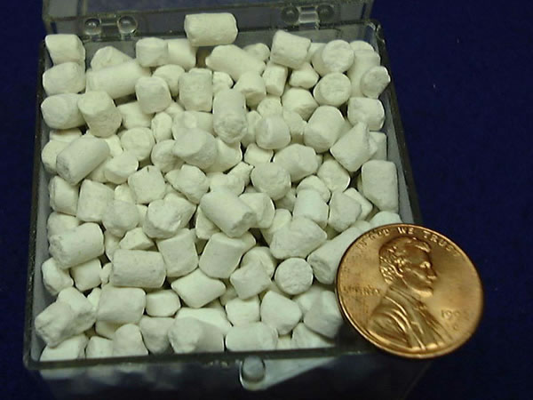

Figure. 1. Lithium pellets (covered in white lithium hydroxide)

**2.2 Chemical**

In moist air, lithium metal rapidly tarnishes to form a black coating of lithium hydroxide (LiOH and LiOH·H2O), lithium nitride (Li3N) and lithium carbonate (Li2CO3, the result of a secondary reaction between LiOH and CO2).[12]

When placed over a flame, lithium gives off a striking crimson color, but when it burns strongly the flame becomes a brilliant white. Lithium will ignite and burn in oxygen when exposed to water or water vapours.[13]

Lithium metal is flammable, and it is potentially explosive when exposed to air and especially to water, though less so than the other alkali metals. The lithium-water reaction at normal temperatures is brisk but not violent, though the hydrogen produced can ignite. As with all alkali metals, lithium fires are difficult to extinguish, requiring dry powder fire extinguishers, specifically Class D type (see Types of extinguishing agents).

**2.3 Lithium compounds**

Lithium has a diagonal relationship with magnesium, an element of similar atomic and ionic radius. Chemical resemblances between the two metals include the formation of a nitride by reaction with N2, the formation of an oxide when burnt in O2, salts with similar solubilities, and thermal instability of the carbonates and nitrides.[12]

**2.4 Isotopes**

Naturally occurring lithium is composed of two stable isotopes, 6Li and 7Li, the latter being the more abundant (92.5% natural abundance).[8][14] Both natural isotopes have anomalously low nuclear binding energy per nucleon compared to the next lighter and heavier elements, helium and beryllium, which means that alone among stable light elements, lithium can produce net energy through nuclear fission. Seven radioisotopes have been characterized, the most stable being 8Li with a half-life of 838 ms and 9Li with a half-life of 178.3 ms. All of the remaining radioactive isotopes have half-lives that are shorter than 8.6 ms. The shortest-lived isotope of lithium is 4Li, which decays through proton emission and has a half-life of 7.58043x10−23 s.

7Li is one of the primordial elements (or, more properly, primordial isotopes) produced in Big Bang nucleosynthesis. A small amount of both 6Li and 7Li are produced in stars, but are thought to be burned as fast as it is produced.[15] Additional small amounts of lithium of both 6Li and 7Li may be generated from solar wind, cosmic rays, and early solar system 7Be and 10Be radioactive decay.[16] 7Li can also be generated in carbon stars.[17]

Lithium isotopes fractionate substantially during a wide variety of natural processes,[18] including mineral formation (chemical precipitation), metabolism, and ion exchange. Lithium ions substitute for magnesium and iron in octahedral sites in clay minerals, where 6Li is preferred to 7Li, resulting in enrichment of the light isotope in processes of hyperfiltration and rock alteration. The exotic 11Li is known to exhibit a nuclear halo.

**3. History and etymology**

Petalite (LiAlSi4O10, which is lithium aluminium silicate) was first discovered in 1800 by the Brazilian chemist José Bonifácio de Andrade e Silva, who discovered this mineral in a mine on the island of Utö, Sweden.[19][20][21] However, it was not until 1817 that Johan August Arfwedson, then working in the laboratory of the chemist Jöns Jakob Berzelius, detected the presence of a new element while analyzing petalite ore.[22][23][24] This element formed compounds similar to those of sodium and potassium, though its carbonate and hydroxide were less soluble in water and more alkaline.[25] Berzelius gave the alkaline material the name "lithos", from the Greek word λιθoς (transliterated as lithos, meaning "stone"), to reflect its discovery in a solid mineral, as opposed to sodium and potassium, which had been discovered in plant tissues. The name of this element was later standardized as "lithium".[8][20][24] Arfwedson later showed that this same element was present in the minerals spodumene and lepidolite.[20] In 1818, Christian Gmelin was the first man to observe that lithium salts give a bright red color in flame.[20] However, both Arfwedson and Gmelin tried and failed to isolate the element from its salts.[20][24][26] This element, lithium, was not isolated until 1821, when William Thomas Brande isolated the element by performing electrolysis on lithium oxide, a process that had previously employed by the chemist Sir Humphry Davy to isolate the alkali metals potassium and sodium.[26][27][28] Brande also described some pure salts of lithium, such as the chloride, and he performed an estimate of its atomic weight. In 1855, larger quantities of lithium were produced through the electrolysis of lithium chloride by Robert Bunsen and Augustus Matthiessen.[20] The discovery of this procedure henceforth led to commercial production of lithium metal, beginning in 1923 by the German company Metallgesellschaft AG, which performed an electrolysis of a liquid mixture of lithium chloride and potassium chloride.[20][29]

The production and use of lithium underwent several drastic changes in history. The first major application of lithium became high temperature grease for aircraft engines or similar applications in World War II and shortly after. This small market was supported by several small mining operations mostly in the United States. The demand for lithium increased dramatically when in the beginning of the cold war the need for the production of nuclear fusion weapons arose and the dominant fusion material tritium had to be made by irradiating lithium-6. The United States became the prime producer of lithium in the period between the late 1950s and the mid 1980s. At the end the stockpile of lithium was roughly 42.000 tons of lithium hydroxide. The stockpiled lithium was depleted in lithium-6 by 75% .[30]

Lithium was used to decrease the melting temperature of glass and to improve the melting behavior of aluminium chloride when using the Hall-Héroult process.[31][31] These two uses dominated the market until the middle of the 1990's. After the end of the nuclear arms race the demand for lithium decreased and the sale of Department of Energy stockpiles on the open market further reduced prices.[30] Then, in the mid 1990's several companies started to extract lithium from brine; this method proved to be less expensive than underground or even open pit mining. Most of the mines closed or shifted their focus to other materials as only the ore from zoned pegmatites could be mined for a competitive price. For example, the US mines near Kings Mountain, North Carolina closed before the turn of the century. The use in lithium ion batteries increased the demand for lithium and became the dominant use in 2007.[30] New companies have expanded brine extraction efforts to meet the rising demand.[32]

**4. Occurrence**

According to theory, the stable isotopes 6Li and 7Li were created in the Big Bang, but the amounts are unclear. Lithium is a fusion fuel in main sequence stars. Because of the method by which elements are built up by fusion in stars, there is a general trend in the cosmos that the lighter elements are more common. However, lithium (element number 3) is tied with krypton as the 32nd/33rd most abundant element in the cosmos (see Cosmochemical Periodic Table of the Elements in the Solar System), being less common than any element between carbon (element 6) and scandium (element 21). It is not until atomic number 36 (krypton) and beyond that chemical elements are found to be universally less common in the cosmos than lithium. The reasons have to do with the failure of any good mechanisms to synthesize lithium in the fusion reactions between nuclides in supernovae. Due to the absence of any quasi-stable nuclide with five nucleons, nuclei of lithium-5 produced from helium and a proton has no time to fuse with a second proton or neutron to form a six nucleon isotope which might decay to lithium-6, even under extreme conditions of bombardment. Also, the product of helium-helium fusion (berylium-8) is immediately unstable toward disintegration to helium again, and is thus not available for formation of lithium. Some lithium-7 is formed in the pp III branch of the proton-proton chain in main sequence and red giant stars, but it is normally consumed by lithium burning as fast as it is formed. This leaves new formation of the stable isotopes lithium 6 and 7 to rare cosmic ray spallation on carbon or other elements in cosmic dust. Meanwhile, existing Li-6 and Li-7 is destroyed in many nuclear reactions in supernovae and by lithium burning in main sequence stars, resulting in net removal of lithium from the cosmos. In turn the destruction of lithium isotopes is due to their very low energy of binding per nucleon with regard to all other nuclides save deuterium (also destroyed in stars) and helium-3.[5] This low energy of binding encourages breakup of lithium in favor of more tightly-bound nuclides under thermonuclear reaction conditions.

Lithium is widely distributed on Earth but does not naturally occur in elemental form due to its high reactivity.[8] Estimates for crustal content range from 20 to 70 ppm by weight.[12] In keeping with its name, lithium forms a minor part of igneous rocks, with the largest concentrations in granites. Granitic pegmatites also provide the greatest abundance of lithium-containing minerals, with spodumene and petalite being the most commercially viable sources.[12] A newer source for lithium is hectorite clay, the only active development of which is through the Western Lithium Corporation in the United States.[34]

According to the Handbook of Lithium and Natural Calcium, "Lithium is a comparatively rare element, although it is found in many rocks and some brines, but always in very low concentrations. There are a fairly large number of both lithium mineral and brine deposits but only comparatively a few of them are of actual or potential commercial value. Many are very small, others are too low in grade."[35] At 20 mg lithium per kg of Earth's crust [36], lithium is the 25th most abundant element. Nickel and lead have the about the same abundance.

The largest reserve base of lithium is in the Salar de Uyuni area of Bolivia, which has 5.4 million tons. According to the US Geological Survey, the production and reserves of lithium in metric tons are as follows[37]:

Contrary to the USGS data in the table, other estimates put Chile's reserve base at 7,520,000 metric tons of lithium, and Argentina's at 6,000,000 metric tons.[38] Seawater contains an estimated 230 billion tons of lithium, though at a low concentration of 0.1 to 0.2 ppm.

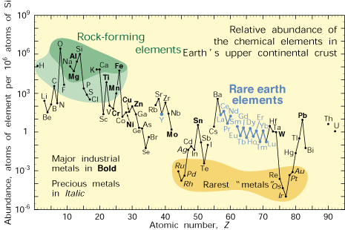

Figure. 2. Lithium is about as common as chlorine in the Earth's upper continental crust, on a per-atom basis.

**5. Production**

Since the end of World War II lithium metal production has greatly increased. The metal is separated from other elements in igneous minerals such as those above. Lithium salts are extracted from the water of mineral springs, brine pools and brine deposits.

The metal is produced electrolytically from a mixture of fused lithium and potassium chloride. In 1998 it was about US$ 43 per pound ($95 per kg).[40]

Deposits of lithium are found in South America throughout the Andes mountain chain. Chile is the leading lithium metal producer, followed by Argentina. Both countries recover the lithium from brine pools. In the United States lithium is recovered from brine pools in Nevada.[41] Nearly half the world's known reserves are located in Bolivia, a nation sitting along the central eastern slope of the Andes. In 2009 Bolivia is negotiating with Japanese, French, and even Korean firms to begin extraction.[42] According to the US Geological Survey, Bolivia's Uyuni Desert has 5.4 million tons of lithium, which can be used to make batteries for hybrid and electric vehicles.[42][43]

China may emerge as a significant producer of brine-source lithium carbonate around 2010. There is potential production of up to 55,000 tons per year if projects in Qinghai province and Tibet proceed.[44]

The total amount of lithium recoverable from global reserves has been estimated at 35 million tonnes, which includes 15 million tons of the known global lithium reserve base.[45]

In 1976 a National Research Council Panel estimated lithium resources at 10.6 million tons for the Western World.[46] With the inclusion of Russian and Chinese resources as well as new discoveries in Australia, Serbia, Argentina and the United States, the total had nearly tripled by 2008.[47][48]

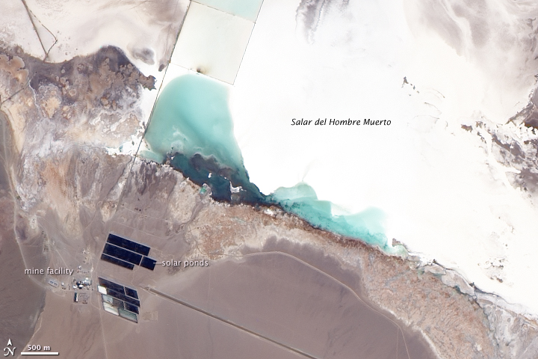

Figure. 3. Lithium mine, Salar del Hombre Muerto, Argentina. The brine in this salar is rich in lithium, and the mine concentrates the brine by pumping it into solar evaporation ponds. 2009 image from NASA’s EO-1 satellite.

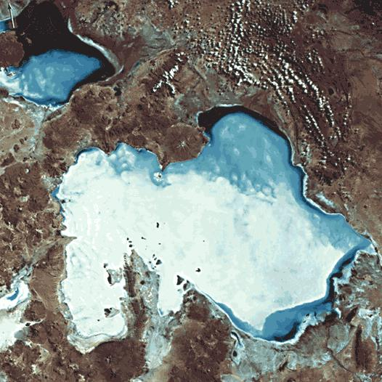

Figure. 4. Salar de Uyuni, Bolivia.

**6. Applications**

Because of its specific heat capacity, the highest of all solids, lithium is often used in heat transfer applications.

In the latter years of the 20th century lithium became important as an anode material. Used in lithium-ion batteries because of its high electrochemical potential, a typical cell can generate approximately 3 volts, compared with 1.5 volts for lead/acid or zinc cells. Because of its low atomic mass, it also has a high charge- and power-to-weight ratio.

Lithium is also used in the pharmaceutical and fine-chemical industry in the manufacture of organolithium reagents, which are used both as strong bases and as reagents for the formation of carbon carbon bonds. Organolithiums are also used in polymer synthesis as catalysts/initiators[49] in anionic polymerisation of unfunctionalised olefins.[50][51][52]

**6.1 Medical use**

Lithium salts were used during the 19th century to treat gout. Lithium salts such as lithium carbonate (Li2CO3), lithium citrate, and lithium orotate are mood stabilizers. They are used in the treatment of bipolar disorder since, unlike most other mood altering drugs, they counteract both mania and depression. Lithium can also be used to augment antidepressants. Because of Lithium's nephrogenic diabetes insipidus effects, it can be used to help treat the syndrome of inappropriate antidiuretic hormone hypersecretion (SIADH). It was also sometimes prescribed as a preventive treatment for migraine disease and cluster headaches.[53]

The active principle in these salts is the lithium ion Li+. Although this ion has a smaller diameter than either Na+ or K+, in a watery environment like the cytoplasmic fluid, Li+ binds to the hydrogen atoms of water, making it effectively larger than either Na+ or K+ ions. How Li+ works in the central nervous system is still a matter of debate. Li+ elevates brain levels of tryptophan, 5-HT (serotonin), and 5-HIAA (a serotonin metabolite). Serotonin is related to mood stability. Li+ also reduces catecholamine activity in the brain (associated with brain activation and mania), by enhancing reuptake and reducing release. Therapeutically useful amounts of lithium (~ 0.6 to 1.2 mmol/l) are only slightly lower than toxic amounts (>1.5 mmol/l), so the blood levels of lithium must be carefully monitored during treatment to avoid toxicity.

Common side effects of lithium treatment include muscle tremors, twitching, ataxia[54] and hypothyroidism. Long term use is linked to hyperparathyroidism[55], hypercalcemia (bone loss), hypertension, kidney damage, nephrogenic diabetes insipidus (polyuria and polydipsia), seizures[56] and weight gain.[57] Some of the side-effects are a result of the increased elimination of potassium.

There appears to be an increased risk of Ebstein (cardiac) Anomaly in infants born to women taking lithium during the first trimester of pregnancy.

According to a study in 2009 at Oita University in Japan and published in the British Journal of Psychiatry, communities whose water contained larger amounts of lithium had significantly lower suicide rates[58][59][60][61] but did not address whether lithium in drinking water causes the negative side effects associated with higher doses of the element.[62]

**6.2 Other uses**

Electrical and electronic uses:

Lithium batteries are disposable (primary) batteries with lithium metal or lithium compounds as an anode. Lithium batteries are not to be confused with lithium-ion batteries, which are high energy-density rechargeable batteries. Other rechargeable batteries include the Lithium-ion polymer battery, Lithium iron phosphate battery, and the Nanowire battery. New technologies are constantly being announced.

Lithium niobate is used extensively in telecommunication products such as mobile phones and optical modulators, for such components as resonant crystals. Lithium applications are used in more than 60% of mobile phones.[63]

Chemical uses:

Lithium chloride and lithium bromide are extremely hygroscopic and are used as desiccants.

Lithium metal is used in the preparation of organo-lithium compounds.

General engineering:

lithium stearate is a common all-purpose, high-temperature lubricant.

When used as a flux for welding or soldering, lithium promotes the fusing of metals during and eliminates the forming of oxides by absorbing impurities. Its fusing quality is also important as a flux for producing ceramics, enamels and glass.

Alloys of the metal with aluminium, cadmium, copper and manganese are used to make high-performance aircraft parts (see also Lithium-aluminium alloys).

Optics:

Lithium is sometimes used in focal lenses, including spectacles and the glass for the 200-inch (5.08 m) telescope at Mt. Palomar.[citation needed]

The high non-linearity of lithium niobate also makes it useful in non-linear optics applications.

Lithium fluoride, artificially grown as crystal, is clear and transparent and often used in specialist optics for IR, UV and VUV (vacuum UV) applications. It has the lowest refractive index and the farthest transmission range in the deep UV of all common materials.

Rocketry:

Metallic lithium and its complex hydrides, such a Li[AlH4], are used as high energy additives to rocket propellants[3].

Lithium peroxide, lithium nitrate, lithium chlorate and lithium perchlorate are used as oxidizers in rocket propellants, and also in oxygen candles that supply submarines and space capsules with oxygen.[64]

Nuclear applications:

Lithium deuteride was the fusion fuel of choice in early versions of the hydrogen bomb. When bombarded by neutrons, both 6Li and 7Li produce tritium—this reaction, which was not fully understood when hydrogen bombs were first tested, was responsible for the runaway yield of the Castle Bravo nuclear test. Tritium fuses with deuterium in a fusion reaction that is relatively easy to achieve. Although details remain secret, lithium-6 deuteride still apparently plays a role in modern nuclear weapons, as a fusion material.

Lithium fluoride (highly enriched in the common isotope lithium-7) forms the basic constituent of the preferred fluoride salt mixture (LiF-BeF2) used in liquid-fluoride nuclear reactors. Lithium fluoride is exceptionally chemically stable and LiF/BeF2 mixtures have low melting points and the best neutronic properties of fluoride salt combinations appropriate for reactor use.[clarification needed]

In conceptualized nuclear fusion power plants, lithium will be used to produce tritium in magnetically confined reactors using deuterium and tritium as the fuel. Tritium does not occur naturally and will be produced by surrounding the reacting plasma with a 'blanket' containing lithium where neutrons from the deuterium-tritium reaction in the plasma will react with the lithium to produce more tritium. 6Li + n → 4He + 3H. Various means of doing this will be tested at the ITER reactor being built at Cadarache, France.

Lithium is used as a source for alpha particles, or helium nuclei. When 7Li is bombarded by accelerated protons 8Be is formed, which undergoes spontaneous fission to form two alpha particles. This was the first man-made nuclear reaction, produced by Cockroft and Walton in 1929.

Other uses:

Lithium hydroxide (LiOH) is an important compound of lithium obtained from lithium carbonate (Li2CO3). It is a strong base, and when heated with a fat it produces a lithium soap. Lithium soap has the ability to thicken oils, and it is used to manufacture lubricating greases.

Lithium hydroxide and lithium peroxide are used in confined areas, such as aboard spacecraft and submarines, for air purification. Lithium hydroxide absorbs carbon dioxide from the air by reacting with it to form lithium carbonate, and is preferred over other alkaline hydroxides for its low weight. Lithium peroxide (Li2O2) in presence of moisture not only absorbs carbon dioxide to form lithium carbonate, but also releases oxygen. For example 2 Li2O2 + 2 CO2 → 2 Li2CO3 + O2.

Lithium compounds are used in red fireworks and flares.

The Mark 50 Torpedo Stored Chemical Energy Propulsion System (SCEPS) uses a small tank of sulfur hexafluoride gas which is sprayed over a block of solid lithium. The reaction generates enormous heat which is used to generate steam from seawater. The steam propels the torpedo in a closed Rankine cycle.[65]

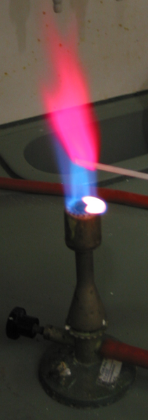

Figure. 5. The red lithium flame leads to lithium's use in flares and pyrotechnics

**7. Precautions**

Due to its alkaline tarnish, lithium metal is corrosive and requires special handling to avoid skin contact. Breathing lithium dust or lithium compounds (which are often alkaline) initially irritate the nose and throat, while higher exposure can cause a buildup of fluid in the lungs, leading to pulmonary edema. The metal itself is a handling hazard because of the caustic hydroxide produced when it is in contact with moisture. Lithium is safely stored in non-reactive compounds such as naphtha.[66]

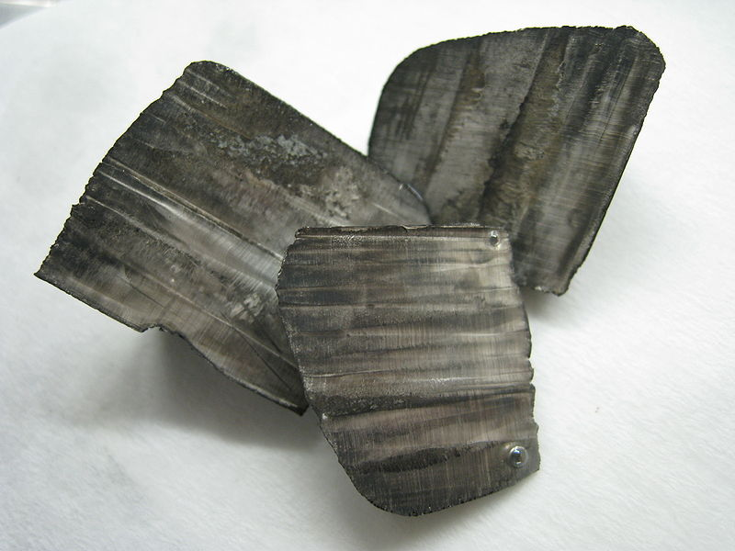

Figure. 6. Lithium ingots with a thin layer of black oxide tarnish

**7.1 Regulation**

Some jurisdictions limit the sale of lithium batteries, which are the most readily available source of lithium metal for ordinary consumers. Lithium can be used to reduce pseudoephedrine and ephedrine to methamphetamine in the Birch reduction method, which employs solutions of alkali metals dissolved in anhydrous ammonia.

Carriage and shipment of some kinds of lithium batteries may be prohibited aboard certain types of transportation (particularly aircraft) because of the ability of most types of lithium batteries to fully discharge very rapidly when short-circuited, leading to overheating and possible explosion in a process called thermal runaway. Most consumer lithium batteries have thermal overload protection built-in to prevent this type of incident, or their design inherently limits short-circuit currents. Internal shorts have been known to develop due to manufacturing defects or damage to batteries that can lead to spontaneous thermal runaway.[67]

**8. Conclusion**

As an individual representative of the periodic table of chemical elements Dmitry Ivanovich Mendeleyev, the element has unique chemical and physical properties

Element is of great economic importance and plays a major role in world culture

**9. References**

1. Fraser Cain (16th Aug 2006). "Why Old Stars Seem to Lack Lithium". http://www.universetoday.com/2006/08/16/why-old-stars-seem-to-lack-lithium/.
2. I.-Juliana Sackmann and Arnold I. Boothroyd (1995). "Lithium Creation In Giant Stars". Proc. of IAU General Assembly "Lithium Joint Discussion 11", ed. F. Spite and R. Pallavicini, Memorie della Societa Astronomica Italiana 66: 403-412. http://www.cita.utoronto.ca/~boothroy/lijd11.html.
3. Leonid S. Marochnik, Anwar Shukurov, Igor Yastrzhembsky, (1996). The Milky Way Galaxy. Taylor & Francis. pp. 42–46. ISBN 2881249310. http://books.google.co.uk/books?id=uRgWHDGpKZIC&printsec=frontcover#PPA42,M1.
4. Takeru Ken Suzuki et al. (2000). "Primordial Lithium Abundance as a Stringent Constraint on the Baryonic Content of the Universe". Astrophysics journal 540: 99–103. doi:10.1086/309337.
5. a b File:Binding energy curve - common isotopes.svg shows binding energies of stable nuclides graphically; the source of the data-set is given in the figure background.
6. Numerical data from: Lodders, Katharina (2003). "Solar System Abundances and Condensation Temperatures of the Elements". The Astrophysical Journal 591: 1220–1247. doi:10.1086/375492. Graphed at File:SolarSystemAbundances.jpg
7. Thonnard. "Lithium". Nutritional Supplement Center. http://www.nutritionalsupplementscenter.com/info/HealthSupplement/lithium.html. Retrieved 2009-11-05.
8. a b c d e f g h Krebs, Robert E. (2006). The History and Use of Our Earth's Chemical Elements: A Reference Guide. Westport, Conn.: Greenwood Press. ISBN 0-313-33438-2.
9. Tuoriniemi, J; Juntunen-Nurmilaukas, K; Uusvuori, J; Pentti, E; Salmela, A; Sebedash, A (2007). "Superconductivity in lithium below 0.4 millikelvin at ambient pressure.". Nature 447 (7141): 187–9. doi:10.1038/nature05820. PMID 17495921.
10. Struzhkin, Vv; Eremets, Mi; Gan, W; Mao, Hk; Hemley, Rj (2002). "Superconductivity in dense lithium.". Science 298 (5596): 1213–5. doi:10.1126/science.1078535. PMID 12386338.
11. Overhauser, A. W. (1984). "Crystal Structure of Lithium at 4.2 K". Physical Review Letters 53: 64–65. doi:10.1103/PhysRevLett.53.64.
12. a b c d "Lithium and lithium compounds". Kirk-Othmer Encyclopedia of Chemical Technology. John Wiley & Sons, Inc.. 2004. doi:10.1002/0471238961.1209200811011309.a01.pub2.
13. Thonnard, Kirchoff; Robert Bunsen. "Chemical Analysis By Observation of Spectra". University of Pittsburgh. http://www.pitt.edu/~alw11/InterestInfo/Articles/Bunsen%20and%20Kirchoff.pdf. Retrieved 2009-11-05.
14. ^ "Isotopes of Lithium". Berkeley National Laboratory, The Isotopes Project. http://ie.lbl.gov/education/parent/Li_iso.htm. Retrieved 2008-04-21.
15. Martin Asplund et al. (2006). "Lithium Isotopic Abundances in Metal-poor Halo Stars". The Astrophysical Journal 644: 229. doi:10.1086/503538.
16. Chaussidon, M.; Robert, F.; McKeegan, K.D. (2006). "Li and B isotopic variations in an Allende CAI: Evidence for the in situ decay of short-lived 10Be and for the possible presence of the short−lived nuclide 7Be in the early solar system" (free download pdf). Geochimica et Cosmochimica Acta 70 (1): 224–245. doi:10.1016/j.gca.2005.08.016. http://sims.ess.ucla.edu/PDF/Chaussidon_et_al_Geochim%20Cosmochim_2006a.pdf.
17. Denissenkov, P. A.; Weiss, A. (2000). "Episodic lithium production by extra-mixing in red giants". Astronomy and Astrophysics 358: L49–L52. Bibcode: 2000A&A...358L..49D.
18. Seitz, H.M.; Brey, G.P.; Lahaye, Y.; Durali, S.; Weyer, S. (2004). "Lithium isotopic signatures of peridotite xenoliths and isotopic fractionation at high temperature between olivine and pyroxenes". Chemical Geology 212 (1-2): 163–177. doi:10.1016/j.chemgeo.2004.08.009.
19. "Petalite Mineral Information". http://www.mindat.org/min-3171.html. Retrieved 10 August 2009.
20. a b c d e f g "Lithium:Historical information". http://www.webelements.com/lithium/history.html. Retrieved 10 August 2009.
21. Weeks, Mary (2003). Discovery of the Elements. Whitefish, Montana, United States: Kessinger Publishing. p. 124. ISBN 0766138720. http://books.google.com/books?id=SJIk9BPdNWcC&source=gbs_navlinks_s. Retrieved 10 August 2009.