Matrix Organization Structure: Advantages and Disadvantages

By Nodir M Ataev

### Contents

Contents

Organizational Structure

Types of Organizational Structures

Line Organizations

Line-and-Stuff organizations

Committee Organizations

Matrix Organization: An Outline

Matrix Organization: Advantages

Matrix Organization: Disadvantages

Matrix Organization: Conclusion

References

Bibliography

# Organizational Structure

An **organization** is the result of the organizing process and can be defined as a structured grouping of people working together to achieve organizational objectives.1 Every organization must choose an overall structure that meets its needs best and allows interactions among individuals and departments to attain the its goals.

For a small business, the organizing process is comparatively simple. The owner of a grocery store employs a few people to sell groceries and to take care of the supplies and personally directs business operations. The handling of such a relatively small store is more or less simple and easy.

However, as a company grows the need for organization increases. As a company enlarges its scope of business, it has to hire more employees. Instead of a single bookkeeper, it will have to employ an entire accounting department, rather than one seller the owner will need a number of them. The large number of employees makes it impossible for a single person to control the business. One or other formal type of organization becomes necessary.

To effectively accomplish their goals large organizations use various techniques such as departmentalization, delegation, and others. Departmentalization is the dividing of work activities into units within the organization. This method can be used to effectively run a large organization and has been used in different organizations throughout the world.

# Types of Organizational Structures

An **organizational structure** is a hierarchical concept of subordination of entities that work together and contribute to serve one common aim2. The structure of an organization is usually built in one of a variety of styles, dependent on the organization’s objectives. The structure of an organization will determine the modes in which it shall operate and will perform.

Organizational structure allows the expressed allocation of responsibilities for different functions and processes to different entities. Ordinary description of such entities is as branch, site, department, work groups and single people.

Organizations can be classified into four main types: line, line-and-stuff, committee, and, matrix organizations. The classification is done according to the nature of internal authority relationships of organizations.

# Line Organizations

matrix Organization committee

The line organization is the oldest and the simplest organizational structure. This structure is defined by its clear chain of command, with final approval on decisions affecting the operations of the company still coming down from the top. Because the line structure is most often used in small organizations—such as small law firms, hair salons, and small stores—the president or CEO can easily provide information and direction to subordinates, thus allowing decisions to be made quickly.

Line structures by nature are informal and involve few departments, making the organizations highly decentralized. Employees are generally on a first-name basis with the president, who is often available throughout the day to answer questions and to respond to situations as they arise. It is common to see the president or CEO working alongside the subordinates. The line organization is effective in the smallest organization only. The reason is that the manager has total responsibility for a number of activities and cannot be efficient at all of them.

# Line-and-Stuff organizations

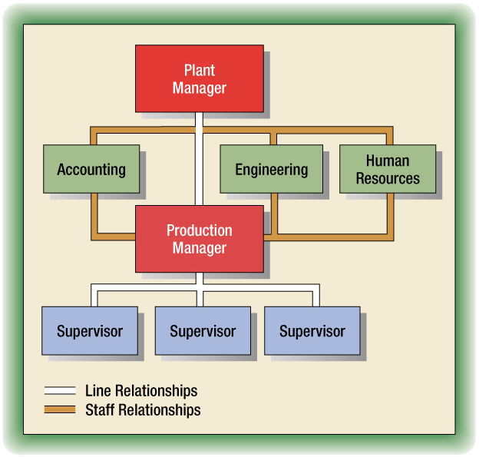

While the line structure would not be appropriate for larger companies, the line-and-staff structure is applicable because it helps to identify a set of guidelines for the people directly involved in completing the organization's work. This type of structure combines the flow of information from the line structure with the staff departments that service, advise, and support them

Line departments are involved in making decisions regarding the operation of the organization, while staff areas provide specialized support. The line-and-staff organizational structure "is necessary to provide specialized, functional assistance to all managers, to ensure adequate checks and balances, and to maintain accountability for end results"3

An example of a line department might be the production department because it is directly responsible for producing the product. A staff department, on the other hand, has employees who advise and assist—making sure the product is advertised or that the customer service representative's computer is working.

# Committee Organizations

In a c**ommittee organization,**  authority and responsibility are in the hands of a group of individuals rather than a single manager. In this type of organization groups of individuals, or committees, make decisions together. This ensures that individuals from diverse departments make more sound decisions. On the other hand, this slows down the decision making process as each member of the committee must agree with the decision.

# Matrix Organization: An Outline

A variation of the line-and-staff organizational structure is the matrix structure (matrix organization structure is sometimes called *project management structure*).

Matrix structures have come about as a result of coordination problems in highly complex industries such as aircraft manufacture4. The term *matrix* comes from the intersection of the horizontal authority-responsibility flow with the vertical flows of the traditional line-and-staff organization5.

In today's workplace, employees are hired into a functional department (a department that performs a specific type of work, such as marketing, finance, accounting, and human resources) but may find themselves working on projects managed by members of another department. Organizations arranged according to project are referred to as **matrix organizations**. Matrix organizations combine both vertical authority relationships (where employees report to their functional manager) and horizontal, or diagonal, work relationships (where employees report to their project supervisor for the length of the project). "Workers are accountable to two supervisors—one functional manger in the department where the employee regularly works and one special project manager who uses the employee's services for a varying period of time" 6

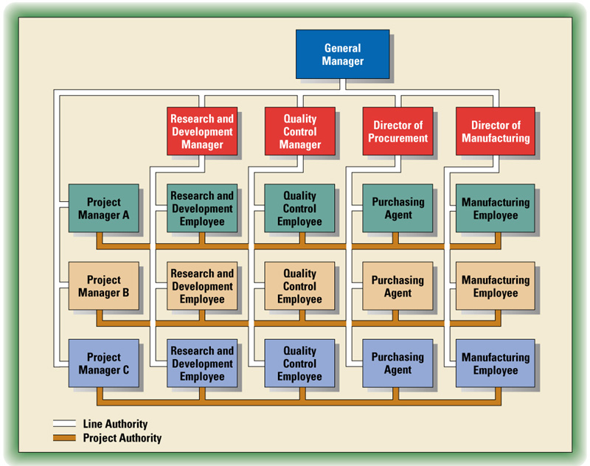

Matrix Organization7

As shown in the figure above, the matrix organization is built to carry out certain projects or to solve specific problems. People with diverse skills come together to implement the projects in hand. A special feature of this type of organization is that employees report to two superiors instead of one. Members of a project receive

# 

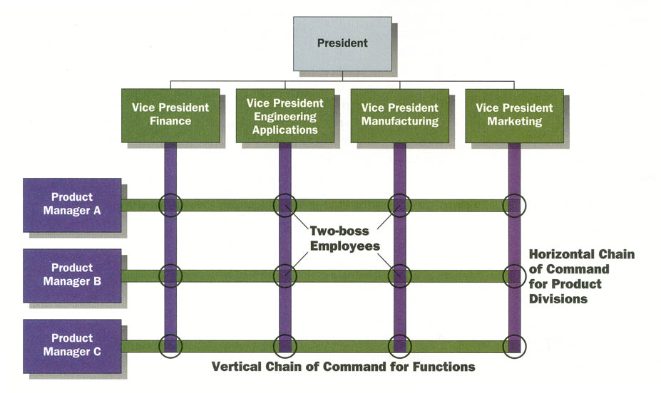

# Dual Authority Structure in a Matrix Organization10

instructions both from the project manager (horizontal authority) and from the permanent functional department heads (vertical authority).

The matrix organization type has been used in organizations such as Procter & Gamble8, the Harvard Business9 School and others.

People working in a matrix organization are often called **two-boss-employees** because they report to two supervisors at the same time10

The matrix organization type is also used successfully by global companies. Global companies must achieve simultaneous coordination of various products in each country they operate. These companies use geographic and product lines of authority. For example, a company producing computers globally may effectively adopt the matrix structure. Let us say a company located in Russia has some affiliates in Central Asian countries. The general manager of a plant in Kyrgyzstan producing computer monitors will report to both the head of the monitor producing division in Russia and the head of Kyrgyz operations. In fact, the matrix organization structure has been used globally by many companies.

According to a project manager’s degree of responsibility, matrix organization can be classified as follows 11:

**Weak/Functional Matrix**: A project manager has only limited authority. The functional managers maintain control over their resources and projects.

**Balanced/Functional Matrix**: A project manager is assigned to oversee the project. Power is shared equally between the project manager and the functional mangers.

**Strong/Project Matrix**: A project manager is primarily responsible for the project. Functional managers provide technical expertise and assign resources as needed.

Note, however, it is impossible to say that one type of matrix organization is better than the others12.

# Matrix Organization: Advantages

Many businesses have turned to a matrix organization structure to track use of resources across traditional functional, departmental, and product line boundaries. A matrix can also map micro-organizations such as project and team structures within an overall organizational structure. In both cases, a main goal is to save money by avoiding duplication of effort.

The Matrix type of organization has several advantages. The matrix can be very effective in a complex, changing environment. Many high-tech companies use the matrix structure to adapt quickly to fast-changing markets. In the matrix, meetings are very common and they allow new issues to be raised and problems to be solved. In the matrix, employees can be transferred from one division to another easily. The matrix also enables the sharing of new experiences, methods of handling problems, skills among employees. In addition, in the matrix employees clearly know who is responsible for the success of the project. The matrix structure also makes possible the participation of workers in team meetings, discussions and in the attainment of divisional objectives. This means that in the matrix organization employees are motivated because they have relatively larger tasks. Finally, this type of organization is best suitable for global organizations, as in such organizations managers can effectively achieve goals and be flexible enough to adapt to changing environments.

The advantages of the matrix can be summarized as follows:

**Pros of the matrix organization:**

* More efficient use of resources than a single hierarchy
* Flexibility, adaptability to changing environment
* Development of general and specialist management skills
* Cooperation between departments
* Expertise available to everyone in the organization
* Clear responsibility
* Enlarged tasks for employees
* Better suitable for global companies

# Matrix Organization: Disadvantages

Like any organizational form, the matrix has its disadvantages. The major problem is the confusion and annoyance caused by the twofold chain of command. Often employees do not know for sure to whom and how to report. Potential conflicts can arise concerning the division of authority. The different styles of the matrix described in the *outline of organizations* are not clearly stated in the organizational charters and this may cause disputes. In global organizations the matrix can cause conflicts related to functional goals of the company and the country’s goals. The third disadvantage is that much time is lost to meeting and discussions dedicated to resolving conflicts. This is true because when the relationships among the departments of a company becomes tense it is really hard to come to a compromise. In fact, many companies that have used the matrix have blamed the structure for wasting time in heated debates and discussions rather than actions to attain the companies’ goals. Managers in the matrix need human relations training to learn to work with two bosses, which is not easy and requires a lot of time and effort. For many organizations, it is difficult to keep the power balanced between the functional and divisional sides of the matrix.

Last, opponents to matrix management believe that it is a dated method to organize a company.13 The belief in the 70's and 80's was that a matrix organization would be the best way to manage project complexity. This has been proven untrue over the years by the failures of companies such as IBM, HP, and AT&T.

The summary of disadvantages of the matrix structure is provided below:

**Cons of the matrix structure:**

* Frustaration and confusiona from dual chain of command
* Conflicts between two sides of the matrix
* Many meetings and discussions
* Human relations skills needed
* Difficult to maintain the power balanced
* Out-of-date method

# Conclusion

Previously, before the matrix structure came about, most large corporations had been structured in departments. These departments were logical partitions of the company and any given groups of employees reported to the head of the department. In the 1970s, companies began to restructure its employees into a matrix organization, mainly with the intent of developing project managing units.

Even though the matrix structure has some disadvantages, matrix organizations provide clear accountability within a specific business function and allow more efficient allocation of specialized skills across the entire business. By taking advantage of the shared services and skills and not having to develop and manage those skills themselves, the divisional or product line organizations can better focus on their core business objectives. This last point was one of the original driving forces behind the development and popularization of matrix organizations. Today, matrix organizations are used to describe more than just the product-based organizations. For example, many IT project managers use smaller matrix-style structures for project and team organizations to track skills, tasks, and resources across multiple projects to ensure skills and resources are used properly. The matrix structure has also been used at Microsoft, and there are more than 5,000 project managers there out of more than 50,000 total employees.14 To sum up, if used properly by companies through clearly defining each manager’s duties, continuously being improved to meet the organization’s needs, the matrix is probably the most suitable structure for middle-sized and large organizations.

References

1. Boone E. Louis, Kurtz L. David: *Contemporary Business*, 1996.
2. *“Organizational Structure”,* http://en.wikipedia.org/wiki/Organizational_structure
3. Allen, 1970, p. 63.
4. Gerald A. Cole, *Management Theory and Practice,*2004, p. 192.
5. Boone E. Louis, Kurtz L. David: *Contemporary Business*, 1996, p.206-207.
6. Keeling and Kallaus, 1996,p. 43.
7. Boone E. Louis, Kurtz L. David: *Contemporary Business*, 1996, p.206.
8. www.pg.com
9. www.harvard.edu
10. Richard L. Daft, *Management,* p.334.
11. *Organizational Structure”,* http://en.wikipedia.org/wiki/Organizational_structure
12. Galbraith, 1971
13. *“Matrix Management”* , http://en.wikipedia.org/wiki/Matrix_management
14. Scott Berkun: *The Art of Project Management,* p. 13

Bibliography

Boone E. Louis, Kurtz L. David: *Contemporary Business*, Orlando, FL: The Dryden Press, 1996

Richard L. Daft: *Management,* Orlando, FL: The Dryden Press, 1997

James M. Higgins: *The Management Challenge*, New York, Macmillan College Publishing Company, 1994

Gerald A. Cole: *Management Theory and Practice*, London: Thomson Learning, 2004

Scott Berkun: *The Art of Project Management,* The USA: O’Reilly Media, Inc., 2005