People of Ancient Britain [History of Britain (история Британии)](http://4flaga.ru/hb/)

Long ago, the British Isles were not isles at all. Britain was part of the European continent: the English Channel did not exist and East Anglia merged into the Netherlands. Then, about 10,000 years ago - when the last Ice Age had ended, when the bones of the last mammoth had sunk into the mud of the Thames valley, when the climate grew warmer - new rivers and seas were formed and Europe was slowly formed into its present shape.

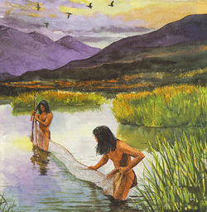

The people of Britain, like their cousins оn the continent, were simple hunters who lived оn the flesh of wild animals, which they shot with flint-tipped arrows or caught in traps. They killed fish in the estuaries and shallow rivers with spears made from the antlers of deer. They gathered wild fruit, nuts and honey, and probably ate snails, caterpillars and other grubs. They did not build permanent houses, but moved from place to place, sheltering in caves in cold weather.

The people of Britain lagged behind the people of certain warmer lands in their development. While they were still living in caves and scratching about for insects to eat, the Egyptians were building pyramids and writing literature.

Of all the stages between the cave and the skyscraper, perhaps man's greatest leap forward was taken when he became а farmer. The Stone Age farmer of about 5,000 years ago had to clear patches in the forests which covered most of Britain that was not barren heath or swamp. Не cut down trees with stone axes, burned off the scrub, and tilled the ground with а stone-headed hoe. Не kept half-wild cattle and pigs in the forest, where they could find their own food, and in treeless parts, like northern Scotland, he kept sheep. The people who grew grain in southern England had flint sickles to reap the harvest.

By the end of the Stone Age, about 2,000 BC, metal was already being used. The Beaker people, who are named after the clay mugs, or 'beakers', they made, also used bronze knives. They came to Britain from northern Europe, and started the building of the stone monuments at Stonehenge and Avebury (Эйвбери).

А simple plough also appeared about this time. It was little more than a spike to rip up the ground: the field was ploughed twice, the second time at right angles to the first. These improvements allowed people to settle in villages, where they stored food for the winter in underground larders. In a few places, like the Orkneys, houses were built of stone, and their remains can still be seen, complete with stone shelves and bedsteads.

Mining and trade were growing during the Bronze Age (roughly 2,000 to 500 BC). Copper was imported from Ireland and tin from Cornwall - the two metals from which the harder alloy, bronze, was made. Amber was imported from the Baltic and pottery from the Mediterranean area. Carts were made for moving heavy goods.

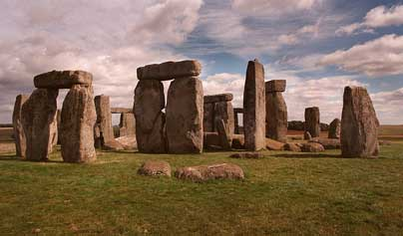

The people of the Wessex (Уэссекс) culture (southern England) developed the most advanced society Britain had seen. They used ornaments of gold and had complicated funeral ceremonies, with burials in round 'barrows', or mounds. Building continued at Stonehenge, which was а kind of temple, perhaps having some connection with the changing seasons. The stones seem to be lined up with the sun at different times of the year, and some experts have suggested that the whole building was а kind of astronomical clock.

About 500 BC, the inhabitants of Britain were learning how to smelt iron. Iron ore was easier to obtain, as it often lay close to the surface and was far more common than copper or tin. Although good tools were made of bronze, iron tools were much cheaper.

The beginning of the Iron Age coincided with the arrival of new people from the continent, mainly from France. They were the Celts. Archaeologists have discovered at least three Celtic groups, whom they call А, В and С people. The С people, the last and most advanced group, were the people known to the Romans as the Belgae (they did indeed come from roughly the area of Belgium). They were not 'pure' Celts, having some German blood. In fact there was less difference between Celtic and Germanic people in ancient times than some modern 'Celts' would like to think.

During the Iron Age large forts, with walls of earth reinforced by timber and stone, were built in many parts of the country. People from the nearby countryside could shelter there when enemies threatened. The largest of the English hill forts - in fact the largest in Europe - is Maiden Castle in Dorset. Standing on its great earthen ramparts, on а silent wintry afternoon if possible, some faint sense of Iron Age Britain can still be felt.

An Iron Age house was found by archaeologists at Little Woodbury, in Wiltshire. It was built on the plan of two circles, one inside the other. The family lived inside the smaller circle and the farm animals were stabled in the outer ring. The men of the family smelted their own iron, from which they made sickles for harvesting. The women made clothes, spinning and weaving their cloth, and clay cooking pots. They probably also pounded grain into flour.

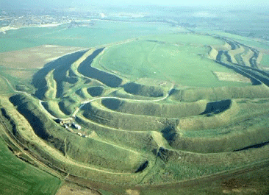

We know of many types of Iron Age house, and round buildings, which are simpler than walled houses, have been found in many places. The mysterious round stone towers of northern Scotland belong to the late Iron Age.

In spite of the evidence of the hill forts and stone towers, life in prehistoric Britain was not always violent. The arrival of new immigrants must have caused problems, but they usually came in smallish groups and soon mingled with the native population. It was never а case of the natives being overwhelmed by more aggressive and more advanced invaders. The Celts, who were of mixed race themselves, married natives whose ancestors had also been immigrants from northern Europe and from Spain.

Britain was unknown to the more civilized parts of Europe until it was visited - 'discovered' in fact - by Pytheas (Пифей), an educated merchant from Marseille (Марсель), in about 320 BC. Pytheas wrote the first description of the people, whom he called Celts. They were gentle folk, he said, and welcomed visitors.

The opinion of Pytheas is surprising. The next educated visitor to Britain described the British as а fierce race, savages. But that visitor came in no friendly spirit. His name was Julius Caesar.



**Люди древней Британии**

Много лет назад Британские острова вообще не были островами. Британия была частью Европейского континента: Ла-Манш не существовал, Восточная Англия и Нидерланды были соединены. Затем, около 10000 лет назад, когда последний Ледниковый период закончился. Кости последнего мамонта погрузились в грязь долины Темзы, когда климат потеплел, были сформированы новые реки и моря, и Европа медленно приняла настоящую форму.

Население Британии, как их «двоюродные братья» на континенте, были простыми охотниками, которые жили за счет мяса диких животных, которых они поражали стрелами с кремниевыми наконечниками или ловили в западнях. Они добывали рыбу в устье и на мелководье при помощи копий сделанных из рогов оленя. Они собирали дикие фрукты, орехи и возможно улиток, гусениц и других личинок. Они не строили постоянных домов, но передвигались от места к месту, прячась в пещерах во время холодной погоды.

Люди Британии запаздывали в развитии в отличие от людей тёплых районов. Пока они жили в пещерах и выцарапывали насекомых для пищи, египтяне строили пирамиды и создавали литературные произведения.

На всех стадиях между пещерой и небоскрёбом, возможно, самым большим шагом человека вперед было, когда он стал фермером. Фермеру каменного века приходилось очищать клочки леса, который покрывал большую часть территории Британии, не являвшуюся болотом и пустошью. Он срубал деревья при помощи каменных топоров, сжигал кустарники и разрыхлял землю деревянной мотыгой с каменным наконечником. Он держали полудиких свиней и рогатый скот в лесу, где они могли найти себе пищу. В безлесных участках, таких как северная Шотландия, он держал овец. Люди, выращивавшие хлеб в южной Англии, имели серпы для сбора урожая.

К концу Каменного века, приблизительно 2000 до н.э., металл уже использовался. Также уже использовал бронзовые ножи. «Гончарный народ», который назван так по имени глиняных кружок, или гончарных изделий, которые они делали, также пользовался бронзовыми ножами. Эти люди прибыли в Англию из северной Европы, и начали постройку каменных памятников в Стоунхендже и Эйвбери.

Простой плуг также появился приблизительно в это время. Он был немного больше чем пика, чтобы разрыхлять землю: поле пахали дважды, второй раз под прямым углом к первому. Эти усовершенствования позволили людям селиться в деревнях, где они хранили продовольствие в течение зимы в подземных кладовых. В нескольких местах, таких как Оркни, дома были построены из камня, и их остатки, наполненные каменными полками и остовами кроватей, все еще можно увидеть.

Горная промышленность и торговля росли в течение Бронзового Века (от 2000 до 500 до н.э.). Медь ввозилась из Ирландии, а олово из Корнуолла - это два металла, из которых делали более твердый сплав - бронзу. Янтарь ввозился из Балтики, и глиняная посуда - из Средиземноморья. Для перемещения тяжелых товаров делались телеги.

Люди Уэссекской культуры (южная Англия) развили наиболее продвинутое общество, которое видела Англия. Они использовали золотые украшения и имели сложные церемонии похорон - могильники в круглых 'холмах', или насыпях. Продолжилось строительство в Стоунхендже, который был чем-то вроде храма, и возможно имел какую-то связь со сменой времен года. Похоже, что камни положены в линию, соответствующую положению солнца в разное время года. Некоторые эксперты предположили, что здание являлось подобием астрономических часов.

Приблизительно 500 до н.э. жители Англии узнали, как плавить железо. Железную руду было гораздо легче добывать, поскольку она часто лежала близко к поверхности, и встречалась чаще, чем медь или олово. Хотя из бронзы делались хорошие инструменты, железные инструменты были дешевле.

Начало железного Века совпало с прибытием новых людей с континента, главным образом из Франции. Это были кельты. Археологи обнаружили по крайней мере три кельтские группы, которых они называют народы А, В и С. Люди группы С, последняя и наиболее продвинутая группа, были народом, известным римлянам как Белги (они действительно прибывали приблизительно с территории Бельгии). Они не были 'чистыми' кельтами, так как имели примесь немецкой крови. Фактически в древние времена различие между кельтами и германцами было меньшим, чем хотелось бы думать некоторым современным 'Кельтам'.

В течение железного века во многих частях страны были построены большие крепости, с валами, укрепленными древесиной и камнем. Люди из близлежащей сельской местности могли укрываться там, во время нападения врагов. Самая большая из английских крепостей на холмах - фактически самая большая в Европе - это Замок Девы в Дорсете. Стоя на его больших глиняных валах по возможности в тихий зимний день, всё ещё можно почувствовать какое-то легкое ощущение железного века Англии.

В Литтл Вудбери в Уилтшире археологами был найден дом железного века. Он был построен в виде двух кругов, один внутри другого. Семья жило внутри меньшего круга, фермерские животные содержались во внешнем кольце. Люди семейства выплавляли своё собственное железо, из которого они делали серпы для сбора урожая. Женщины делали одежду, пряли и ткали ткань, делали горшки из глины. Они, вероятно, также мололи зерно в муку.

Мы знаем о многих типах домов железного века. Круглые строения, которые были более простыми, чем здания со стенами, найдены во многих местах. Таинственные круглые каменные башни северной Шотландии принадлежат к последнему периоду железного века.

Несмотря на свидетельства в виде крепостей на холмах и каменных башен, жизнь в доисторической Англии не всегда была полна насилия. Прибытие новых иммигрантов должно быть создавало проблемы, но они обычно прибывали небольшими группами и вскоре смешивались с местным населением. Никогда не было случая, чтобы местные племена были разгромлены более агрессивными и более продвинутыми захватчиками. Кельты, которые являлись смешанной расой, женились на аборигенах, чьи предки также были иммигрантами из северной Европы и из Испании.

Англия была неизвестна более цивилизованным частям Европы, пока её не посетил – 'открыл' фактически - Пифей, образованный торговец из Марселя приблизительно в 320 до н.э. Пифей создал первое описание людей, которых он назвал кельтами. Он говорил, что они были благородным и гостеприимным народом.

Мнение Пифея удивляет. Следующий образованный человек, посетивший Британию, описал британцев как жестокую расу, дикарей. Но этот человек явился не с дружественными намерениями. Его звали Юлий Цезарь.

Britain conquered by the Romans [History of Britain (история Британии)](http://4flaga.ru/hb/)

In 55 ВС Britain was invaded by Julius Caesar, а Roman general and governor of Gaul (France), soon to be, in all but name, the first Roman emperor.

At that time the city of Rome was about 700 years old, but the Roman empire was much younger. As late as 211 ВС Rome had narrowly escaped destruction by the Carthaginian general, Hannibal. But Hannibal's defeat left Rome without а serious rival, and by Caesar's time it controlled an empire that stretched from Spain to the Near East.

Two places more different than imperial Rome and Celtic Britain could hardly have existed. Roman society was urban, with grand public buildings built of marble. Britain was а country of mud huts, with no settlement large enough to be called а town. An upper-class Roman lived in greater comfort than any Britisher before the 15th century. His house even had central heating.

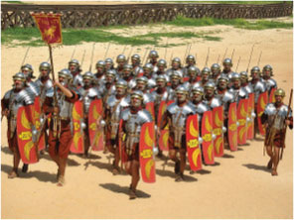

The Romans, as heirs of the civilization of Ancient Greece, were interested in art, philosophy and history (Caesar himself wrote good military history in simple prose). The British could neither read nor write. They were not savages, and in some ways Celtic art was superior to Roman, or so it seems to us, but the Romans naturally thought of them as hopelessly primitive barbarians. То the Romans - and to many non-Romans too - there was but one worthwhile form of society, and that was their own. The only useful function of other peoples was to contribute to the glory of Rome.

Britain was а mysterious isle to the Romans. But Caesar knew it contained valuable minerals, and he knew also that the British were helping their cousins in Gaul against Rome. Не decided on invasion.

Caesar had another motive - personal glory; yet his invasion nearly ended in disaster. Landing on an open beach near Deal, the Romans fought their way ashore, beat the assembled British, and accepted tributes from some of the chiefs. But а storm wrecked their ships and they had to scramblе back to Gaul, having advanced little farther than the Kent coast.

Next year Caesar came again, this time with а much larger expedition - five legions (about 25,000 men) and 800 ships. The British tribes sank their differences, uniting under the leadership of Cassivellaunus, and it took some time for Caesar to work out а way of dealing with the British chariots. The Romans were not used to this form of warfare, as chariots were obsolete in Gaul.

But Cassivellaunus failed to stop the attack. Caesar advanced through Kent, crossed the Thames at London, and marched through the thick forests of Essex towards Colchester. When an attack on the Romans' naval camp failed, the British decided to come to terms. Caesar took hostages and imposed an annual tax (we do not know for how long the British paid it). Then he sailed back to Gaul.

The British had been defeated but not conquered, and for nearly а hundred years afterwards no Roman army appeared in Britain. Caesar's expeditions had shown that Britain would not be conquered easily.

Between 54 BC and AD 43, the date of the Roman conquest, Lowland Britain prospered. The country enjoyed the benefits of trade with the great Roman empire without the disadvantages of Roman rule. The British came to know the Romans well. Roman merchants travelled to Britain, and Roman influence was strong. Many British leaders were pro-Roman. In some respects, Britain was 'Romanized' before the Roman conquest.

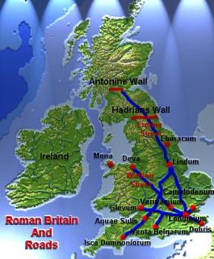

In AD 43 the Romans landed at Richborough, Kent, and advanced steadily north and west. They were chiefly interested in the fertile south-east, but they soon found that the minerals they wanted (lead, copper, etc.) lау in the mountainous parts. They found, too, that having conquered part of Britain it was hard to draw а line and say: that is where we stop.

The British were still not united, and the main opponent of the Romans, а clever and determined king of the Catuvellauni named Caratacus, was unable to create а national coalition. Не did his best, and when defeated in central England he retired to south-east Wales, where the Silures resisted the Romans more fiercely than any other people. Then, as Roman strength built up in the West Country, Caratacus fell back to Snowdonia, where the Ordovices kept up the struggle. After а hard battle, the Rоmans captured their stronghold near Caersws, and all of Caratacus's family were taken prisoner. Не fled to Brigantia (northern England), but the queen of the Brigantes favoured Rome and had him arrested. Не was sent in chains to Rome. There, he was triumphantly displayed before the people as а symbol of the Roman victory. Caratacus looked in wonder at the rich and powerful city. 'Why', he asked his captors, 'with all these great buildings, do you still want our poor huts?'

The Romans brought their campaign in Wales to а conclusion by conquering the Isle of Anglesey, off North Wales. Anglesey was а centre of the cult of the Druids, а class of priests (or witchdoctors) who had great influence among the British and knew that Rome's victory would mean their deaths. The Romans, who were tolerant of most local customs, were determined to destroy the Druids, as they disliked their ritual of human sacrifice.

As the Romans looked across the Menai Straits, they saw а hoard of hostile warriors, urged on to battle by mad-looking women in black and by the robed figures of the Druids, lifting their bloody hands to heaven to сall down curses on their enemies. Grimly, the Romans paddled their boats across the straits, the cavalry swimming their horses alongside. They cut their way through the rabble opposing them and slaughtered the Druids among their own altars.

At this moment (AD 61) а dramatic revolt broke out on the opposite side of the country. The king of the Iceni had died, and the Romans refused to recognize his daughters as his successors. The Roman soldiers in East Anglia were not well led (their governor was in Wales, of course), and they behaved stupidly towards the local people.They swaggered brutally through the country, stealing what they fancied. They raped the king's daughters and gave their mother, Queen Boudicca, а whipping.

Suddenly the country was in flames. Boudicca's people were joined by others, including many who had first welcomed the Romans but had since suffered from their greed and pride. А wild army swept down upon Colchester. London and St Albans fеll to the rebels, who killed аll the Roman colonists. Meanwhile, the governor hastily gathered his troops and, with 10,000 men, he met Boudicca in battle north-west of Towcester. The rebels were defeated. Boudicca died soon afterwards, and the revolt fizzled out.

Probably, the Romans could have conquered all of Britain if they had been determined to do so. But Britain was on the fringe of their empire; it was small, and expensive to govern. Some Romans thought it was not worth the cost.

Julius Agricola - the best of the governors of Britain, came near to completing the conquest before he was recalled to Rome. Не advanced north across the Forth and the Тау, and in AD 84 he defeated the Caledonians of northern Scotland at the great battle of Mons Graupius. Roman historians say that 10,000 Caledonians were killed, and only 360 Romans.

But soon afterwards the Romans decided to retreat. After some serious setbacks in the north, the Emperor Hadrian marked the frontier with а great wall across Britain. Built in the 120s, the wall was the largest structure in the Roman empire.

Although Hadrian's Wall was such а vast engineering project, the Romans were never certain that it was in quite the right place. In 142 а second wall was built farther north. Serious outbreaks continued; the Picts attacked from Scotland and the Brigantes from Yorkshire. In а revolt at the end of the 2nd century all the forts from York northward were destroyed.

Eventually, the Romans withdrew to Hadrian's Wall, which marked the real frontier of their power, although Roman patrols ranged far beyond it and Roman peace prevailed in the Scottish Lowlands.

In the third century, Roman Britain was already being attacked by Saxon pirates from Germany, and forts had to be built along the 'Saxon Shore'. In 367 the Saxons, the Picts and the Scots (aggressive Irish immigrants who were beginning to settle in south-west Scotland) attacked together. Although order was eventually restored, Roman power was waning fast and in 406 all troops were recalled from Britain to defend Rome from the attacks of the Goths. The legions never returned.

The Roman Province of Britain [History of Britain (история Британии)](http://4flaga.ru/hb/)

The Romans were in Britain for over 350 years - а very long time in the history of any country. In the north and west they remained an occupying army, keeping а grip on an often hostile people; but Lowland Britain (most of England) was thoroughly Romanized. The effects of the occupation were surprisingly small in the long run, but Roman rule certainly changed the lives of the British.

The greatest blessing of Roman rule was the рах Romana, 'Roman peace'. Tribal wars in Lowland Britain stopped, and the attacks of outsiders, like the Picts from the north and the Saxons from overseas, were resisted. The Romans set up law courts and enforced justice, though their idea of justice was not the same as ours and their punishments, which included execution by crucifixion, were cruel.

The Romans built the first towns. London was the largest, with about 30,000 people. Colchester and St Albans each had about half as many, but most Roman towns had only 3,000 or 4,000.

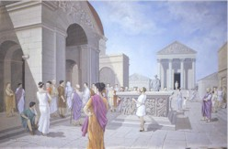

The typical Roman town was surrounded by а defensive wall, and was entered through stone-towered gateways. Streets were laid out in squares, and many of the ordinary houses and shops were made of timber and plaster. Larger, stone houses belonged to local leaders, government officials or merchants. The centre of the town was the marketplace, or forum, and nearby were а town hall, several temples, public baths (the Romans were fond of bathing and even had а type of sauna), and an inn or two. Some buildings, such as the amphitheatre where plays were performed, were outside the defensive walls.

Roman towns in Britain were less grand than towns nearer the heart of the empire, but they included fine marble buildings decorated with sculpture, and advanced engineering works, like the water supply and drainage system оf Lincoln.

Lincoln's water was pumped - uphill - from а spring two kilometres away, through а pipe protected by concrete, to а reservoir inside the wall. There was enough water to provide а sluice or flush for each house. А drain carried water into the sewers, stone tunnels large enough for a child to walk along, which ran under the main streets, with manholes at regular intervals.

As well as the first towns, the Romans built the first English country houses, or villas. Wе know the sites of about 600 villas (many can be visited), and more will undoubtedly be discovered. Unlike the Roman villas of southern Europe, which were weekend retreats for the rich, villas in England were usually working farms. The old Celtic leaders did not like the new-fangled idea of towns, and preferred to live on their estates.

Some villas were small farmhouses and others were grand palaces. The Romans, more sensible than later builders, usually chose good, sunny places. The villa had glass windows, something not seen again for а thousand years, and was decorated with paintings, mosaics and sculpture. Although а 20th-century family would miss some comforts, like electricity, few people today live in so pleasant а house.

Large villas were for the wealthy few. Wе should not forget that the estate was run by slaves. and that at one villa archaeologists found the skeletons of seventy new-born babies - unwanted slave children put outside to die.

Of all the relics of Roman Britain, the roads lasted best. Their routes can still be seen from the air, and many modern roads follow them. Roman roads were built straight, going over hills rather than around them, because their purpose was the swift movement of soldiers. They were also built to last, with massive stone foundations. The Romans built everything that way, thinking their empire would continue for ever.

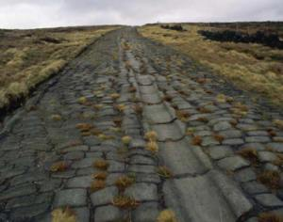

Like all imperialists, the Romans were interested in their colony for what they could get out of it. Metals were Britain's most important product from а Roman point of view, and Britain provided lead (from which silver was obtained), copper, and other useful metals. There was even а gold mine in Wales. Britain also exported jet and pearls, which came from oysters (the fish-and-chips of ancient times), bearskins and sealskins, corn, and slaves. British hunting dogs (the ancestors of our bulldogs and greyhounds) fetched good prices in Rome.

But in Roman times, as now, Britain probably had an 'unfavourable balance of payments', meaning more imports than exports. Though the British were great beer-drinkers, wine was а big import item, and so was olive oil. Most luxury goods came from abroad because British products were inferior. The rich man's silver, bronze-ware, glass and pottery came from older parts of the empire, although such things were made in Britain too. Egyptian papyrus (for writing on), spices and incense were the kind of goods that had to be imported.

The Romans brought new developments to British farming. They built watermills fоr grinding corn, and used iron ploughs (Celtic ploughs were wooden, though iron-tipped). New crops were introduced: rye, oats, flax, cabbages, parsnips, turnips and many other vegetables. The Romans brought larger horses and cattle, new fruit trees, perhaps including apples, and many flowers that we think of as typically British, like the rose. They were the first beеkeepers in Britain, and the first to eat home-reared roast goose.

The Romans also brought their gods to Britain. There were an immense number of them, and they often became merged with local Celtic gods. Especially popular with Roman soldiers was the worship of Mithras, originally а Persian god, one of whose temples was found а few years ago buried in the heart of London. Another new religion was Christianity. Christians were intolerant of other religions, especially the Romans' worship of their emperor, and until 313 they were persecuted in Rome. The British also disliked emperor-worship, which was one of the causes behind Boudicca's revolt, and Christianity seems to have been established in Britain by about 150.

In spite of all the Roman improvements, the mass of the British may have been worse оff under Roman rule. Tribal wars in Lowland Britain could have ended without the рах Romana. Towns did nоt suit the simple British economy, and the villa was а Меditerranean house, which was nоt ideal fоr Britain's colder, wetter climate. Farmers may have grown mоrе food, but they had to pay imperial taxes, which ate up their prоfits. Public buildings and roads were all very well, but their cost-inlabour as well as cash - was heavy. Mining expanded, but Cornish tin-mining, Britain’s greatest industry in prе-Romаn times, was stopped because the Romans did nоt want it to compete with Spanish tin production.

Britain existed to serve Rome. In doing so, it gаinеd benefits but also suffered from disadvantages. Were the benеfits greater than the drawbacks? The answer would depend on whether you were а prince or а peasant.

Britain after the Romans [History of Britain (история Британии)](http://4flaga.ru/hb/)

The decline of the Roman empire was а long process. In а waу, it began before the conquest of Britain, when some of the old Roman virtues were already disappearing. Ву the 3rd century, there could bе no mistaking the decadence of Rome. Ordinary people seemed to care for nothing except 'bread and circuses' (food and cheap entertainment). The aristocracy had grown lazy and soft through living on the work of slaves. Standards of education had fallen, and inflation was ruining the есоnomy.

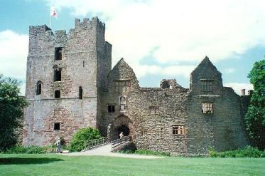

The slow breakdown of Rome coincided with the restless stirrings of more vigorous people. The fierce Huns were expanding westwards from central Asia, and others - Vandals, Goths, Franks, etc. - moved west ahead of them. Among them were the Saxons who came to Britain.

Roman civilization in Britain was dying for many years before the legions departed. Some towns, like Bath, were ruined and deserted before the Saxon invaders reached them. Coins and pottery, which provide such valuable clues for archaeologists, were becoming scarce before 400. Written records disappeared almost entirely. Looking back, we seem to see а gloomy northern mist falling on Britain. Through it we hear the cries and sounds of battle, while now and then some menacing figure looms dimly through the mist, bent on plunder.

However, Roman civilization did not suddenly disappear in 406, the year that the Roman legions suddenly disappeared for good. The Mildenhall treasure, discovered in Suffolk in the 1940s, is а dazzling witness to the wealth of some households at the time when Roman rule was collapsing. British leaders thought themselves better Romans than the citizens of sinful Rome for, influenced by Pelagius, they were critical of the Roman 'establishment' in both Church and State.

Without the legions Britain was almost defenceless against its various enemies, and Saxon raids increased. А British king, Vortigern (а title not а name), allowed some of the raiders to settle in Kent about 430. Не hoped these people, who were probably Jutes, would prevent further raids, but he soon fеll out with them himself. Almost the last direct word we hear from Britain for over а hundred years is а letter of about 446, which speaks of 'the groans of the Britons', whom 'the barbarians are driving to the sea'.

This was an appeal for help to Rome (never answered), and it probablу exaggerated the plight of the British. With so little historical evidence, we tend to think that Roman-British society was quickly wiped out. But that did not happen. We now know that cities like St Alban's and Silchester were still inhabited in the 6th century, and that there was а revival of Celtic art, probably resulting from the weakening of Roman influence in the late 4th century. We know too that the British succeeded, at least for а short time, in halting the Germanic invaders.

In the late 5th century, the British were led by а shadowy figure called Ambrosius Aurelianus (note the Latin, i.e. 'Roman', name). Не harassed the Saxons by fast-striking attacks at fords and crossroads. When he died, some time after 500, the leadership was taken over by his chief general, whose name was Arthur.

We are now in Round Table country: the stories of King Arthur, his Queen Guinevere and his noble Knights of the Round Table are well-known. But these beautiful stories are legends - made up by poets in the later Middle Ages. It was once thought that they were total fiction. But we now know that Arthur was а real general or king.

Не must have been а good commander, for he beat the Saxons twelve times before his greatest battle at Mount Badon, somewhere in the West County, about 516. Arthur's victory there not only stopped the Saxons, it persuaded some of them to go back to Gеrmany.

About twenty years later Arthur was killed, probably in а civil war. The Saxons advanced again, and before the end of the 6th century they had spread throughout Lowland Britain.

The arrival of the Anglo-Saxons [History of Britain (история Британии)](http://4flaga.ru/hb/)

The Germanic invaders of Britain, who were to become the English, came from north-west Europe, between the mouth of the Rhine and the Baltic Sea. By Roman standards they were uncivilized people. They had never known Roman rule, and when they reached Britain they were startled by the Roman buildings. Only а race of giants, they thought, could have built them. They avoided the towns, preferring their own simpler settlements.

At first the Anglo-Saxons arrived in small groups. Then, liking the country, they came in larger bands, and began to move inland, finding their way to the heart of England up the Thames and other rivers. The England they found was not much like the England of modem times. То judge from Anglo-Saxon poetry it was а grim, cold place. Thorny forests and barren heaths covered much of the land, swamps and marshes covered more. Rivers were not neatly confined within banks but oozed over the fields. Bears, wolves and wild boar roamed the forests. There were pelicans in Somerset and golden eagles in Surrey.

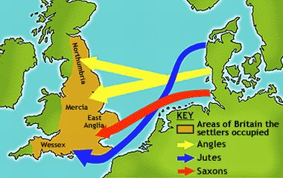

When immigration was at its height in the 6th century, the Anglo-Saxon bands numbered many hundreds, perhaps thousands. But it was never а mass migration. Few large battles took place, but the Anglo-Saxons did not gain the land without violence.

Not only did they fight the British, they fought among themselves. Saxons and Angles battled for possession of the Midlands, Saxons and Jutes for Surrey and Hampshire. Gradually, family groups came together to form larger, stronger tribes, and then kingdoms. By about 600, the newcomers controlled all England except the extreme north-west and south-west, plus south-east Scotland; but they did not hold Wales.

What, meanwhile, happened to the Celtic British? Here and there archaeologists have found evidence of the two peoples living side by side - or dying side by side - for at York there were Roman-style coffins buried next to Germanic funeral urns. Yet there are few signs of Roman or Celtic influence in Anglo-Saxon England. The British were driven back, into the more remote and mountainous parts of Britain which the Anglo-Saxons, like the Romans before them, hardly entered.

Although there is almost no evidence for such а thing, we can be sure that many of the ancient British remained. Certainly they had little in common with the newcomers, and failed, for example, to convert them to Christianity. But it does not seem likely that the whole native population was killed or driven away. Many of the British must have become slaves of the Anglo-Saxons, and many British women must have borne the children of Saxon fathers. But as far as history is concerned, in the regions settled by the Anglo-Saxons the old British society ceased to exist.



**Прибытие англосаксов**

Германцы, захватившие Британию, которым суждено было стать англичанами, прибыли из северо-западной Европы, области между устьем Рейна и Балтийским морем. По стандартам римлян они были нецивилизованными людьми. Они никогда не были под властью римлян, и когда они достигли Англии, они были поражены римскими зданиями. Только раса гигантов, думали они, могла бы построить их. Они избегали городов, предпочитая свои собственные, более простые поселения.

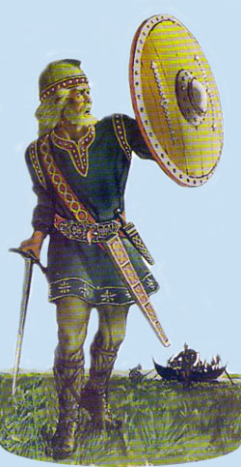

Сначала англосаксы прибывали малыми группами. Позже, полюбив страну, они начали прибывать большими отрядами, и стали перемещаться внутрь страны, найдя путь к сердцу Англии, к Темзе и другим рекам. Англия, которая предстала перед ними, не многим была похожа на Англию наших дней. Судя по англосаксонской поэзии, это было мрачное, холодное место. Тернистые леса и бесплодные пустоши покрывали многие земли, болота и топи покрывали и того больше. Реки не были аккуратно заключены в пределах своих берегов, а растекались по полям. Медведи, волки и дикие боровы бродили по лесам. В Сомерсете водились пеликаны, а в Суррее золотые орлы.

В самый пиковый момент иммиграции, в 6-ом веке, количество англо-саксонских отрядов насчитывало многие сотни, возможно тысячи. Но это никогда не было массовой миграцией. Имело место несколько больших сражений, но англосаксы не получали землю без применения силы.

Мало того, что они воевали с британцами, они воевали между собой. Саксы и Англы воевали за владение Центральными графствами, саксы и юты за Суррей и Гэмпшир. Постепенно, семейства соединялись, чтобы образовать более крупные, более сильные племена, а затем королевства. Примерно к 600-ому году, вновь прибывшие контролировали всю Англию кроме самого северо-запада и юго-запада, вдобавок к этому и юго-восток Шотландии; но они не овладели Уэльсом.

Что же, тем временем, происходило с британцами-кельтами? То здесь, то там археологи находят свидетельство того, что эти два народа жили бок о бок – или же умирали бок о бок – так в Йорке гробы Римского стиля были погребены рядом с германскими урнами. Все же есть некоторые признаки римского или же кельтского влияния на англосаксов в Англии. Британцы отступали назад, в более отдаленные и гористые части Британии, в которые англосаксы, как и римляне до них, почти не проникли.

Хотя тому нет почти никаких свидетельств, мы можем быть уверенными, что многие из древних британцев остались. Конечно, они имели немного общего со вновь прибывшими, и не смогли, например, обратить их в христианство. Но не кажется вероятным, что всё коренное население было уничтожено или изгнано. Многие из британцев должно быть стали рабами англосаксов, а многие британские женщины должно быть родили детей от англосаксонских отцов. Но с точки зрения истории в областях, заселенных англосаксами, старое британское общество перестало существовать.

The England of the Anglo-Saxons [History of Britain (история Британии)](http://4flaga.ru/hb/)

Anglo-Saxon England settled into a pattern of seven kingdoms. The three largest, Northumbria, Mercia and Wessex eventually came to dominate the country, each at different times. First it was Northumbria (the only time in English history when the centre of power has been in the north). Northumbria stretched as far as Edinburgh and for a time included part of the kingdom of Strathclyde, in south-west Scotland.

Offa's Dyke

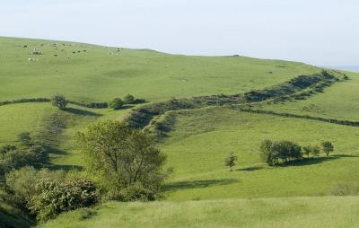

During the 8th century, Northumbrian leadership was replaced by the midlands kingdom of Mercia. The greatest of Mercian kings, Offa (757-796), corresponded with the mighty Charlemagne, emperor of the Franks; he minted his own coins - the first nationwide currency since Roman times. He is remembered also as the builder of Offa's Dyke (ров), an earth rampart over 190 kilometres long which marked the border of Mercia with Wales. It can still be seen, but it was much higher in Offa's time.

On his coins, Offa called himself 'king of the English', and his power stretched far enough for him to have a rebellious king of East Anglia beheaded, and to give estates to his subjects in Sussex. He even had some influence in Northumbria.

However, neither Northumbria nor Mercia succeeded in making their kings the rulers of all England. That honour was to fall to the House of Wessex, made great by King Alfred.

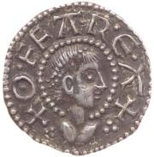

But what was this office of kingship, and how did it work in Anglo-Saxon England?

The idea of kingship was not invented in England. The Anglo-Saxons knew it in Germany. Kings grew from simple tribal chiefs who were leaders successful in war, and therefore conquest of land. As time went by, the king became a grander, more exalted figure, and when England became Christian again in the 7th century reverence for kingship was encouraged by the Church.

The king was elected; he did not gain his crown by right of inheritance. Or not at first. In time it became the custom to elect a member of the royal family. Still the king's power was not total. He ruled with the advice of his council - the great men of the kingdom. He had no permanent capital and was always on the move. It must have been quite difficult for visitors hoping for a royal interview to track him down.

The later Anglo-Saxon kings received a constant stream of visitors, from overseas and from other parts of Britain. In 973 King Edgar was visited by no less than eight sub-kings at the same time. They manned the oars of his boat as a gesture of loyalty.

Such visitors brought expensive gifts, or tributes. But for his regular income the king relied on the profits of his own estates. which were large and widely scattered, and. on rent, usually paid 'in kind' - i.e. as goods, not cash. Receipts from tolls of various kinds and fines from the law courts added something. His subjects gave him free labour and military service: in an emergency that meant every male who could swing a sword. Special expenses, like bribing the Vikings not to attack, were met by special taxes, and various persons or places owed special duties to the king. Norwich, for example, supplied a bear and six dogs for the sport of bear-baiting.

Anglo-Saxon kings were less worried by money problems than their successors in medieval and modern times, but from Alfred's time maintaining the fleet became a costly business.

In return for the support of his subjects, the king gave them protection and rewarded them with grants of land.

Besides their loyalty to the king, men were also bound by obligations to their own relations: the bond of kinship. If someone were murdered, it was the duty of his relations to avenge him: to die unavenged was a terrible thing. Fear of family vengeance helped to prevent crime at a time when there was no better way of enforcing the law. Everyone had a *wergild* ('man-price'), the sum payable in compensation to his family by those responsible for his death. Sometimes *wergild* was refused by the injured family, who preferred violent revenge. Then tremendous feuds began, with one act of vengeance following another. We know of one feud in Northumbria which began in 1016 and was still going strong nearly seventy years later. But kinship also meant cooperation in everything within the clan, looking after orphans, and even protecting the interests of a young woman who married outside the family.

The amount of a man's *wergild* was a sign of his position in society. A nobleman's *wergild* was larger than a peasant's.

To be classed as a nobleman, or thegn, a man had to have at least five hides of land (a hide was the amount needed to support one household). The nobleman lived in a windowless, barn-like hall, built of wood, surrounded by smaller houses and protected by a stockade. (Stone buildings appeared in the 9th century.) The furniture was simple - trestle tables, benches, and straw mattresses on the floor. In this hall, much heavy drinking and telling of stories took place after a day's hunting. Anglo-Saxon poetry is full of fighting, feasts and falconry - the main activities of the thegns. Before Alfred's time, few could read.

Running the household was the woman's job. But an Anglo-Saxon household was nothing like a suburban semidetached. It was almost self-sufficient, doing its own baking, brewing and so on. The woman's job was not mere housework, more like managing a business. Anglo-Saxon women were not oppressed. Divorce was easy (Christianity made it harder), arid a divorced woman was entitled to half the household goods. She could hold property in her own right-impossible in later times.

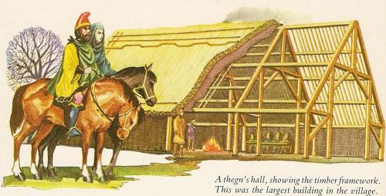

The *wergild* of a churl, or peasant, was one-sixth that of a nobleman. The churl normally held at least one hide of land, and lived in a simple thatched hut with no window or chimney - just a hole in the roof. The better kinds of tradesmen - goldsmiths, sword-makers, falconers and small merchants - were also classed as churls. The churl was free but poor, and he depended on the nobleman for protection. In time, he often came to sell his service to the nobleman and so, gradually, he became less independent.

The third class in society was the slave, or unfree peasant. He had no rights and no *wergild*, though if you killed him you had to pay compensation to his owner (about 1 pound - the price of eight oxen). Unlike the churl, the slaves could often improved his position and even buy his freedom.

Although Anglo-Saxon settlements were nearly self-sufficient, trade in goods like salt, fish and metals went on inside the country and overseas. The contents of the Sutton Hoo burial ship proved that an early East Anglian king owned luxuries imported from Europe. England's chief exports were wool and slaves (although the slave trade declined in Christian times because of Church opposition.) Trade led to towns growing up at harbours and crossing places. London and Winchester were the largest; few others had more than 5,000 people.

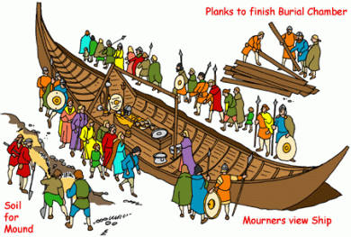

Although several kings issued written laws, a lot of Anglo-Saxon law was simply custom, passed on by word of mouth from one generation to the next. There were no professional lawyers, and the nearest thing to a law court was the folk moot, a public assembly where quarrels were settled, local problems discussed and crime punished. (Later, some noblemen had private courts on their own estates.)

An accused man sometimes had to prove his innocence by ordeal. One form of ordeal - probably not so common, though we hear a lot about it in books - was by water. The accused was thrown in, and if he floated he was guilty. The trouble was that if he sank, although he might be proved innocent, he was likely to be drowned. However, not many crimes carried the death penalty. The Church disliked capital punishment, though the alternative it preferred - chopping off a hand or an ear - seems savage enough to us.

The Christian Church in Britain [History of Britain (история Британии)](http://4flaga.ru/hb/)

In the Roman slave market one day, Pope Gregory noticed some pretty fair-haired Yorkshire children for sale. He asked who they were and was told they were Angli, English. *'Angli who look like Angeli (angels)'*, the Pope replied, making a famous pun.

If this old story is true, the Pope's interest in Britain was aroused on that day, and he decided to send a missionary to convert these attractive heathens to Christianity. In 597, St Augustine landed in Kent. After 150 years of silence, England's contact with Rome was restored.

St Augustine landed very near the spot where the Roman legions had waded ashore, but unlike them he came in peace, and with the agreement of the king of Kent. His message was gratefully received: on Christmas Day 10,000 people were baptized at Canterbury, where a Christian church was still standing.

Beyond Kent, Christianity spread less rapidly. King Edwin of Northumbria, after consulting his council, accepted Christianity in 626; but he was killed a few years later and the new churches were destroyed in a pagan reaction. Although Christianity was soon restored, it was not by missionaries from the Church of Rome.

For Christianity had never disappeared from the British Isles. The British, when they retreated from the Anglo-Saxons, took their religion with them. More than thirty years before St Augustine landed in Kent, an Irish monk, St Columba, founded the monastery of Iona, Scotland's Holy Isle, which became the centre of British Christianity. It was to Iona that the new king of Northumbria sent for a bishop in 635, and the man appointed was St Aidan, who settled at Lindisfarne. He soon made that island a Northumbrian counterpart to Iona.

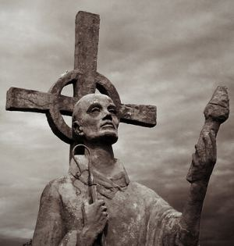

While out of touch with Rome, the British, or Celtic, Church had developed differently from the continental Church. Even the date of Easter was different, so that in places where both Churches were represented, half the people were mourning the crucifixion of Christ while the other half were celebrating his resurrection.

In 663 a synod (a meeting of clergy) was held at Whitby in Yorkshire to decide the matter of the double Easter. At least, that was the main point on the agenda; but what the synod really decided was a much wide question: was the Church of England to be British or Roman? The King of Northumbria, who presided, decided that English Christians should not cut themselves from fellow Christians in the rest of Europe. But although the Romanists won the argument, Celtic influence remained strong. The Church in England was always to remain different in spirit from the Church in Italy or France, and the influence of Celtic Christianity, gentler and less grand than Roman, was one of the chief reasons for it.

The Celtic Church was a Church of missionary monks, while the Roman Church was organized under bishops, whose headquarters were in large towns. The Roman Church was supported by a mass of learned laws and, from a political point of view, it looked like a more orderly, stable institution. For that reason kings preferred it.

Monasteries were also a vital part of Roman Christianity. St Augustine himself was a monk (he founded the monastery of St Peter and St Paul at Canterbury), and monastic influence was strong in early Christian England. All kinds of people became monks, including several kings, and many of them deliberately chose a monastery far away from home, to cut themselves off more thoroughly from ordinary life.

Devout Christians went on pilgrimages if they possibly could, mostly to Rome though one or two bold people went to Jerusalem. King Alfred was taken to Rome as a child. But a pilgrimage, or any journey, was neither safe nor simple. Storms and pirates made the Channel crossing a fearful experience, and on land bandits and swindlers waited to trap the innocent traveller. One archbishop, on his way to Rome, was frozen to death crossing the Alps. Sensible people made their wills (завещания) before they set out on a pilgrimage.

Irish monks were working as missionaries in Europe before 597, and this tradition was continued by early English Christians. Most of northern Europe was converted to Christianity by English missionaries. Charlemagne's chief assistant in his programme of educating the people of his empire was a Yorkshireman, Alcuin.

Christianity was a great civilizing influence. To begin with, it introduced more education. Its teaching was narrow, as it was simply designed to make native Englishmen fit to be priests, but it did produce scholars who knew Greek as well as Latin and had read some Classical - i.e. pre-Christian - literature. Among them was the 'father of English history', Bede.

*Venerable Bede Translating the Gospel of John, by JD Penrose*

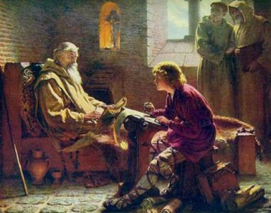

Bede, who is sometimes called 'the Venerable' (Бéда Достопочтенный), though such a dusty title does not suit him, spent all his life in the Northumbrian monastery ofJarrow. He wrote many books, but the most famous is his Ecclesiastical History of the English People, finished in 731. It is the only worthwhile history of England in the earliest period. Bede had a remarkable sense of history - of the passing of time - as well as a rare scholarly attitude to facts. His book, in English translation, still makes good reading.

Although books were written in increasing numbers, a far greater number were imported from the continent. Up and down the country monks were kept busy copying them, and often decorating them with beautiful miniature illustrations. The Lindisfarne Gospels in the British Museum (produced about 700) are a magnificent example of their work.

All these books were written in Latin. But English too was being written. According to Bede, the first Anglo-Saxon poet was a peasant named Caedmon, who was inspired by a dream to write about the Creation. Anglo-Saxon is, of course, almost a foreign language to us. Caedmon's poem, for instance, runs like this:

Nu scylum hergan hefaenricaes uard,  
metudaes maecti end his modgidanc …

(Now we must praise the guardian of heaven, the powers of the Creator and his thoughts ... ).

The most famous Anglo-Saxon poem is Beowulf, the saga of a hero who saves his people from a series of evil monsters. Like many Anglo-Saxon stories, it is on the grim side.

The objects - works of art, to weapons, etc. - that survive through the centuries do not always give a perfectly accurate picture of the works of an ancient people. Most Anglo-Saxon art that has survived is Christian, for people went round smashing pagan idols after they were converted. We also have examples of swordhilts, drinking horns and jewellery, but not much to show us the fine quality of early English needlework, because cloth does not last as well as metal or stone.

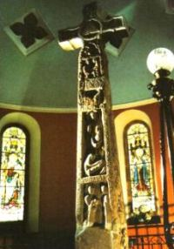

Anglo-Saxon art was similar to Celtic art in design and inspiration; at least, it was more like Celtic than Roman art. Patterns of decoration were often abstract, or semiabstract, based on animals and plants. Christianity brought foreign influences with it, in particular the tradition of realistic art inherited from Ancient Rome. In Northumbria the two styles merged to prouce sculpture, like the stone cross at Ruthwell, Dumfries, made in the 7th centuty, which experts once believed to have been made 500 years later.

Invasions of the Vikings [History of Britain (история Британии)](http://4flaga.ru/hb/)

Before the end of the 8th century, the British Isles were raided again by another non-Christian people, from Scandinavia. In 793 the Vikings, as we call them, destroyed the monastery of Lindisfarne, drowning some of the monks and stealing precious objects.

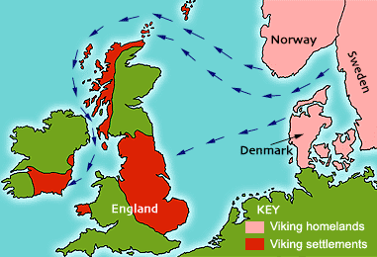

The Vikings were a sea-going people; they had the best boats yet seen in Europe, powered by oar and sail. They crossed the Atlantic, founding a colony in Newfoundland 500 years before Columbus discovered America; they rounded Lapland and sailed up the rivers of Russia; they raided Europe from the Baltic to the Mediterranean. Norsemen sailed around Scotland and down the west coast of Britain as far as the Mersey; they established colonies in northern Scotland and created a Scandinavian kingdom in Ireland. Danes raided the east coast of England, burning and killing, exulting in violence. Nothing stopped the Vikings, not even the northern winter.

These long-haired warriors wore coats of mail, carried hefty battle-axes and long shields. No one had the ships to match them at sea, and when they landed they moved so fast - rounding up all the horses in the neighbourhood - that they could destroy a town, burn a church and slaughter the people before a force could be raised against them. When they were brought to battle, they were often too strong for the motley group of poorly armed peasants who confronted them, and when they were defeated they were back again, stronger than ever, a year or two later.

What began as raids for quick plunder soon developed into something more. The Danes descended on England in ever-larger bands and raided steadily farther inland. In 851 a Danish host spent the winter in Kent. A few years later they wintered near London. The English were in no position to prevent them. Northumbria was feeble, with rival kings fighting for the crown. In Mercia another royal argument was going on, and the midland kingdom was squeezed between the Danes from the east and the forces of the Welsh prince, Rhodi Mawr, from the west.

That was the situation in 865, when a Danish army larger than any before arrived in England. This time the Danes came not merely for plunder, and they had no plans to return in the autumn or the following spring. They meant to conquer England.

York fell in 866, and the rival kings of Northumbria were killed. East Mercia was overrun and the rest of the kingdom saved, for a short time only, by a truce bought with Mercian gold. In 869 King Edmund of East Anglia (St Edmund of Bury) was savagely murdered while a prisoner. Essex was conquered. By 870 only Wessex was left to resist the barbaric Danes, whose main camp at Reading was well placed to receive reinforcements up the Thames.

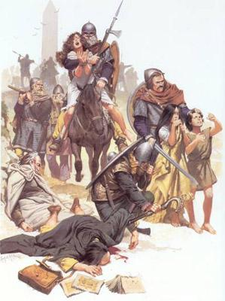

Soon after the Danes turned against Wesses, the West Saxons gained a new king, who was only about twenty-two years old. His name was Alfred (849-899), and we know him as 'the Great'. He is the only English king who has earned that title.

After one stirring victory, Alfred was forced on to the defensive, and for a few years it looked as though Wessex too would soon be submerged. By 878 Alfred was a fugitive, hiding in the wintry marshes of Somerset. (It is from this period in his life that legends later grew - stories like the tale of the burning cakes which the king was supposed to be watching while the farmer's wife was out of the kitchen.)

But Alfred's West Saxon peasant-warriors, or most of them, remained loyal. With the spring, he surged out of the marshes to harass the Danes. In May, the men of Wiltshire and Hampshire met him in the forest near Southampton. They told him they were 'glad to see him'. Two days later Alfred's Christian army smashed the Danes at the battle of Edington. 'The turn of the tide!' Alfred exclaimed.

Under their able commander, Guthrum, the Danes fell back to Chippenham. Alfred swept the surrounding country bare of food and horses, and in two weeks the Danes were forced to surrender. They promised to leave the country. Guthrum accepted Christian baptism, with Alfred acting as god-father.

What made Alfred a great man was not just his military victories but his statesman-ship. After years and years of bloody conflict, he saw the futility of trying to destroy the Danes by force. He believed that a man who grows content will cease to be a dangerous enemy, and he was determined to reach friendly agreement with the defeated Danes. This he did. His treaty with Guthrum gave the Danes a large part of eastern England, where Alfred hoped they would settle down as peaceful farmers.

Alfred's statesmanship showed itself also in his ability to learn from his enemies. When new groups of Vikings resumed the attack some years later, they found England far better prepared. Having studied the defenceworks of Guthrum's camps, Alfred set up a system of strongly fortified burghs in southern England. (Traces of his fortifications can still be seen at Wareham in Dorset, among other places.) He also built warships on the Danish pattern and, as the English were not experienced sailors, he hired men from the coastal districts of the Low Countries to man his navy. We know that more than once Viking raiders were defeated at sea by Alfred's ships, and prevented from landing.

f

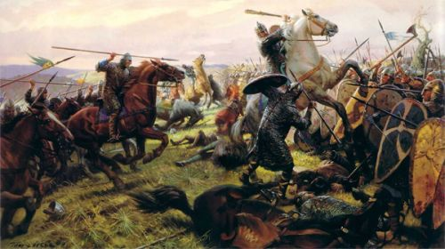

Edward the Confessor (Эдуард Исповедник) was half-Norman by birth. He had spent most of his life in Normandy; and he appointed Normans to important positions in the state (partly to balance the power of great English earls (графов) like Godwine of Wessex). England was already half 'Normanized' before the Norman Conquest of 1066.  
   
Edward had no children, and as he died he recognized Harold, son of Godwine, as his heir (наследник). Across the Channel in Normandy, а loud protest was heard. According to Duke (герцог) William, Edward the Confessor had made the same promise to him; what was more, Harold had already accepted William's claim during а visit to Normandy two years before.  
   
Such arguments are usually decided by force. William swept across the Channel with his army and landed near Hastings. Harold was in the north, where he had just defeated а Norse invasion, but he hurried south and, brave but foolish, offered battle. His men were tired and he would have done better to have starved the Normans out. Still, his position on а hill was а strong one, until the Normans, pretending to run away, lured (выманили) the English down the hill.

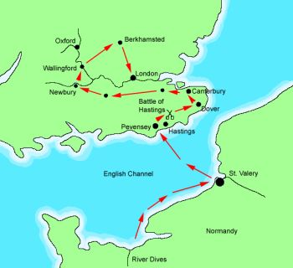

We know King William I as 'the Conqueror'. But he wanted no talk of conquest. Не had come, he told the English, to restore the good laws of King Edward and to uphold the constitution. All conquerors talk like that, and William was an expert politician as well as а good general. Yet he was probably sincere.

At first he moved gently, and tried to disturb Anglo-Saxon institutions as little as possible. England already possessed better government machinery than Normandy, so that was only sensible. But rebellions against the Normans provoked him into harsher action. In the north, his soldiers swept through the country like fire. Between York and Durham they left hardly а building standing.

Although Norman influence was strong in England before 1066, that date is still the most famous onе in English history, and the Conquest certainly did cause quite а number of great changes. For onе thing, it tied England more closely to Europe. William ruled Normandy as well as England, and for the next 500 years English kings also held land in France.

The Conquest caused sweeping changes among the leading land-holding families. There were Norman landlords before 1066, but most were Anglo-Saxon or Danish. Within twenty years, all William’s chief tenants (strictly speaking, no onе 'owned' land except the king) were Normans. As а sign of the change, stone castles rose threateningly at every strongpoint, and work was started on the great cathedrals in the cities. In the early stages of construction, the two types of building looked alike - а sign of the alliance in Norman England of the powers of Church and State.