Ministry of Education and Science of Ukraine

National Technical University of Ukraine

“Kiev Polytechnic Institute”

Faculty of Management and Marketing

Report on Macroeconomics

«The Business Cycles as a Form of Economic Development»

Written by

The student of UZ-92

Osipov Dmitry

Checked by

Ereshko Yu. A.

Kiev-2010

Contents

busines economic cycle

Introduction

Definition of Cyclicity

Stages of the Business Cycles

Recession

Through

Recovery

Peak

Causes of Economic Cycles

Types and Continuity of the Business Cycles

Short Cycles

Middle Term Cycles

Long Cycles (The Kondratiev wave)

Stabilizing policy of the State

The Great Depression

The List of Used Literature

Introduction

The modern society strives to continuously improve the level of life and living conditions, which can only provide sustainable economic growth. However, long-term economic growth is not even, but is constantly being interrupted by periods of the economic instability. The ups and downs along the level of output, following one another, are commonly called the business or economic cycles.

We can meet cycles, including economic ones, almost everywhere. Our life, the career develops cyclically - we always feel expansions, recessions. The topic is relevant because we all have to understand that once we hit the pick, it’s going to be followed by the recession.

Definition of Cyclicity

The economy has the ability to develop cyclically: it has its own crises, recoveries, "booms". People always strive to reach the peak, the "boom" of their welfare; the government - to the peak of economic development of the state. But the economy can’t stay at the peak of its development forever, it’s always followed by the recession, crisis. Under these two words we all understand something bad, something we want quickly to get rid of. Crises have a negative impact on almost everything, so we try to avoid it. But even in the developed countries like USA, UK, France, Germany and other countries of Western Europe we don’t see the successful experience of avoiding them.

Scientists have not determined the exact causes of the cycles for several centuries. Currently, there are only theories of economic cycles. The other economists agree with them or offer brand new ideas on the problem .However, this question remains open to this day.

Economic cycle (or the business cycle) – is the periodic but irregular up-and-down movements in economic activity, measured by fluctuations in real GDP and other macroeconomic variables.

The main characteristics of business cycles:

* Self renewal;
* Continuity;
* Wave-looking dynamics of macroeconomics factors.

The economic cycles depend on output. The output is expressed by the quantity of commodities and services, produced by the economy of the exact country.

Stages of the Business Cycles

The full business cycles have four stages it’s gone through. They are: recession, through, recovery and peak (or “boom”).

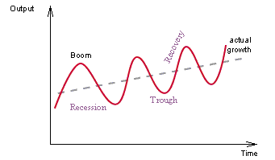

Recession

At the moment of recession there is a decline in economic growth, and then, as a rule, direct reduction in output. These phenomena are associated with the overproduction of goods. At this time, the amount of unsold goods dramatically increases. We can see massive bankruptcy (ruin), industrial and commercial enterprises which can not sell goods that are accumulated. Because of the suspension of production, the unemployment is rapidly growing, wages are declining. The stock market is crushed, we observe falling stock prices. All entrepreneurs are in dire need of money to pay debts quickly formed and therefore the norm of banks-sky percentage will increase significantly.

Here are the longest recessions of the last century:

1929-33: 43 months

1910-12: 24 months

1913-14: 23 months

1920-21: 18 months

1973-75: 16 months

1980-81: 16 months

As we can see the longest recession happened during the Great Depression (1929-33). It lasted 43 months.

Trough

Following the recession here comes another phase – trough (depression). The declining of production suspends and the prices are getting lower. Stocks of goods are gradually decreasing. Because of the small demand, mass of free capital increases, the bank interest rate reduces to a minimum level. Industry and employment, having got to the lowest level, slowly and gradually begin to grow.

During the depression the supply of goods stops to dominate on demand, that’s why an economic equilibrium appears between them. At the same time conditions to end the crisis are being naturally created.

Speaking of through, let’s get back to the Great Depression. For instance, stock prices fell from $89 to 15$ billion. An unemployment rate was 25%. 100 000 failed.

Recovery

The stage of recovery is the most pleasant phase of any cycle.

The economic conditions which we have described in depression phase do not remain as such for ever. After sometime revival or recovery sets in under the influence of a variety of factors. The revival phase develops when the accumulated stock of commodities with the businessmen are exhausted. The cost under the impact prolonged depression begins to fall. The price which have reached its lowest level stop falling further.

There is then complete harmony between costs and price relationship. When profits begin to reappear, the businessmen are induced to invest their hoarded money in some enterprise. In order to steal a march over other industrialists, they start repairs, renewal and replacements of their capital equipments and stocks. The capital goods industries resume activities. There is gradual reemployment of labor.

The money incomes begin to increase and the effective demand is revived. The government also tries to break the spell of depression by starting construction or expanding some public works with a view to give more employment. The commercial banks which have accumulated large reserve offer credit on favorable terms. The marginal efficiency of capital begins to rise and investment opportunitiesbrighten up. The consumers start buying commodities to avoid the rise. Due to increase in demand for commodities, investment in various industries is stimulated and thus the revival takes place.

In the Great Depression recovery real GDP raised from $580 billion to $1300 billion.

Peak

Recovery ends with a "boom" or peak of cycle when the economy is operating at maximum capacity, there is full employment, investment and spending of customers are very high, we observe an expansion of production, wages and profits are rising. Now because of many customers who are willing to buy a lot of commodities, prices trend to rise. Entrepreneurs feel limitation of recourses and an output level stops going up. Then the economy is "overheated", and it sinks into a new crisis.

The cycle is completed. And here comes a new one.

Of course, the way how business cycles go depends on each situation of different countries. In some of them recessions take no more then a year, but others stay in that phase for 5-10 years. It also depends on what caused the recession.

Causes of the Business Cycles

A lot of economists have conducted researches on what causes the business cycles to take place. Even though we don’t have an actual answer to that question. There are about 200 concepts that will describe economic crisis and their cyclicity. All of those concepts are divided into two groups.

At first, the nature of economic cycles is explained by the factors not having anything in common with economic system. They are: political events, psychological problems, solar activity cycles, wars, revolutions, the powerful breakthroughs in techniques and technology.

In particular. One Englishman explains it through the solar activity. An American, G. Moor, was talking about Venus motion rythm.

Secondly, the cycle is considered as an internal phenomenon, dealing with economics. Internal factors can cause a recession, and the rise in economic activity through certain periods of time. One of the crucial factors is the cyclicity of basic capital. In particular, the beginning of economic boom, accompanied by a sharp increase in demand for machinery and equipment, apparently suggesting that it repeated over a period of time when this technique is physically and mentally worn out.

So, generally there are two types of causes. They are internal and external cause.

Internal causes:

* political and other events;
* new land discoveries;
* climate conditions;

External causes:

* unstable consumer spending;
* unstable investment rate;
* recourses price changes.

Types and Continuity of the Business Cycles

Short business cycle(Kitchin cycle )

This cycle is believed to be accounted for by time lags in information movements affecting the decision making of commercial firms. Firms react to the improvement of commercial situation through the increase in output through the full employment of the extent fixed capital assets. As a result, within a certain period of time the market gets ‘flooded’ with commodities whose quantity becomes gradually excessive. The demand declines, prices drop, the produced commodities get accumulated in inventories, which informs entrepreneurs of the necessity to reduce output. However, this process takes some time. It takes some time for the information that the supply exceeds significantly the demand to get to the businessmen. Further it takes entrepreneurs some time to check this information and to make the decision to reduce production, some time is also necessary to materialize this decision (these are the time lags that generate the Kitchin cycles). Another relevant time lag is the lag between the materialization of the above mentioned decision (causing the capital assets to work well below the level of their full employment) and the decrease of the excessive amounts of commodities accumulated in inventories. Yet, after this decrease takes place one can observe the conditions for a new phase of growth of demand, prices, output, etc.

Middle-term cycles

Juglar was one of the first to develop an economic theory of business cycles. He identified the 7-11 year fixed investment cycle that is now associated with his name. Within the Juglar cycle one can observe oscillations of investments into fixed capital and not just changes in the level of employment of the fixed capital (and respective changes in inventories), as is observed with respect to Kitchin cycles. The recent research employing spectral analysis has confirmed the presence of Juglar cycles in the world GDP dynamics up to the present time.

Long Cycles (The Kondratiev wave)

The cycle is supposedly more visible in international production data than in individual national economies. It affects all the sectors of an economy, and concerns mainly output rather than prices. According to Kondratieff, the ascendant phase is characterized by an increase in prices and low interest rates, while the other phase consists of a decrease in prices and high interest rates.

Kondratieff identified three phases in the cycle: expansion, stagnation, recession. More common today is the division into four periods with a turning point (collapse) between the first and second phases.

A fourth cycle may have roughly coincided with the Cold War: beginning in 1949, turning with the economic peak of the mid-1960s and the Vietnam War escalation, hitting a trough in 1982 amidst growing predictions in the United States of worldwide Soviet domination and ending with the fall of the Berlin Wall in 1989. The current cycle most likely peaked in 1999 with a possible “winter” phase beginning in late 2008. The Austrian-school economists point out that extreme price inflation in the absence of economic growth is a form of capital destruction, allowing either stagflation or deflation to represent a recession or depression phase of the Kondratieff theory.

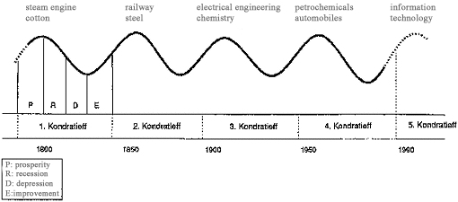

Stabilizing policy of the State

The main goal of the stabilizing policy is to reduce the wave hesitance. There are two types of policies like this.

The Policy of containment.

This is an activity to reduce the demand. Government uses it at the stage of peak. At this moment the demand is growing that’s why entrepreneurs are striving to rise the prices and expand the production. And this causes the inflation potential. At this point the economy needs to be “cooled”. Apparently, the government wants to raise taxes, reduce state budget spendings, to raise interest rates.

This policy is good to fight against inflation, but it also causes a problem of unemployment.

The Policy of Expansion

This is exact opposite policy - it’s aimed to expand the demand. This is relevant when the country is in a stage of through. Stimulating spendings, government tries to make the production flourish. They want to raise the output level.

Main instruments are: decreasing interest rate, rising wages, stimulating investments.

The Policy of Expansion creates conditions for economic growth and lowers the unemployment rate but at the same time it threats by rising prices which can lead to inflation.

The Great Depression

Historians most often attribute the start of the Great Depression to the sudden and total collapse of US stock market prices on October 29, 1929, known as Black Tuesday. However, some dispute this conclusion, and see the stock crash as a symptom, rather than a cause of the Great Depression. Even after the Wall Street Crash of 1929, optimism persisted for some time; John D. Rockefeller said that "These are days when many are discouraged. In the 93 years of my life, depressions have come and gone. Prosperity has always returned and will again." The stock market turned upward in early 1930, returning to early 1929 levels by April, though still almost 30% below the peak of September 1929. Together, government and business actually spent more in the first half of 1930 than in the corresponding period of the previous year. But consumers, many of whom had suffered severe losses in the stock market the previous year, cut back their expenditures by ten percent, and a severe drought ravaged the agricultural heartland of the USA beginning in the summer of 1930.

By mid-1930, interest rates had dropped to low levels, but expected deflationand the reluctance of people to add new debt by borrowing, meant that consumer spending and investment were depressed. In May 1930, automobile sales had declined to below the levels of 1928. Prices in general began to decline, but wages held steady in 1930; but then a deflationary started in 1931. Conditions were worse in farming areas, where commodity prices plunged, and in mining and logging areas, where unemployment was high and there were few other jobs. The decline in the US economy was the factor that pulled down most other countries at first, then internal weaknesses or strengths in each country made conditions worse or better. Frantic attempts to shore up the economies of individual nations through protectionist policies, such as the 1930 U.S. Smoot–Hawley Tariff Act and retaliatory tariffs in other countries, exacerbated the collapse in global trade. By late in 1930, a steady decline set in which reached bottom by March 1933.

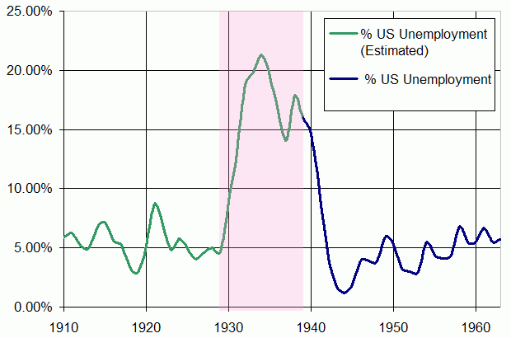

US Unemployment rate

The List of Used Literature

1. П.В. Круш, С.О. Тульчинская "Макроэкономика"
2. Tim Taylor “Principles of Macroeconomics”
3. Kitchin, Joseph "Cycles and Trends in Economic Factors", 1923
4. http://www.english.illinois.edu/maps/depression/overview.htm