# Introduction.

Leadership is one of the most mysterious phenomena that occur in our society. Leaders appeared in the ancient times and since then the necessity in leadership has increased. Our society has become more complicated. Today there are a lot of social units on different levels that need leaders to function effectively. But it has been a difficult task to understand how leadership occurs. Leaders are different, their tasks vary, as well as the way they lead their teams. Being an effective leader in one organisation does not presuppose the same success in other organisation. There are many “but” in this field of study, leadership raises lots of questions. No wonder that there are several approaches to leadership.

The aim of this paper is to assess the applicability and value of different approaches using a service organisation as an example. I have chosen Quality Arcticus Hotel in Harstad and three of its leaders as a field for my research. I work at this organisation, so I know the personnel and I have observed the style of their work for some period. Now I will use my knowledge and the method of interview to go deeper into the question. Quality Arcticus Hotel is a typical service organisation that offers lodging and catering. The restaurant and the café belonging to the hotel are both very popular among the citizens of Harstad. The hotel itself is the second best in the town, following Røkenes Gjestegård (which takes the first place due to its exclusiveness) Such success of Arcticus Hotel would be impossible without effective leadership.

My work consists of theoretical and practical parts. In the theoretical part I describe the approaches that we have been introduced to.

In the practical part I take a look at the structure of the Quality Arcticus Hotel and try to apply different approaches to leadership to understand the style of work of the three leaders that I have chosen as the subject for my study. I describe what, in my opinion, helps these three persons to be effective leaders (if they are so in reality)

# 2. Theory about leadership.

## 2.1 Definitions of leadership

Defining leadership has been a complex and elusive problem largely because the nature of leadership itself is complex. A lot of studies have emerged from every discipline “that has had some interest in the subject of leadership: anthropology, business administration, educational administration, history, military science, nursing administration, organizational behaviour, philosophy, political science, public administration, psychology, sociology, and theology.” (Rost, J. C. Leadership for the Twenty-first Century, p. 45)

Joseph Rost -- and many others, including James MacGregor Burns, Warren Bennis, and Henry Mintzberg -- goes on to argue that the entire history of modern leadership studies has been seriously flawed. First, because while everyone talks about leadership, no-one has satisfactorily defined what it actually is. Like art, we seem to know it only when we see it. (www.infinitefutures.com)

We can see how definition of leadership changed:

1927: “...the ability to impress the will of the leader on those led and induce obedience, respect, loyalty, and cooperation.” (Steward, in Moore, 1927)

1930’s: “…interaction between specific traits of one person and other traits of the many, in such a way that the course of action of the many is changed by the one.” (Bogardus, 1934)

“Leadership may be broadly defined as the relation between an individual and a group built around some common interest and behaving in a manner directed or determined by him.” (Schmidt, 1933, page 282, quoted in Rost, page 48)

1940’s: “Leadership…is the art of influencing…people by persuasion or example to follow a line of action. It must never be confused with drivership…which is the art of compelling…people by intimidation or force to follow a line of action.” (Copeland, 1942)

1950’s: “...the process (act) of influencing the activities of an organized group in its efforts towards goal setting and goal achievement.” (Stogdill, 1950/1958)

1960’s: “…acts by persons which influence other persons in a shared direction.” (Seeman, 1960)

1970’s: “…a process in which an individual takes initiative to assist a group to move towards the production goals that are acceptable to maintain the group, and to dispose the needs of individuals within the group that compelled them to join it.” (Boles and Davenport, 1975)

Warren Bennis and Burt Nanus in their book “Leaders” said that “Leaders lead by pulling rather than pushing; by inspiring rather than ordering; by creating achievable, though challenging, expectations and rewarding progress toward them rather than by manipulating; by enabling people to use their own initiative and experiences rather than by denying or constraining their experiences and actions. (Bennis, W.,Nanus, B.,1985:225)

In 1993 Joseph C. Rost defined leadership for the twenty-first century: “Leadership is an influence relationship among leaders and followers who intend real changes that reflect their mutual purposes.” Four essential elements must be present:

1. The relationship is based on influence.

The influence relationship is multidirectional;

the influence behaviours are no coercive.

2. Leaders and followers are the people in this relationship.

The followers are active;

there must be more than one follower, and there is typically more than one leader in the relationship;

the relationship is inherently unequal because the influence patterns are unequal

The definition given by Rost comprises all the previous attempts to define leadership, as it includes the elements reflected in the other definitions. However, most of the scholars considered some elements to be more important than others, so we have a number of approaches to leadership. We will describe the major ones in the next chapter.

## 2.2 Leadership evolution

Our world is changing and these changing surroundings need new leaders. When the world used to be stable, the tasks of the leaders were to control and predict. Further, as the world was getting more chaotic, leaders faced new tasks. This model shows the evolution of leadership:

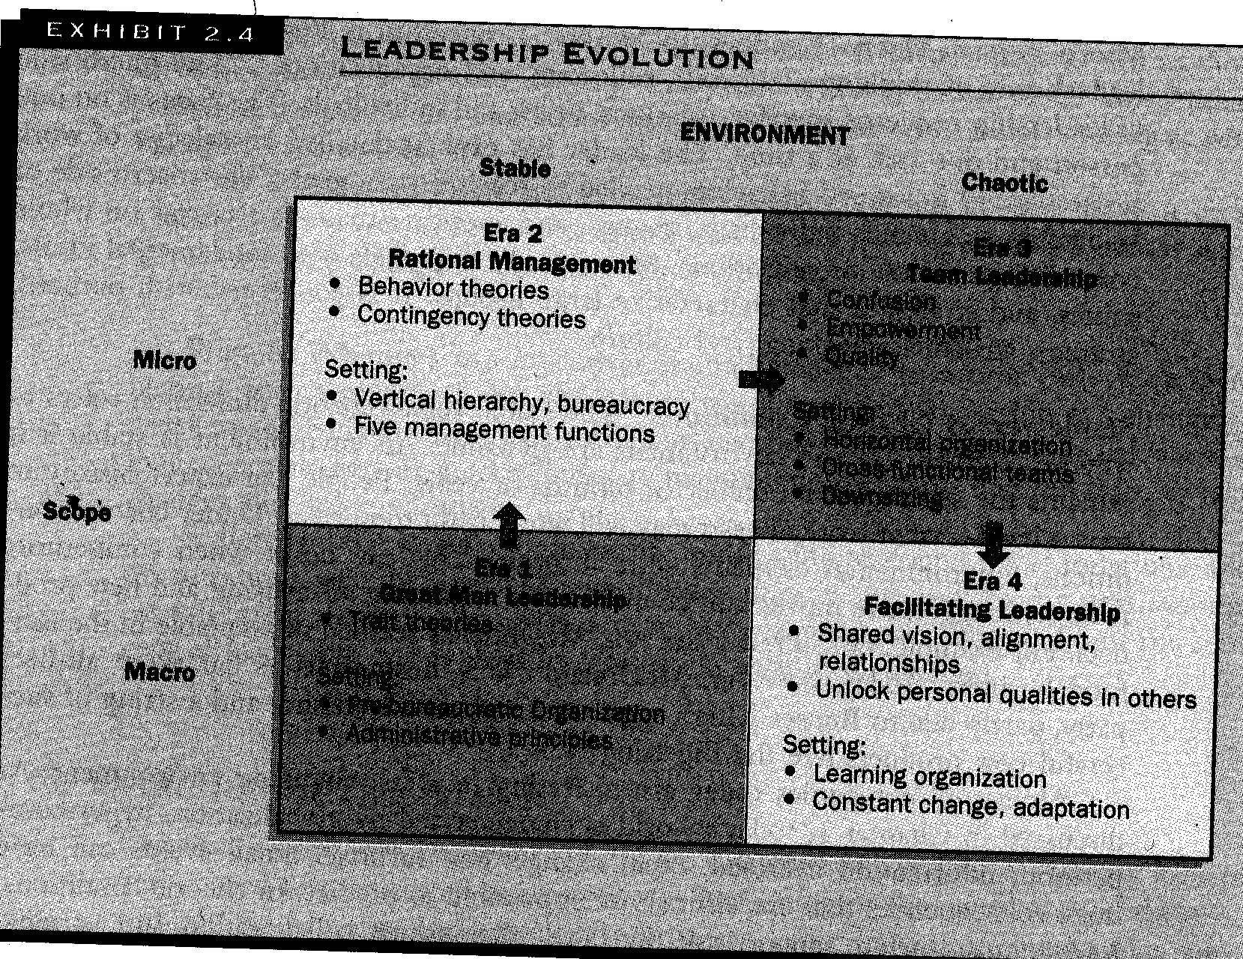

**Figure 1.** Source: Richard L. Daft: Leadership: theory and practice. (1999, p

Different approaches to leadership concentrate on different eras or types of leaders.

## 2.3 Trait approach to leadership.

Early efforts to understand leadership success focused on the leader’s personal traits. In the 1990’s the “great man” theories appeared. They tried to figure out who is *born* to lead. They studied the great leaders of the past such as Caesar, Napoleon, and Richard III. Those days the world was stable and predictable, the societies were not so complex, the groups were few and small. The leaders acted on “macro” level and were associated with heroes. Later researches (1940’s-1950’s) tried to find the universal traits common to all leaders. There was a sense that some critical leadership traits could be isolated. There was also a feeling that people with such traits could then be recruited, selected, trained and installed into leadership positions. In their studies some traits did appear more frequently than others: *technical skills, friendliness, intelligence, general charisma, drive, task motivation, application to task, social skills, emotional control, administrative skill, group-task supportiveness.*

The problem with the trait approach lies in the fact that almost as many traits as studies undertaken were identified. Stogdill examined over 100 studies based on the trait approach. (Daft, R., 1999:65) He uncovered that the importance of a particular trait was often relative to another factor- the situation. Indeed, when we look at such leaders as Stalin, Hitler, Churchill, Mother Theresa, Gandhi, Martin Luther King, Jr., John Kennedy, Margareth Thatcher, do they have any traits in common all together? Having failed to identify the leader’s traits, the researchers understood that leadership is usually a more complicated process.

## 2.3 Behaviour approaches

The results of the trait studies were inconclusive. Researchers changed the focus from the “great men” to small groups and their leaders. Researchers turned to an examination of leader behaviours. Rather than concentrating on what leaders are, as the trait approach urged, the behavioural approach forced looking at what leaders do. This approach (1950’s-60’s) says that anyone who adopts the appropriate behaviour can be a good leader. (Daft, R., 1999:69) Behavioural patterns can be learned in contrast with traits that must be possessed.

The studies of Iowa State University were a precursor to behaviour approach. They recognised autocratic versus democratic leadership styles.

The most prominent studies were those undertaken by the University of Michigan and by Ohio State University. Interestingly, both studies concluded that leadership behaviours could be classified into two groups.

**Ohio State University University of Michigan**

- Initiating Structure - Production Centered task-oriented

-Consideration - Employee Centered people-oriented

Likert (the University of Michigan) found that employee-centered leader behaviour generally tended to be more effective. Blake and Mouton of the University of Texas went into the same direction and suggested the two similar dimensions: concern for people and concern for results. But they worked out the leadership grid and suggested five leadership styles:

* 1. Impoverishment Management (minimal degree of each concern). The less effective leadership.

9.1 Authority-Compliance Management (maximal degree of concern for results, minimal degree of concern for people)

5.5 Middle-of.the-Road- Management (average degree of both concerns)

1.9 Country Club Management (minimal degree of concern for results, maximal degree of concern for people)

9.9 Team Management (maximal degree of each concern). This was considered to be the most effective leadership style.

This approach goes further that trait approach by trying to group leaders into several categories instead of finding something common to all leaders. Still, leaders were supposed to have “either-or” style.

## 2.4. Situational (contingency) approach

Unable to determine which particular behaviour patterns consistently resulted in effective leadership, researches then attempted to match behaviour patterns that worked best in specific contexts or situations. The previous researches studied two dimensions: leaders themselves and their relationships with followers. The central focus of the new research was situation in which leadership occurred. The most important point is that the components of leadership style, subordinate characteristics and situational elements impact one another. Fiedler’s contingency model, Hersey and Blanchard’s situational theory, the path-goal theory, and substitutes for leadership each describe that different situations need different styles of leadership behaviour so that it was an effective leadership.

According to Fiedler, leaders can determine if the situation is favourable to their leadership style. Task-oriented leaders tend to do better in very easy or very difficult situations, while person-oriented leaders do best in situations of intermediate favourability. Hersey and Blanchard say that leaders can adjust their task or relationship style to accommodate the readiness level of their subordinates. The path-goal theory states that leaders can use a style that either clarifies the path to desired rewards or increases the rewards so that the followers would display increased effort and motivation. (Daft, R., 1999:114) We will have a closer look at two of these theories in our practical part.

The limits of this paper do not allow us to analyse other theories as dyadic theory, integrate and alternative approaches. But all these theories took into consideration the fact that leadership is a complex phenomenon and its effectiveness depends on many factors.

# 3. Implementation of the theory in practice.

## 3.1 Presentation of Quality Arcticus Hotel

Quality Arcticus Hotel is a typical service organisation. It is an equivalent of a four-star hotel, and a member of a hotel chain Choice Hotels. Here is an organisation plan of the hotel.

**Executive Committee**

**Hotell**

**Manager**

**Economy**

**Manager**

**restaurant chief**

**Barchief**

**Chief-cook**

**Reception**

**chief**

**Selling**

**Manager**

As an action company, it has a committee, consisting of 5 persons who were chosen by the personnel. In the hotel we can see a vertical power structure. One can observe three levels of leaders here:

Strategic level – the hotel manager (administrative director)

Middle level – the economy chief

Operative level – the restaurant chief, the bar chief, the chief-cook, the reception chief, and the selling manager.

I have chosen three leaders for my research: the hotel manager, the economy chief and the restaurant chief. I work at this restaurant, so I know the restaurant chief’s work best out of the operative leaders.

In connection with this paper I am interested in what kind of leader styles these three persons practice. I consider their work as very effective. To this point, the hotel has not had serious economical problems or conflicts with the personnel. I should mention that it is a small hotel, and it can be considered a family organisation.[1] Moreover, all the three were not elected to their positions and in reality can take their leader positions as long as they wish to. Such relations give more power to the leaders. However, their relationship to the personnel is very good. Their subordinates call them democratic bosses. I would like to find out what helps these leaders work effectively and keep such a good reputation. I am going to use the leader theories that I have talked about in this paper. I want to find out whether those theories are relevant when explaining the success of these three leaders.

Now I want to look closer at the tasks of these three leaders. The hotel manager works with daily leadership and strategic planning. Since it is a little hotel with few departments, most of the leaders have additional responsibility. Quality Arcticus Hotel does not have a marketing department and the hotel leader has marketing as an additional task to his main tasks. This leader has a number of tasks which he handles alone, e.g. problems outside the hotel: the marked, competition, promotion. He can take decisions alone, having consulted the economy chief if it is possible to put his ideas into reality. In my opinion, this fact that he can solve some problems by himself helps him to avoid possible conflicts with the subordinates. Actually there are fields where he does not need to lead a team.

The economy chief takes charge of economy and budget, this is her main responsibility. Her additional responsibility is the personnel. Her tasks are more management tasks than leadership, as she works mostly with calculating and controlling, and this is the work that she handles alone. Still, she also works with the personnel, deciding who and how much is going to work in different situations.

The restaurant chief takes responsibility for the personnel in the restaurant and for the budget. She also takes charge of the arranging, marketing and selling of all the products that the restaurant can offer.

## 3.2 Trait approach in practice

First, I want to find out if these three leaders have some traits that explain their success. I have interviewed the leaders and asked what particular traits help them in their work, in their opinion. I have asked their subordinates as well to describe these persons as chiefs. At last I have tested the three leaders, using the questionnaire from the book “Leadership” , to find out if these persons have potential leadership qualities. The test showed that all the three of them may have such qualities, especially the restaurant chief. On my question, if they could be leaders of a big concern/company, the economy chief answered “no”, the restaurant chief answered “yes” and the hotel chief was not sure. The restaurant chief was very excited of the thought to lead a big company, which, to my mind, means that she has qualities and abilities necessary for a leader.

Among the qualities the hotel chief possesses his subordinates mentioned: democratic, flexible, not so demanding, motivating, honest, social, result-oriented, fair, friendly, well-organised, purposeful. He himself means that what helps him in work is an ability to listen to other people and to foresee the situation.

The economy chief was characterised as fair, polite, well-organised, nice, understanding, with sense of humour, flexible, democratic, precise, consequent, hardworking, and motivating. She herself considers the most important for her success is being social, friendly and co-operative.

The restaurant chief got a variety of characteristics from her subordinates: flexible, understanding, drive, motivating, demanding, obliging, stressful, funny, purposeful, open, helpful, optimistic, active, with a sense of humour, charismatic, absent-minded, messy, enthusiastic, precise, co-operative, concerned about quality. She herself pointed out such traits as open, helpful, purposeful, tough, and a bit autocratic.

As we can see all the three leaders possess a number of qualities that many researchers consider having great value for leaders, such as drive, honesty, friendliness, and motivating. Still, all the three possess different qualities, what does not prevent their success. Such traits as messy and stressful, for example, can be an obstacle in handling situations that demand responsibility and self-confidence. To my mind, this approach does not go deep enough to explain the success of the leaders.

## 3.3 Behaviour approach in practice

Further, I have tried to find out what kind of behaviour these three leaders practise. I have tested all of them, using two questionnaires from the book “Leadership” . I have also interviewed both the leaders and their subordinates.

One of the approaches, which I have described above, recognises autocratic versus democratic leadership styles. The hotel chief is a democratic leader. All his subordinates pointed it out. The characteristics he got from the personnel, such as flexible, fair, friendly, not so demanding, indicate his democratic relations with the subordinates. In the interview the hotel chief explained that although the organisation has a hierarchic structure, in practice he and his subordinates is one team, working together. When there is a problem to lose, he is on one line with the other leaders. Everyone has the right to say what they mean.

One of the tests I have used was designed to assess aggressive, passive and assertive behaviour. According to the test, the hotel chief’s behaviour is assertive. This behaviour is considered to be the most effective for leadership. Assertive people ask for what they believe, and stand up for their rights in a way that others can accept. The quality of assertiveness means being straightforward yet open to the needs of others. Assertiveness strikes the correct balance between being too dominant and too “soft”, which are not effective ways to influence others.

Another test shows if a person is people-oriented or task-oriented. The hotel chief is task-oriented according to the test, but only with a one point’s difference.

The economy chief is also rather democratic than autocratic. All her subordinates named her social characteristics. She delegates authority to others, encourages participation and relies on her subordinates.

However, the test showed that she practises passive behaviour, which is not effective for leadership. She prefers conflict avoidance, suppressing her own needs, being inhibited and submissive.

She is also more people-oriented than task-oriented. She trusts her colleagues and asks their opinion. For example, is there are too many rooms to clean, she never insists on cleaning all of them the same day. Satisfied room-maids are more important for her than 100% done work.

The restaurant chief is both democratic and autocratic. Her subordinates mentioned her social qualities as well as her concern for work, e.g. demanding, drive etc. She is a person who always helps her subordinates, asks for their opinion, in some cases fully delegates authority to the team of waiters and lets them decide how to complete the tasks. But in some cases, especially demanding to represent the restaurant at its best, she becomes autocratic and tells how to do the work. In such cases perfectly-done work is more important for her than satisfied subordinates. When a new waiter/waitress is being trained up, she pays much attention to every detail in doing the everyday tasks, such as laying up the table, talking to the guests and so on. When she lets her subordinates do the job without her supervision, every worker knows how to do the tasks so that the chief would like it. It is obvious that she is more task-oriented than people-oriented. She characterises her relationship with the subordinates as good, but she is aware of the fact that some persons are discontent with her pressure and a great deal of work which she expects to be done.

Another test showed her assertive behaviour, which is considered the most effective for leadership. (Daft..)

## 3.4 Situational approach in practice

All the three leaders behave in different ways. It is interesting that the hotel chief, having serious tasks, allows higher degree of democracy than the restaurant chief. To my mind the difference is the situations they work in. Both the hotel chief and the economy chief have a number of tasks they can handle alone and the number of their subordinates they work with on the other tasks is little. [2] The restaurant chief has around 20 waiters under her charge. And there is almost no task she can do alone without any help. Moreover, she needs to co-operate with the kitchen. Her working surroundings are more conflictable and she needs to be firm. I think it is incorrect to say that some behaviour is more effective than other, without taking into consideration in what situation the leader work. The leader effectiveness is in other words contingent on the situation.

The situational theory of Hersey and Blanchard focuses on the characteristics of followers. According to this theory I can say that the restaurant chief has telling style, as she gives explicit directions about how tasks should be accomplished. And this is an appropriate style in her situation if we take into consideration the fact that 50% of the subordinates are not professional waiters. Half of the waters started to work without any knowledge about the specificity of the job, many of them work part-time. So, not all the waiters show high degree of readiness. Letting them decide and giving them responsibility is not the right thing to do.

On the opposite, the hotel chief and the economy chief work with a team that has high readiness and shares the goals of the organisation. The department chiefs can take responsibility for their own task behaviour. The hotel chief prefers delegating and participating styles of work. The economy chief has delegating style.

Fiedler takes more factors into consideration than just the characteristics of the followers. He also means that task structure and the degree of leader power are important. Here is the table showing different situations the leaders can work at.

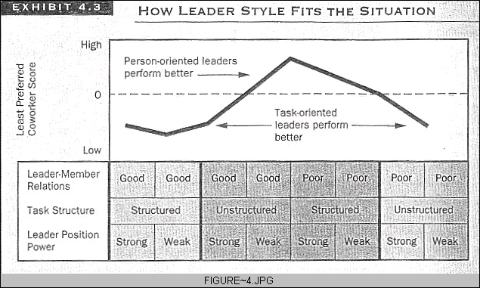

**Figure 2.**

Source: Richard L. Daft: Leadership: theory and practice. (1999: 97)

Knowing the situation we can say what is more effective for a leader: being people-oriented or task-oriented.

The leader-member relations are good with all the three leaders in our case. The task structure is high. There are little ill-defined tasks or researches, the hotel chief and the economy chief handle such tasks alone. At the restaurant it can be a challenge to work with new unexpected tasks, here we have work that sometimes needs creativeness. The task structure at the restaurant is lower. I would place the restaurant chief in the situation with unstructured tasks.

The formal position power is strong with all the three leaders. Although the hotel chief and the economy chief prefer to work on one line with their subordinates, formally they have power to evaluate, reward or punish.

I can conclude that the hotel and economy chiefs work in a favourable situation, while the restaurant chief- in an intermediate. In both cases task-oriented leaders perform better. As I have found out before, the hotel chief and the restaurant chief are task-oriented leaders, while the economy chief is more people-oriented. But as she is as popular as a chief and does her work successfully, I presume she can allow being people-oriented in her situation as well. The tasks for her subordinates are so clear and routine, and the relations with her team are so favourable that she does not need focus on tasks.

# 

Conclusion

In this paper we have tried to analyse different approaches to leadership and implement them in practice using Quality Arcticus Hotel as a model. I think that all the three approaches are relevant to some extent. All the three leaders possess traits that are necessary to succeed in a leading position. The leaders in my analysis possess different behaviour styles but it is understandable. If a leader has to handle with tasks demanding high degree of responsibility from the subordinates he is more task-oriented. To be a hotel chief is a responsible work, the leader should be more task-oriented than people-oriented. On the operative level as well there are a lot of daily tasks which need to be performed with high quality. All the goals that the leaders on the upper levels set up for the organisations shall be realised on the operative level. We can judge the work of the hotel by the work of the departments on the operative level (reception, kitchen, restaurant, bar, selling department). That is why it is more natural, to my mind, for these leaders to focus more on the tasks than on their subordinates.

Situational approach takes more factors into consideration and that is why I think it is a more applicable theory to find out the best style of leadership. Leadership is a complex phenomenon and it can not been explained with simple concepts. I do not mean to say that contingency approaches are the best in explaining success in leadership. There are many theories about this phenomenon. But out of the three approaches analysed it gives more concrete answers on the question, why exactly this leader performs well in exactly these surroundings.

### Literature

* Yukl, Gary Leadership in organisations, fifth edition, 2002
* Daft, Richard L. Leadership: theory and practice, 1999

1. The hotell manager is married to the economy chief and one of the operative leaders is their son-in-law.
2. The hotel chief normally handles problems with the economy chief and the five operative leaders. The economy chief has two persons working with economy under her supervision. Besides she takes charge of the 8 room-maids.