**ТВОРЧЕСКИЙ ПРОЕКТ**

**по латинскому языку**

**«Анатомическая лексика**

**в кроссвордах»**

**2007г.**

**Задание №1.**

**Для выполнения этого задания вам пригодятся не только знание латинского языка, но и знания в курсе анатомии и физиологии. Внимательно посмотрите на рисунки и впишите названия внутренних органов на латинском языке в клеточки. Удачи!**

**1.**

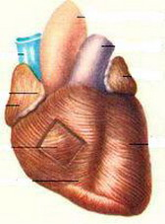

|  |  |  |
| --- | --- | --- |
|  |  |  |

**2.**

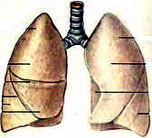

|  |  |  |  |  |  |  |  |
| --- | --- | --- | --- | --- | --- | --- | --- |
|  |  |  |  |  |  |  |  |

**3.**

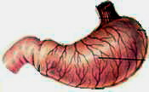

|  |  |  |  |  |  |
| --- | --- | --- | --- | --- | --- |
|  |  |  |  |  |  |

**4.**

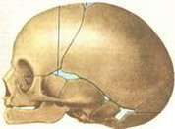

|  |  |  |  |  |  |  |
| --- | --- | --- | --- | --- | --- | --- |
|  |  |  |  |  |  |  |

**5.**

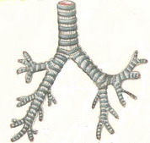

|  |  |  |  |  |  |  |  |
| --- | --- | --- | --- | --- | --- | --- | --- |
|  |  |  |  |  |  |  |  |

**6.**

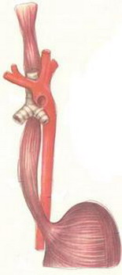

|  |  |  |  |  |  |  |  |  |
| --- | --- | --- | --- | --- | --- | --- | --- | --- |
|  |  |  |  |  |  |  |  |  |

**7.**

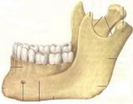

|  |  |  |  |  |  |  |  |  |
| --- | --- | --- | --- | --- | --- | --- | --- | --- |
|  |  |  |  |  |  |  |  |  |

**8.**

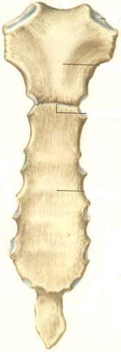

|  |  |  |  |  |  |  |
| --- | --- | --- | --- | --- | --- | --- |
|  |  |  |  |  |  |  |

**9.**

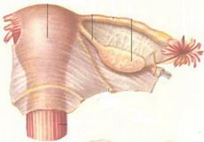

|  |  |  |  |  |  |
| --- | --- | --- | --- | --- | --- |
|  |  |  |  |  |  |

**10.**

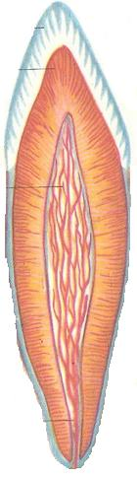

|  |  |  |  |
| --- | --- | --- | --- |
|  |  |  |  |

**11.**

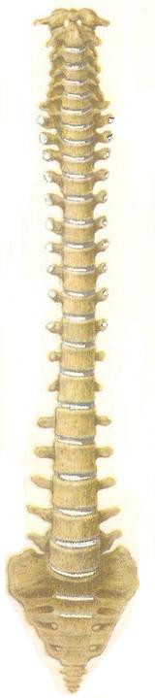

|  |  |  |  |  |  |  |
| --- | --- | --- | --- | --- | --- | --- |
|  |  |  |  |  |  |  |

|  |  |  |  |  |  |  |  |  |  |  |
| --- | --- | --- | --- | --- | --- | --- | --- | --- | --- | --- |
|  |  |  |  |  |  |  |  |  |  |  |

**Задание №2.**

**Для выполнения следующего задания вам необходимо под каждым словом, данным на русском языке, написать его перевод, затем заглавную букву каждого слова по порядку прочитать по вертикали. Впишите то, что у вас получилось в клеточки, расположенные внизу. Если вы сделали все правильно, то у вас получится латинская поговорка. Переведите ее.**

**1. Нос.**

|  |  |  |  |  |
| --- | --- | --- | --- | --- |
|  |  |  |  |  |

**2. Сустав.**

|  |  |  |  |  |  |  |  |  |  |  |
| --- | --- | --- | --- | --- | --- | --- | --- | --- | --- | --- |
|  |  |  |  |  |  |  |  |  |  |  |

**3. Большеберцовая кость.**

|  |  |  |  |  |
| --- | --- | --- | --- | --- |
|  |  |  |  |  |

**4. Мазь.**

|  |  |  |  |  |  |  |  |  |
| --- | --- | --- | --- | --- | --- | --- | --- | --- |
|  |  |  |  |  |  |  |  |  |

**5. Почка.**

|  |  |  |
| --- | --- | --- |
|  |  |  |

**6. Предсердие.**

|  |  |  |  |  |  |
| --- | --- | --- | --- | --- | --- |
|  |  |  |  |  |  |

**7. Кровь.**

|  |  |  |  |  |  |  |
| --- | --- | --- | --- | --- | --- | --- |
|  |  |  |  |  |  |  |

**8. Аорта.**

|  |  |  |  |  |
| --- | --- | --- | --- | --- |
|  |  |  |  |  |

**9. Нерв.**

|  |  |  |  |  |  |
| --- | --- | --- | --- | --- | --- |
|  |  |  |  |  |  |

**10. Аппендикс.**

|  |  |  |  |  |  |  |  |
| --- | --- | --- | --- | --- | --- | --- | --- |
|  |  |  |  |  |  |  |  |

**11. Таблетка.**

|  |  |  |  |  |  |  |  |  |
| --- | --- | --- | --- | --- | --- | --- | --- | --- |
|  |  |  |  |  |  |  |  |  |

**12. Молочная железа.**

|  |  |  |  |  |
| --- | --- | --- | --- | --- |
|  |  |  |  |  |

**13. Эндокард.**

|  |  |  |  |  |  |  |  |  |  |  |
| --- | --- | --- | --- | --- | --- | --- | --- | --- | --- | --- |
|  |  |  |  |  |  |  |  |  |  |  |

**14. Отвар.**

|  |  |  |  |  |  |  |  |
| --- | --- | --- | --- | --- | --- | --- | --- |
|  |  |  |  |  |  |  |  |

**15. Настой.**

|  |  |  |  |  |  |  |
| --- | --- | --- | --- | --- | --- | --- |
|  |  |  |  |  |  |  |

**16. Клетка.**

|  |  |  |  |  |
| --- | --- | --- | --- | --- |
|  |  |  |  |  |

**17. Локтевая кость.**

|  |  |  |  |
| --- | --- | --- | --- |
|  |  |  |  |

**18. Крестец.**

|  |  |  |  |  |  |
| --- | --- | --- | --- | --- | --- |
|  |  |  |  |  |  |

**19. Ключица.**

|  |  |  |  |  |  |  |  |  |
| --- | --- | --- | --- | --- | --- | --- | --- | --- |
|  |  |  |  |  |  |  |  |  |

**20. Мочеточник.**

|  |  |  |  |  |  |
| --- | --- | --- | --- | --- | --- |
|  |  |  |  |  |  |

**21. Прямая кишка.**

|  |  |  |  |  |  |
| --- | --- | --- | --- | --- | --- |
|  |  |  |  |  |  |

**22. Ухо.**

|  |  |  |  |  |
| --- | --- | --- | --- | --- |
|  |  |  |  |  |

**23. Сухожилие.**

|  |  |  |  |  |
| --- | --- | --- | --- | --- |
|  |  |  |  |  |

**24. Рука.**

|  |  |  |  |
| --- | --- | --- | --- |
|  |  |  |  |

**25. Глаз.**

|  |  |  |  |  |  |
| --- | --- | --- | --- | --- | --- |
|  |  |  |  |  |  |

**26. Рецепт.**

|  |  |  |  |  |  |  |  |
| --- | --- | --- | --- | --- | --- | --- | --- |
|  |  |  |  |  |  |  |  |

**27. Плечо.**

|  |  |  |  |  |  |  |  |
| --- | --- | --- | --- | --- | --- | --- | --- |
|  |  |  |  |  |  |  |  |

**28. Масло.**

|  |  |  |  |  |
| --- | --- | --- | --- | --- |
|  |  |  |  |  |

**29. Селезенка.**

|  |  |  |  |  |
| --- | --- | --- | --- | --- |
|  |  |  |  |  |

**Латинская поговорка.**

|  |  |  |  |  |  |
| --- | --- | --- | --- | --- | --- |
|  |  |  |  |  |  |

|  |  |  |  |  |
| --- | --- | --- | --- | --- |
|  |  |  |  |  |

|  |  |  |  |  |  |  |
| --- | --- | --- | --- | --- | --- | --- |
|  |  |  |  |  |  |  |

|  |  |  |  |  |  |
| --- | --- | --- | --- | --- | --- |
|  |  |  |  |  |  |

|  |  |  |  |  |  |
| --- | --- | --- | --- | --- | --- |
|  |  |  |  |  |  |

**ОТВЕТЫ.**

**Задание №1.**

1. **Сердце – cor.**
2. **Легкие – pulmones.**
3. **Желудок – gaster.**
4. **Череп – cranium.**
5. **Бронх – bronchus.**
6. **Пищевод – esophagus.**
7. **Нижняя челюсть – mandibula.**
8. **Грудина – sternum.**
9. **Матка – uterus.**

**10) Зуб – dens.**

**11) Позвоночный столб – columna vertebralis.**

**Задание №2.**

**1) Nasus**

**2) Articulatio**

**3) Tibia**

**4) Unguentum**

**5) Ren**

**6) Atrium**

**7) Sangius**

**8) Aorta**

**9) Nervus**

**10) Appendix**

**11) Tabuletta**

**12) Mamma**

**13) Endocardium**

**14) Decoctum**

**15) Infusum**

**16) Cella**

**17) Ulna**

**18) Sacrum**

**19) Clavicula**

**20) Ureter**

**21) Rectum**

**22) Aurus**

**23) Tendo**

**24) Manus**

**25) Oculus**

**26) Receptum**

**27) Brachium**

**28) Oleum**

**29) Splen**

**Поговорка: Natura sanat, medicus curat morbos.**

**Природа оздоравливает, врач лечит.**