***The Beatles***

The English ROCK MUSIC group The Beatles gave the 1960s its characteristic musical flavor and had a profound influence on the course of popular music, equaled by few performers. The guitarists John Winston Lennon, Oct. 9, 1940; James Paul McCartney, June 18, 1942; and George Harrison, Feb. 25, 1943; and the drummer Ringo Starr, Richard Starkey, July 7, 1940, were all born and raised in Liverpool. Lennon and McCartney had played together in a group called The Quarrymen. With Harrison, they formed their own group, The Silver Beatles, in 1959, and Starr joined them in 1962. As The Beatles, they developed a local following in Liverpool clubs, and their first recordings, "Love Me Do" (1962) and "Please Please Me" (1963), quickly made them Britain's top rock group. Their early music was influenced by the American rock singers Chuck BERRY and Elvis PRESLEY, but they infused a hackneyed musical form with freshness, vitality, and wit.

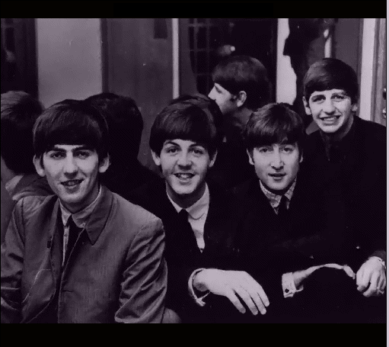

The release of "I Want to Hold Your Hand" in 1964 marked the beginning of the phenomenon known as "Beatlemania" in the United States. The Beatles' first U.S. tour aroused a universal mob adulation. Their concerts were scenes of mass worship, and their records sold in the millions. Their first film, the innovative A Hard Day's Night (1964), was received enthusiastically by a wide audience that included many who had never before listened to rock music.

Composing their own material (Lennon and McCartney were the major creative forces), The Beatles established the precedent for other rock groups to play their own music. Experimenting with new musical forms, they produced an extraordinary variety of songs: the childishly simple "Yellow Submarine"; the bitter social commentary of "Eleanor Rigby"; parodies of earlier pop styles; new electronic sounds; and compositions that were scored for cellos, violins, trumpets, and sitars, as well as for conventional guitars and drums. Some enthusiasts cite the albums Rubber Soul (1965) and Revolver (1966) as the apex of Beatle art, although Sergeant Pepper's Lonely Hearts Club Band (1967), perhaps the first rock album designed thematically as a single musical entity, is more generally considered their triumph. The group disbanded in 1970, after the release of their final album, Let It Be, to pursue individual careers. On Dec. 8, 1980, John Lennon was fatally shot in New York City. In 1991, Paul McCartney's classical composition Liverpool Oratorio was performed to some acclaim in Britain and the United States.

# Igor Popov gr.3.1