*Project*

*Ecological problems in big cities, particular in Moscow. How can a contradiction between the technological progress and ecology be solved from my point of view?*

By

*Anton Litvin*

*Moscow 2004.*

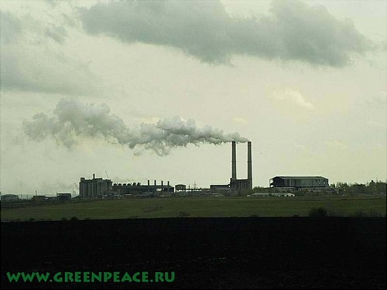

**THE CONTENT:**

1. *The introduction*

*II. Pollution of Moscow environment*

*1. Air pollution.*

*2. Condition of flora and fauna.*

*3. Thermal pollution****.***

*III. Condition of health of the Moscow citizen.*

*IV. Processing of waste products*

*V. How can a contradiction between the technological progress and ecology can be solved?*

***The introduction.***

*We are living in the century of the technological progress trying to open all new and unknown, each day brings us new ideas, each month brings us new technological solutions, people go strait in development new invents and do not look back, do not stop, do not think of the act… All they think about is making their life more convenient for them self. That is why the have forgotten one of the most valuable things– the environment. You see we are living in the symbiosis with nature and we strongly depend on it. I will try to tell in my research work about its problems in my native city Moscow.*

*It was founded in1147by Jury Dolgoruky. During its history it was roughly all developed, and became more beautiful. Now it is one of the largest cities in the world with the population more than 9’000’000 of people. It is obvious, that in Moscow there are environmental problems as radioactive pollution, toxic pollution, air pollution,… just like in other cities. In my research work I shall try to meet you with the ecology of Moscow. And I will also tell you my point of view on it.*

*All figures and data given in my work present as it was taken from the official site of Moscow administration.*

***Pollution of Moscow environment.***

***1 Air pollution.***

*The main problem of Moscow is the pollution of air. Each year atmosphere gets 1.8 million tons of harmful substances 90% from them is due to motor transport, and it is very clean because in my native city 35% of automobiles are more than 10 years old. There motors have fulfilled there term. 94% of all machines are not equipped with special filters to protect environment from harmful gases.*

*The number of automobiles in Moscow is growing from year to year, and ecologists predict that in some years it will plunge in smoke. Whether there is an exit from this situation?*

*The Moscow government has developed the new program. According to it in Moscow new roads and high ways will be constricted. It should solve the problem of transport circulation. On public transport there will be filters putted. And we will come to euro-1 euro-2 standards. It is also planned to develop the electric transport like monorail trains. In November of 2000 year the program “Strategy of struggle against motor transport emissions in Moscow” was accepted by Moscow government. But of course the process will not pass quickly.*

***2 Condition of flora and fauna.***

*A major component of urban terrain is the green massive (parks, urban forests and gardens), birds and animals inhabiting them. The greenery as well as the environmental system, provide comfort of living conditions for people in the city, adjusts to definite limits the gas composition of air and the degree of its pollution, climatic characteristics of urban territories, reduces the influence of noise factor and is a source of aesthetic perception.*

***Urban forests****.*

*In the territory of Moscow there are not less than 36 wood missives. The largest woods massive of Moscow are Лосиный остров – in the city limits, Узкое and Измайлово. In old part of the city, within the boundaries of the Moscow Circular rail road, kept only two relevantly large woods massive: Сокольники and Останкино. The condition of forests as a whole can be described as loosened, that first of all determined by the site of the city limits and, accordingly, level of techno genetic loads.*

*Kept within the Moscow boundary other natural components (moors and rivers) are also in a bad condition, as well as forests they have undergone definite changes as a result of effect of the complex of anthropogenic factors and have lost those or divers qualities and properties, characteristic for natural eco system. These natural components more than woods are subjecting to threat to a full degradation because of their unattended development.*

*The city of Moscow includes green plantations parks (urban specialized), districts and children’s parks, squares and boulevard. The gardening of the streets takes the special place in improvement of an ecological condition of the city. The green plantations should execute one more function protection of terrains of a housing estate against a transport noise.*

***Fauna****.*

*Since 1961 from a structure of a fauna of Moscow 23 kinds have vanished, first of all, by availability in borders of the city large forests and park of missives, bound with forests and parks by a protective belt.*

***Thermal pollution.***

*The analysis of thermal anomalies has shown, that the areas with positive highly and medium contrast by thermal anomalies (temperature rise above background more than 10ºC) are connected to industrial objects and intensive thermal outflow from underground of the water carrying communications.*

*Out come of outflow of ardent water from underground water carryings of the communications, in particular, is the change of a temperature schedule of underground waters.*

***Condition of health of the Moscow citizen.***

*The ecological analyses have shown that 80% of illnesses have arisen in a result of the bad ecological situation in Moscow. Now days in big cities oncology death rate in age grade 40 years; maximum rating the rate of mortality gains in an age-grade of 80-90 years, the oncology death rate of men in age after 45 years exceeds death rate of the women in the same group in 2 times.*

*The most unfavorable situation in the city on a children’s morbidity was added up in central, Eastern, Northwest and Зеленоградском district. The high level of illnesses of respiratory organs is also reiterated there.*

***Processing of waste products.***

*An important problem of a big city is the recycling of waste. Who enjoy living in dump? This problem recently began to get huge values because the development of his industry is accompanied by growth of industrial wastes, and it is not possible to dump all waste products in one big heap, that is why this problem has to be solved somehow.*

*For that in Moscow special factories were built. For example in 1998, factories on processing dust was advanced 423’000 tons of waste products, buried 980’000 tons of waste products. For processing waste we use advanced technologies. The new factory in Чертаново and Котляково is constructed, these factories can process on 40’000 tons per one year, the factory in Рудникого is constructed, but the level of the processed waste is still very low. For example in 1998 at factories it was advanced 6% of waste products, 35%*

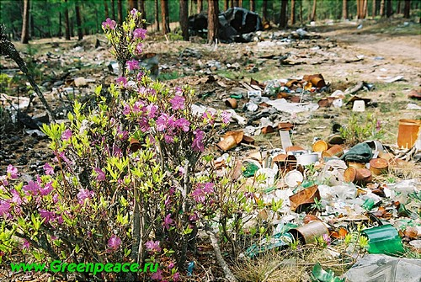

*were buried. Others sent to dumps of the Moscow area. In 1998 it was liquidated 13’000 cases of illegal dumps of the Moscow area.*

*As for me I can see that more and more factories are built and we are not going to sink in a heap of waste products.*

***How can a contradiction between the technological progress and ecology be solved?***

*My survey research claimed that 100% of Moscow citizen want there streets to be cleaned, but only 29.8% of them are ready to pay more taxes to deal with the problem. Next problem is that every third person in the street will through away different kind of liter just in the street for different reasons. From that fact the conclusion is that we should not only think of cleaned streets, we must work on saving them cleaned. That is what we must teach our children if we are not going to live like pigs.*

*The next kind of pollution that we can easily feel on our self is the air pollution.*

*It is not a new for any one that cars, which all we like, are the main cause for it.*

*Some people say that we should better use bicycles, not to pollute the environment; I advise them to live in caves with out electricity and other technological conveniences, to protect the environment. But there are much more useful ideas of saving our planet and there is one thing which sums them up: - The main idea is that technology must help us to protect the environment which has already suffered from it. From that idea recycling factories were maid, different filters invented, people even started to invent alternative kinds of fuel, which are nearly harm less to the planet, and at least we think so at the moment. There are even cars maid, which are working on new fuel elements, this is how we have called these kind of fuel.*

*Surely we will not be able to use these cars tomorrow and even in the next 10 years, that is why our government must continue working on pollution problems in our country at real time, and we will have to come to euro-3 standard. We must also use special filters in our cars and other last developments in this area.*

*What do you think must be done to make the ecological situation of Moscow better? That is the question which was told to people on line.*

RESULTS   
(24 – 25march) 2004.

|  |  |
| --- | --- |
|  | Total number of people voted : 7178 |
| **:::::::::::::::::::::::::::::** | To get the plants and factories out of the city- 2439 (36%) |
| **:::::::::::::::::::::::::** | There must be much more green plants in the city- 1788 (24%) |
| **::::::::::::::::::::** | The traffic must be limited- 1463 (20%) |
| **:::::::::::::** | We can do nothing already- 939 (13%) |
| **::::::::** | I do not know- 549 (7%) |

Big thanks to the RosBusinessConsulting by which the pool was maid it’s site- www.rbcnews.com

*I think that it shows that 80% of Moscow citizen are interested in making our environment cleaner and that the main things they are interested is the air pollution which was produced by the plants and factories out of the city.*

*It shoes that people sees the problem, but as I have already sad they do nothing to solve It, that is why there must be strict government control on the pollution in big cities like Moscow, government must also think of the recycling of the waste products, and of course much more strict ecological laws must be maid. There must be even Special Forces made to control the pollution in the streets and all these must be not on paper, but in the air we breathe, water we drink, and in the streets we are all walking through.*

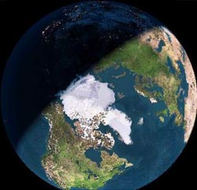

*Our planet needs us as well as we need our planet.*

***THE LIST OF USED MATERIALS.***

***Internet***

***www.ecolife.ru***

***www.greenpeace.ru***

***www.moscow.ru***

***www.rbcnews.com***