##### **Contents**

I. Introduction 2

II. The structure of the foreign exchange market 3

1. What is the foreign exchange? 3

2. The participants of the foreign exchange markets 4

3. Instruments of the foreign exchange markets 5

III. Foreign exchange rates 6

1. Determining foreign exchange rates 6

2. Supply and Demand for foreign exchange 7

3. Factors affecting foreign exchange rates 11

IV. Conclusion 13

V. Recommendations 14

VI. Literature used 16

# 

# Introduction

Trade and payments across national borders require that one of the parties to the transaction contract to pay or receive funds in a foreign currency. At some stage, one party must convert domestic money into foreign money. Moreover, knowledgeable investors based in each country are aware of the opportunities of buying assets or selling debts denominated in foreign cur­rencies when the anticipated returns are higher abroad or when the interest costs are lower. These investors also must use the foreign exchange market whenever they invest or borrow abroad.

I’d like to add that the foreign exchange market is the largest market in the world in terms of the volume of transactions. That the volume of foreign exchange trading is many times larger than the volume of international trade and investment reflects that a distinction should be made between transactions that involve only banks and those that involve banks, individuals, and firms involved in international trade and investment.

The phenomenal explosion of activity and interest in foreign exchange markets reflects in large measure a desire for self-preservation by businesses, governments, and individuals. As the international financial system has moved increasingly toward freely floating exchange rates, currency prices have become significantly more volatile. The risks of buying and selling dollars and other currencies have increased markedly in recent years. Moreover, fluctuations in the prices of foreign currencies affect domestic economic conditions, international investment, and the success or failure of government economic policies. Governments, businesses, and individuals involved in international affairs find it is more important today than ever before to understand how foreign currencies are traded and what affects their relative values.

In this work, we examine the structure, instruments, and price-determining forces of the world's currency markets.

# The structure of the foreign exchange market

## What is the foreign exchange?

The **foreign exchange markets** are among the largest markets in the world, with annual trading volume in excess of $160 trillion. The purpose of the foreign exchange markets is to bring buyers and sellers of currencies together. It is an over-the-counter market, with no central trading location and no set hours of trading. Prices and other terms of trade are determined by negotiation over the telephone or by wire, satellite, or telex. The foreign exchange market is informal in its operations: there are no special requirements for market participants, and trading conforms to an unwritten code of rules.

You know that almost every country has its own currency for domestic transactions. Trading among the residents of different countries requires an efficient exchange of national currencies. This is usually accomplished on a large scale through foreign exchange markets, located in financial centers such as London, New York, or Paris—in order of importance—where exchange rates for convertible currencies are determined. The instruments used to effect international monetary payments or transfers are called foreign exchange. Foreign exchange is the monetary means of making payments from one currency area to another. The funds available as foreign exchange include foreign coin and currency, deposits in foreign banks, and other short-term, liquid financial claims payable in foreign currencies. An **international exchange rate** is the price of one (foreign) currency measured in terms of another (domestic) currency. More accurately, it is the price of foreign exchange. Since exchange rates are the vehicle that translates prices measured in one currency into prices measured in another currency, changes in exchange rates affect the price and, therefore, the volume of imports and exports ex­changed. In turn the domestic rate of inflation and the value of assets and liabilities of international borrowers and lenders is influenced. The exchange rate rises (falls) when the quantity demanded exceeds (is less than) the quantity supplied. Broadly speaking, the quantity of U.S. dollars supplied to foreign exchange markets is composed of the dollars spent on imports, plus the amount of funds spent or invested by U.S. residents outside the United States. The demand for U.S. dollars arises from the reverse of these transactions.

Many newspapers keep a daily record of the exchange rates in the highly organized foreign exchange market, where currencies of different nations are bought and sold. For instance, the *Wall Street Journal* shows the price of a currency in two ways: first the price of the other currency is given in U.S. dollars, and second the price of the U.S. dollar is quoted in units of the other currency. Pairs of prices represent reciprocals of each other. These rates refer to trading among banks, the primary marketplace for foreign currencies.

## 2. The participants of the foreign exchange markets

The foreign exchange market is extremely competitive so there are many participants, none of whom is large relative to the market.

The central institution in modern foreign exchange markets is the **commercial bank**. Most transactions of any size in foreign currencies represent merely an exchange of the deposits of one bank for the deposits of another bank. If an individual or business firm needs foreign currency, it contacts a bank, which in turn secures a deposit denominated in foreign money or actually takes delivery of foreign currency if the customer requires it. If the bank is a large money center institution, it may hold inventories of foreign currency just to accommodate its customers. Small banks typically do not, hold foreign currency or foreign currency-denominated deposits. Rather, they contact large correspondent banks, which in turn contact foreign exchange dealers.

The major international commercial banks act as both dealers and brokers. In their dealer role, banks maintain a net long or short position in a currency, and seek to profit from an anticipated change in the exchange rate. (A long position means their holdings of assets denominated in one currency exceed their liabilities denominated in this same currency.) In their broker function, banks compete to obtain buy and sell orders from commercial customers, such as the multinational oil com­panies, both to profit from the spread between the rates at which they buy foreign exchange from some customers and the rates at which they sell foreign exchange to other customers, and to sell other types of banking services to these customers.

Frequently, currency-trading banks do not deal directly with each other but rely on **foreign exchange brokers**. These firms are in constant communication with the exchange trading rooms of the world's major banks. Their principal function is to bring currency buyers and sellers together.

Security brokerage firms, commodity traders, insurance companies, and scores of other nonbank companies have come to play a growing role in the foreign exchange markets today. These **Nonbank Financial Institutions** have entered in the wake of deregulation of the financial marketplace and the lifting of some foreign controls on international investment, especially by Japan and the United Kingdom. Nonbank traders now offer a wide range of services to international investors and export-import firms, including assistance with foreign mergers, currency swaps and options, hedging foreign security offerings against exchange rate fluctuations, and providing currencies needed for purchases abroad.

In main all participants of an exchange market are usually divided on two groups. The first group of participants is called **speculators**; by definition, they seek to profit from anticipated changes in exchange rates. The second group of participants is known as **arbitragers.** Arbitrage refers to the purchase of one currency in a certain market and the sale of that currency in another market in response to differences in price between the two markets. The force of arbitrage generally keeps foreign exchange rates from getting too far out of line in different markets.

## 3. Instruments of the foreign exchange markets

* Cable and Mail Transfers

Several financial instruments are used to facilitate foreign exchange trading. One of the most important is the cable transfer, an execute order sent by cable to a foreign bank holding a currency seller's account. The cable directs the bank to debit the seller's account and credit the account of a buyer or someone the buyer designates.

The essential advantage of the cable transfer is speed because the transaction can be carried out the same day or within one or two business days. Business firms selling their goods in international markets can avoid tying up substantial sums of money in foreign exchange by using cable transfers.

When speed is not a critical factor, a mail transfer of foreign exchange may be used. Such transfers are written orders from the holder of a foreign exchange deposit to a bank to pay a designated individual or institution on presentation of a draft. A mail transfer may require days to execute, depending on the speed of mail deliveries.

* Bills of Exchange

One of the most important of all international financial instruments is the Bill of Exchange. Frequently today the word draft is used instead of bill. Either way, a draft or bill of exchange is a written order requiring a person, business firm, or bank to pay a specified sum of money to the bearer of the bill.

We may distinguish sight bills, which are payable on demand, from time bills, which mature at a future date and are payable only at that time. There are also documentary hills, which typically accompany the international shipment of goods. A documentary bill must be accompanied by shipping papers allowing importers to pick up their merchandise. In contrast, a clean hill has no accompanying documents and is simply an order to a bank to pay a certain sum of money. The most common example arises when an importer requests its bank to send a letter of credit to an exporter in another country. The letter authorizes the exporter to draw bills for payment, either against the importer's bank or against one of its correspondent banks.

* Foreign Currency and Coin

Foreign currency and coin itself (as opposed to bank deposits) is an important instrument for payment in the foreign exchange markets. This is especially true for tourists who require pocket money to pay for lodging, meals, and transportation. Usually this money winds up in the hands of merchants accepting it in payment for purchases and is deposited in domestic banks. For example, U.S. banks operating along the Canadian and Mexican borders receive a substantial volume of Canadian dollars and Mexican pesos each day. These funds normally are routed through the banking system back to banks in the country of issue, and the U.S. banks receive credit in the form of a deposit denominated in a foreign currency. This deposit may then be loaned to a customer or to another bank.

* Other Foreign Exchange Instruments

A wide variety of other financial instruments are denominated in foreign currencies, most of this small in amount. For example, traveler's checks denominated in dollars and other convertible currencies may be spent directly or converted into the currency of the country where purchases are being made. International investors frequently receive interest coupons or dividend warrants denominated in foreign currencies. These documents normally are sold to a domestic bank at the current exchange rate.

# Foreign exchange rates

## 1. Determining foreign exchange rates

As I’ve already mentioned the prices of foreign currencies expressed in terms of other currencies are called **foreign exchange rates**. There are today three markets for foreign exchange: the spot market, which deals in currency for immediate delivery; the forward market, which involves the future delivery of foreign currency; and the currency futures and options market, which deals in contracts to hedge against future changes in foreign exchange rates. Immediate delivery is defined as one or two business days for most transactions. Future delivery typically means one, three, or six months from today.

Dealers and brokers in foreign exchange actually set not one, but two, exchange rates for each pair of currencies. That is, each trader sets a bid (buy) price and an asked (sell) price. The dealer makes a profit on the spread between the bid and asked price, although that spread is normally very small.

## 2. Supply and Demand for foreign exchange

The underlying forces that determine the exchange rate between two currencies are the supply and demand resulting from commercial and financial transactions (including speculation). Foreign-exchange supply and demand schedules relate to the price, or exchange rate. This is illustrated in **Figure 1**, which assumes free-market or flexible exchange rates.

##### Figure 1

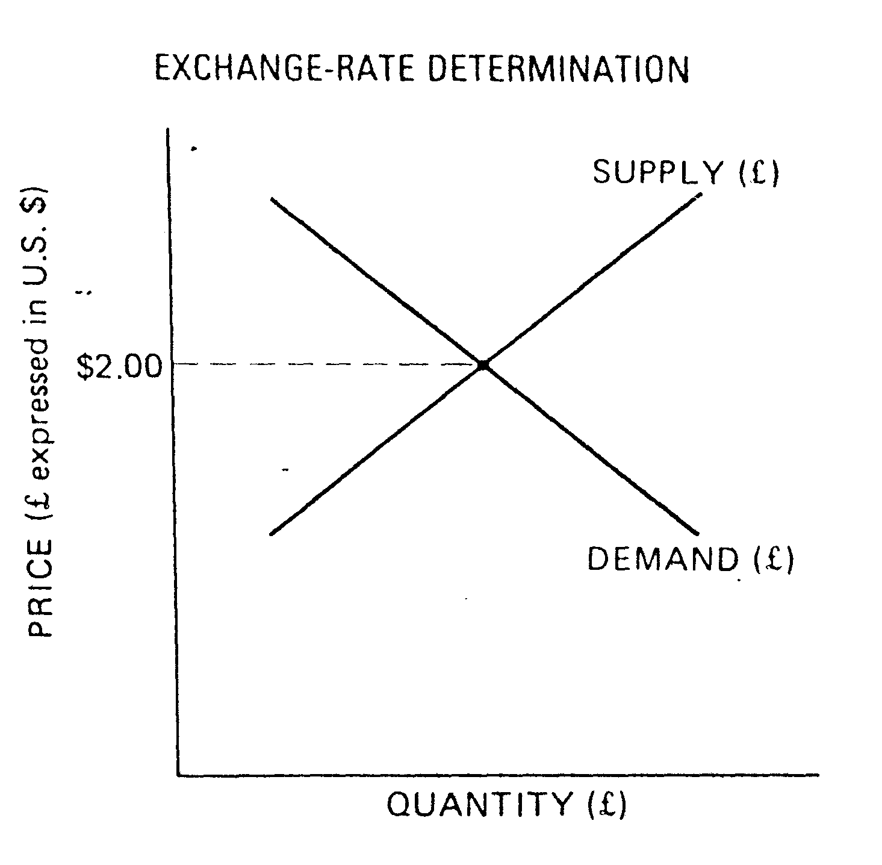

Before examining this figure, we need to define two terms. Depreciation (appreciation) of a domestic currency is a decline (rise) brought about by market forces in the price of a domestic currency in terms of a foreign currency. In contrast, devaluation (revaluation) of a domestic currency is a decline (rise) brought about by government intervention in the official price of a domestic currency in terms of a foreign currency. Depreciation or appreciation is the appropriate concept to deal with floating, or flexible, exchange rates, whereas devaluation or revaluation is appropriate when dealing with fixed exchange rates.

In the dollar-pound exchange market, the demand schedule for pounds represents the demands of U.S. buyers of British goods, U.S. travelers to Britain, currency speculators, and those who wish to purchase British stocks and securi­ties. It slopes downward because the dollar price to U.S. residents of British goods and services declines as the exchange rate declines. An item selling for £1 in Britain would cost $2.00 in the U.S. if the exchange rate were £1/$2.00 U.S. If this exchange rate declined to £1/$1.50 U.S., the same item is $.50 cheaper in the United States, increasing the demand for British goods and thus the demand for pounds. The supply schedule of pounds represents the pounds supplied by British buyers of U.S. goods, British travelers, currency speculators, and those who wish to purchase U.S. stocks and securities. It slopes upward because the pound price to British residents of U.S. goods and services rises as the $ price of the £ falls. Assuming an exchange rate of £1 /$2.00 U.S., a $2.00 item in the U.S. costs £1 in Britain. If this exchange rate declined to £1/$1.50 U.S., the same item is 33 percent more expensive in Britain, decreasing the demand for dollars to buy U.S. goods and thus reducing the supply of pounds. The equilibrium exchange rate in Figure 1 is £1/$2.00 U.S. The amounts supplied and demanded by the market participants are in balance.

##### Figure 2

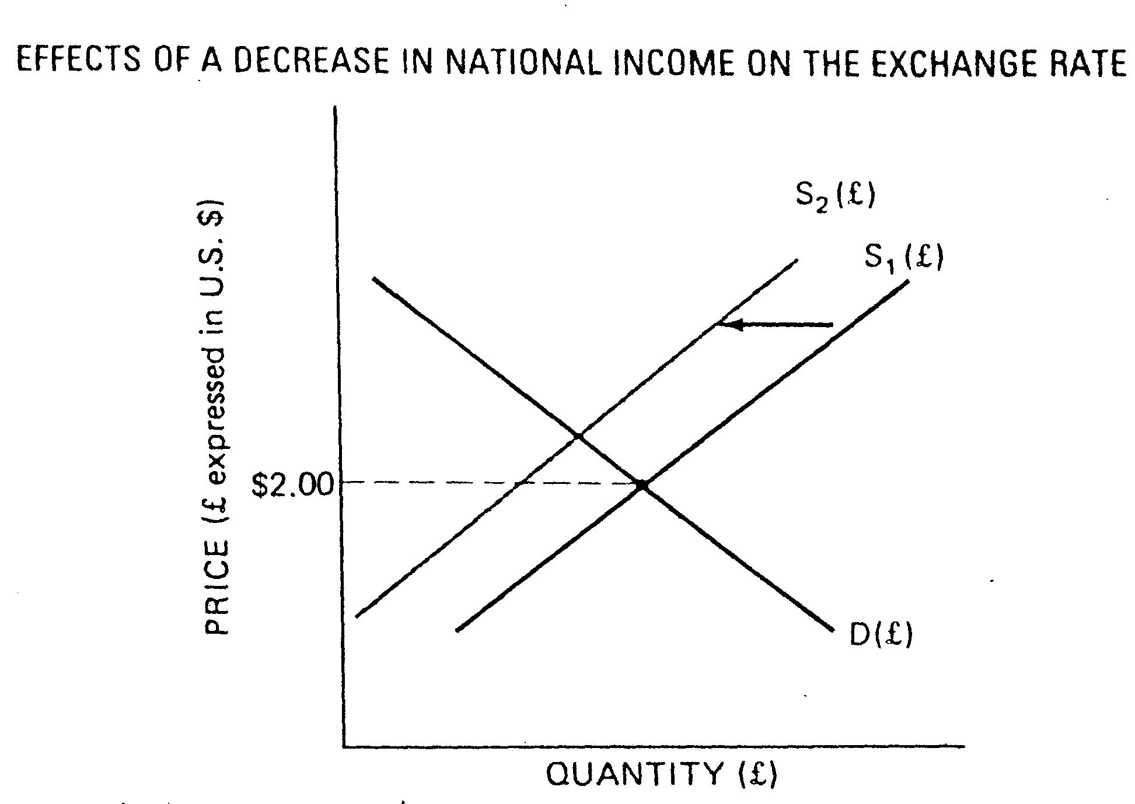

To understand better the schedules, several of the factors that might cause these curves to shift are discussed next. If there is a decrease in national income and output in one country relative to others, that nation's currency tends to appreciate relative to others. The domestic income level of any country is a major determinant of the demand for imported goods in that country (and hence a determinant of the demand for foreign currencies). **Figure 2** shows the effects of a decline in national income in Britain (assuming all other factors remain constant). The decrease in British income implies a decrease in demand for goods and services (both domestic and foreign) by British people. This reduction in demand for imported goods leads to a reduction in the supply of pounds, which is shown by a leftward shift of the supply curve in Figure 2 (from S to S). If the exchange rate floats freely, the British pound appreciates against the U.S. dollar. If the exchange rate is artifi­cially maintained at the old equilibrium of £1/$2.00 U.S., however, a balance-of-payments surplus (for Britain) likely results.



##### Figure 3

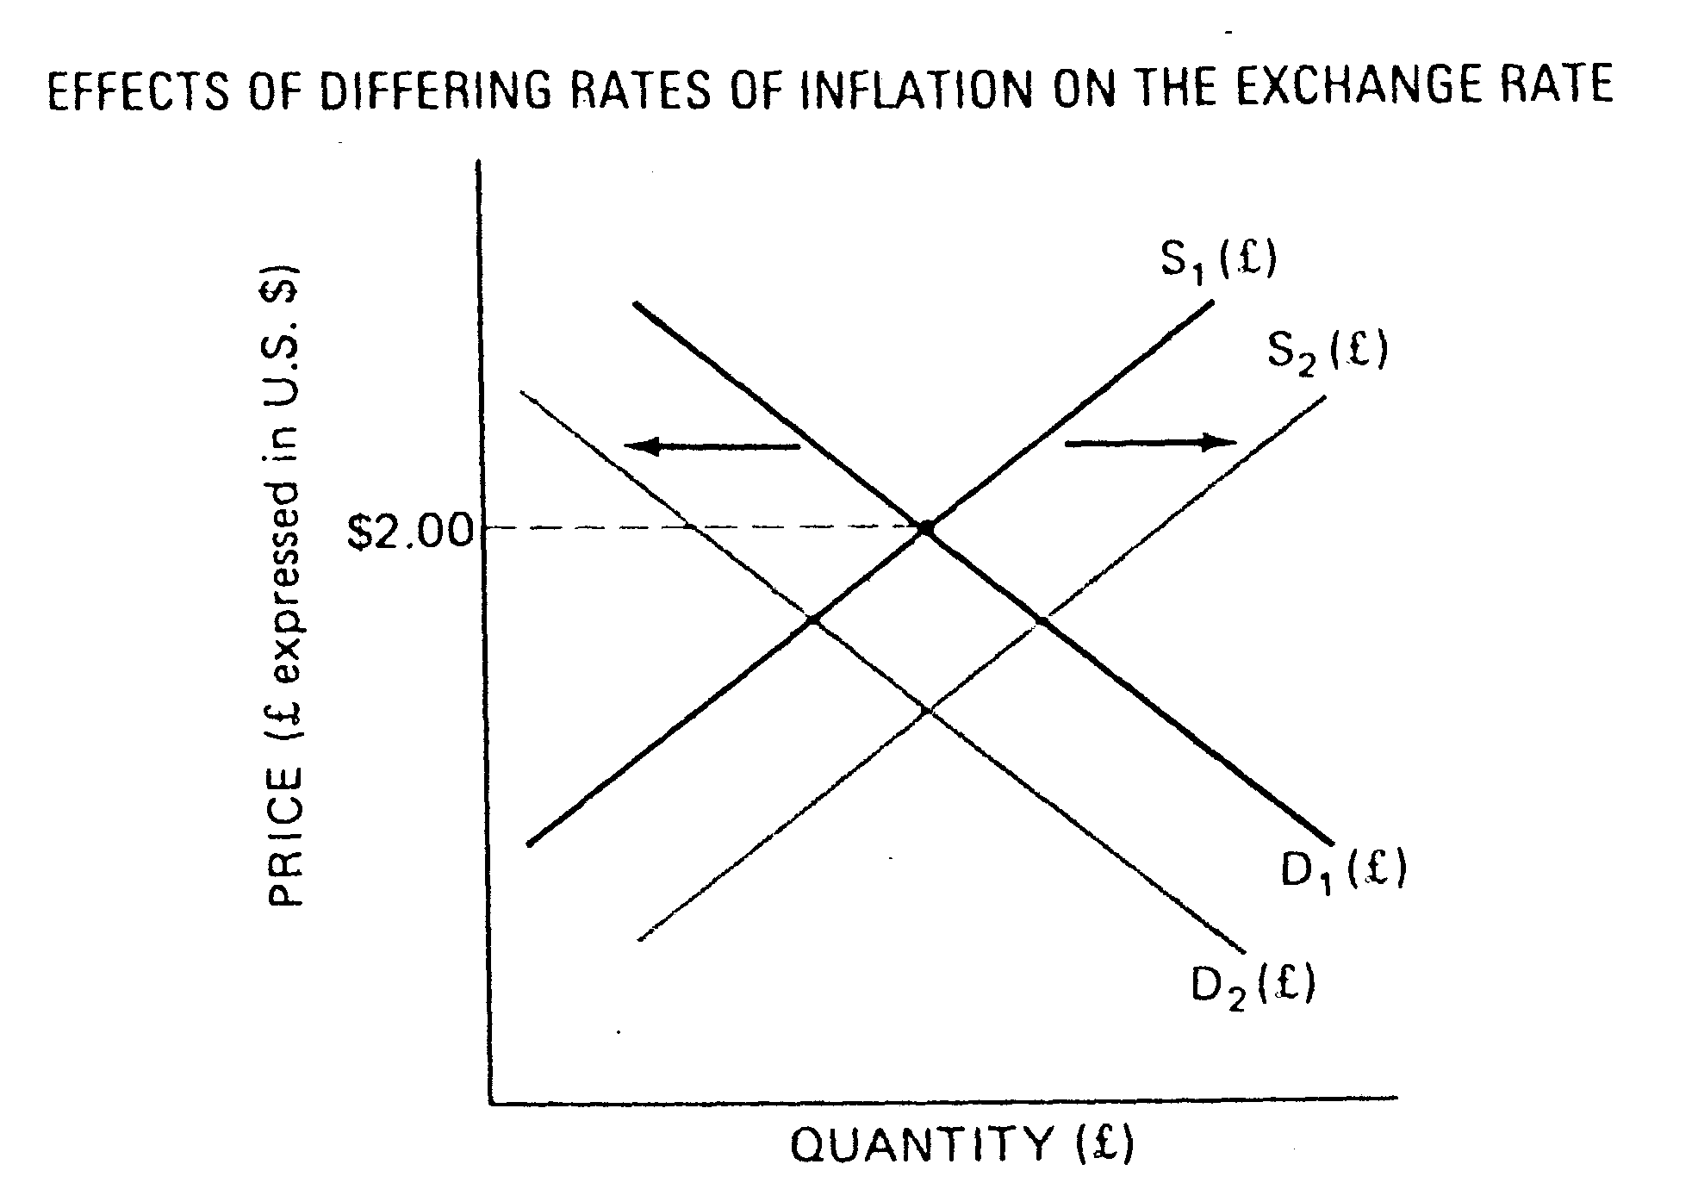

In **Figure 3**, an initial exchange-rate equilibrium of £1/$2.00 U.S. is assumed. Now presume the rate of price inflation in Britain is higher than in the United States. British products become less attractive to U.S. buyers (because their prices are increasing faster), which causes the demand schedule for pounds to shift leftward (D to D). On the other hand, because prices in Britain are rising faster than prices in the U.S., U.S. products become more attractive to British buyers, which causes the supply schedule of pounds to shift to the right (S to S). In other words, there is an increased demand for U.S. dollars in Britain. The reduced demand for pounds and the increased supply (resulting from British purchases of U.S. goods) man­dates a newer, lower, equilibrium exchange rate. Furthermore, as long as the inflation rate in Britain exceeded that in the United States, the British pound would continually depreciate against the U.S. dollar.



Differences in yields on various short-term and long-term securities can influence portfolio investments among different countries and also the flow of funds of large banks and multinational corporations. If British yields rise relative to others, an investor wishing to take advantage of these higher interest rates must first obtain British pounds to buy the securities. This increases the demand for British pounds shift the demand schedule in **Figure 4** to the right (D to D). British investors are also less inclined to purchase U.S. securi­ties, moving the supply schedule of pounds to the left (S to S). Both activities raise the equilibrium exchange rate of the British pound in terms of U.S. dollars.



##### Figure 4

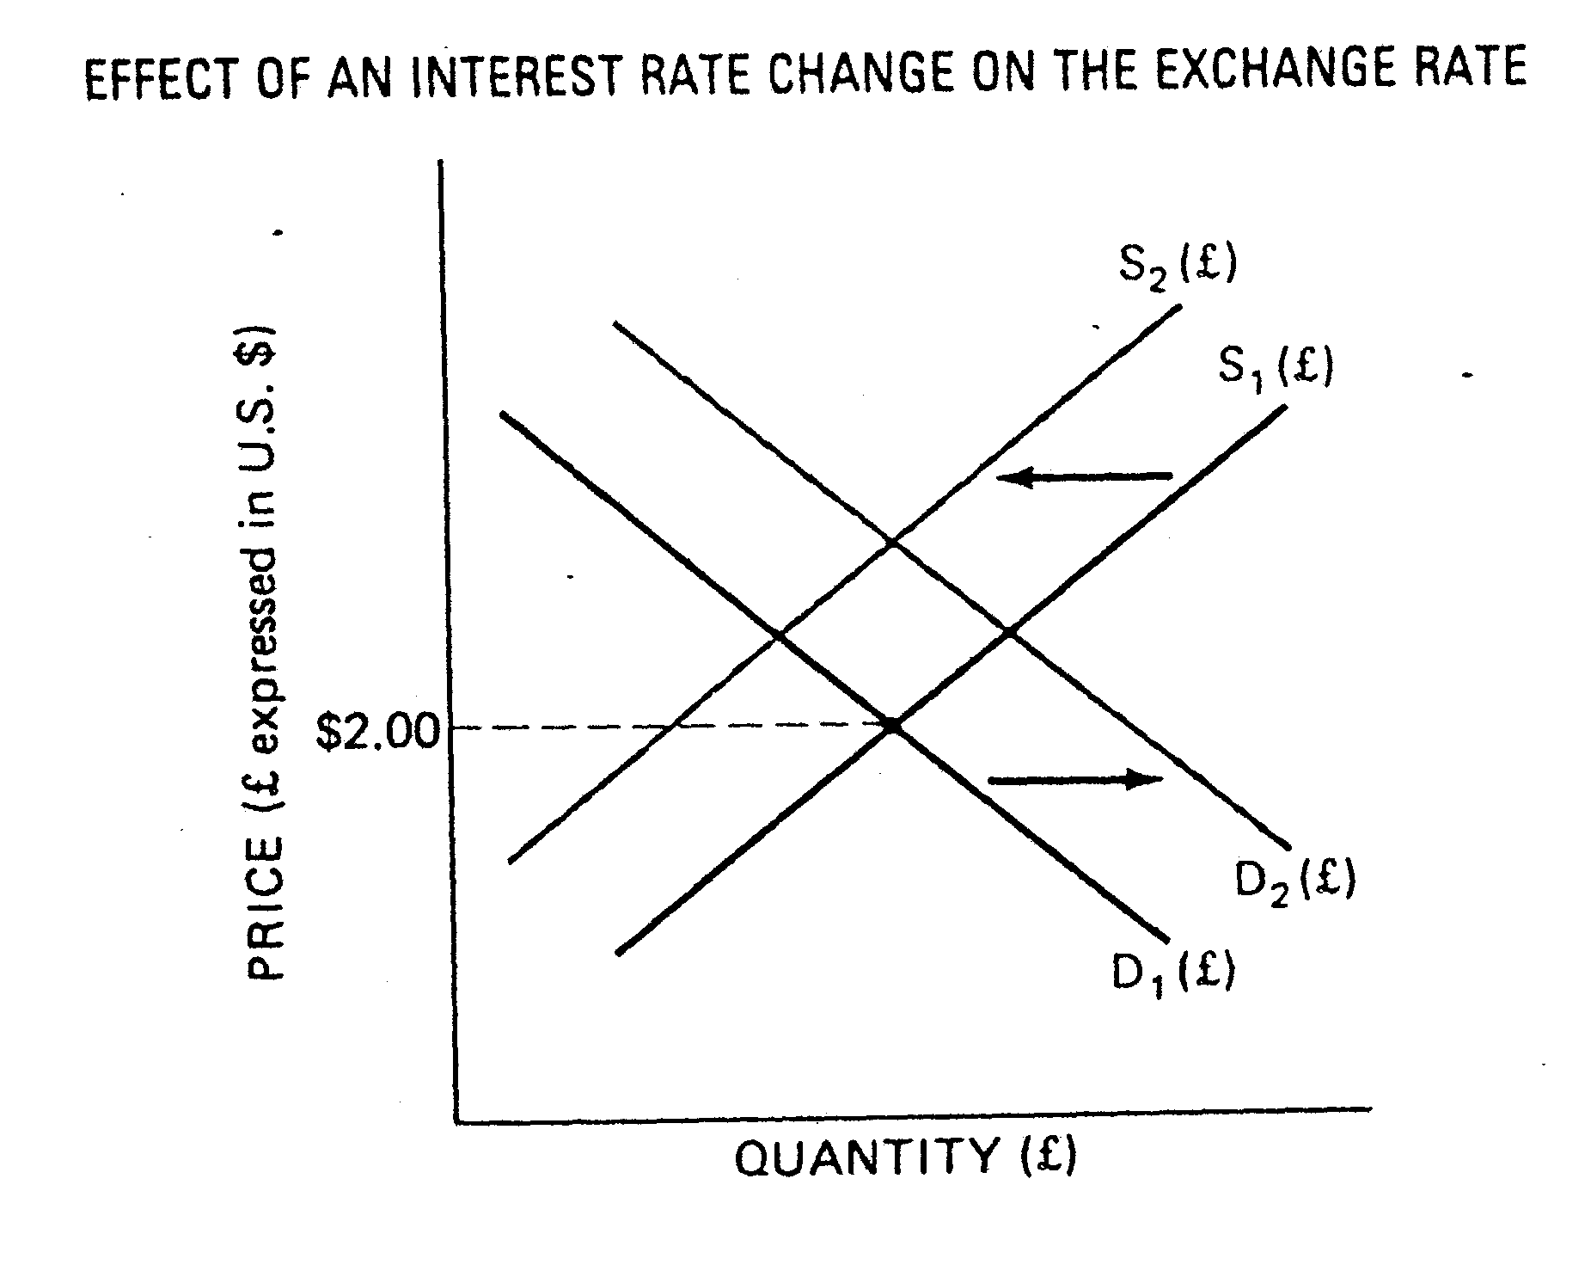

## 3. Factors affecting foreign exchange rates

* **Balance-of-Payments Position**

The exchange rate for any foreign currency depends on a multitude of factors reflecting economic and financial conditions in the country issuing the currency. One of the most important factors is the status of a nation's balance-of-payments position. When a country experiences a deficit in its balance of payments, it becomes a net demander of foreign currencies and is forced to sell substantial amounts of its own currency to pay for imports of goods and services. Therefore, balance-of-payments deficits often lead to price depreciation of a nation's currency relative to the prices of other currencies. For example, during most of the 1970s, 1980s, and into the 1990s, when the United States was experiencing deep balance-of-payments deficits and owed substantial amounts abroad for imported oil, the value of the dollar fell.

* **Speculation**

Exchange rates also are profoundly affected by speculation over future currency values. Dealers and investors in foreign exchange monitor the currency markets daily, looking for profitable trading opportunities. A currency viewed as temporarily undervalued quickly brings forth buy orders, driving its price higher vis-a-vis other currencies. A currency considered to be overvalued is greeted by a rash of sell orders, depressing its price. Today, the international financial system is so efficient and finely tuned that billions of dollars can flow across national boundaries in a matter of hours in response to speculative fever. These massive unregulated flows can wreak havoc with the plans of policymakers because currency trading affects interest rates and ultimately the entire economy.

* **Domestic Economic and Political Conditions**

The market for a national currency is, of course, influenced by domestic conditions. Wars, revolutions, the death of a political leader, inflation, recession, and labor strikes have all been observed to have adverse effects on the currency of a nation experiencing these problems. On the other hand, signs of rapid economic growth, improving government finances, rising stock and bond prices, and successful economic policies to control inflation and unemployment usually lead to a stronger currency in the exchange markets.

Inflation has a particularly potent impact on exchange rates, as do differences in real interest rates between nations. When one nation's inflation rate rises relative to others, its currency tends to fall in value. Similarly, a nation that reduces its inflation rate usually experiences a rise in the value of its currency. Moreover, countries with higher real interest rates generally experience an increase in the exchange value of their currencies, and countries with low real interest rates usually face relatively low currency prices.

* **Government Intervention**

It is known that each national government has its own system or policy of exchange-rate changes. Two of the most important are floating and fixed exchange-rate systems. In the floating system, a nation's monetary authorities, usually the central bank, do not attempt to prevent fundamental changes in the rate of exchange between its own currency and any other currency. In the fixed-rate system, a currency is kept fixed within a narrow range of values relative to some reference (or key) currency by governmental action.

National policymakers can influence exchange rates directly by buying or selling foreign currency in the market, and indirectly with policy actions that influence the volume of private transactions. A third method of influencing exchange rates is exchange control—i.e., direct control of foreign-exchange transactions.

Intervention of a central bank involves purchases or sales of the national money against a foreign money, most frequently the U.S. dollar. A central bank is obliged to prevent its currency from depreciating below its lower support limit. The central bank should buy its own currency from commercial banks oper­ating in the exchange market and sell them dollars in exchange. These trans­actions are effectively an open-market sale using dollar demand deposits rather than domestic bonds. Such transactions reduce the central bank's domestic liabilities in the hands of the public. The ability of a foreign cen­tral bank to prevent its currency from depreciating depends upon its hold­ings of dollars, together with dollars that might be obtained by borrowing. Even if a national monetary authority has the foreign exchange necessary for intervention, its need to support its currency in the exchange market might be inconsistent with its efforts to undertake a more expansive mone­tary policy to achieve its domestic economic objectives.

Also I’d like to say a few words about **currency sterilization. A** decision by a central bank to intervene in the foreign currency markets will have both currency market and money supply effects unless an operation known as currency sterilization is carried out. Any increase in reserves and deposits that results from a central bank currency purchase can be "sterilized" by using monetary policy tools that absorb reserves. There is currently a great debate among economists as to whether sterilized central bank intervention can significantly affect exchange rates, in either the short term or the long term, with most research studies finding little impact on relative currency prices.

# Conclusion

A market in national monies is a necessity in a world of national currencies; this market is the foreign-exchange market. The assets traded in this market are demand deposits denominated in the different currencies. Individuals who wish to buy goods or securities in a foreign country must first obtain that country's currency in the foreign-exchange market. If these individuals pay in their own currency, then the sellers of the goods or securities, use the foreign-exchange market to convert receipts into their own currency.

One from the most important participants of an exchange market is a business bank, which act as the intermediaries between the buyers and sellers. As already it is known they can execute a role speculators and arbitragers.

Most foreign-exchange transactions entail trades involving the U.S. dol­lar and individual foreign currencies. The exchange rate between any two foreign currencies can be inferred as the ratio of the price of the U.S. dollar in terms of each of their currencies.

The exchange rates are prices that equalize the demand and supply of foreign exchange. In recent years, exchange rates have moved sharply, more sharply than is suggested by the change in the relationship between do­mestic price level and foreign price level. Exchange rates do not accurately reflect the relationship between the domestic price level and foreign price levels. Rather, exchange rates change so that the anticipated rates of return from holding domestic securities and foreign securities are the same after adjustment for any anticipated change in the exchange rate.

The major factor influencing to the rate of exchange, is interference of government in the person of central bank in currency policy of the country. The value of a nation's currency in the international markets has long been a source of concern to governments around the world. National pride plays a significant role in this case because a strong currency, avidly sought by traders and investors in the international marketplace, implies the existence of a vigorous and well-managed economy at home. A strong and stable currency encourages investment in the home country, stimulating its economic development. Moreover, changes in currency values affect a nation's balance-of-payments position. A weak and declining currency makes foreign imports more expen­sive, lowering the standard of living at home. And a nation whose currency is not well regarded in the international marketplace will have difficulty selling its goods and services abroad, giving rise to unemployment at home. This explains why Russia made such stren­uous efforts in the early 1990s to make the Russian ruble fully convertible into other glob­al currencies, hoping that ruble convertibility will attract large-scale foreign investment.

# Recommendations

The problem of “laundering” money is essential with regard to the exchange market. I’d like to add that the Russian exchange market comes first in this respect.

The origin of this problem directly is connected with activity of the organized crime: funds obtained in a criminal way are presented as legal capital to introduce them in economic and financial structures of the state. Therefore struggle against “laundering” money is recognized in all countries as one from major means of a counteraction of the organized crime. The sources of “dirty” money are as follows:

international drugs traffic;

mafia’s activity;

illegal trade of weapon.

The use of exchange markets for “laundering” money is not a contingency. This process is promoted by absence of restrictions concerning foreign exchange.

Unfortunately today participation of Russia in international struggle against outline problem is limited by signing of the Viennese convention on struggle against an international drugs trafficking and entering Interpol. The work on struggle against “laundering” money in Russia should start from the very beginning. The process of developing legislation and mechanisms of its application is supposed to give instructions aimed at lawful struggle against “laundering” money, developing bilateral cooperation with countries of European Union, USA and Japan.

# Literature used

1. “Money, banking and the economy” T. Mayer, J.S. Duesenberry, R.Z. Aliber

W.W. Norton & company New York, London 1981

1. “Principles of international finance” Daniel R. Kane

Croom Helm 1988

1. “Money and banking” David R. Kamerschen

College Division South-western Publishing Co. 1992

1. “Money and capital markets: the financial system in a increasingly global economy” fifth edition Peter S. Rose

IRWIN 1994