SALVADOR DALI & SURREALISM

Surrealism (from French surrealisme - supernaturalism) - a modernistic direction in the art, appeared after the First World War in France, during 1920s. Its founders considered surrealism as a way to recognize subconscious, or supernatural. By definition of the founder, and the ideologist of this direction André Breton the surrealism is " the pure mental automatism, the purpose of which is to express, either orally, or in writing, everyday ideas. Surrealism is a dictation of ideas beyond any control of mind, beyond any aesthetic or moral imaginations." (Ades 28) Artists weren’t only creating new style in art and literature, but, first of all, they were modifying the world and life. Surrealists were sure that inconceivable was beginning to incarnate the earth.

The formation of Surrealism takes its roots from Dadaism. The impudent art arisen in conditions of horror and disappointment of the artists before the major catastrophe – the European revolutions (1916-1918). This event shattered Switzerland, Austria, France and Germany. Dadaism basically rejected any positive aesthetic value, and offered an “antiaesthetic” value for everything. For Dadaists everything " reasonable, kind, eternal " had failed, and the world appeared to be unfair, mean, and ugly. The values of Dadaists were to destroy any style of beauty by means of "ugliness". Revolt of Dadaist had somewhat settled in the middle of 1920s. Dadaists mainly relied on “accidental effects” as a main working tool. Artists began dripping paint on canvas, and forming irrational configurations. The surrealistic attitude towards inconceivable, or to the elements of chaos is directly grown from Dadaistic roots. But surrealists trend in art wasn’t simply to destroy, but create through destruction. The bohemian anarchism of Dadaists had a strong affect on Dali, and therefore he became a true follower of their scandalous behavior. (Faerna, 32-40)

Surrealists hunted for unpredicted in order to free from the control of the mind. (For example, they placed a sheet of a paper on rough surfaces and rubbed a paper with dry paints, and received fantastic configurations reminding of thickets of a fantastic wood.) But great masters weren’t satisfied with such primitive methods of painting. They had to achieve internal irrationality or mindless state of mental life. For this purpose, forms of visual self-hypnosis were practiced. They created "bewitching" forces by staring at the movement of fire, or the movement of clouds, or etc. Transition from "mechanical" perceptions to "psychological” (or psychoanalytical) perception, gradually influenced all masters of surrealism. (Descharnes, 8)

Surrealists assembled meetings or "trainings" which were named as sommeils – or "dreams in reality ". They played during these meetings. They were interested in accidental and unconscious semantic combinations, which occurred during "bouts-rimes (word game).” Each of them made a phrase, not knowing about the words made by the other participants of the game. So, once they came up with a phrase "The refined corpse will drink a fine wine " was invented. The purpose of this game was to train to free your consciousness and logic. By doing so they were able to gain chaotic forces from the chasms of subconscious. By this way, ideas of surrealism had really turned into an explosive: destroying everything on its way, shattering any truth or a principle based on a reason, belief, virtue, or ideal beauty. It destroyed beauty that was viewed by radical innovators as art. They viewed life as a synonym of deceit, and lifelessness. Many surrealists did not focus much on techniques of painting, they were interested in the outcome of the painting. The burst of nihilism was formed among young artists during those times. Not having faith in anything, they also drew this “ANYTHING."

Dali’s surrealism, doesn’t present any politics, an intimate life, an aesthetic beauty, a history, or anything else. In his art there is only a Surrealistic Creativity, which transforms everything into something new as it contacts it. Dali painted about everything that was essential for the person of that time. The themes of his painting varied from sexual revolution to preparation of meal. Some of other themes of his paintings were civil war, nuclear explosions, Nazism, Catholic beliefs, science, or classical art. For sane people, Dali’s art was something inconceivable and shocking. Somehow he even built a so-called “surrealistic object,” which was absolutely not suitable for actual use. This was his embodiment of his obsessive ideas, and manias. This object was called “the astral chair.” The chair’s leather coating was replaced by chocolate coating, a door handle was screwed on one leg, and other leg stood on a mug with beer. Surely such a chair would simply collapse by the impact of a door swing, spilling the beer all over the floor, and causing an alarm and confusion for the people around it.

Dali alienated himself from his colleagues. Therefore they turned against Dali. His friends started denying Dali’s art. André Breton after another disagreement with the artist, made an anagram of letters of his name “Avida Dollars – Dollar Thirsty.” He hinted that all that Dali created, had an advertising character, and are directed strictly at making money, and that art itself had no value for him.

Dali sometimes proclaimed to be the only unique surrealist. And at the same time he said that, "Painting is the color photo made by a brush ". But it’s useless to blame Dali for inconsistency, because irrationality – was his value and element of thinking and painting. This method was the true description of Dali’s style both in life, and in art. Dali has literally treated all those ideas, principles, values, and people with whom he associated with impudently, and disrespectfully. He implemented the ideas of surrealism to the extent. Dali is dangerous to the silent human nature; he is dangerous for humans’ "well-being" because he discredits senses and values of human culture. He discredits both religion and godlessness, both Nazism and antifascism, both admirations of art, and avant-guard revolt against them, both belief in the humanity and disbelief in it.

Dali searched for new decisions, and forms of art starting from his childhood. Once, he painted a still life painting with only three colors on an old worn-out door. He used the door instead of canvas. It surprised him that this still-life painting amazed his friends and relatives. It was the image of a handful of the berries put under the sun. Then someone from spectators had noticed, that at cherries were missing tails. The young artist had forgotten to paint them. He quickly ate the berries that he was drawing earlier, and attached the real tails to the still-life painting. He pulls out the woodworms of old door, and attached them to berries, and he created painting with live woodworms and real berry tails. At seeing this, the spectators were overwhelmed.

Having entered the School of fine Arts in Madrid, Dali hoped to find worthy teachers. He hoped to find someone who could teach him the sacred craft of drawing, but he very soon got disappointed. He publicly declared that he didn’t want to be tested by those teachers who "knew almost nothing, and incapable of anything.” Therefore he got expelled from the art school. He admired the great masters of Italian Renaissance. He explained how his surrealistic creativity began. He wrote, "The inevitable happened -here comes Dali. The core surrealist, moved by "will and authority." He proclaimed unlimited freedom from any aesthetic or moral compulsions, and declared that it is possible to go up to the extreme limits of any artistic experiments, as long as you don’t care about any consequence. (Gibson, 6-9)

All this wasn’t only his private affair; it was the purpose of surrealism. Dali truly was the surrealist to the core. Everything he touched or spoke about turned into surrealistic images. Dali in his life mainly focused on his surrealistic "ego.”

The artist has created some sort of "password" that led to the secrets of his creativity and personality. His masterpieces and graphic works are constructed like texts. In his works, he presents the history of World’s culture as a series of metaphors. And same kinds of citations are applicable to his masters of the past. In his painting "Spain", we see the resemblance to Leonardo da Vinci’s drawings. And in his portraits and still-life drawings we can relate to Italian painter of XVI century Arcimboldi Giuseppe. (Descharnes, 27)

Dali perfectly managed to change the format of an art on an easel painting. The extended horizontal canvas are full of narration, that contain consecutive display of metamorphosis ("Metamorphosis of Narcissus." Oil on canvas, 20 1/8x30 3/8 inches, 1937)

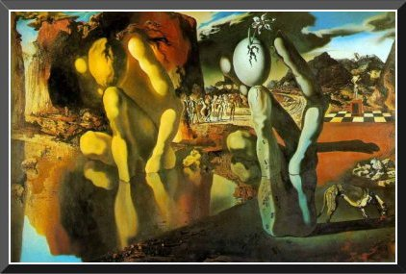

The vertical stretched canvas changes the dynamics of the picture, adding solemnity to it Dali thought that horizon in the paintings were very essential.” The low horizon gives an image some sort of theatrical look (for example, "The Sacrament of the Last Super.” Oil on canvas, 65 5/8x105 ½ inches, 1955)

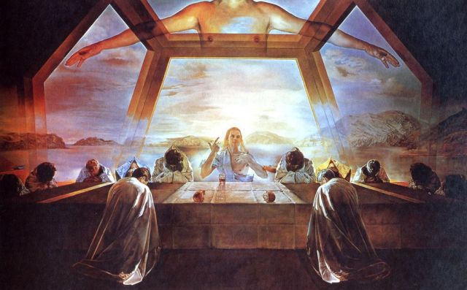

In his compositions with high horizon, the features close to the folklore beginning are seen. The images have ornamental - symbolical character. The artist loved big canvases. His wide canvases are similar to those of medieval masters. The main value of works of Dali consists of creation of magnificent picturesque and graphic images. The artist presents himself in his paintings, as the refined colorist, brilliant painter, master of complexity, and yet architectonically conceivable painter (Ades, 17). Those paintings, in which Dali transforms the sign into artistic images, are authentic masterpieces of paintings and graphics. The tragic gift of Salvador Dali has found its bright reflection in his one of the most famous painting called " Soft construction with boiled beans – Premonition of Civil War." (Oil on canvas, 29 5/16x39 3/8 inches, 1936)

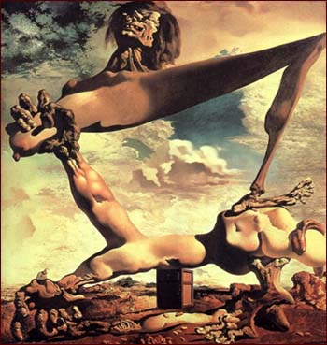

The background of the painting is covered with cloudy sky. There is an inconceivable figure that has human body parts, and the face that is in total agony. The hand is holding the breast that doesn’t have a body, it has a head, and a neck with inflated veins, and from there onward comes a leg that is standing on the other part of human body that stretches out diagonally. And in the middle of this diagonally stretched body part, there is a small locker – a design that Dali frequently presented in his paintings as an illusion of stability of ordinary life. There are beans all over the ground, and an ordinary man, near this figure looking down to the ground. The horizon is given low in this picture, covering only small part of the ground. The picture has an enormous anti-war pathos. It has a very expressive message in its composition, contrast color combinations, and a linear composition.

The unusual gift of Salvador Dali, his overwhelming creativity makes him a genius of his age. His art presents the humanistic symbol of his century. Surrealism is not an artistic movement; it is an artistic thinking of how to interact with world. When one journalist asked Salvador Dali “what the surrealism was, Dali answered that Surrealism is Dali himself, and he had a full right to say so.

Works Cited

Ades, Dawn. *Dali’s optical Illusion.* Wadworth Athenaeum Museum of Art in association with Yale University Pres Ney Haven and London, 1999.

Descharnes, Robert. *Dali.* Harry N. Abrams Publishers, New York 2000

Faerna, Jose Maria, ed. *Dali.* Trans. Teresa Waldes. Harry n. Abrams, Inc., Publishers 2000.

Gibson, Ian. *The Shameful life of Salvador Dali*. W. W. Norton & Company:

New York, 1998.