**Plan:**

1. The “unknown land” of Asia – India.
2. Early Indian Civilization.
3. Key Features of Indian Society.
4. Religion and the Indian way of life.
5. Lack of Political Unity.
6. India’s literature represented by Mahabharata and Ramayana.
7. Customs in India – the practice of self-immolation by fire.
8. The role of muslims in India’s life.
9. Taj Mahal.
10. Art of India.

The “unknown lands” of Asia and Africa have fascinated Westerners for centuries. The Orient, with her silks and her unique cultures, has attracted travelers since early days. Despite the contacts, between Asia and Africa remained virtually unaffected by Western influences until the twentieth century.

India is a land of great diversity, in its topography (the physical features of a land), climate, and population, it is a study in contrasts. This triangular subcontinent extends from southern Asia into the Indian Ocean, forming a giant Pennsylvania. It’s terrain varies from subtropical rain forest to barren deserts, from low coastal plains to the highest mountain range in the world, the Himalayas. Between the rugged mountain regions in the north and the coastal plains and tropical plateaus of the south lie fertile valleys watered by two great river systems, the Indus and the Ganges. Like the Mesopotamian and Egyptian cultures, the earliest Indian civilization began along riverbanks. The first inhabitants of India settled in river valleys along the Indus and Ganges rivers.

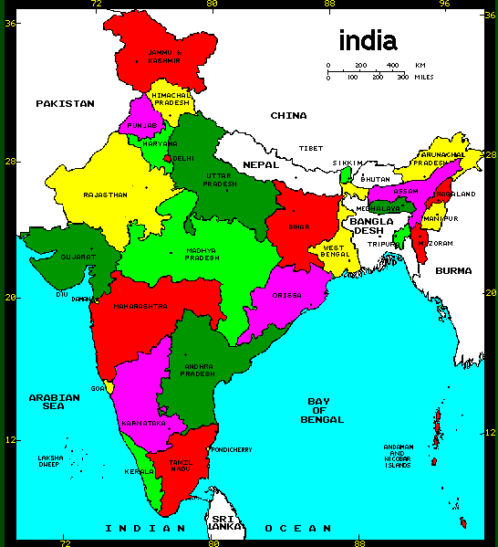

These people must have felt secure from invaders and foreign influences. They were protected by tall mountain ranges in the north and by seas on the east and west. But despite these natural barriers, India did not remain an isolated land.

Throughout her history, merchants, foreign invaders and Wandering tribes crossed the mountains along India’s northwestern border and settled in the fertile river valleys. As a result, India became a land of diverse elements. Within Indian Society, a unique culture developed.

# **Early Indian Civilization**

India derives its name from the Indus River, along whose fertile banks the earliest Indian civilization flourished (ca 2300 BC). Much of our limited knowledge of this civilization has come from excavations of two of its leading cities: Mohenjo – Daro and Harappa. These carefully planned cities had wide, straight streets lined with brick houses. Evidence indicates that, these cities had elaborate drainage and sewer systems, which were more advanced than those in most, modern Indian Villages.

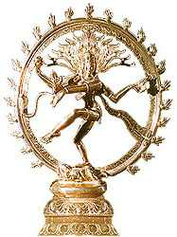

Although a great distance separates India and the Near East, the early inhabitants of India carried on trade with Egypt and Mesopotamia. From archeological evidence it is known that the Indus civilization ended suddenly – perhaps by flood on by enemy invasion. It was at this time that a warlike people called the Aryans migrated into the Indus Valley.

The Aryans were a fair-skinned people who came from central Asia sometime after 1500 BC and subdued the non Aryan people of northwest India. Many historians believe that the Aryans were related to tribes that were invading the Near East Greece and Rome about the same time. The Aryans were herdsmen; they kept large numbers of cows and horses. Although they left behind no cities as the Indus civilization did, they did establish a new language in India – Sanskrit.

Our knowledge of the Aryans and their influence on Indian society comes not from archaeology, but from a collection of religious literature known as the Vedas, meaning “knowledge”. Preserved in the Vedas are early traditions and religious beliefs of the Indians, which were passed down orally from one generation to the next. From Sanskrit literature, we gain insights into the Aryan way of life, which became the basis of Indian culture and tradition.

# **Key Features of Indian Society**

India has one of the oldest cultures in the modern world. The basic characteristics of Indian society, described in the Vedas, have changed little from ancient to modern days.

## Joint-Family

The family has always been one of the most important social units in India. The extended or Joint-Family included the children, grandchildren wives, and close blood relatives of a common ancestor. The oldest male of the group was the dominant authority over the family. When married, sons did not establish their own homes; instead they remained in their father’s or grandfather’s household. Each family member had his own duties and obligations. The interests of the family came before those of the individual family members.

Parents chose the husbands or wives for their children in order to maintain the family’s position and honor in society.

### Caste

Imagine living in a country in which your status in life was determined the moment you were born. India was such a country. Her population was divided into rigid social groups called castes. The Indians formulated strict rules governing the life of the members of each caste group: where they lived, what they did (profession), what they wore, what and with whom they could eat, as well as, whom they could marry.

India had between two and three thousand different castes and subcastes. Each one fell into one of four broad “class” groups. The most important group was the priests, called the Brahmans.

Next in rank were the rulers, and warriors, followed by the merchants and traders. The lowest class group was the sudras – composed of servants and serfs. Outside the caste system and at the bottom of the Indian social ladder were the outcastes, or “untouchables”, for mere contact with them was thought to bring defilement. While anyone could improve his status within his caste system there was little change in the village and family life of India.

This fact explains in part why Indian society remained nearly the same for thousands of years.

#### Religion and the Indian Way of Life

Religion has played a dominant role in shaping Indian culture. From India came two pagan religions that have had a major impact on Asian culture: Hinduism and Buddhism.

## Hinduism

Hinduism is ingrained in the Indian way of life. It developed from the early culture and traditions of India: her social structure, literature, arts and customs. It has not only preserved the traditional elements of Indian’s past but also served as a unifying influence in India’s diverse society.

Because Hinduism has no formal statement of doctrine, it was able to absorb into its system of belief a wide variety of gods and religious concepts found among the many of the people of India. The majority of people in India are Hindus.

The basic tenets of Hinduism are found in the religions literature of ancient India, namely the Vedas and the Upanishads. Hindus believe that a great god called Brahman permeates everything in the universe. The Hindus acknowledge many gods; all deities, however, are considered only manifestations of the eternal, unchanging Brahman .

Since Brahman is not a personal being, he is often referred to as the great soul or world soul. The ultimate purpose and goal of man according to the Vedas, is to reunite his soul with the world soul. This reunification is accomplished through the process of reincarnation, in which a man’s soul passes through many states (or rebirths) before it escapes the physical world and unites with Brahman. This cycle of rebirths is called the wheel of life.

The Hindu believes that a person’s deeds in this life determine his status in the next. If he has lived a good life, then he will move to a higher caste in the next life. The soul of an evil person may be reborn into a lower caste or even into some form of animal life. By observing the religious ritual and ceremonies prescribed by the Hindu priests and by fulfilling the duties and obligations of his caste a Hindu believes that he can ultimately gain release from the “wheel of life” and attain union with the world soul.

Buddhism.

India was also the birth of Buddhism. The founder of this new religion was Siddhartha Gautama later know as Buddha, the Enlightened One”.

At the age of twenty-nine, Gautama became troubled over the world. He became convinced that he should devote all his efforts to find the way of deliverance from suffering. Therefore, he renounced his wife and child, and set out to find peace and true happiness. After six frustrating years, living as a hermit in self-sacrifice and meditation, Gautama was at the point of despair. Sitting down under a tree, he vowed that he would not move until the truth came to him. According to Gautama, he was pondering the questions of life when he realized the truth and attained enlightenment. Central to Buddha’s teaching are his Four Noble Truths: 1) suffering is part of all existence; 2) suffering has a cause – selfish desires. As long as man has a craving for pleasure, possessions, and power, he will have sorrow and misery; 3) suffering can be overcome by destroying selfish desires. 4) If man follows the Eightfold Path, he will destroy selfish desires and end all suffering. This pattern for living includes correct beliefs, intentions, speech, conduct, livelihood, effort, thoughts, and meditations.

Buddhism is a religion built upon works and moral behavior. Buddhists believe that man does not need the help of the gods or membership in a higher caste in order to obtain freedom from suffering. Once a man has absolutely freed himself from his selfish craving, he will no longer be reborn but will enter into Nirvana – the state of absolute peace and happiness, where he loses himself in the world soul.

#### Lack of Political Unity

While many aspects of Indian Society have remained the same for centuries, the political history of India has been one of constant change. Through much of her history India has been little more than a patchwork of small rival kingdoms. Successive waves of foreign invaders have streamed into the Indian Subcontinent. The powerful empires established by these invaders have provided brief periods of Unity and stability for the Indian peoples.

#### Mauryan Empire

In 326 B.C. Alexander the Great threatened India. His armies crossed the Indus River and conquered many small kingdoms in India’s northwestern region. Alexander intended to advance further into India, but when his army refused to continue, he had to turn back. According to traditional accounts, he met a young man named Chandragupta Maurya while in India. As Alexander’s empire began to disintegrate after his death, Chandragupta conquered the disorganized and weak kingdoms in the north and created the first strong empire of India – The Mauryan Empire.

The most famous of the Mauryan rulers was Chandragupta’s grandson Asoka. He extended the Mauryan Empire to include all but the southern tip of India. Sickened by the results of his own bloody conquests, Asoka renounced war and became a convert to Buddhism. He spent much of his reign promoting the Buddhist religion.

Asoca is created with building thousands of Buddhist shrines called steepas. He also had Buddhist teaching inscribed on stone pillars still stand, providing valuable information concerning Asoca’s reign.

One of his most far-reaching acts was the sending of Buddhist missionaries abroad. Buddhism soon spread across much of Southeast Asia, where it became a powerful force in other Asian cultures. It did not gain a wide following in India, however.

Hindu priests viewed Buddhist teaching as dangerous to the caste system. Fearing that they might lose their prestige and rank in society, they worked against the acceptance of Buddhist beliefs.

#### Gupta Empire

##### The first great period of Indian unity was short-lived. Not long after Asoka’s death (232 B.C.), the Mauryan Empire collapsed. The years between the second century B.C. and the third century A.D. Witnessed new invasions and the rise of small competing kingdoms. However, during this time of turmoil, India did enjoy a profitable trade with Rome and China.

Even so, it was not until the fourth century A.D. with the rise of the Gupta Empire, that India entered a new, and perhaps her greatest, era of prosperity and achievement.

One historian has stated that “at the time India was perhaps the happiest and most civilized region of the world”. The rulers of the Gupta dynasty reunited northern India under a strong and effective government. Trade flourished and the people prospered materially. India’s culture spread throughout Southeast Asia. Her universities attracted students from all over the continent, and she made great strides in the fields of textiles and finest periods of Indian art, architecture, literature and science.

Gupta literature became renowned for its adventurous and imaginative fables and fairy tales.

The foremost Indian poet and dramatist of this period was Kalidasa, whose plays have earned him the title “the Indian Shakespeare”. The popularity of various Indian Stories soon spread outside India, where many of them found their way into the literature of other lands.

But Indian literature is represented by **Mahabharata and Ramayana**.

Mahabharata is one of the two great Sanscrit epics. It’s the story of the Great Bharata War, a fratricidal war of succession between the Kaurava and Pandava cousins (descendants of Bharata) in which nearly all the kings of India joined on one side or the other. The Kauravas were destroyed and the Pandavas attained sovereign power but in the end the eldest.

(Yo) Yudhishthira, renounced the throne and with his four brothers (heroes of the war) and Daraypadi (the joint wife of all 5) parted for Mount Meru, India’s heaven. Mahabharta is the longest poem in the World (2.20.000 lines). It is perhaps 15 centuries old and is written in classical Sanscrit. It consists of 18 books with a supplement, the Harivamsa – a poem of 16.375 verses written by different people in different times, and of a much later date, which has nothing to do with the main theme.

Book III Ch.313

**“The Mahabharata”**

The following represents a selection of the questions and answers that passed between the Spirit and Youdhishthira:

1. “What is greater than Earth? What is higher than heaven?” “Mother is greater than Earth; father is higher than heaven.”
2. “In what one thing is all dharma summed up? What single thing constitutes all fame? What sole means takes one to heaven?” “Skill in the discharge of one’s duties sums up all dharma; giving sums up all fame; truthfulness is the sole road to heaven and good conduct is the one means to happiness”.
3. “What is the foremost wealth?” “Learning”.
4. “What is the best gain?” “Health”.
5. “What is the supreme happiness?” “Contentment”.
6. “What is superior to all other dharmas in the world?” “Benevolence”
7. “Whose control leads to absence of sorrow?” “The control of mind”.
8. “Which friendship ages not?” “That with good souls”.
9. “By abandoning what thing does man become rich?” “Desire”.
10. “By giving up what, does one become happy?” “Avarice”.
11. “What is penance?” “Penance is the observance of one’s own obtained duty.”
12. “What is self –control?” “Control of the mind”.
13. “What is forbearance?” “Putting up with opposites”. (pleasure and pain, profit and loss)
14. “What is shame?” “Aversion to do reprehensible act is shame”.
15. “What is straight forwardness?” “Equanimity”.
16. “Who is the enemy hard to be won?” “Anger”.
17. “What is the endless disease?” “Avarice”.
18. “Who is said to be a good man?” “He who is benevolent to all things”.
19. “Who is a bad man?” “He who is barren of sympathy”.
20. “What is the best path?” “To cast away all mental dirt”.
21. “What is gift?” “Protection of life”.
22. “What is the wonder of the world?” “Every day live beings enter the abode of death; those who remain think that they will survive; what greater wonder is there than this?”
23. “What is the news of the world?” “With Earth as the pot, the firmament as the covering lid, the sun as the fire, day and nights as faggots and the seasons and months as the stirring ladle. Time cooks all beings; this is the great news”.

*Extract from Mahabharata*

Romayana (adventures of Rama) is the earliest of the two great Sanscrit epics, the incidents of which precede the Mahabharata by about 150 years. Rama was a king before he became translated into a deity. In course of time, his story and epic became sacred and the belief became established that spiritual and other blessings would be conferred on its knowers ramayana became popular in India in every Hindy home. The story is told in 7 books (96 000 lines).

At instigation of his second queen Dasaratha sends Rama, his eldest son, into exile for 14 years. He is accompanied by Sita, his young Wife and Lakshmana, his younger brother, when they are living happily in the forest, Sita is abduced by Ravana (King of Lanka) Rama and Lakshmana go through many adventures, battles, etc in their pursuit of Ravana, in which they’re assisted by Sugriva, the monkey king and his general, Hanuman. Eventually, Lanka is stormed and set fire to by Hanuman; Ravana is killed; Sita is rescued and victorious party returns to Ayodhya, their capital city. Later because her chastity is suspected (because she stayed in Ravana’s house), Sita proves her innocence voluntarily undergoing an ordeal by fire.

Rama accepts her but for the same reason banishes her (again) the next time. She goes away to Valmiki’s ashram, where her twin sons are born and brought up. She prays to the earth goddess to take her away if she is innocent who seated on her throne appears out of the earth and seating Sita on her lap takes her away for good.

The epics Ramayana and Mahabharrata arose to supplement and reinforce the teaching of the Vedas, particularly in respect of the moral, religious and spiritual ideas of men and women. Since remote times, the two epics have been the two eyes of the nation guiding it and holding up before it the ideas of the truth and righteousness of Rama and Yudhishthira and of chastity and wifely devotion of Sita, as also of the negative example of Ravana and other characters who came to grief because of their lust, avarice and wickedness.

These epics were expected to fulfil the mission of placing before the people examples of how virtue triumphed and vicefell.

This was also an age of advance in mathematics, science, and medicine. Our so called Arabic numerals originally came from India. Indian mathematicians were among the first to use negative numbers, the decimal, and the zero. Centuries before Isaac Newton, Indian Scientist developed their own theories of gravity. Indian astronomers knew that the earth was round and that it rotated on its axis. If in need of medical attention, the people of the Gupta Empire could go to free hospitals where Indian physicians were able to perform many surgical procedures and mention 300 different operations and 20 instruments.

**Customs in India**

India has many customs. The practice of self-information by fire has a strange and terrible place in the lore of India, and it brings to mind the practice of suttee, widow burning. This barbaric survival of ancient customs lasted in India to a late day.

In 1817 there were 706 cases of suttee in Bengal alone. This was at a time when the British authorities were making efforts to stop the practice. They were afraid to prohibit window burning entirely in the face of fanatical.

Hindu addiction to tradition, and resorted to intensive persuasion. No suttee was permitted until the prospective, victim had been examined by a magistrate, who made sure that she was proceeding of her own free will and urged her to give up her ghastly intention.

The great source of information in that period is a massive volume “Hindu Manners, Customs and ceremonies” by the Abbe Dubois, a French missionary who spent years in India at the end of the eighteenth century and the beginning of the nineteenth. He writes:

*The last king of Tanjore, who died in 1801, left behind him four lawful wives. The Brahmins decided that two of these should be burnt with the body of their husband, and selected the couple that should have the preference. It would have been the everlasting shame to them and the grossest insult to the memory of the deceased had they hesitated to accept this singular, honor, so they seemed perfectly ready to yield to the terrible lot which awaited them. The necessary preparations for the obsequies were completed in a single day.*

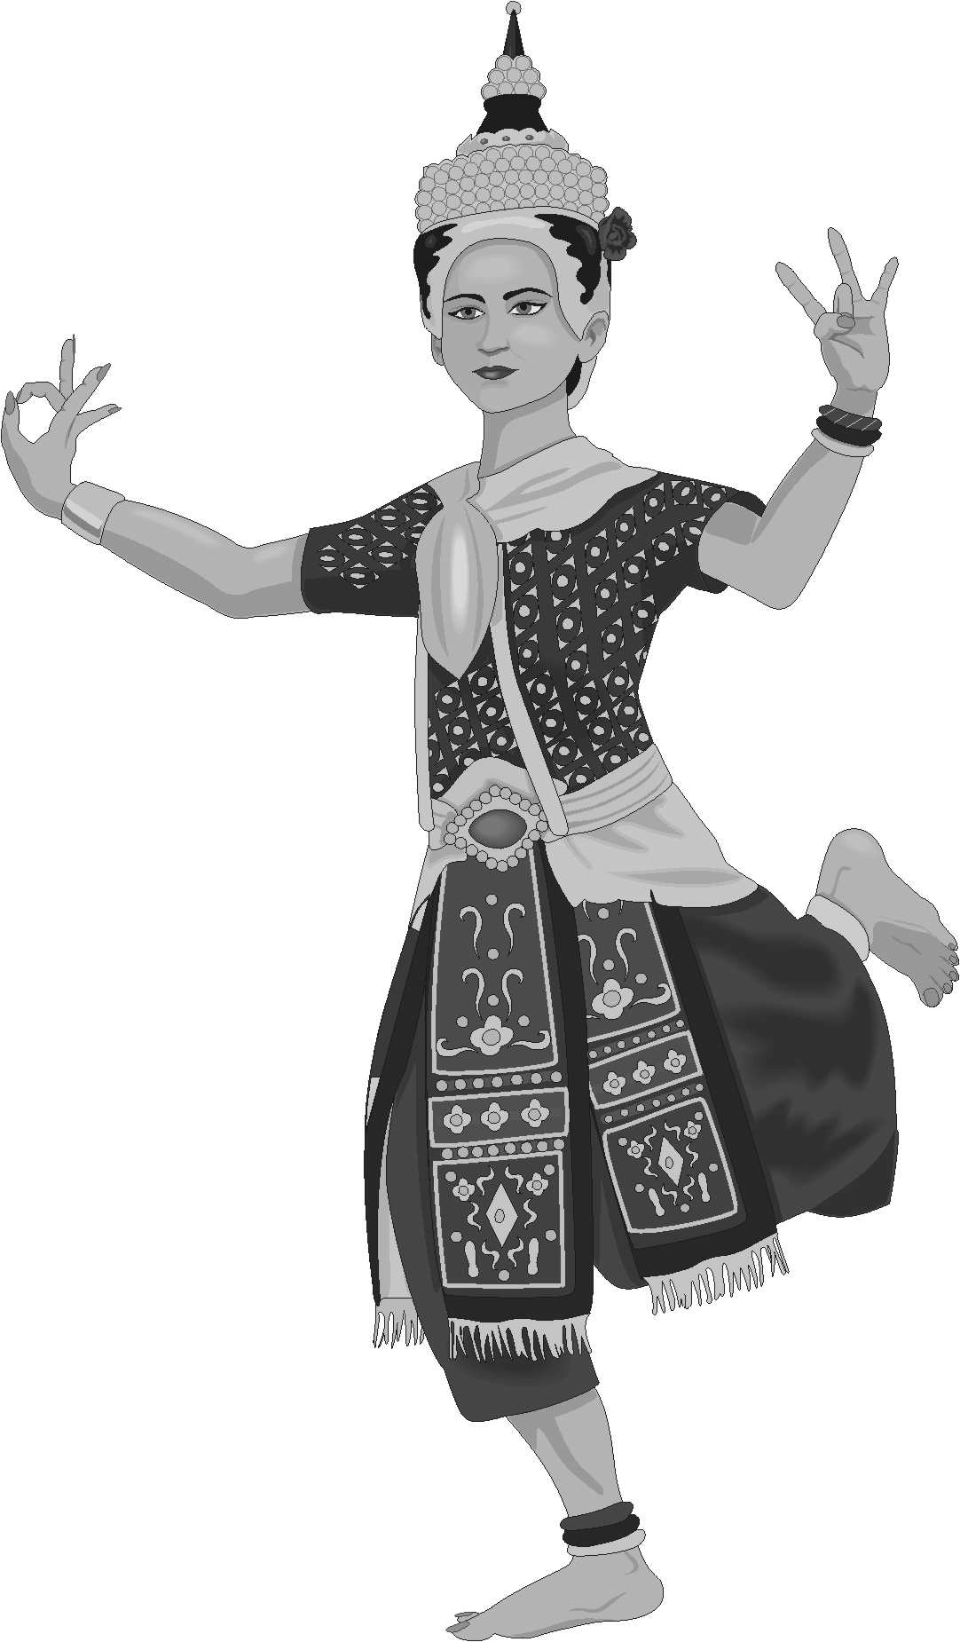

*Three or four leagues from the royal residence a square pit of no great depth, and about twelve to fifteen feet square, was excavated*

*Within it was erected a pyramid of sandalwood, resting on a kind of scaffolding of the same wood. The posts which supported it were so arranged that they could easily be removed and would thereby cause the whole structure to collapse suddenly. At the four courners of the pit were placed huge brass jars filled with ghee, to be thrown on the wood in order to hasten combustion .*

*The following was the order of the procession as it wended its way to the pyre. It was headed by a large force of armed soldiers. Then followed a crowd of musicians chiefly trumpeters, who made the air ring with the dismal sound of their instruments. Next came the king’s body borne in a splendid open palanquin, accompanied by his guru, his principal officers, and his nearest relatives, who were all on foot and wore no turbans in token of mourning.*

*Then came two victims, each borne on a richly decorated palanquin. They were loaded rather than decked, with jewels. Several ranks of soldiers surrounded them to preserve order and to keep back the great crowds that flocked in from every side.*

*The two queens were accompanied by some of their favorite women, with whom they occasionally conversed.*

*Then followed relatives of both sexes, to whom the victims had made valuable presents before leaving the palace. An innumerable multitude of Brahmins and persons of all castes followed in the rear.*

*On reaching the spot where their fate awaited them, the victims were required to perform the ablutions and other ceremonies proper on such occasions and they went through the whole of them without hesitation and without the least sign of fear. When, however, it came to walking round the pyre, it was observed that their features underwent a sudden change.*

*During this interval the body of the king had been placed on the top of the pyramid of sandalwood. The two queen, still wearing their rich attire and ornaments, were next compelled to ascend the pyre. Lying down beside the body of the deceased prince, one on the right and other on the left, they joined hands across the corpse.*

*The officiating Brahmins then sprinkled the pile with holy water, and emptied the jars of ghee over the wood, setting fire on it at the same moment. The flames quickly spread and the props being removed, the whole structure collapsed and in its fall must have crushed to death the two unfortunate victims. Thereupon all the spectators shouted aloud for joy.*

During the sixth century the Gupta Empire collapsed under the repeated attacks of the White Huns (perhaps related to the Huns who plagued the Roman Empire during the fifth century) India again entered a period of political disorder; the country became divided into small warring kingdoms. Waves of foreign invaders again entered the land; but as in the past, Hinduism absorbed these foreign elements into Indian society. However, the history of India took a dramatic turn when northern India fell under the domination of Muslims who brought with them a religion and culture as strong as Hinduism.

After years of constant raids, Muslim warriors conquered much of northern India, where they established a Muslim kingdom in 1206 near the city of Delhi. Almost immediately a conflict arose between the Muslim and Hindu elements within Indian society. This was a struggle not only between two religions, but between two distinct ways of line. The Hindus believed in many gods, but the Muslims acknowledged only one.

The Hindus followed the rigid caste system while the Muslims believed in the equality of all men before their god, Allah.

Although Muslim control of northern India ended at the close of the fourteenth century, the hostilities between Hindus and Muslims in Indian society have continued to the present.

Muslims contributed to the development of Indian culture. They left the valuable monument of art, the great masterpiece – Taj Mahal.

**Taj Mahal**

Of the seven Wonders of the Ancient World, two were dedicated to sentiment in marriage: the Mausoleum, monument of a wife’s devotion to the memory of her husband; the Hanging Gardens of Babylon, erected by a husband for the happiness of a favourite wife. Among the wonders of the modern world, one of the most famous commemorates a husband’s devotion to a wife.

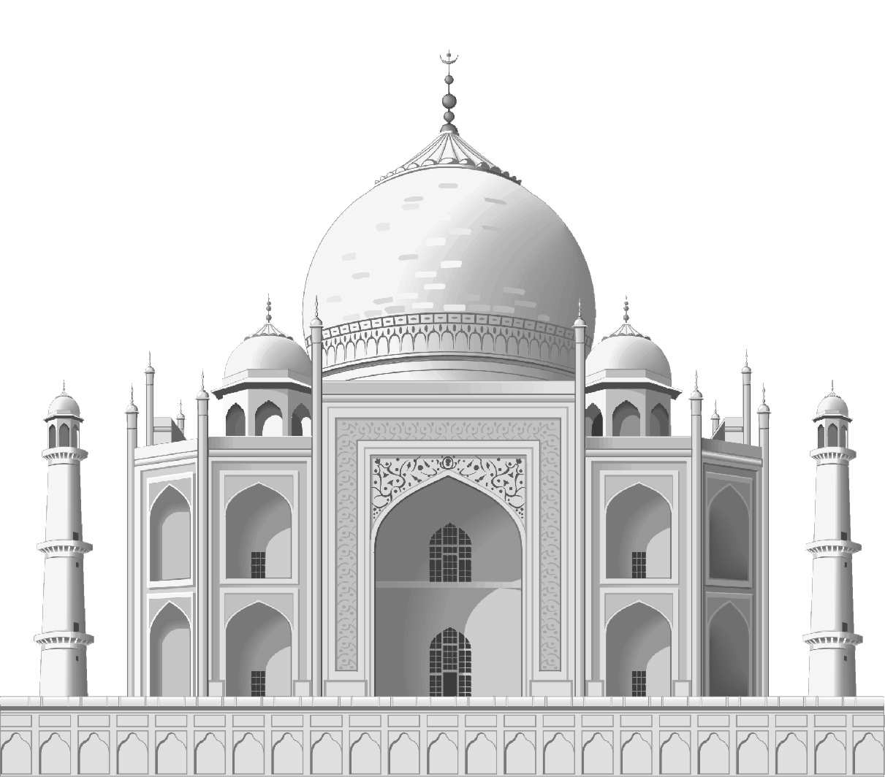

It is, of course, the incomparable Taj Mahal, the tomb that Shah Jehan created for the beauteous Mumtaz Mahal, at the city of Agra, in India. The French traveler Francois Bernier, who toured the East three centuries ago, was in Agra during the 1660s, saw the building when it had been up for less than twenty years, and wrote in his journal: “Possibly I have acquired an Indian taste, but I am of the opinion that this monument has much more right to be included among the wonders of the world than the pyramids of Egypt”. Some critics have gone beyond him, declaring the Taj Mahal to be the most beautiful edifice ever erected by man. Shah Jehan was one of the Mogul emperors who reigned over India in golden splendour. A Moslem, he practiced the polygamy ordained in the Koran, which permitted four wife not counting the concubines whom it was customary for an Islamic potentate to have in his harem. Mumtaz Mahal, young dainty, and beautiful, was the favourite wife. Taj Mahal, therefore, is a monument to romantic sentiment in the harem, a husband’s devotion in polygamous family life.

The Taj Mahal is the masterpieces of Mohammedan Art. That it arose on Indian soil is explained by history. The Moglus came originally from Central Asia, their name being a variant of the world “Mongol”. They were Moslems, and they conquered India.

The founder of the Mogul Empire was one of the remarkable men of all time. In martial ardor and ability to command, Baber may have been a typical princeling of Iartary, but he was also a man of culture, the author of perhaps best political memoirs ever written by a reigning monarch. In December of 1525 he led his army into India. The battle took place on April 12, 1526, and proved to be one of the decisive conflicts of world history for Baber won the victory, that gave him a permanent foothold in the land that was to be ruled by this descendants.

Baber did not finish the work of integrating an imperial domain. But the Moguls were lucky in the next representative of their dynasty Akbar, known to history as Akbar The Great. He introduced a new system of government, bringing ale the land under his direct authority naming his own viceroys, setting up a comprehensive tax levy, keeping the provincial military forces in the pay of the central treasury to prevent local rebellious before they could get started.

At his death (1605) he left behind an empire so closely knit and organized that it could continue in much the same form for another century. By patronizing artists and architects he forwarded the development of style and skill to the point where under his grand son, the miracle of the Taj Mahal became possible. Akbar was succeeded by his son Sahangir, the potentate to whom the title of “The Great Mogul” was first applied. The imagination of the west was inflamed, by stories of the beauty, power, luxury and oriental splendour of the Mogul Empire. Merchants, travellers, ambassadors, missionaries – all helped to fill in the picture of the Great Mogul and his kingdom.

Iahangir died in 1627 and the throne passed to his son, Shah Jehan. Under his popular rule the Mogul Empire reached its height. His reign was remembered for its order, security and justice. In 1612 he had married Argumand Banu a cousin, and their wedded bliss until her death in 1631 constitutes one of the great love stories of the world. It was not dimmed by the fact that Shah Jehan, in Moslem fashion, had a harem of other wives. She was his favourite, the one he called Mumtaz Mahal, or Ornament of the Palace”. A powerful influence with him, she was largely responsible for his orthodox Mohammedanism, for she held strictly to the tenets of Islam Mumtaz Mahal bore her husband fourteen children, the last of which caused her death on June 17, 1631.

Shah Ielah reacted to the tragedy as did Artemisia on the death Mausolus. He was so inconsolable that it was feared he would die of grief. In fact he never recovered from the shock, although he did rouse himself because he wanted to venerate the memory of his wife, with a suitable monument. The greatest thing he did during the rest of his reign was to build the Taj Mahal. As a site he chose a high bank of the Yumna River, one of the holy rives of Hundustan, where it bends around at Agra. He summoned the finest architects and craftsmen from all over his empire and had them submit plans for the proposed buildings. The Portuquese Iesuists in Agra reported that the man who won was a Venetian Geronimo Verroneo, and that this Westerner actually erected the Taj. But that story has been rejected by some later scholars on the grounds that the building shows no European influence. Other accounts name a Turk or a Persian.

The basic material used was wite marble, with the wall and gates of red sandstone, a colour scheme, that has the remarkable effect of showing different tints at different times of the day. The building stands on a 186-foot square with the angles cut to form on octagon. Beneath it is a raised marble platform, extending all around and marked by delicate minarets at each corner. Above swells the great dome, about two thirds of a sphere, surmounted by a crescent and flanked by smaller domes, each of the walls is cut by arches of a similar but not at all mono fonous pattern, rather, they contribute to the unity of the whole, Light enters through marble screens.

There is an old saying that “The Moguls built like titans and finished like jewelers”. The Taj Mahal proves the truth of the remark. Looked from a distance, its appearance is indeed dreamlike, with a grare and balance that make us wonder how human beings ever achieved so miraculous a result from marble and sandstone.

After Shah Jehan the Mogul Empire had no place to go except downward. This great ruler lived to see the first bitter fruits of failure, for his sons rebelled against him, and the one who came out on top, Aurangzeb, deposed him and threw him into prison.

Then Aurangzeb moved the capital of the Mogul Empire from Agra to Delhi. For seven years Shah Jehan remained in a cell in the fort at Agra, protesting against the unfilial behaviour of the new emperor, and spending much of his time gazing across at the Taj Mahal where the symbol of his best days lay Buried. Shah Iahan died in 1658 and finally left prison to lie by the side of Mumtaz Mahal in her glorious tomb. Aurangzeb maintained his throne for fifty years, the last Mogul of any consequence. On his death in 1767 fierce fighting among his sons broke out. Final ruin came in 1739 when the powerful king of Persia, Nadir Shah, invaded Hundustan. From then on the Mogul Empire of Akbar, Yahangir, and Shah Jehan, was but a memory, but it had left behind a colorful page of history climaxed by the enduring monument that attracts and charms visitors to this day that wonder the modern world, the Taj Mahal.

But India is famous not only for this monument of art – It has other wonderful masterpieces of architecture.

**Art of India**

Indian civilization was one of the oldest and most original in the East. Her contribution to world culture was great. In the ancient times, India was famed for her wonderful miracles, vast natural resources and craft works.

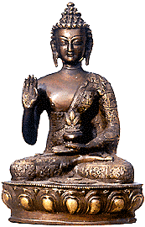

In the 3rd century b.c. almost the whole Hindostan peninsula and some neighbouring countries, were united into one gigantic empire under the powerful king, Ashoch (273).

Only stone edifies in that period have survived till nowadays: temples and cells, stone-shrines. Shrines were erected of brick and stone in the form of hemisphere, surrounding by the fence with 4 gates in it.

Stone statues served as adornments of architecture and more often were created in the form of scenic relief. Motions, gestures and poses of the people on the relief are extremely expressive and graceful. That was under the influence of the dance art, widely spread and popular in India.

Religious architecture of the Ashoch period is represented by cave complexes and temples. Such temples were usually carved in the picturesque and secluded places out of the solid rock massif. Excavations in the North – West India brought the discovery of the wonderful statues created in the 1st century a.d.. These were mainly the statues of Buddha. Influence of the Greco-Roman art was great here.

Figures of Buddha resemble much statues of the Roman emperors and some of the Greek gods. They were made by Greek masters who lived in Indian and adopted Indian religions. Later on the Indian apprentices of Greek masters started sculpting Buddha according to the notion of the Indian people: sitting with his legs crossed. Period of the blossoming Indian culture dates back to the 4th –6th centuries a.d. Remarkable specimen of the ancient Indian painting have survived in Buddhist temples and monasteries in Adjanta. Walls, ceilings, pillars in these temples are painted with the scenes from Buddhist legends and are decorated with statues and carving. Murals in Adjanta are the visual encyclopaedia of life of the ancient Indian people.

Conclusion

The Indian civilization was one of the oldest and most original in the last. Its contribution to the culture of human kind is immense. At a very early stage, ancient India maintained close cultural contacts with many countries of the ancient Orient and with the Greco-Roman World.

Ancient traditions are highly viable in India and it is therefore not surprising that many achievements of the ancient Indian civilization long outlived the epoch of antiquity becoming an important component of the country’s modern culture and of world civilizations.

Bibliography

1. “A Crown of Eagles” by Anne Covell.
2. “The Indians” by Blecker Sonia
3. “Across the Centuries” by S. Armento. G.B. Nash
4. “The story of Ancient Times” by Meclure C.H.
5. “People and Nations World History” by Mazour Anatol
6. “Lands and Peoples” by Bulliet Richard W.
7. “Investigations Man’s World” by Hanna Paul
8. ‘The West Indies” by Harman Carter
9. “Southeast Asia” by Karnow Stanley
10. “People” by Frederick King
11. “World History Atlas”
12. “Atlas of World and Environmental” by Middleton Nick
13. “World History” by David A. Fisher
14. “Hindu Manners, Customs and Ceremonies” by Abbe Dubois
15. Encyclopedia “India”
16. “The New and Wander Book of Explorations and Discoveries” by D. Sweet
17. New English – Russian Dictionary (1999 Moscow)
18. Oxford Russian – English, English – Russian (Oxford)
19. English – Romanian, Romanian – English Dictionary by Andre Bantash