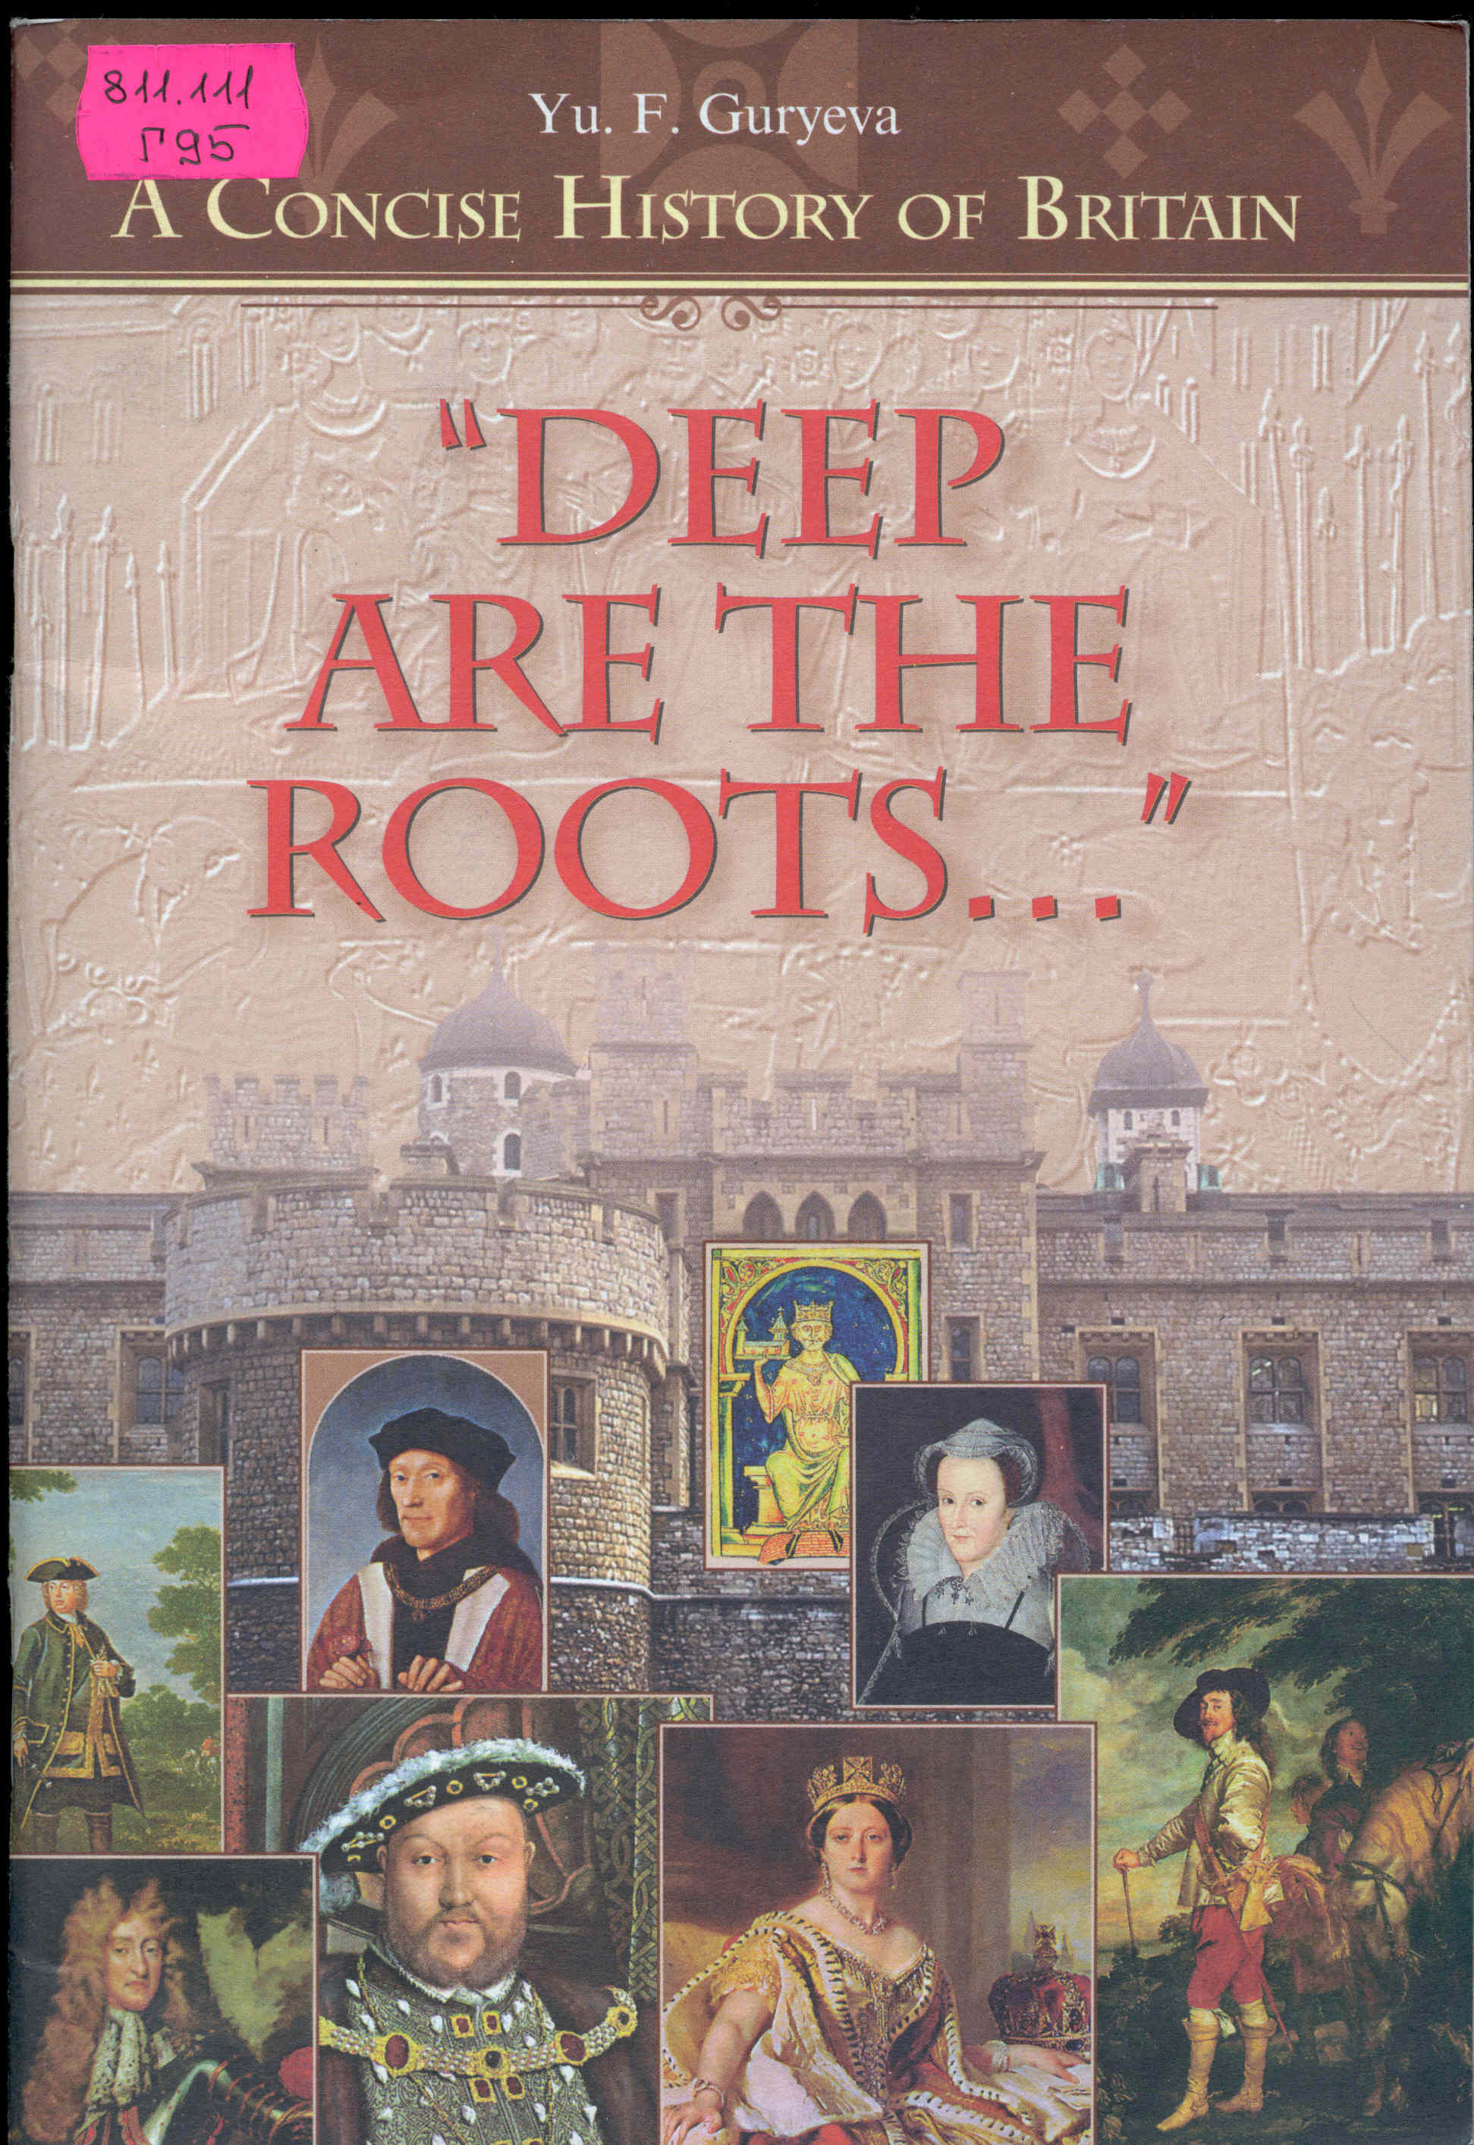

Yu. F. Guryeva

A concise history of britain

“DEEP

ARE THE

ROOTS…”

(Очерки по краткой истории Британии)

"ГЛУБОКИ КОРНИ..."



ББК 81.2Англ-923

Г95

УДК 820

Guryeva Yu. F.

Г 95 "Deep Are the Roots...": A Concise History of Britain. = Гурьева Ю. Ф. Глубоки корни...: Очерки по краткой истории Британии.– Обнинск: Титул, 1999.– 72 с.: ил.

ISBN 5-86866-109-5

*Учебное пособие "Deep Are the Roots..." представляет собой краткое историческое введение в курсы страноведения и лингвострановедения для факультетов иностранных языков педагогических университетов и других высших учебных заведений.*

Пособие содержит сжатую информацию об исторических событиях в Великобритании, выделяет ключевые слова и термины для каждого раздела, предлагает вопросы для проверки понимания и усвоения материала по каждому историческому периоду.

*Это пособие может найти применение у широкого круга студентов, изучающих английский язык и английскую историю:* *оно вполне доступно для учащихся старших классов спецшкол, студентов колледжей, курсов иностранных языков.*

ББК 81.2Англ-923

© Ю.Ф. Гурьева, 1998

© Издательство «Титул», 1998

ISBN 5-86866-109-5

Глубоки корни современного британского общества, государственности, английской нации и других народов, населяющих Британские острова.

Любая страна и нация, любое государство и общество тесно связаны с историческими корнями в своем развитии, а Великобритания и англичане всегда являли миру свою особенность, свою обособленность и почтение к собственной истории. Несмотря на модернистские планы современных молодых реформаторов изменить и заменить традиционные стереотипы старой доброй Англии, исторические корни не только определяют современные традиции и английский менталитет, они вошли в плоть и кровь английской культуры, вплелись во все слои и структуры Великого английского языка.

Современная лингводидактика, выделяя **формированне коммуникативной компетенции** в качестве цели обучения иностранным языкам, подчеркивает значимость ее разновидностей, прежде всего лингвистической компетенции, а также, среди прочих, и **социально-культурную компетенцию.** Именно социокультурная компетенция является основой **культурной грамотности,** определяет понимание учащимися **национально-культурных особенностей лексических единиц,** экстралингвистических характеристик общения.

Лингводидактические традиции и концепция преподавания ИЯ на факультете иностранных языков МПГУ опираются на **интеграцию лингвострановедческого (социокультурного) подхода** в обучении ИЯ с постоянным **изучением фоновой информации и социокультурных реалий,** которые содержатся во многих специальных учебных дисциплинах: зарубежной литературе, страноведении, лингвострановедении.

Предлагаемое читателю пособие содержиткраткий, исторический материал, необходимый минимум фактологической и лексической британской социокультурной информации. Это пособие можно использовать в качестве основы для лекционного курса «Введение в страноведение», или, например, как материал для самостоятельной работы, домашнего или индивидуального чтения. В любом случае рекомендуется давать задание учащимся предварительно ознакомиться с текстом каждого раздела, затем самостоятельно, по словарям подготовить перевод выделенных ключевых слов и других незнакомых слов для создания в конце работы над курсом собственного словарика – глоссария.

Помещенные после разделов и подразделов вопросы можно и следует использовать для проверки понимания и знания материала на семинарах, коллоквиумах, контрольных работах, а также на зачетах и экзаменах.

Удачи Вам!

Автор с признательностью примет замечания и пожелания.

Ю. Гурьева

CONTENTS

**UNIT I**

ANCIENT BRITAIN 4

**UNIT II**

BRITAIN IN MIDDLE AGES 13

**UNIT III**

THE TUDOR AGE

(1485–1603) 29

**UNIT IV**

THE STUARTS AND THE STUGGLE OF THE PARLIAMENT AGAINST THE CROWN 41

**UNIT V**

THE 18тн CENTURY– OF WEALTH, TECH­NOLOGICAL REVOLU­TION AND POWER 53

**UNIT VI**

THE 19тн CENTURY– THE VICTORIAN AGE OF THE BRITISH EMPIRE AND... THE NEW RIVAL 64



# ANCIENT BRITAIN

Invasion, Resistance, Settlement and Conquest

PRE CELTIC AND CELTIC PEOPLE. ANGLO-SAXON BRITAIN. INVASIONS OF THE VIKINGS. THE ENGLAND OF ALFRED THE GREAT. EDWARD THE CONFESSOR. THE BATTLE OF HASTINGS.

*Key words, terms and concepts:*

*1. Stonehenge*

*2. "Beaker" people*

*3. Celts, Druids, Celtic curves*

*4. Celtic languages – Gaelic and Brythonic*

*5. Roman Britain*

*6. Hadrian's Wall*

*7. Scots and Picts*

*8. Queen Boadicea– (Boudicca)*

*9. Villas*

*10. Roman roads – straight as a die*

*11. Pax Romana, Roman Peace*

*12. Saxons: Saxon kings and Saxon kingdoms:*

*Northumbria, Mercia, East Anglia, Sussex, Wessex, Essex, Kent*

*13. Vikings*

*14. Venerable Bede (731)*

*15. Alfred the Great (849-899)*

*16. The Danelaw*

*17. Edward the Confessor (1042-1066)*

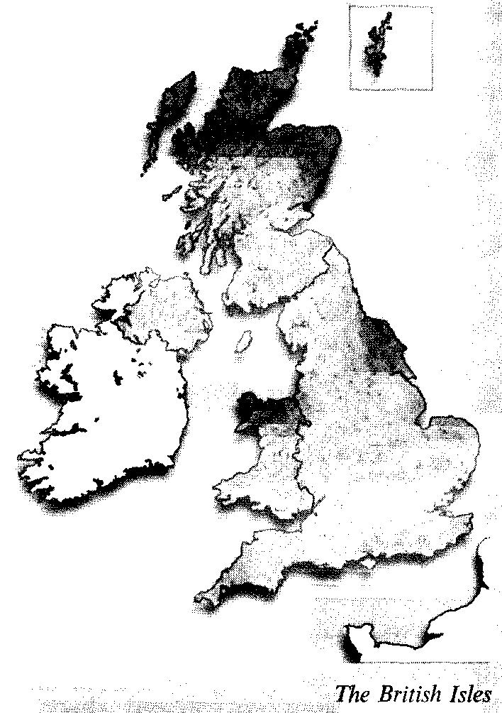

The very first stages of the existence of people on the British Isles are frequenly described as prehistoric and referredto as unwritten history of Britain.

The geographical position of the land was both a blessing and a problem: on the one hand the insular position pro­tected the country from invasions; and on the other – the lowland facing the continent always invited invasions.

The greatest material monument of the ancient population of the British Isles is Stonehenge on the Salisbury plain,– a monumental stone circle and a memo­rial of the Stone Age culture.

The first ever inhabitants are believed to be hunters of the Old Stone Age who came from the Continent, to be followed by new waves of imigrants.

By the end of the Stone Age the Beak­er people who were called so after the clay mugs or "beakers" they could make,– were farmers and metal was al­ready being used.

The beginning of the Stone Age co­incided with the arrival of new invaders, mainly from France. They were the Celts. Reputed to be tall, fair and well built, they had artistic skills and were good craftsmen. Their dialects were imposed on the native population: the Gaelic form was spread in Ireland and Scotland, and the Brythonic in England and Wales. It was the Brythonic tribe of the Celts that gave its name to the whole country.

The culture of Celts in the Iron Age was not altogether barbaric. Their Priests, the Druids, were skillful in teach­ing and administration.

But the Romans came with a heavy hand,

And bridgedand roaded andruled the land,...

wrote R. Kipling

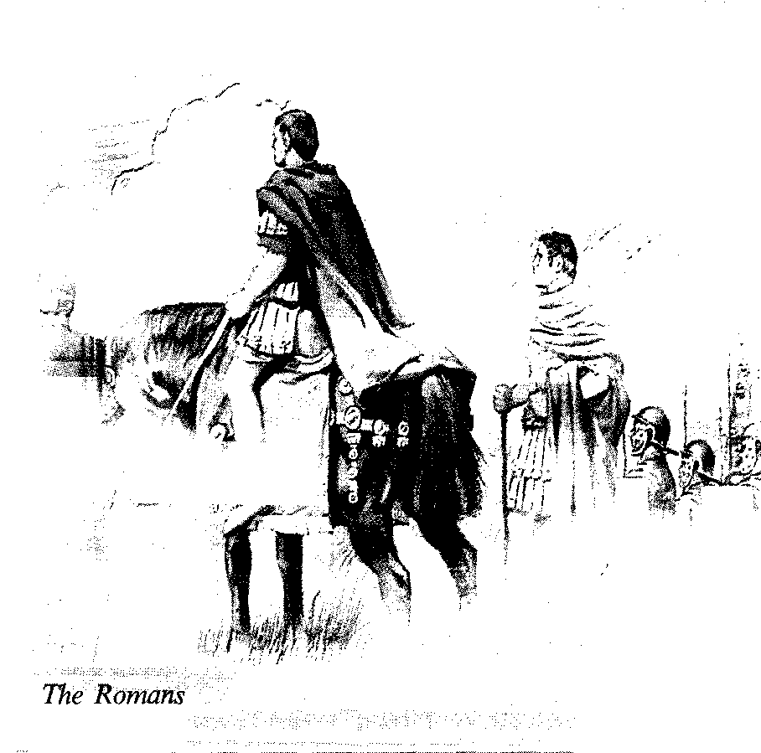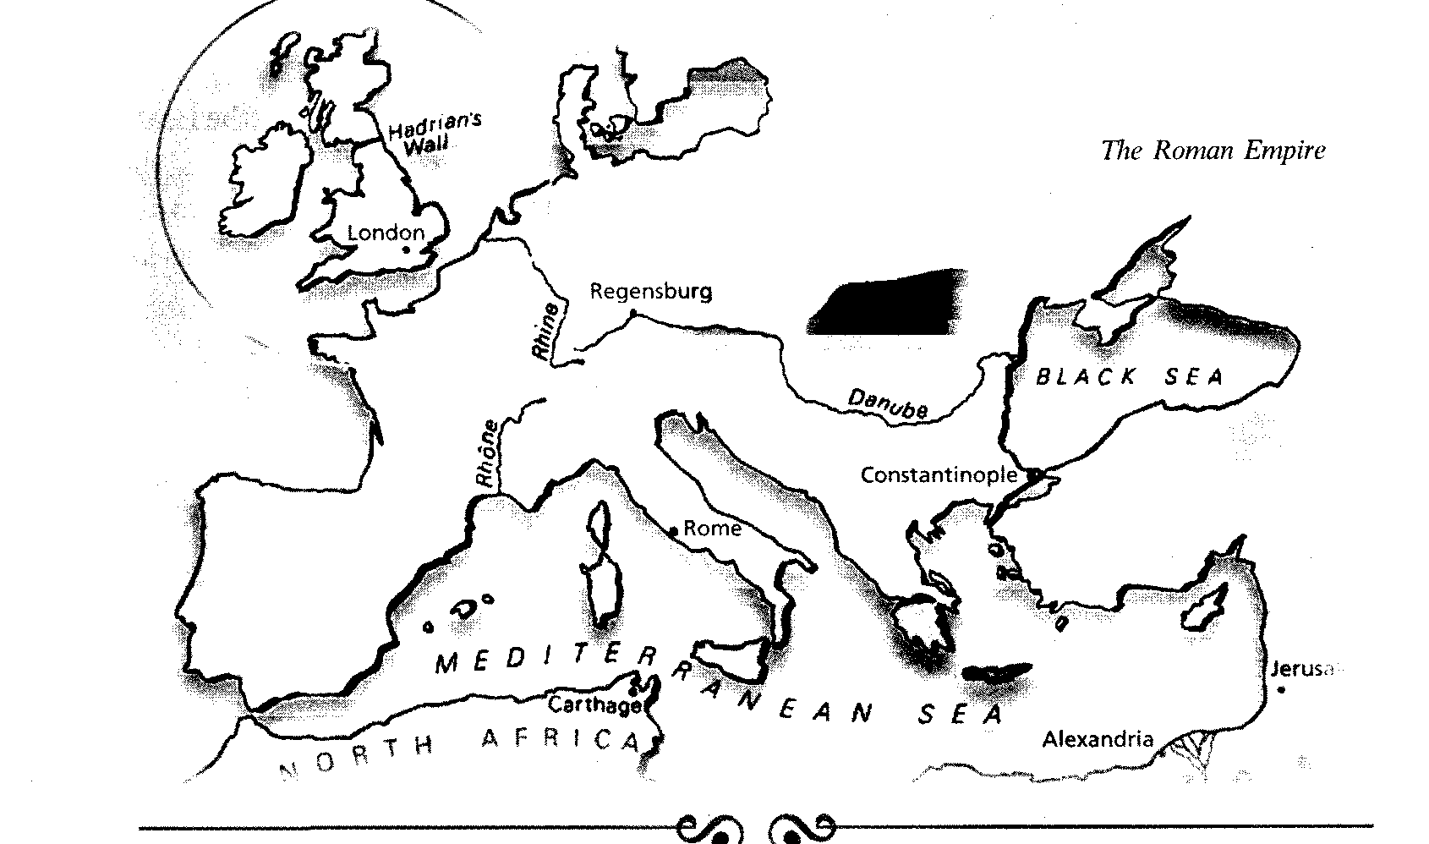

The Roman Emperor Julius Caesar carried out two expeditions in 55 and 54 ВС, neither of which led to immediate Roman settlement in Britain. Caesar's summer expeditions were a failure. Al­most a century later in 43 AD Emperor Claudius sent his legions over the seas to occupy Britain. The occupation was to last more than three centuries and the Romans saw their mission of civilizing the country. The British were not con­quered easily. There was a resistance in Wales and the Romans destroyed the Druids, a class of Celtic priests (or witch­doctors) as their rutuals alledgedly in­volved human sacrifice.

There was a revolt in East Anglia, where Queen Boadicea (Boudicca) and her daughters in their chariots were fight­ing against Roman soldiers and were de­feated. The Roman occupation was spread mainly over England, while Wales, Scotland and Ireland remained unconquered areas of the Celtic fringe – preserving Celtic culture and traditions.

The Romans were in Great Britain for over 350 years, they were both an occupying army and the rulers. They imposed Pax Romana,– Roman peace – which stopped tribal wars, and protected Britain from the attacks of outsiders – Picts in the North, Saxons from overseas.

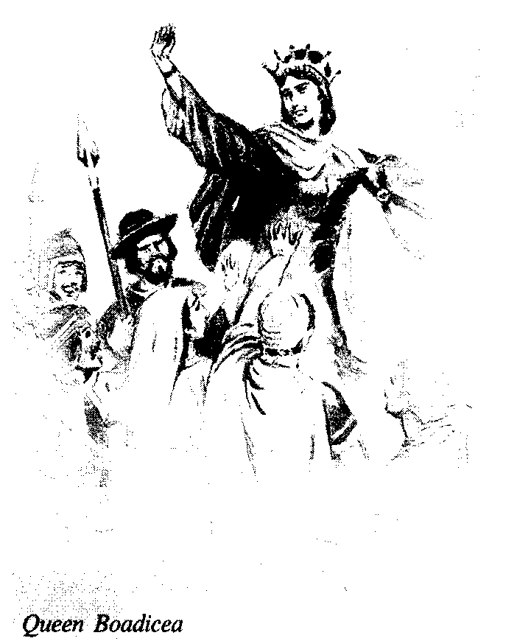

London is a Celtic name, but many towns that Romans built along their roads – Lancaster, Winchester, Chichester, etc. have the Latin component "castra"– a camp, a fortified town.

London was the centre of Roman Rule in Britain, it was walled, the Thames was bridged; and straight paved roads (Roman Roads,– that are as straight as a die) connected London with garrison towns.

Under the Emperor Hadrian in 120 AD a great wall was built across Britain between the Tyne and the Solway to pro­tect the Romans against the attacks of Scots and Picts.

Hadrian's wall was a vast engineer­ing project and is a material monument of the Roman times alongside with roads, frescoes and mosaics on the vil­las and baths (in the city of Bath).

The Romans also brought Christi­anity to Britain and the British Church became a strong institution.

The native language absorbed many Latin words at that time.

By the fifth century the Roman Em­pire was beginning to disintegrate and the Roman legions in Britain had to re­turn back to Rome to defend it from the attacks of the new waves of barbar­ic invaders. Britain was left to defend and rule itself.

Acceding to the writing of Venera­ble Bede, an English monk, barbaric teu­tonic tribes of **Angles, Saxons and Jutes** were making raids against the British throughout the fifth and sixth centuries. The British Celts tried to check the Ger­manic tribes, and that was the period of the half-legendary King Arthur and his knights of the Round Table who defend­ed Christianity against the heathen An­glo-Saxons.

The Germanic invaders first arrived in small groups throughout thefifth cen­tury but managed to settle and oust the British population to the mountainous parts of the Isle of Great Britain.

The Anglo-Saxons controlled the cen­tral part of Britain which was described as England while the romanizedCeltsfled West taking with them their culture, language and Christianity.

The Anglo-Saxon England was a net­work of small kingdoms.

The seventh century saw the estab­lishment of seven kingdoms: **Essex (East Saxons), Sussex (South Saxons), Wessex (West Saxons), East Anglia (East An­gles), Kent, Mersia and Northumbria,** and the largest three of them – **Northumbria, Mercia and Wessex** – dominatedthecountry at different times.

The Anglo-Saxon kings were elected by the members of the Council of Chief­tains (the Witan) (see ChartI**,** p. 9) and they ruled with the advice of the coun­cilors, the great men of the kingdom. In time it became the custom to elect a member of the royal family, and the power of the king grew parallel to the size and the strength of his kingdom. In return for the support of his subjects,– who gave him free labour and military service, paid taxes and duties – the King gave them his protection and granted lands.

By the end of the eighth century the British Isles were subjected to one more invasion by nonChristian people from **Scandinavia.**

...But the Romans left

And the Danes blew in...

That's where your historybook begins...

R. Kipling

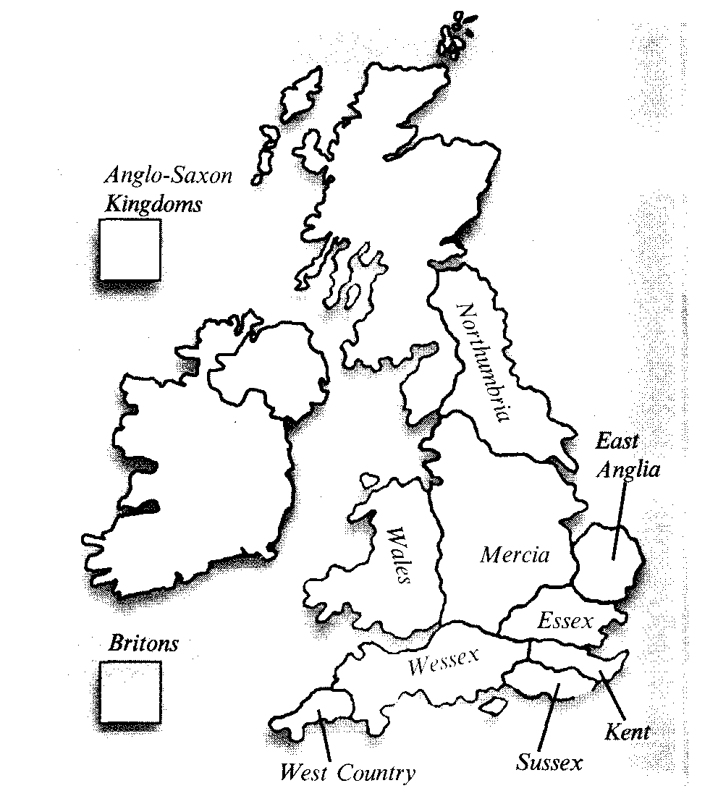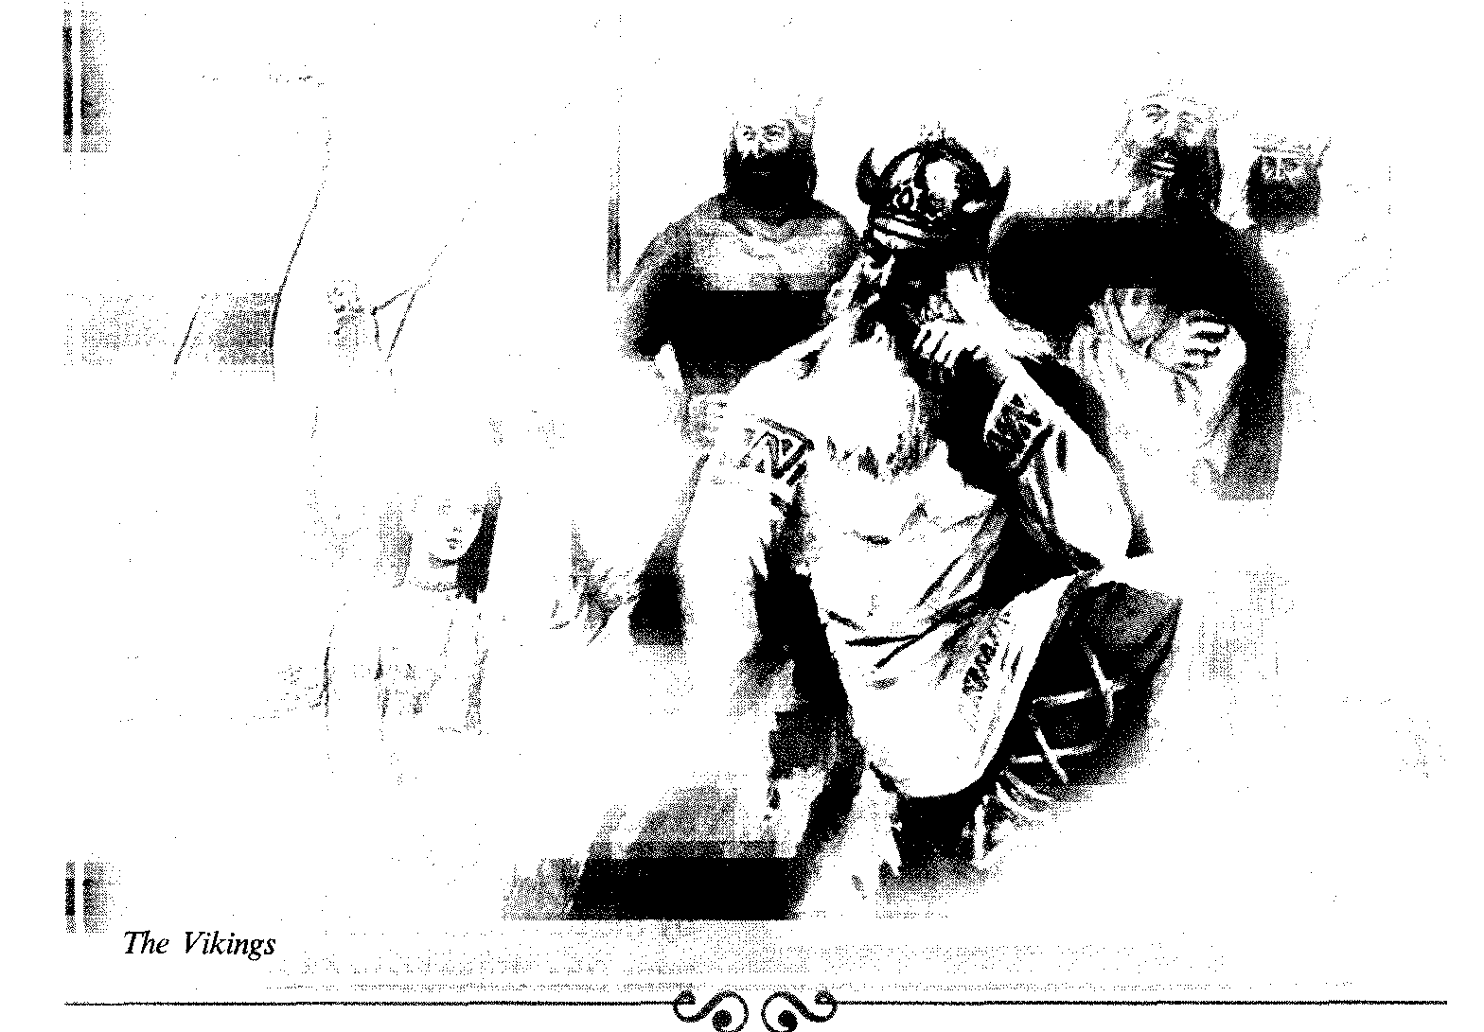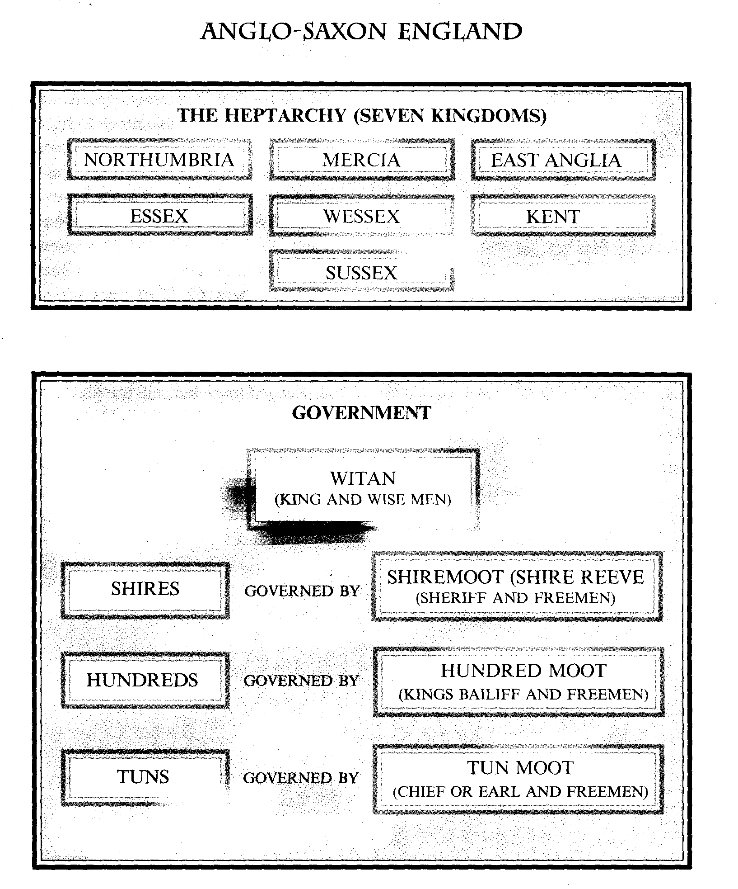

*Note how Anglo-Saxon England was divided* ***into******Seven Kingdoms****, known as the* ***Heptarchy.*** *The chart shows how each Kingdom was split up, and how each part had its own moot, or council, to look after its affairs.* ***The Witan was the council for the country.***

*Chart I*

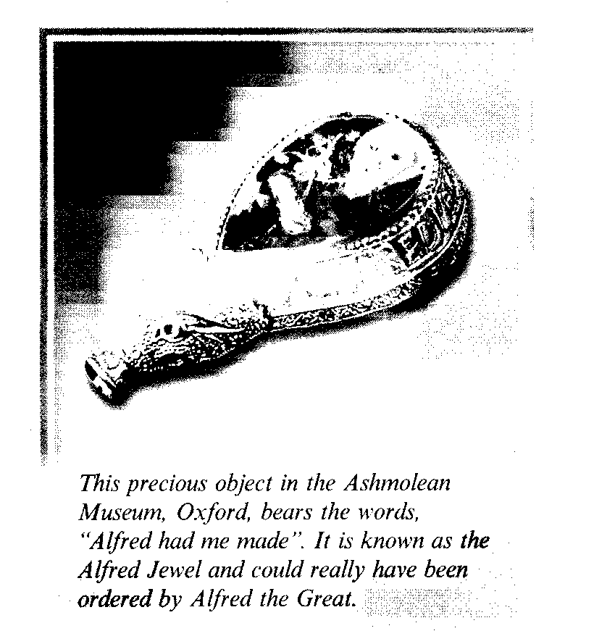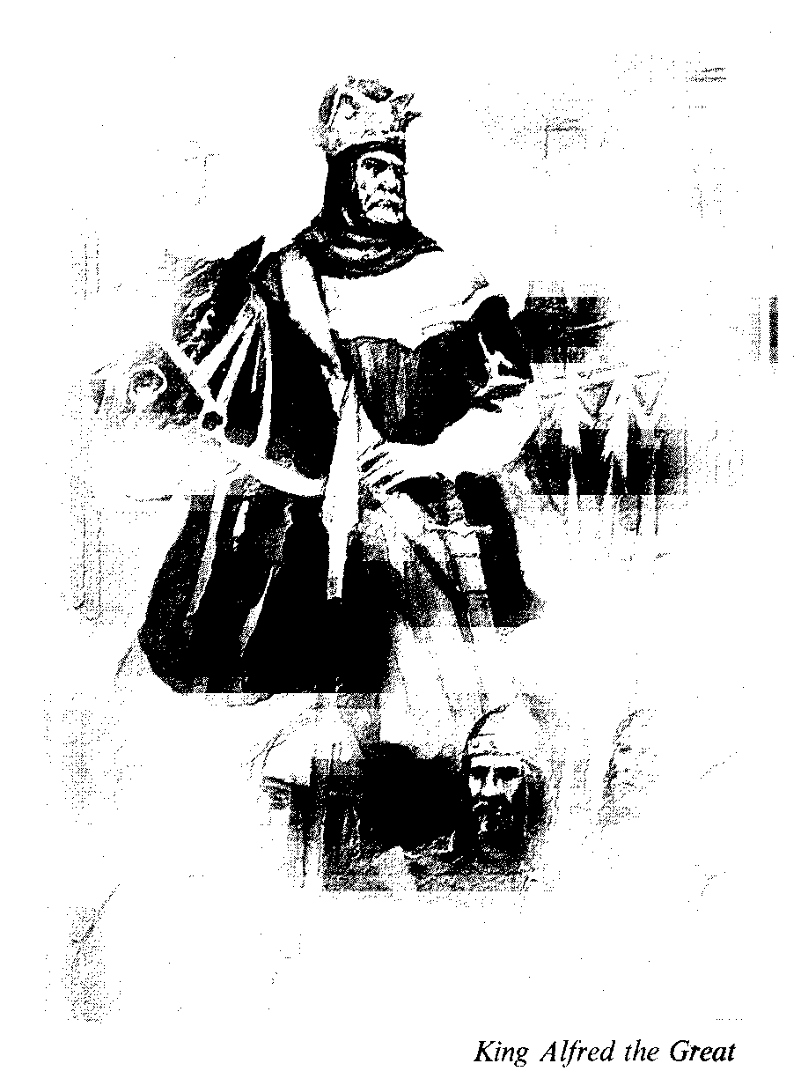

They were called **Norsemen or Danes,** or the **Vikings.** The Vikings were bril­liant sailors, they had the fastest boats in Europe, that were moving powered by sail. They crossed the Atlantic, and founded a colony in North America 500 years before Columbus. They had re­peatedly raided the Eastern Coast of England, and by the middle of the ninth century almost all English Kingdoms were defeated by the Danes. In 870 only Wessex was left to resist the barbaric Danes. At that time the West Saxons got a new young King, **his name was Alfred,** later he was called **Alfred the Great.** And no other king has earned this title. Alfred forced the Danes to come to terms – to accept Christianity and live within the frontiers of the Danelaw – a large part of Eastern England, while he was master of the South and West of England.

King Alfred was quick to learn from his enemies: he created an efficient army and built a fleet of warships on a Dan­ish pattern, which were known to have defeated Viking invaders at sea more than once. They were forced to go South and settle in Northern France, where their settlement became known as **Nor­mandy,** the province of the Northmen. The England of King Alfred the Great received a new Code of laws which raised the standards of English society. New churches were built, foreign schol­ars were brought, schools were found­ed, King Alfred himself translated a number of books from Latin, including Bede's Historia Ecclesiastica and began the Anglo-Saxon chronicle, a year-by year history of England.

Alfred the Great saved England from the Danish conquest, but in the 10th– 11th centuries the Danes managed to expand their possesion in Great Britain and from 1013 to 1042 the Danish royal power triumphed in England. King al power triumphed in England. King Canut's empire included Norway, Den­mark and England. In **1042** the **house of Wessex** was restored to power in Eng­land, when **Edward the Confessor** was elected king by the Witan. He was half-Norman, had spent his exile in Norman­dy, and **Wiffiam the Duke of Normandy** was his cousin and a close friend.

Edward the Confessor was a religious monarch and devoted his attention to the construction of churches and most of all to the building of Westminster Abbey.

Edward the Confessor died in 1066 without an obvious heir. And the Witan elected **Harold,** a Saxon nobleman from the family of the Godwine, **the king of England.** Harold's right to the English throne was challenged by William the Duke of Normandy who claimed the English Kingdom as his rightfull inherit­ ance which had been alledgedly prom­ised to him by the late King Edward the Confessor.

**1066 was a crucial year for the Saxon** **King, and for the history of the English.**

Harold had to fight against two ene­mies at the same time. In the South Wil­liam of Normandy was preparing to land in England, in the North, in Yorkshire, the Danes renewed their attacks against England.

Harold succeded in defeating the Danes and rushed his armies back to the South to meet William who had landed near Hastings. His men were tired, though they had done so well in the bat­tle against the Danish vikings. William's army was better armed, better organized and he had cavalry.

#### Had Harold waited and given his army a rest, the outcome of thebattlemight have been different.

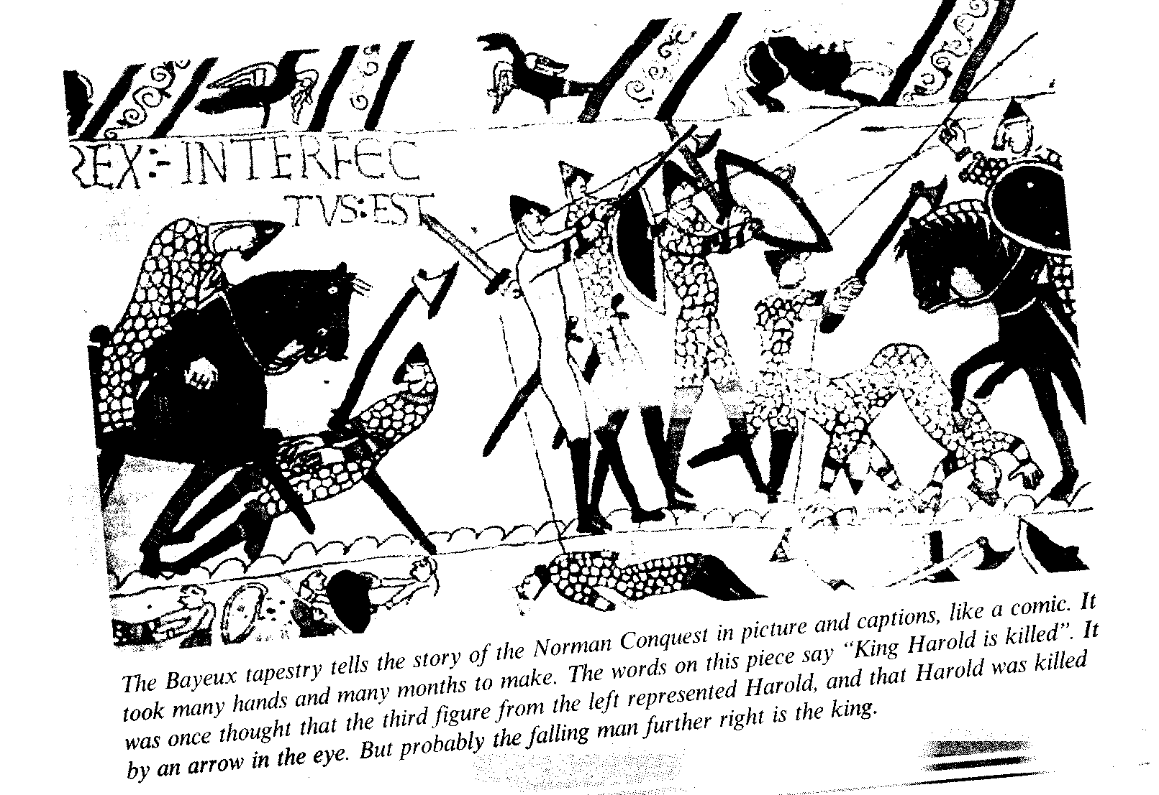

But after a hard and long struggle Harold and his brothers were killed in the **battle of Hastings** and the flower of Saxon nobility lay dead together with them on the battle field.

The **Bayeux Tapestry** (231 feet long 19 inches wide) tells a complete story of the Norman Conquest of Saxon Eng­land in over seventy scenes. In one of the scenes the Latin writing says "Ha­rold the King is dead", and under the inscription stands a man with an arrow in his eye believed to be King Harold.

William captured London and was crowned King of England in Westmister Abbey on **Christmas Day, 1066.**

The Norman period in English histo­ry had begun.

Some historians argue concerning pos­sible ways of English history, had the An­glo-Saxons defeated William. But History doesn't rely on the Conditional Mood.

All the invasions, raids and conquests were contributing new and new waves of peoples to be integrated into a newly appearing nation of the English, to un­derstand which we must know its his­torical roots, studying historical facts.

*Questions:*

*1. What is traditionally said about the geographical position of Britain? What do you think of it?*

*2. What material monuments of Pre-Celtic population culture still exist on the British territory?*

*3. Which of the Celtic tribes gave their name to their new home-country?*

*4. What functions were performed by Celtic Priests? What were they called?*

*5. Which Roman expeditions were successful in subjugating Britain and when? Was it a peaceful development?*

*6. What are the well-recognized contributions of Roman civilisation to British culture?*

*7. Did King Arthur and his Knights of the Round table exist and when if they did?*

*8. What Germanic tribes invaded Britain from the Continent and what states emerged as a result of that invasion?*

*9. What was the historical role of the Vikings on the British Isles?*

*10. Which of the Anglo-Saxon kings rightly deserved the title of Great? What were his great accomplishments?*

*11. In what way was Edward the Confessor responsible for William's claim to the English crown?*

*12. What: is the name of the battle which is a historic turning point for England?*



# BRITAIN IN MIDDLE AGES

##### early middle ages

**A** MATURING FEUDALISM. THE DOMESDAY BOOK. THE PLANTAGENET KINGS. CONFLICTS WITH THE CHURCH AND BARONS. RICHARD I, JOHN LACKLAND. MAGNA CARTA LIBERTATA.

###### later middle ages

**B** SIMON DE MONFORT. THE GROWTH OF PARLIAMENT. THE HUNDRED YEARS' WAR. THE BLACK DEATH. THE PEASANTS' REVOLT.

Key words, terms and concepts

*1. Feudalism, feudal hierarchy*

*2. A language gap*

*3. Domesday book*

*4. Tenants-in-chief (barons), vassals*

*5. Freemen, freeholders, cottagers, villeins, serfs*

*6. To raise money (shield money)*

*7. To impose taxes, fiscal policy*

*8. Thomas Becket – the martyr*

*9. Richard (Coeur-de-Lion), the Lion-Heart*

*10. John Lackland. Magna Carta – the Great Charter of Liberty (1215)*

*11. Simon de Montfort. The Parliament*

*12. The Plague – the black death*

*13. Poll Tax*

*14. Wycliffe*

*15. John Ball, Wat Tyier (1381)*

## Anglo-Norman Britan

**The Norman Conquest** did have immediate social, political and cultural implications. The new tough foreign aristocracy captured power and lands. By 1100 (12th c.) there were 500 Norman castles in the English country­side. There was a blow against the Church as well; Saxon bishops were ei­ther deposed or replaced by Normans. During the 11th and 12th centuries an apparatus of Government of exception­al effectiveness was established.

England was also drawn into close links with the other side of the Channel. But there was a language gap between the local (Anglo-Saxon) population and the new landowners, of both the Church and the Norman Aristocracy.

Latin was a language of monasteries, Norman French was now the language of law and authority. Inflected English, spoken differently in the various regions remained the language of the people.

The brightest evidence of the situa­tion in the country was the Domesday Book (1086), a survey of England's land and people; according to it Norman so­ciety still rested on **"lordship, secular** and **spiritual,** and **the King,** wise or foolish, was the lord of lords, with only Lord in Heaven and the Saints above him.”

Historians have introduced into their interpretation of Norman and other Eu­ropean lordship the term **"feudalism",** first employed during the 12th century. The term was used in both narrow and broad sense. Narrowly it was related to military **(knightly)** service **as a condition of tenure of land.** Broadly it was related to the tenure of land itself, obligation and dependence, as expressed in the term **"vassalage".** The first relationship focus­es on warfare in an age of violence, the second on the use as well as the tenure of land in an age when land was the key to society.

All land in the country belonged to the Crown. The king was the greatest landowner in the country and he par­celled out (gave away) the land to the great landowners who were **his tenants-in-chief (barons).** The barons held their land as a gift, in return for specified serv­ices to the Crown. When barons parceled out their land, they also required knightly services from their tenants. During the reign of William 1170 barons had in their service about 4000 knights who were dis­tinguishable as a social group.

The two social groups were opposed to "the poor men": lords themselves cul­tivated only a third or two fifths of the arable land in use. The rest was cultivat­ed by various kinds of "peasants" (a con­troversial term not in use at that time): **villeins** (41%), **cottagers** (32%), **free hold­ers** (14%) the group holding (20% of the land) and **serfs** (10%) – the group with no land at all. At the time of the Domes­day Book, the basic distinction was, however, that all men are either free (free holders) or serfs.

In the 13th century King John (Lack­land) (1199-1216) replaced military serv­ice of his tenants-in-chief by payments, known as "shield money".

In rural England lords lived in **ma­nors** which were in their own estates. The peasants, free holders and others lived in villages and hamlets.

The Domesday Book was designed for fiscal purposes to increase and pro­tect the King's revenue.

The full implications of the social, po­litical and cultural changes following the Norman Conquest took time to work themselves out.

**They were: a political unification of the country and the centralization of go­vernment - a strong royal government, feudal interdependence; the supreme po­wer of the King over all his vassals; the establishment of the feudal hierarchy, a further development of the relationship be­tween the King and the barons, sometimes stormy, sometimes cohesive, an emergence of English common law (from precedent to precedent), the making of Parliament.**

The latter two were the most obvious phenomena if we investigate (consider) the historical events chronologically and examine the sequence of monarchs.

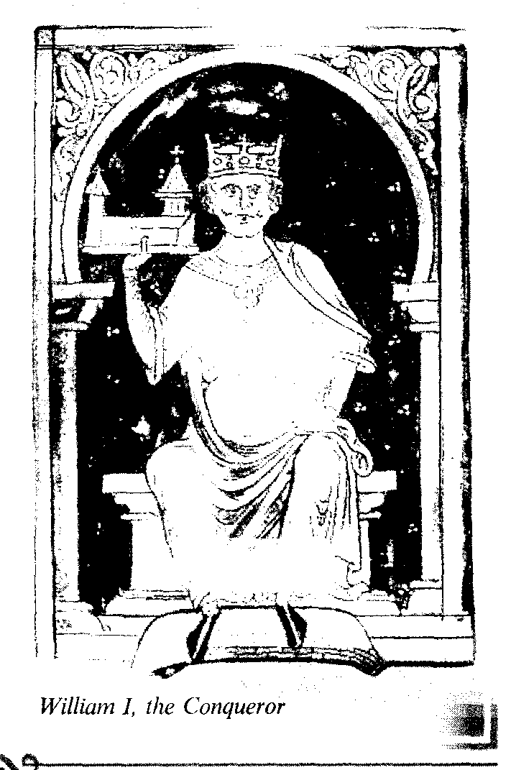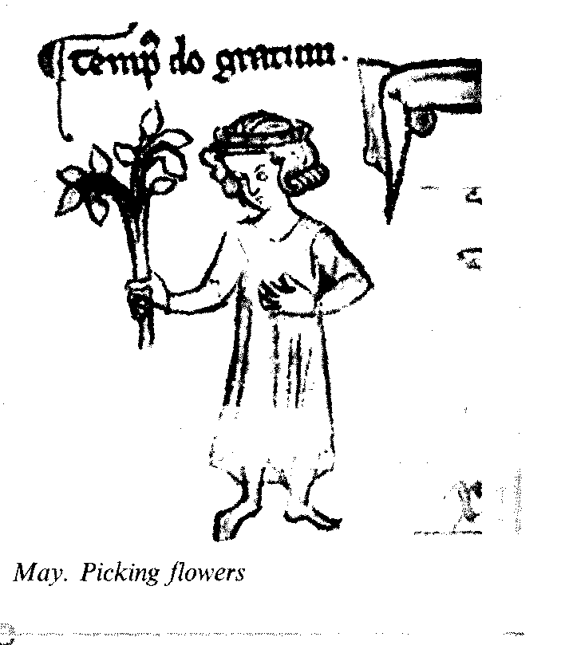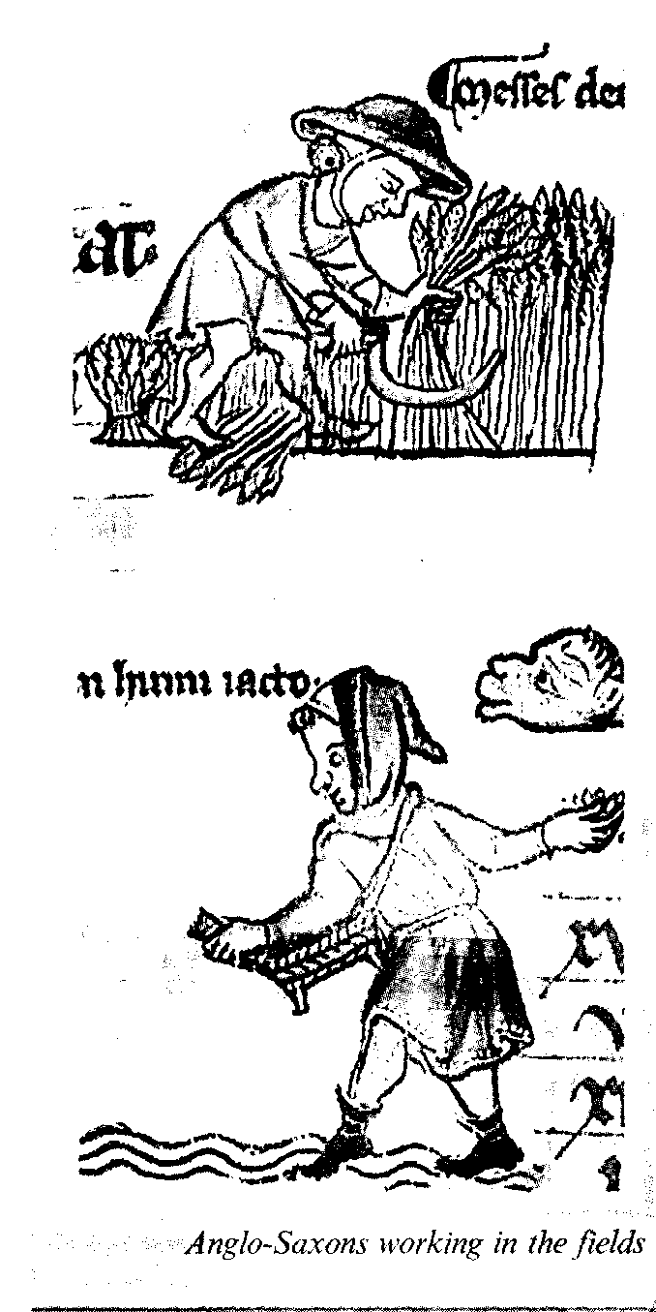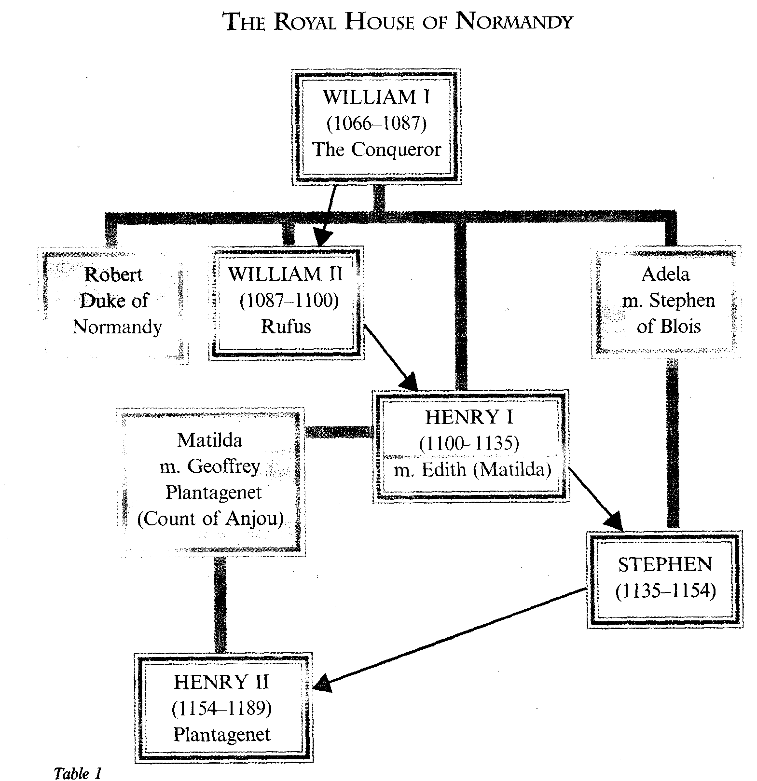

**William I The Conqueror** (1066-1087) (the Norman Dynasty) died as a result of falling from his horse in a bat­tle in France, was succeeded by his two sons, one after the other:

**William II** (1087-1100) was cruel but a brave soldier, little loved and little missed when he died.

**Henry I** (1100-1135) was scholarly and well educated. His daughter was married to the German Emperor Henry V, and later upon his death to Geophrey of Anjou; the son of Geophrey of Anjou (An­gevin) became the first Plantagenet*.

* Planta genista – Latin for **"broom".**

**Henry II** (1154-1189) was friendly with **Thomas Becket,** a humble clerk, who was appointed the archbishop of Canterbury. Henry misjudged this man who considered his first loyalty to be the Church and not the King.

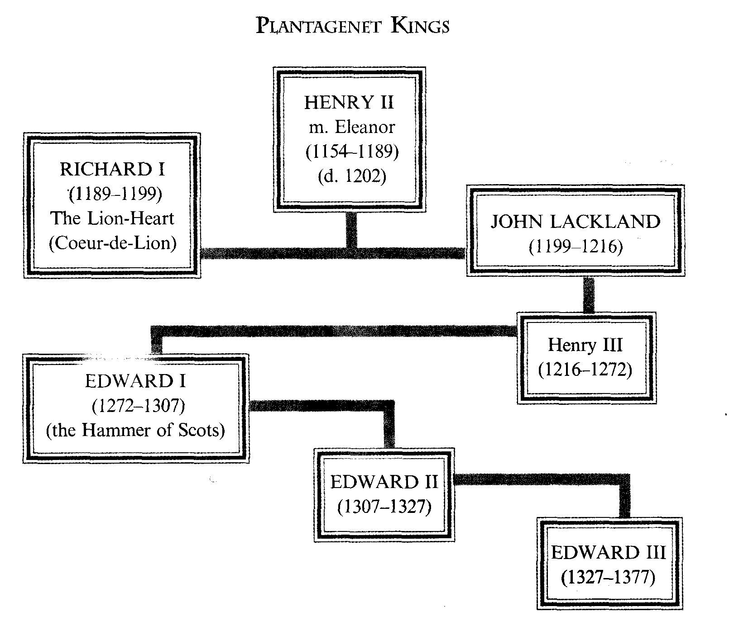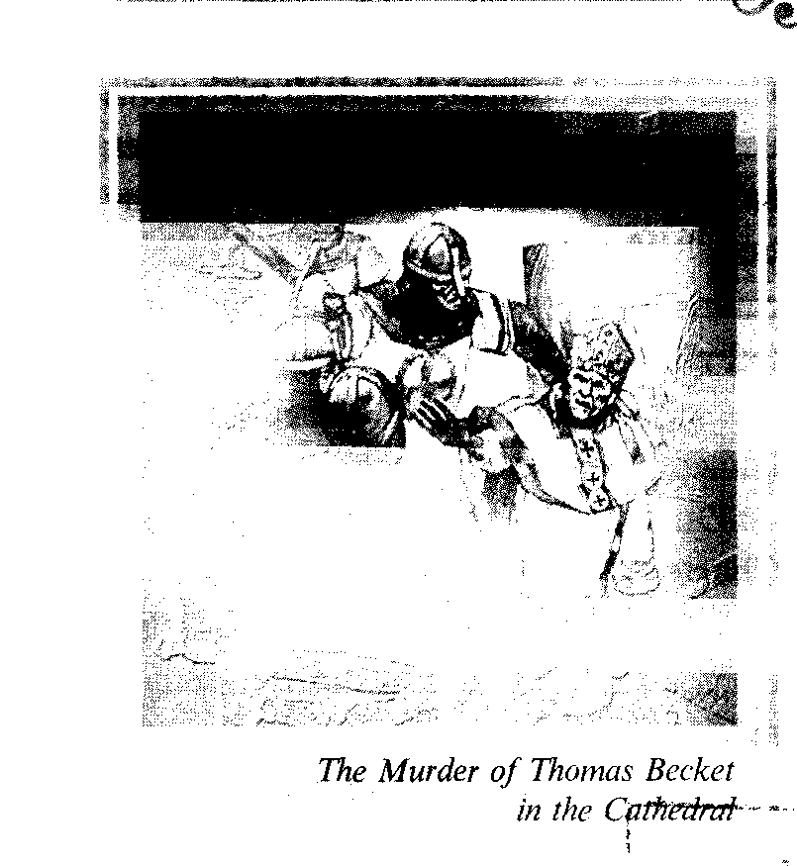

The conflict ended in the murder of Thomas Becket in his own cathedral by the King's servants. Becket was cano­nized (St. Thomas); his shrine became a place of pilgrimage for the whole of Eu­rope, for the cures effected there, until it was destroyed by Henry VIII in 1538. So the King of the House of Plantagenet was the first to have a conflict with the Church and he physically destroyed the opposition.

His wife Eleanor took a lively inte­rest in politics. Somewhat too lively at times, for she abetted (helped and supported) her song when they rebelled against their father, she was, as a result, imprisoned.

Henry II's reign was one of constitu­tional progress and territorial expansion.

**Richard I the Lion-Heart** (1189-1199).

**King Richard** may have had the heart of a lion but England saw all too little of him. He was called a romantic sports­man and spent most of his life in Cru­sades in the Holy Land.

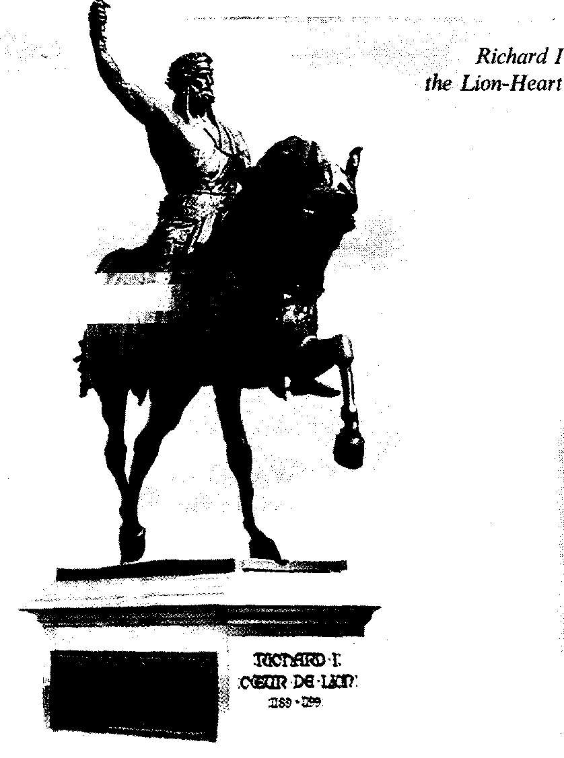

He used England's money to finance his crusades and other adventures, but he was not very lucky – returning from his successful mission, he was captured, and was kept imprisoned in Austria, awaiting the payment of a huge ransom.

He returned to England to stop his younger brother **John** from usurping the throne, soon after, he rushed to fight King Philip of France who had support­ed John. Philip was defeated but Richard was killed in a siege of a castle.

His wife who never set foot in Eng­land, left no children. So, **John (Lack­land)** (1199-1216), the youngest son of King Henry II, continued the dynasty's rule.

**King John Lackland** was the most un­popular king: he lost most of his French possessions; he broke his father's heart with his misbehavior, he rebelled against his brother, quarrelled with the Pope, etc. The list of his stupidities and misdemea­nours was endless but he did one good thing (or was forced to do it). In 1215 the barons made him seal **the Magna Carta,** which, though it limited the pre­rogative of the Crown and extended the powers of the Barons, has since become the foundation stone of an Englishman's liberty.

The pressure on the pocket is more quickly felt than the pressure on the mind - that is why John Lackland was forced by his barons to seal **the Magna Carta Libertata** (the Great Charter of 1215). Pressed by the demands of war, he had imposed taxes that irritated many of his most powerful subjects. The Magna Carta is a document that dealt with priv­ileges claimed by Norman barons. It was to become part of the English constitutional inheritance, because the baronial claims for liberties were in time transla­ted into the universal language of free­dom and justice. It was the beginning of limiting the prerogatives of the Crown.

During the struggle for the Great Charter (Magna Carta) the legions of barons openly opposed the King – dis­obeyed him, did not pay taxes, raised an army of knights, enjoyed support of townsmen (London supported them), the King was forced to seal the Charter.

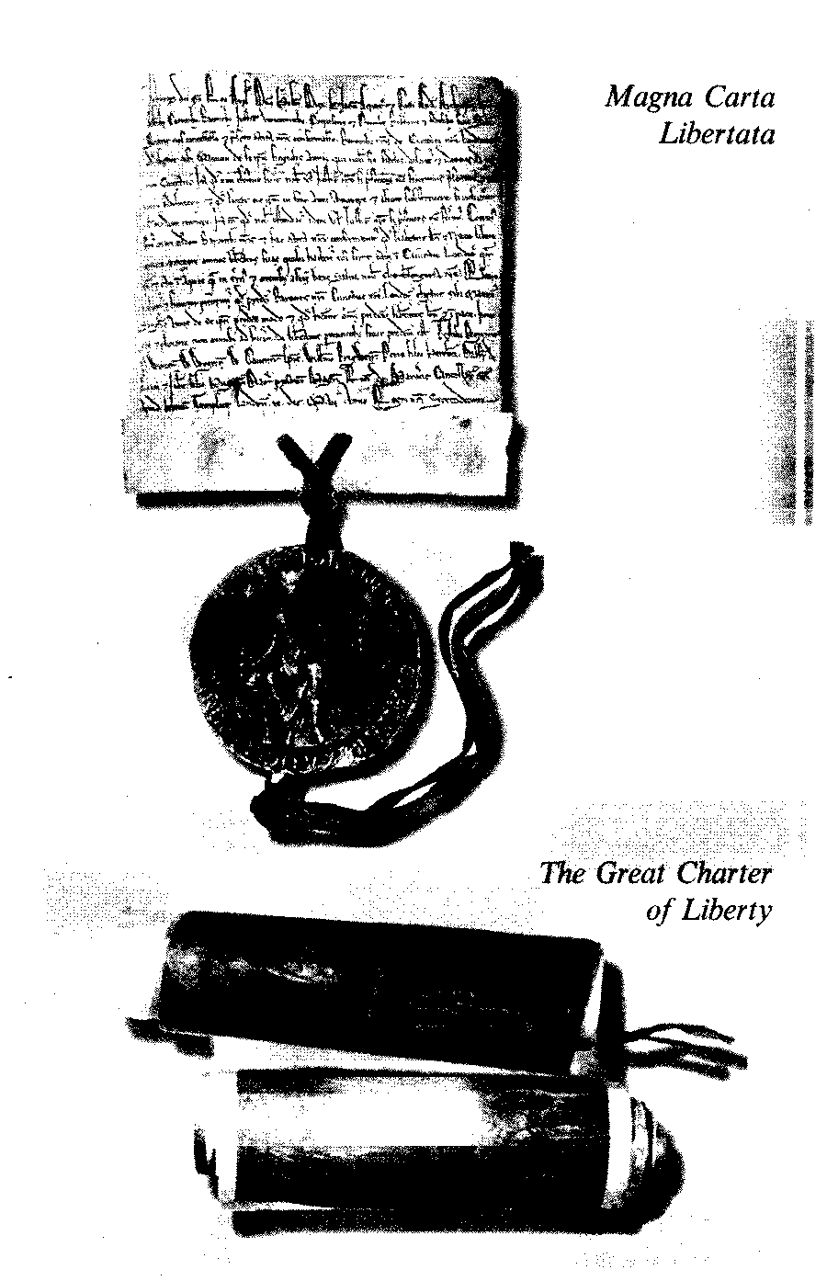

It's important to point out that by li­miting the King's power, Magna Carta restricted arbitrary actions of barons to­wards knights and proclaimed the pow­er of law over the free people of the country.

King John was succeeded by his son **Henry III** (1216-1272). He was not as bad as his father but he was continually short of money and extravagant by na­ture.

Henry III faced a further development of baronial ambitions and protests. They accused the King of violating their rights and liberties. After a very bad harvest in 1257 Henry III demanded a third of all English property. This aroused a new ba­ronial riot. The barons finally came armed to the Parliament at Oxford and drew up "provisions"–"Oxford Provi­sions" and additional "Westminster pro­visions"–to protect the knights from barons which gave all the power in the country to barons. The King and his son did not want to become puppets; and as a result a military conflict developed.

The country was divided into sup­porters and enemies of the King and a Civil war broke out.

The army of barons was headed (led) by **Earl Simon de Montfort** and was at first successful in capturing the King's fortresses and castles. They were greet­ed by townsmen and students of Oxford and church bells.

In 1264 Earl Simon took the King prisoner; in **1265 – Parliament** was sum­moned with "commons" represented in it – two knights from a shire and two merchants from a town.

Prince Edward, Henry's son and heir, (later to succeed Henry as **Edward** I) res­cued Henry. King Henry III managed to defeat Simon de Monfort and killed him in a battle and secured his Crown and his rule.

The **1295** Parliament was called **Mo­del Parliament,** though it assured a con­tinuity of the **1265** Parliament of Simon de Monfort.

The commons were summoned by the King's Writ to some of the Parliaments (one in eight before 1284; one in three – in the later years of Edward the I's reign, one of which was the so-called Model Parliament of 1295).

The "Oxford Provisions" were not observed by Kings. So, in the 12th and 13th centuries, relationships between the king and the barons, and the making of Parliment were the main historical phe­nomena of that period.

During the reign of Edward I (1272-1307) there were not only lords, bishops and great abbots present in Parliament, but there were also "commons". This demonstrated the growing wealth and importance of townsmen and knights of the shire not only in the local communi­ties but also in the whole country.

Economics and politics were very closely connected, and the King's main goal in summoning Parliament was to raise money from the population through taxes – 1/10th from people in towns, 1/15th – from the people in the country.

Social relations in the country were undergoing changes in the 13th centu­ry. Enforced **labour services** by villeins were giving way **to** **wage labour,** and vil­leins commuted their labor-dues by pay­ing money to the lord instead. Then the pattern changed: the lords again required labor services. But a lot of villeins were freed, and some of the freed were able, energetic or lucky enough to buy land and prosper as **Yomen.**

The 13th century was a period of substantial economic activity. Wheat was shipped overseas, but the country's wealth was coming from the exports of wool**.** Later on, when the wool began to be made into cloth in England, rather than exported as raw material, it stim­ulated the growth of industry. In the 13th and 14th centuries England was far behind Flanders in the production of cloth but there was enough develop­ment.

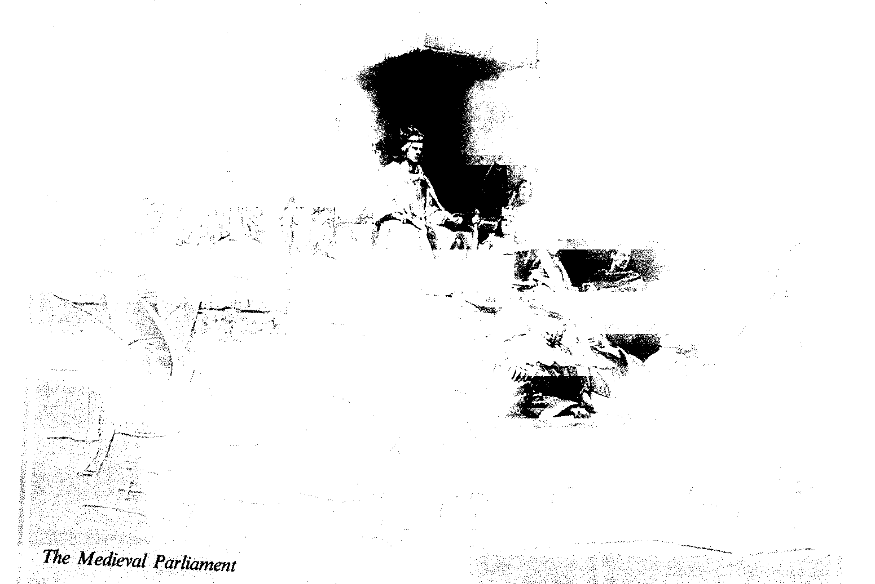

*Questions:*

*1. What were the peculiar traits of the Norman Rule in England?*

*2. What was the meaning of the term "feudalism" in relation to Norman England?*

*3. Why was the Domesday book written?*

*4. What were the political, social, economic and cultural consequences of the Norman Conquest?*

*5. When was the first conflict of the King with Church?*

*6. What do you know about the relations in the family of Henry II?*

*7. What was the first attempt to limit the power of the King? When was it and why?*

*8. When did the British Parliament appear and how did it develop in the Middle Ages?*

*9. What were economic and social relations in the early Middle Ages in England?*

## Later Middle Ages

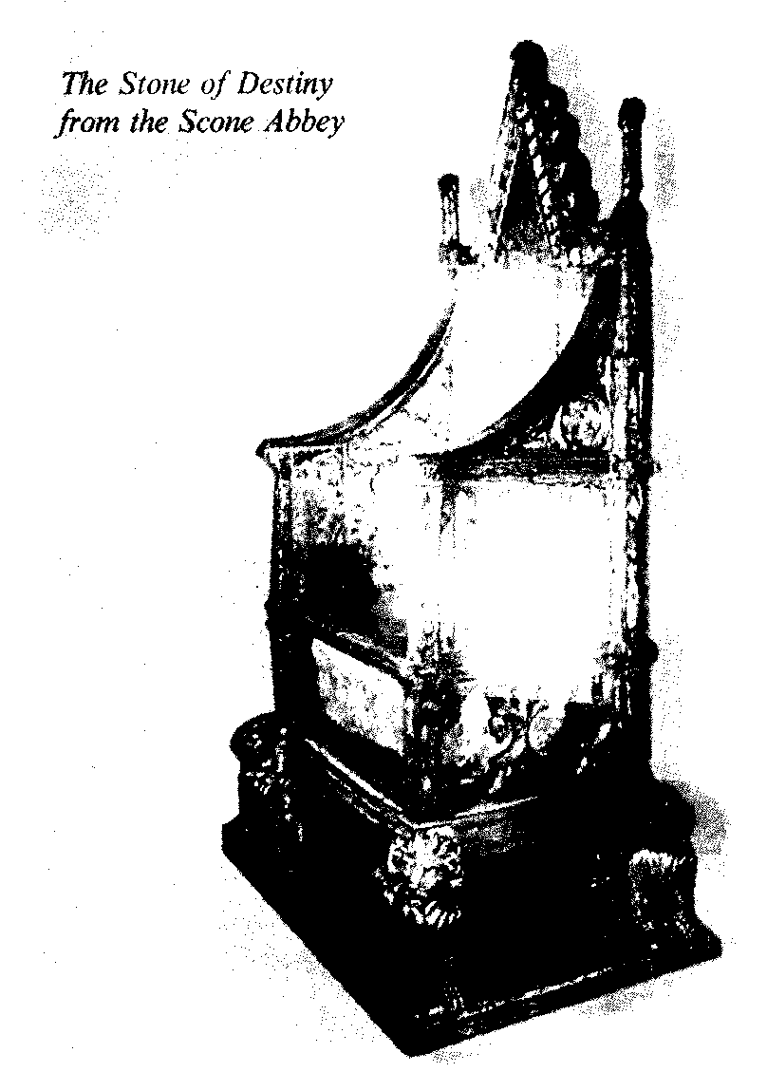

Edward I (1272-1307) was determined to strengthen his royal authority and his Kingdom. To do that he asserted his rule in all territories on the British Isles, especially in Wales and Scotland. He succeeded in imposing English rule on Wales: his son, who was born in a Welsh castle and "could spell not a word of English” at that time, la­ter, in 1301 was created the Prince of Wales and ruler of the principality. Since that time the eldest son of the English monarch has been given that title.

Relationships between England and Scotland were similar to those between England and Wales, but the Scots had a greater degree of independence. Edward I had made several military raids to the Northern kingdom, seized the national treasure – **the Stone of Destiny from the Scone Abbey** (1296) but had failed to sub­due the Scots. Edward I who had been called "the Hammer of Scots" died not far from the border of Scotland during his last abortive campaign to defeat the Scots.

The rule of his son, EdwardII (1307-1327) is traditionally characterized as a great failure of the hereditary principles of Monarchy: Edward II had no talent to be a King, but he was the eldest son and succeeded his father. He angered the barons by his foolishness, his extrava­gance, favourites and military defeats. His reign was a troubled one and he was deposed and forced to abdicate by the barons, assisted by his wife. He died, probably murdered, and was succeeded by his son, Edward III (1327-1377).

Edward III is recognized by histori­ans as a passionate fighter, who was fond of tournaments, chivalry and battles. He instituted the **Order of the Garter** and cultivated the spirit of chivalry at his court. He pursued a sensible policy of tolerance with barons, thus securing their loyalty. His commercial policies facili­tated the development of wool trade and rise of prosperity. But the warrior king was eager to lead his knights in battles, so Scotland was his first rather hard prey as he had failed to subjugate it, though having taken its King David prisoner to England. The dynastic accident helped Edward III to start the Hundred Years' War (1338-1453) which was carried dur­ing the reigns of five English Kings.

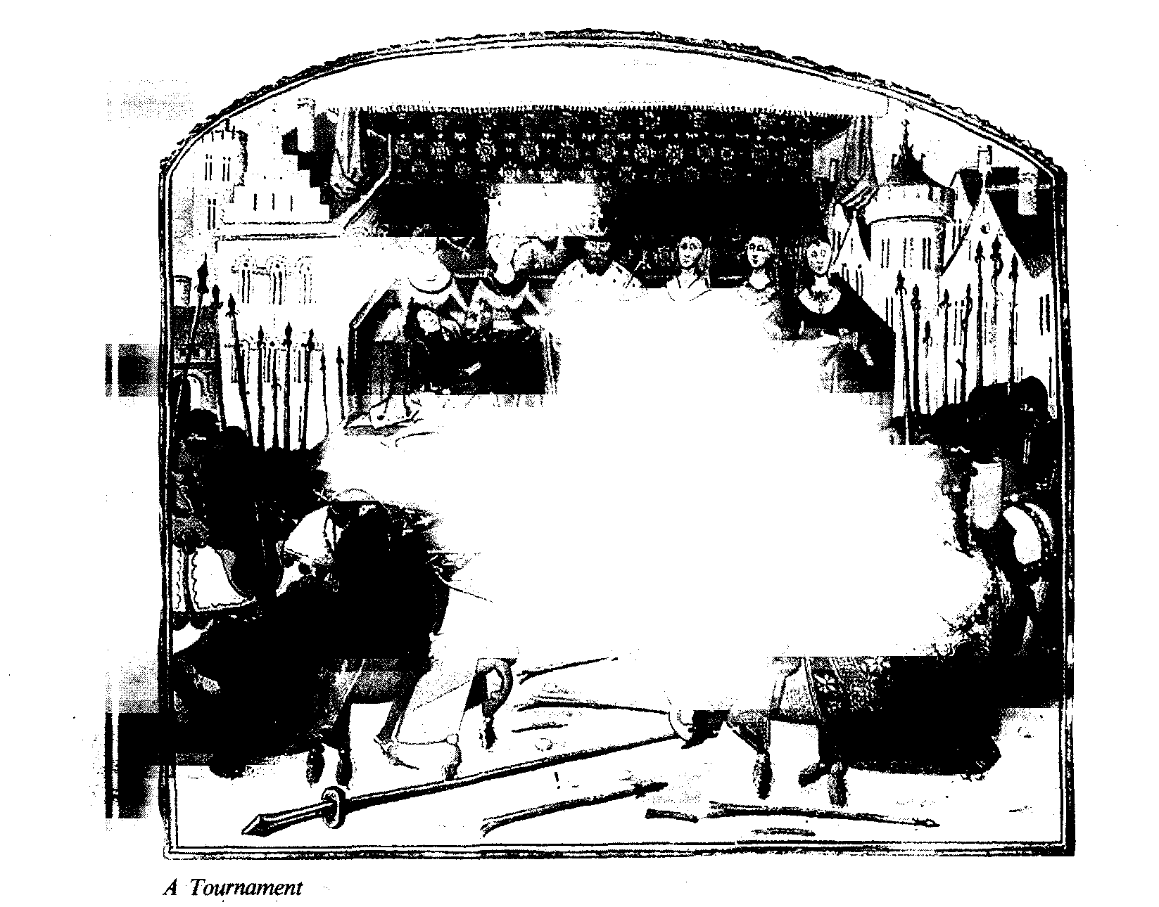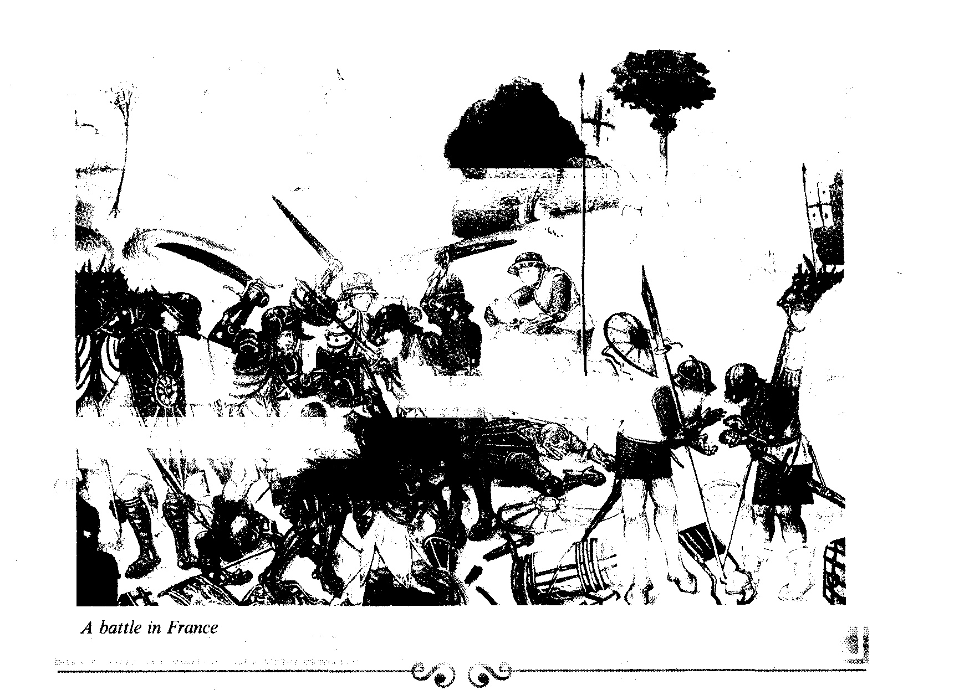

Edward declared his claim to the French throne, as his mother had been the sister of Charles IV, king of France, who left no male heir when he died in 1338. This was a respectable enough rea­son for the war to return the lost Eng­lish lands in France. The results of the first stage of the war were not as suc­cessful as the English had expected them to be. But several victories were won at sea (1340 at Sluys), and in the field– Gascony was recaptured, at Crecy the English archers made the King of France flee from the battle field, Calais after a long siege surrendered in the face of star­vation. King Edward's eldest son,– Ed­ward, the Black Prince, a warrior of a high reputation, in 1356 won a victory as Poitiers. In 1348 the outbreak of plague, **"the Black death"** dealt a terri­ble blow at the people of Europe and England. It was a terrible disaster, more than 1/3 of the English population died.

The economy and trade of England suffered and the social unrest was spread­ing due to the results of the economic, social, political and military status. Vio­lence was sparked off by yet another polltax of 1381. People revolted against the tax-collectors and judges, in the south and south-east of England. The rebels, led by Wat Tyler and John Ball, a cler­gyman, marched to London, captured the Tower with the help of Londoners, killed the archbishop of Canterbury and the Lord Chancellor. John Ball was a radical opponent of the Church-lords and supported the ideas of John Wycliffe, the first reformer of the Church (1330–1384). He preached ideas of so­cial justice: "When Adam delved and Eve Span who was then the gentleman?"

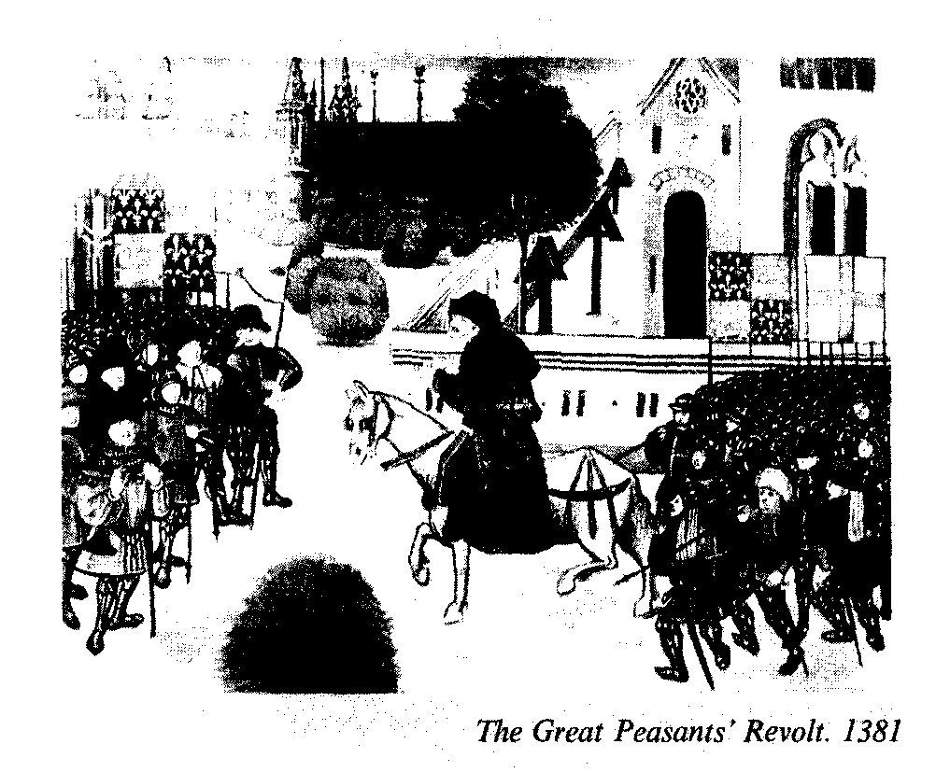

The Peasants' Revolt made far reach­ing demands: a charter of liberties, the end of all lordship except the King's, the end of serfdom, return of church land to people, etc.

The young King Richard II met the Kentismen face-to-face at Smithsfield. Wat Tyler was pronouncing their de­mands which were unacceptable to feu­dalism.

The King appeared to agree but dur­ing the negotiations Wat Tyler was treacherously killed and his head, set up on a spear, was shown to the rebels to persuade them to retreat from London and disband. Shocked and morally de­stroyed they obeyed only to be physically tortured and executed, John Ball was hanged. The punitive actions continued long into autumn. The Great Peasants' Revolt was defeated. But the ruling class had been badly frightened and the un­popular Poll Tax withdrawn.

Through a primitive faith in the King (a kindly king) senior lords prevented the peasants from any attempts to establish their power. But the rebellion under­mined the strength and rule of the feu­dal class and as a consequence few bar­ons dared to refuse the peasants attempts to buy freedom. Actually, peasant de­pendence in Britain disappeared by the 15th century and the Wat Tyler rebel­lion was instrumental in that.

King Richard II (1377-1399) after considerable civil struggle, eventually wrested the power from Parliament and the barons. He seems to have pursued a policy of revenge and high-handed des­potism.

He brought Duke John of Lancas­ter's son Henry to England, but Henry gained enough support to take King Ri­chard prisoner and cause him to abdi­cate in his favour. The House of Lan­caster's Henry IV (1399-1413), Henry V (1413-1422), Henry VI (1422-1461)– were followed by the kings of the York family – two Edwards: Edward IV and Edward V, and Richard III, a hunch back, a cruel monster, deformed in body, mind and soul according to the Tudor historians).

There is a statement, that King Rich­ard II was the last King from the House of Plantagenets – he was deposed and dethroned by **the House of Lancaster.** But it is to be stressed, that the two new royal branches were related to the Plan­tagenets, were the derivatives of the main stem.

The 13th century was described by historians as a Plantagenet spring after a grim Norman winter.It was the centu­ry of the new gothic style in architec­ture, of Salisbury Cathedral, foundation of universities, the development of the Common Law & the Parliament, and the emergence of English as the language of the nation. The symbol of this spring can be seen in the lyrics "Summer is icumen in". But the following two centuries were filled with wars, discord and discontent.

The 14th century – brought the dis­asters of the Hundred Years War (1337-1453) the Peasants' Revolt 1381, the ex­termination of the population by the Black death (1348-1349) and punitive execution of the participants, with posi­tive achievements in literature (Geoffrey Chaucer completes the Canterbury Tales (1393)),– architecture,– and further strengthening of the English language.

The 15th century saw the continua­tion of the struggle for the crown and the establishment of the Lancaster dy­nasty in the person of Henry IV, King of England (1399-1414).

*Questions:*

*1. How did Edward I manage to impose English Rule on Wales?*

*2. What were the English relations with Scotland in the reign of Edward I?*

*3. What were the military and territorial ambitions of Edward III? Please give the dates of his rule.*

*4. What were the reasons of social unrest in England in the last quarter of 14th century? Speak of the Great Peasants' Revolt.*

*5. Why is the destiny of the last Plantagenet King Richard**II**considered tragic?*

*6. Please give a concise characteristic of the 14th century.*

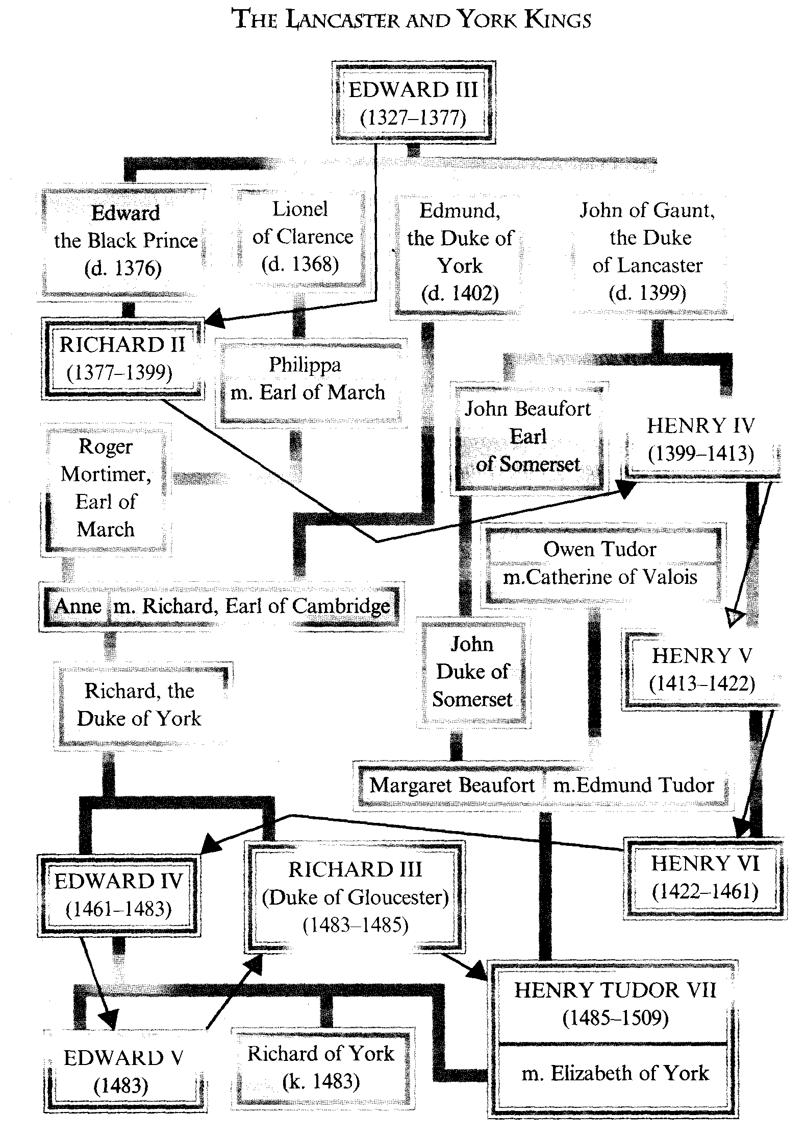

## Britain in Late Middle Ages

LANCASTER DYNASTY. WARS OF THE ROSES. THE TRIUMPH OF THE TUDORS. ECONOMIC DEVELOPMENT OF BRITAIN. THE ABSOLUTE MONARCHY OF HENRY VII, TUDOR.

*Key words, terms and concepts:*

*1. Wars of the Roses*

*2. Indentures*

*3. Knights and esquires*

*4. Bastard feudalism*

*5. Vassals*

6. *A crest*

7. *Annihilation*

*8. Esquire*

9. *A printing press*

*10*. *A* *village common*.

*11. To disband baronial armies*

*12.* *Controversial arbitrary developments*

*13. Saint Joan of Arc*

The Lancaster Kings continued campaigns in France in the Hundred Years' War: Henry V (1413-1422) was successful in his expeditions in France, HenryVIthough having been crowned to Britain and France, lost those French lands and probably Saint Joan of Arc helped the French. Henry VI's reign ended in (1422-1461), confusion, deposition and a cruel war – the Wars of the Roses, a term coined by Sir Walter Scott (1455-1485).

During the Wars of the Roses, great men attached lesser men to their service by lip indentures; the Duke of Lancas­ter had pointed the way in the late four­teenth century. When he indentured a large number of knights and esquires, most of them were retained for life in his service and in war and peace. Such bas­tard feudalism as this has been called, was quite different from feudalism. The retainer was not a vassal, who owed loy­alty to his lord and was linked to him through ties of mutual obligations. The retainer's lord was his patron, and he was his follower, wearing his livery and being maintained by him.

The Wars of the Roses began when in 1399 barons of the North supported the Lancaster who had a red rose in their crest. The Barons of the South support­ed the Yorks whose crest was decorated by a white rose. The bloody struggle for the crown and rule practically lasted for about 30 years (1455-1485) with some breaks, it was a merciless annihilation of the old aristocracy with rights and claims to become rulers, and its romantic name the War of the Roses only em­phasizes the ruthlessness by a degree of contrast.

Finally, the two dynasties had been destroyed, and a distant relative of the Lancaster family – Henry Tudor mar­ried Elisabeth of York in 1485 (the two roses united) and Henry Tudor was crowned Henry VII of England (1485-1509).

The 15th century with its baronial wars though putting brakes on the de­velopment of the economy could not stop the progress of productive forces released by the disintegration of depend­ent feudal relations in agriculture.

The 15th century saw a development of woolen textile manufacture, steel making developed (South Wales, Birmingham and Sheffield), trade develop­ment facilitated the growth of the Navy and shipbuilding.

The formation of the common na­tional language manifested itself in fic­tion and Geoffrey Chaucer (1340-1400) works (Canterbury Tales) and in geo­graphical, commercial, etc. books.

William Caxton (1477) brought a printing press and started book printing in England.

Since the middle of the 15th century the English language became the one working language in the whole of Eng­land.

The 15th century saw a development of folklore – ballads of Robin Hood's were dramatized on the village com­mons; singing and other musical arts, dramatic arts, portrait painting left won­derful examples for us to admire.

So, in the 15th century for all the con­flicts, the forces of progress were break­ing through, laying foundations for de­stroying feudalism, for developing capi­talism and formation of the English na­tional economy.

*Questions:*

*1. What was the reason of the Wars of the Roses and was it a*

*romantic event?*

*2. What was the end of this**baronial bloodshed and how was the struggle finally finished?*

*3. What industrial progress was achieved in the 15th century?*

*4. What were the great cultural achievements of that age?*

*5. Give a short general outline of the main political, economic**and**cultural events**in the middle ages in Britain.*



# THE TUDOR AGE

# (1485–1603)

THE NEW DYNASTY. THE ENGLISH REFORMATION, HENRY VIII AND HIS HEIRS.

THE GOLDEN AGE OF ELIZABETH. MARY QUEEN OF SCOTS.

*Keywords, terms and concepts:*

*1. The Court of Star chamber*

*2. Thomas More*

*3. Cardinal Wolsey, Thomas Cromwel*

*4. Catherine of Aragon*

*5. Anne Boleyn*

*6. Jane Seymour*

*7. Anne of Cleves*

*8. Catherine Howard*

*9. Catherine Parr*

*10. Mary Queen of Scots*

*11. The Act of Supremacy (1534)*

*12. The Act of Union with Wales (1536)*

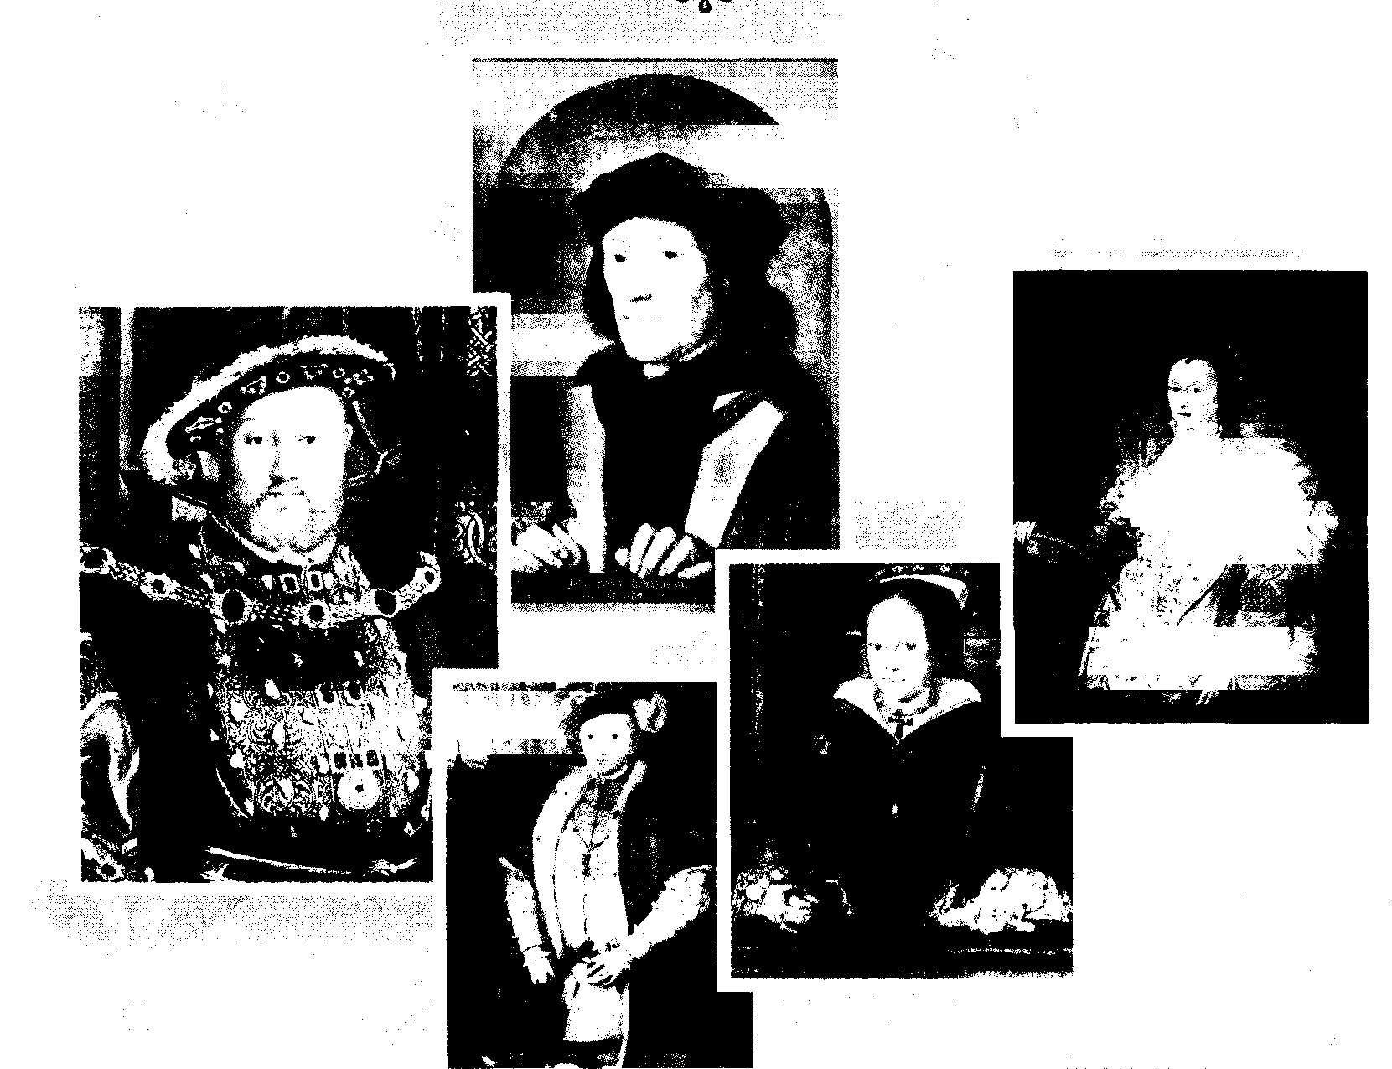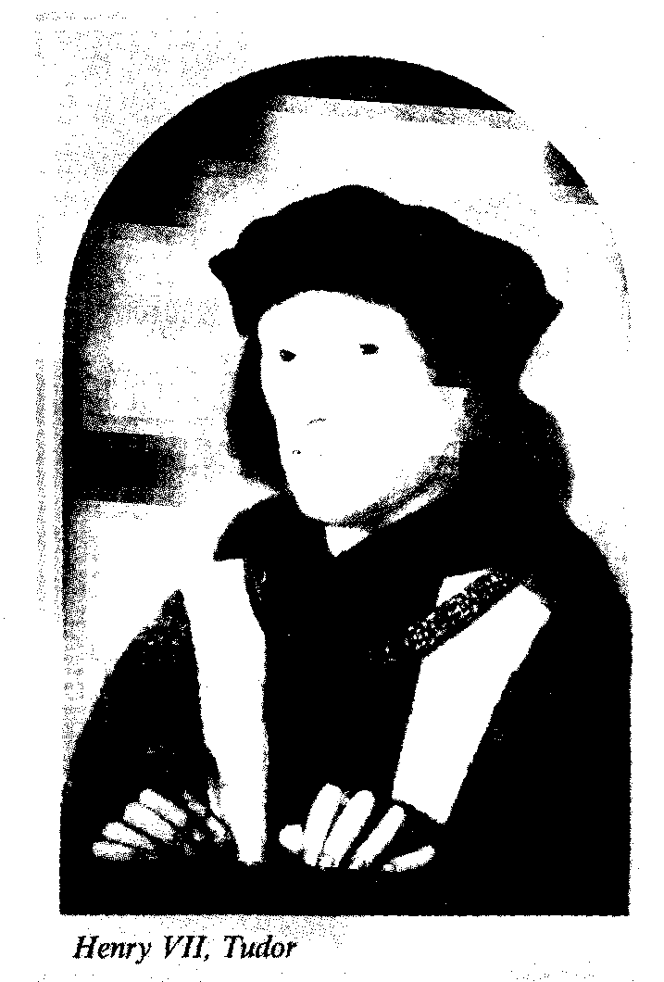

The end of the Wars of the Roses, the victory of Henry Tudor at Bosworth field and his marriage with Princess Elizabeth, heiress of the House of York (1485) were the events that sym­bolized the end of the Middle Ages in Britain. The year of 1485 is traditionally considered the watershed and the beginn­ing of the Tudor Age.

In historical development the rule of the Tudors (1485-1603) with their abso­lute power in the long run contributed to the strengthening of its role in interna­tional affairs.

The 16th century was the age of a growing absolutism of monarchy and centralisation of the state; these pheno­mena facilitated the development and foundation of new capitalist relations in production.

The English type of absolute monar­chy was shaped by Henry VII, who was opposed to the power of old barons. He ordered that the old castles should be destroyed (pulled down) and the feudal baronial armies should be disbanded. He was very rich with the confiscated wealth of his defeated rivals. He was strong enough to prevent any revival of armed strenghth of any group of nobles, and he enjoyed support of merchants and small landowners who had all suffered from the civil war.

These two groups, linked by a com­mon interest in the wool trade not yet powerful enough to claim the political power were to fight for in the 17th cen­tury. They were strong enough to be use­ful allies of the Tudor kings and queens. Their support enabled the Tudors to be­come despotic rulers, while at first play­ing a progressive historic role.

But their reign was abundant in vari­ous controversial arbitrary developments.

The financial policy of HenryVIIfilled the Treasury and strengthened the throne and the church position, improved the contacts with Rome. The King skil­fully steered through the complexities of European politics. His eldest son was married to the Spanish princess Cather­ine of Aragon, and his daughter Margaret to King James IV of Scotland.

His son **Henry VIII** (1509-1547) whose court was glamorous with royal games, balls and entertainments, deve­lopment of culture, was among other things – a wasteful monarch, on his death his treasury was practically empty.

Henry VIII's despotism was fatal for the country's progressive minds and ter­rible for his family.

The king invited to court outstand­ing people – humanists of the Renais­sance period: **Thomas More –** "The man for all seasons" – a play and a film with Paul Scolfield in the title role, the great­est thinker and the founder of the Utopic Socialism (1478-1535). In 1516 he wrote a book about Utopia – the best govern­ment structure on the Island of Utopia and was invited and appointed Chancel­lor. But Thomas More dared to contra­dict the King and was beheaded. That was the destiny of many a Chancellor which made the post the most danger­ous in the country.

One could compare the fate of the Chancellors only with the destiny of the King's spouses, the Queens. The plural of the noun is explained by the fact of Henry VIII's record number of wives, their fate is "humorously" described by some school teachers with the following rhyme:

divorced, beheaded, died,

divorced, beheaded, survived.

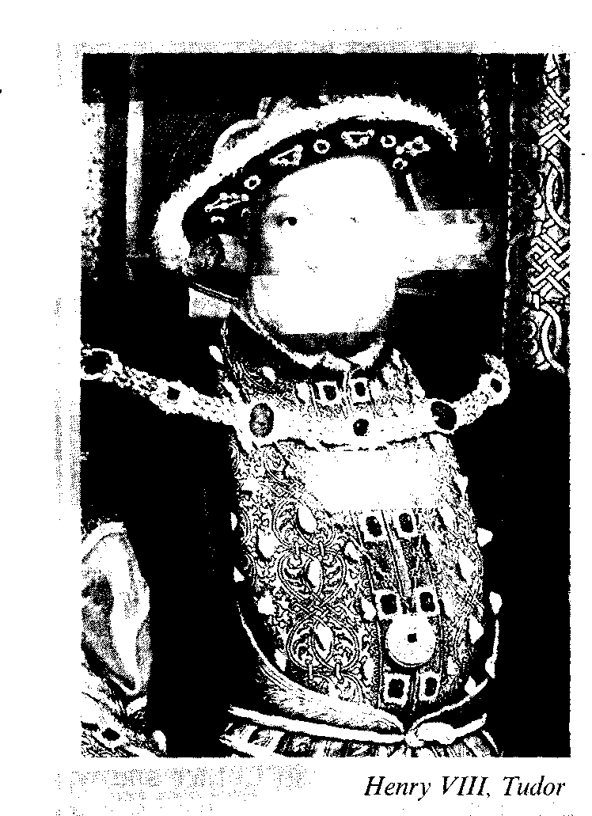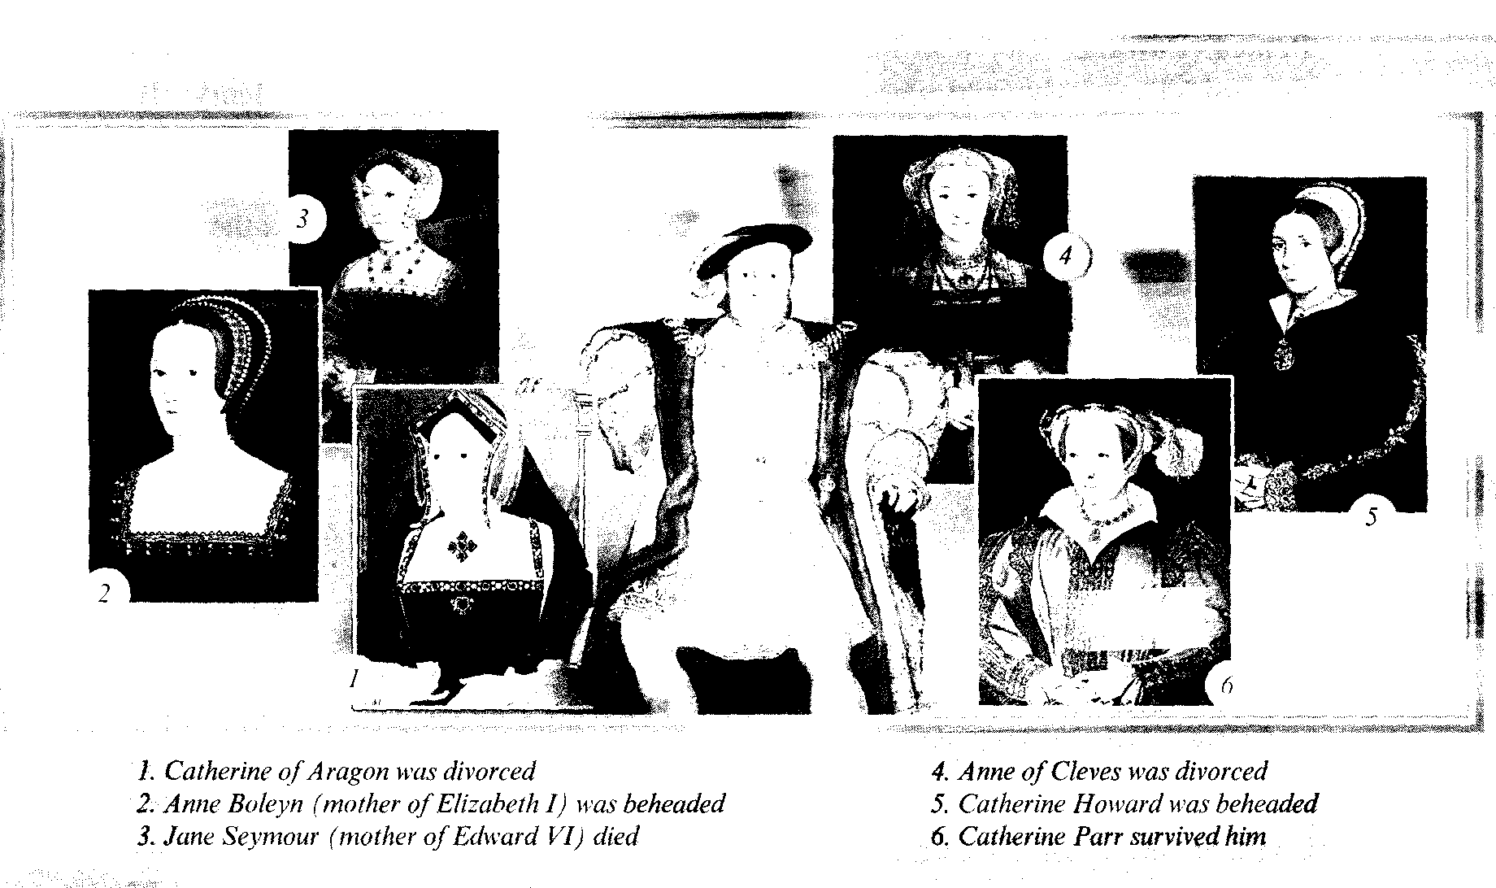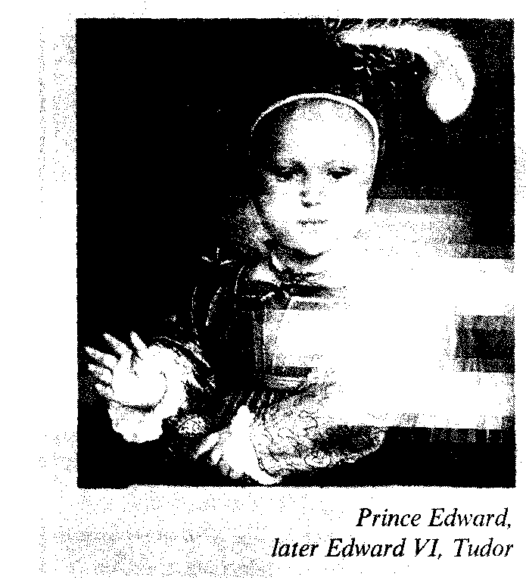

**Catherine of Aragon** was **divorced** by Henry VIII against the will of the Pope and that caused a break up with the Holy See*. The declaration of Henry VIII in 1531 that he now was Head of the Church, was an English way of Refor­mation, so the Reformation in England was conducted from above by the King.

* The Holly See - святейший престол.

His second wife was **Anne Boleyn** (1532-1536). She gave birth to a baby-girl (her daughter was Princess Elizabeth) that caused the disappointment of the King. No one could forsee the triumph of Elizabeth I. He disposed of Anne ac­cusing her of unfaithfulness, and she was **beheaded.** But two days before she died her marriage was dissolved. Henry was a bachelor once more and Anne's decapi­tated body was buried without ceremony in the Tower of London. Ten days later the King was married again. His third wife was **Jane Seymour.** She **died** in 1537 soon after giving birth to a son and heir – **Prince Edward,** (to become later Edward VI) a sickly child who died of consumption in 1553 aged 15 years. Henry VIII died in 1547 and his wife Catherine Parr **survived** him.

Henry VIII had a powerful adviser and a skilful minister Cardinal Thomas Wolsey, who was very rich and ambi­tious. But for all his efforts he failed to get the King a divorce from his first wife Catherine of Aragon as the Pope did not want to anger Spain and France, two Ca­tholic powers.

Henry was outraged with his minis­ter and the Pope. The Power of the Ca­tholic Church in England was out of his authority and he wanted to control it for material and personal reasons. Though at the initial stages of the Reformation in Europe Henry VIII had not approved of the ideas of Martin Luther and was awarded by the Pope with the title Fidei Defensor, – Defender of the Faith. The letters "F. D." are still to be found on every British coin.

The opposition to the Pope as a po­litical prince but not the religious leader was growing in England and Henry VIII started his own Reformation. Thomas Cromwel was his faithful reformer.

In 1531 Henry was elected the Head of the Church of England by the English bishops and in 1534 the Parliament passed the Act of Supremacy declaring him the Supreme Head of the Church of England. His Chancellor Sir Thomas More refused to recognize the Act and that cost him his life – he was charged with high treason and executed in the Tower.

With the help of his new Chancellor Thomas Cromwell Henry VIII ordered to suppress the monasteries, he captured the wealth of the monasteries that had been dissolved and destroyed. The lands of the monasteries were either sold or given to the new supporters who turned out to be enthusiastic protestants all of a sudden.

Within a few years an enormous wealth went into the empty treasury of the King.

In **1536** he managed to unite Wales with England, as the Welsh nobility were showing interest in the support of their representative on the English throne. It was the first **Act of Union** in the history of Britain.

His beloved wife Jane Seymour left him the long-waited-for heir Prince Edward. Mary and Elizabeth had been declared il­legitimate. He wanted to achieve a be­trothal of his son with the future Mary Queen of Scots who was born when Edward was 5 years old. The Scots refused the wooing of the English King as they could see through his far-reaching plans and sent Mary to France. On her return she became Queen of Scots (1561-1567).

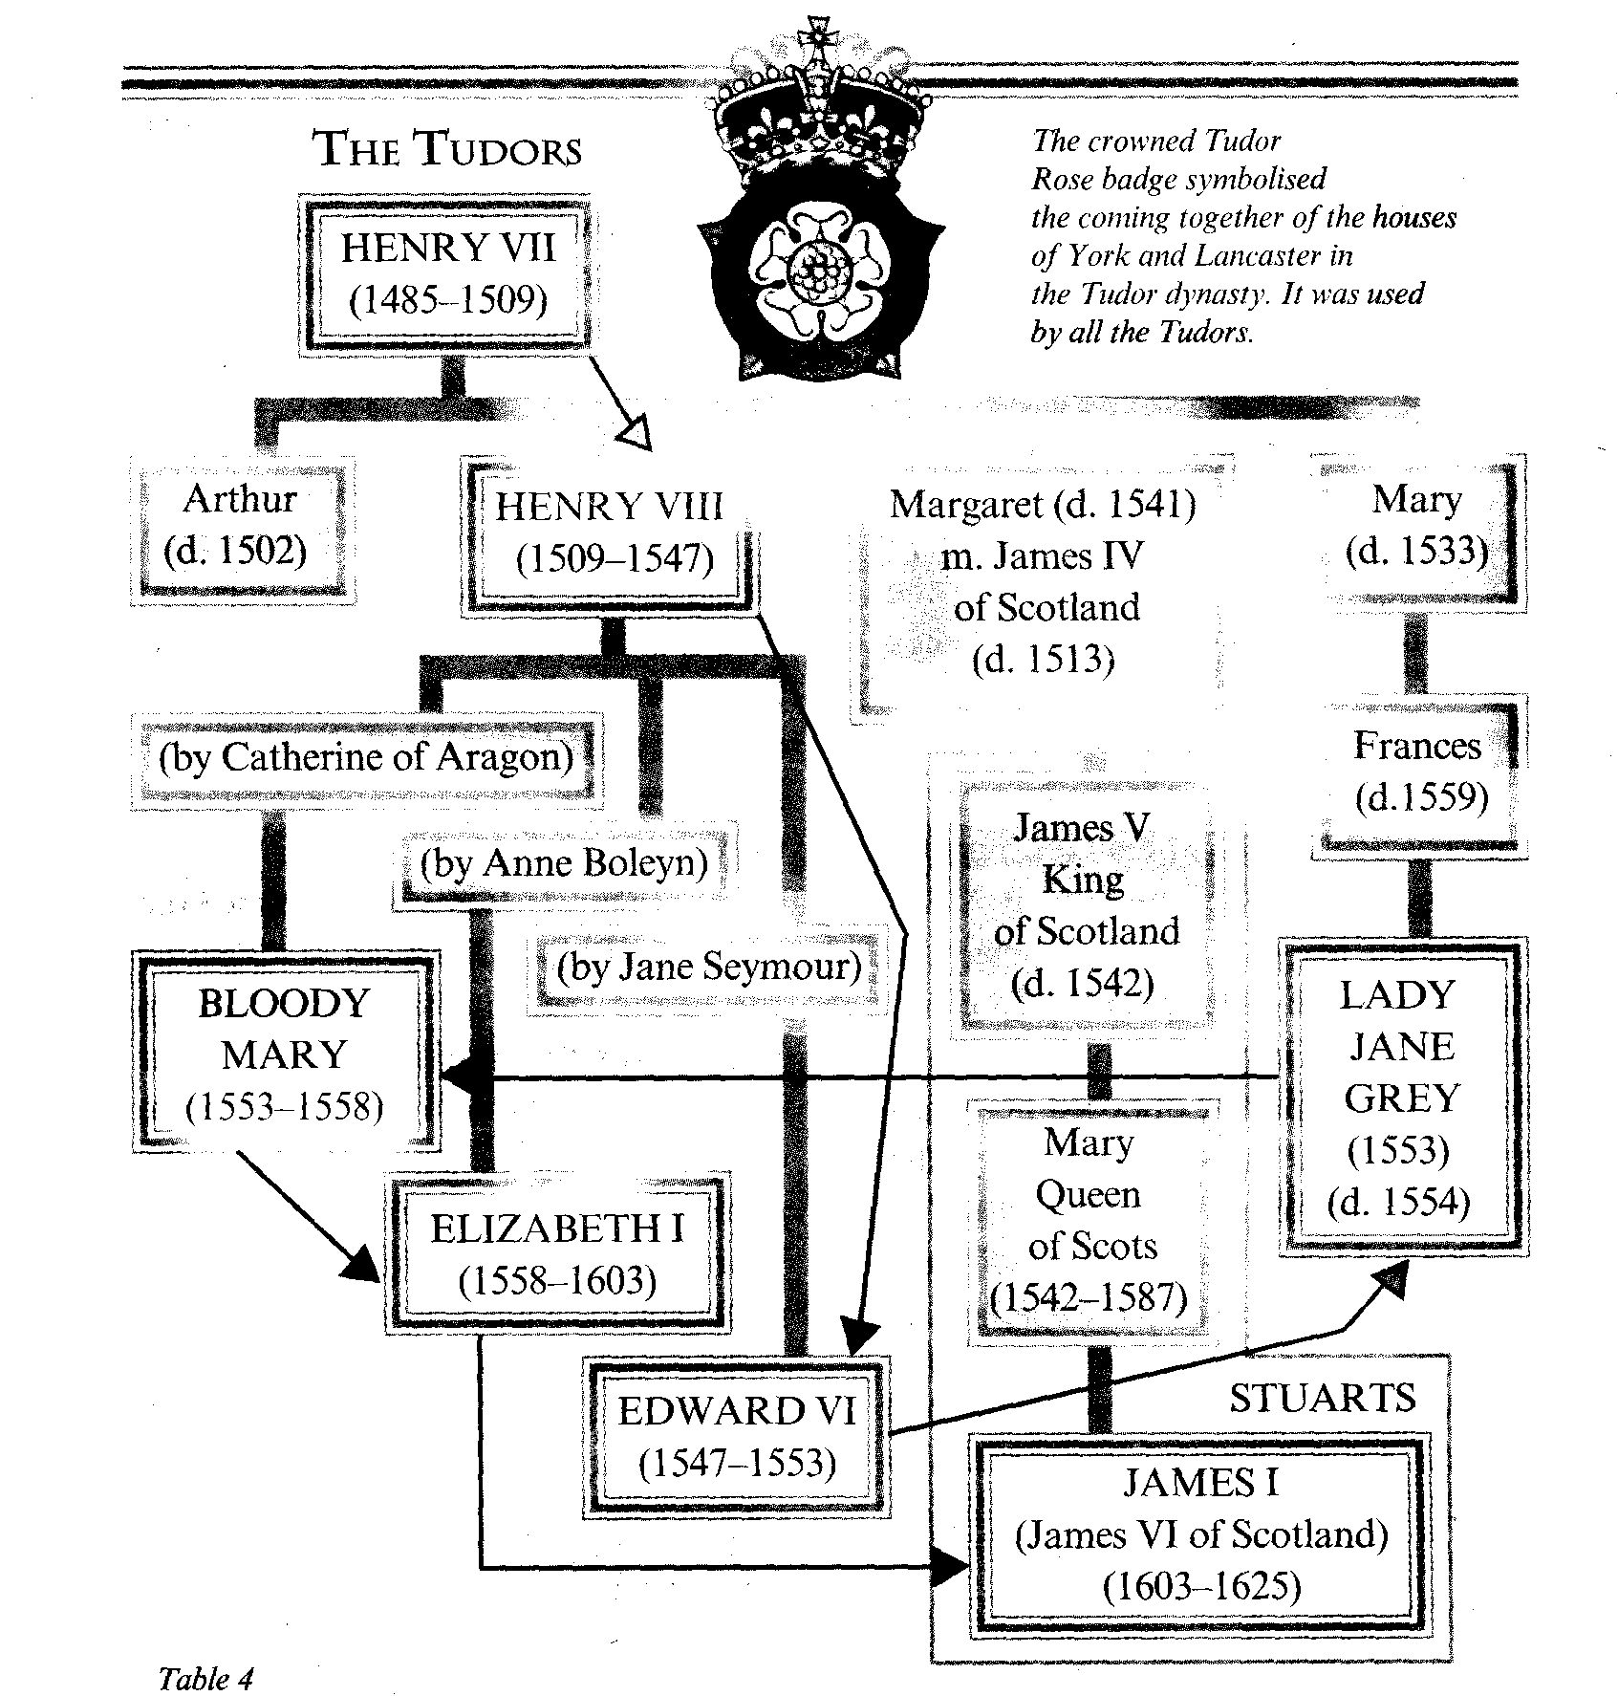

Henry died in 1547. Though he was a gross and selfish tyrant he left his coun­try more united and more confident than before, and his reign was glorified by the Utopian vision of More, drawings of Holbein, poetry and music of the Tudor court and other claims to greatness.

Henry VIII had destroyed the power of the Pope in England, but he didn't change the religious doctrine. He ap­pointed Protestants as guardians of the young **Edward VI** (1547-1553) and they carried out the religious reformation.

After the death of Edward VI there was a highly unstable situation in the country. In his will which contradicted his father's bequest, King Edward VI di­sinherited his sisters and proclaimed Lady Jane Grey the Queen of England (1553). Jane Grey ruled only for nine days. But the people opposed her reign and supported the claim of Mary, the daughter of Catherine of Aragon.

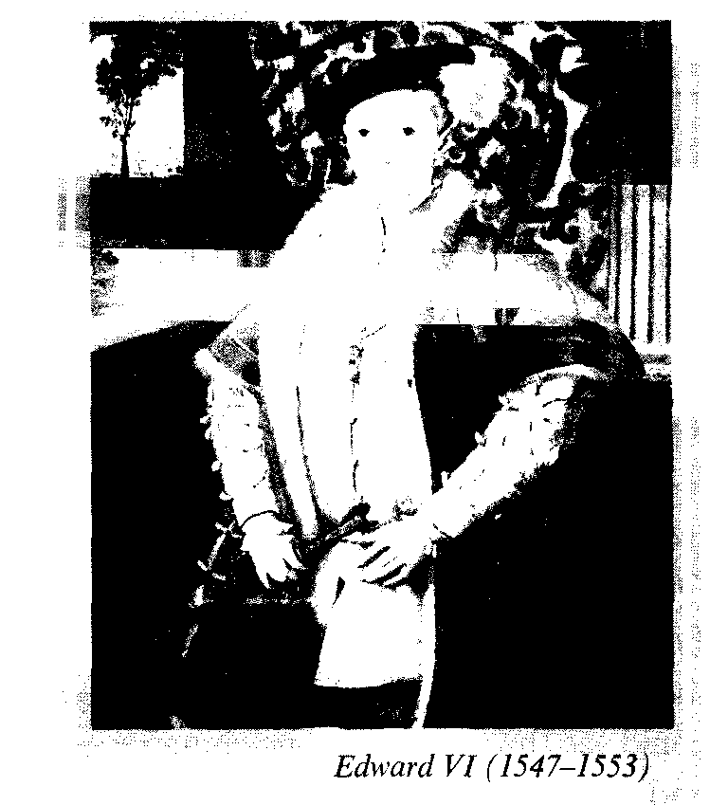

**Queen Mary** **I** was determined to re­turn England back to the Pope, as she was a fanatic Roman Catholic. She failed to understand the English hostility to Catholic Spain, and her marriage to Philip of Spain, son of the Emperor Charles V, was her own idea, celebrated in July 1554 despite the pleas of privy councillors and Parliament. Parliament had to accept Philip as King of England for Mary's lifetime; moreover, his rights in England were to expire if Mary died childless, which proved to be the case. Her marriage was very unpopular and caused several uprisings simultaneously. She crushed the rebels and pursued an aggressive policy against protestants: more than 300 people were executed in the worst traditions of the Inquisition – burned them. That is why she earned the nickname Bloody Mary.

During the reign of Bloody Mary France was the traditional enemy and England was little better than a Province of Spain. Being the wife of Philip II she got England to be drawn into a war with France and Calais, the last English pos­session on the continent, was lost in 1558.

Her reign and life were a political and a personal disaster. When Mary died in November 1558, deserted, unhappy and hated by many, people in the streets of London danced and drank to the health of the new queen.

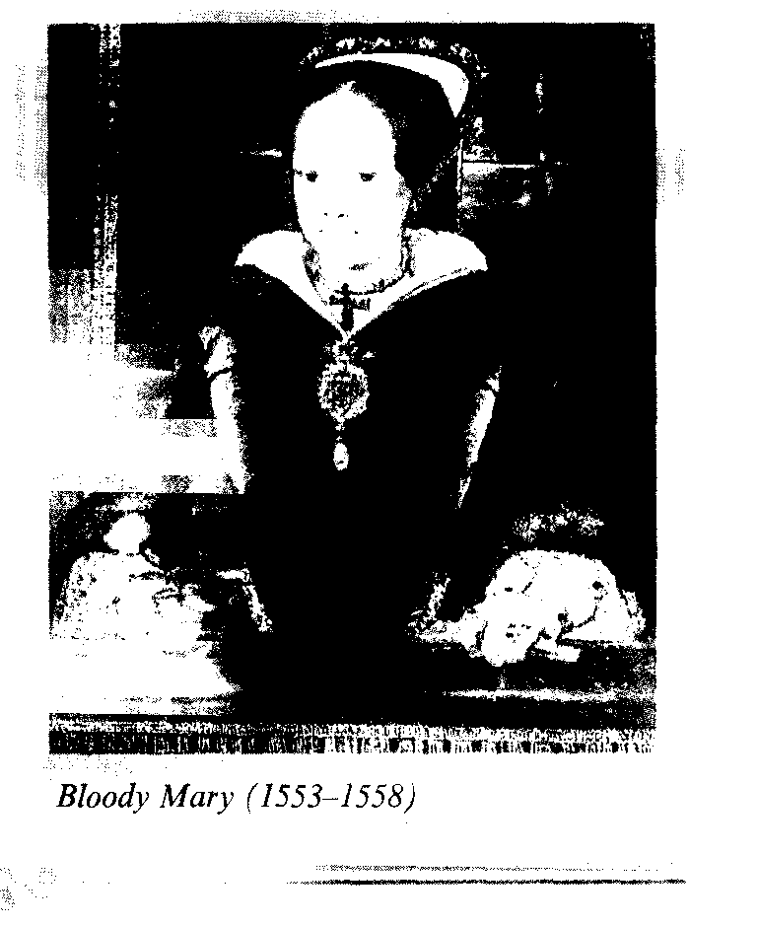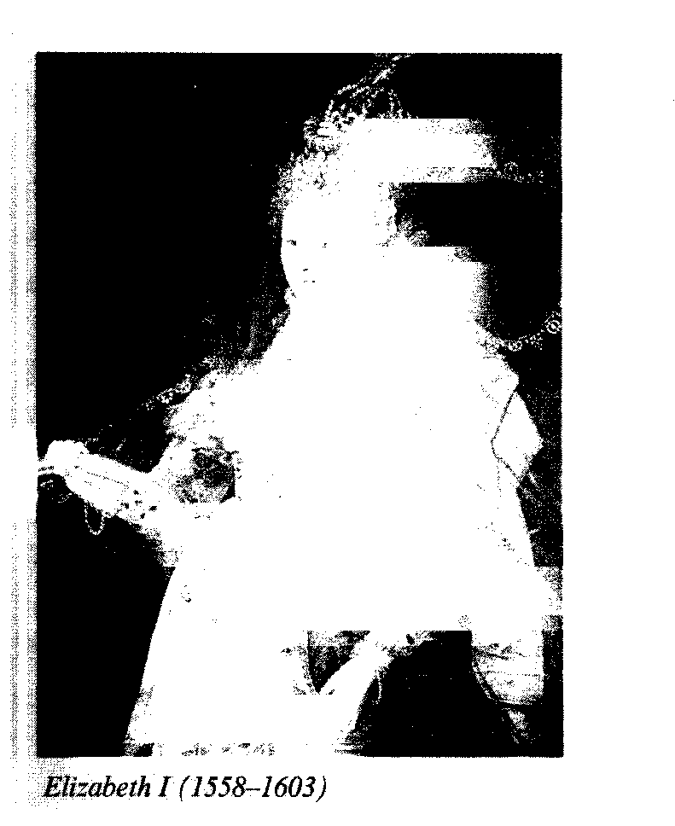

**Elizabeth I,** Queen of England and Ireland, daughter of Henry VIII and Anne Boleyn, succeeded her half-sister to the great delight of the people.

Princess Elizabeth after her mother's execution was declared illegitimate, she spent her childhood in loneliness, and only sometimes enjoyed the company of her brother Edward, encouraged by her step mother Catherine Parr.

Elizabeth was a well educated, re­markable woman, who had endured the hardships other youth and succeeded to a dangerous heritage. The country was surrounded by powerful enemies: Spain possessed the Netherlands and France controlled Scotland, where the French mother of the 16 year old **Mary Queen of Scots** was Regent. To all the true Catholics Elizabeth still remained illegiti­mate, but Mary Stuart, the great grand­daughter of Henry VII Tudor by his daughter Margaret was supported in her claim to the English throne as the right­ful Queen of England.

Yet Elizabeth was equal to the situa­tion. She had the Tudor courage and combined an almost masculine intelli­gence with an altogether feminine intui­tion, which enabled her to understand her people and select the right advisers.

Her first steps were to restore the mode­rate Protestantism other father: the Angli­can service was reintroduced, and 39 arti­cles, formulating the established doctrine of the Church, the Symbol of the Faith.

Specific differences in the develop­ment of the Reformation in England and Scotland didn't prevent the Scottish Pres­byterians and the Church of England from cooperation in the conflict and struggle against the Catholics, bothinEngland and Scotland.

The Scottish merchants supported their own variant of Calvinism, the Presbyterianism – a cheaper church founded on democratic principles of elected preachers and community chiefs. They denied the right of one man (the Pope, the King**,** or the bishops) to the Su­premacy in Church.

The Presbyterian Church helpedtosecure the Independence of Scotlandintheir struggle against catholic France.

The policy of Elizabeth was one of compromise and settlement. In foreign affairs she continued the work of Henry VII encouraging the expansion of the English merchants. Spain was the great­est trade rival and enemy as it dominated both Europe and the New World. The Spanish Catholic kings plotted against Elizabeth in their desire to substitute Mary for Elizabeth as Queen and re­sented the first English efforts in the ex­ploration of the New World.

Elizabeth was a competent diplomat and maintained the balance of power in Europe.

But she helped Dutch Protestants who rebelled against Philip II of Spain and al­lowed them to use English harbours. English ships were attacking Spanish ships as those were returning from America. The English captains – the sea dogs" tried to appear private adven­tures – John Hawkins, Francis Drake and Martin Frobisher, but they shared their plunder with their beloved Queen.

Philip was outraged and began to build up his naval forces to conquer Eng­land.

**In 1587 Francis Drake** attacked the fleet in the Spanish harbours of Cadiz and destroyed a great number of ships. And that was the last straw in this unde­clared war.

1587 was the most dramatic year for Elizabeth. Mary Queen of Scots was forced to abdicate in Scotland in 1567 and having left her baby son James VI of Scotland, had to flee from Scottish calvinists in 1568 and throw herself on Elizabeth's mercy. The Queen of England had no alternative but to keep her in close custody. Mary's presence in England pro­voked rebellions and plots to depose Elizabeth. The Spanish ambassador was involved in a plot to murder Elizabeth and expelled from the country. Then Mary herself was implicated into a simi­lar conspiracy.

The Parliament demanded her death; and Elizabeth had to agree, and in 1587 **Mary Queen of Scots** was executed. But Elizabeth blamed her death on her offi­cials.

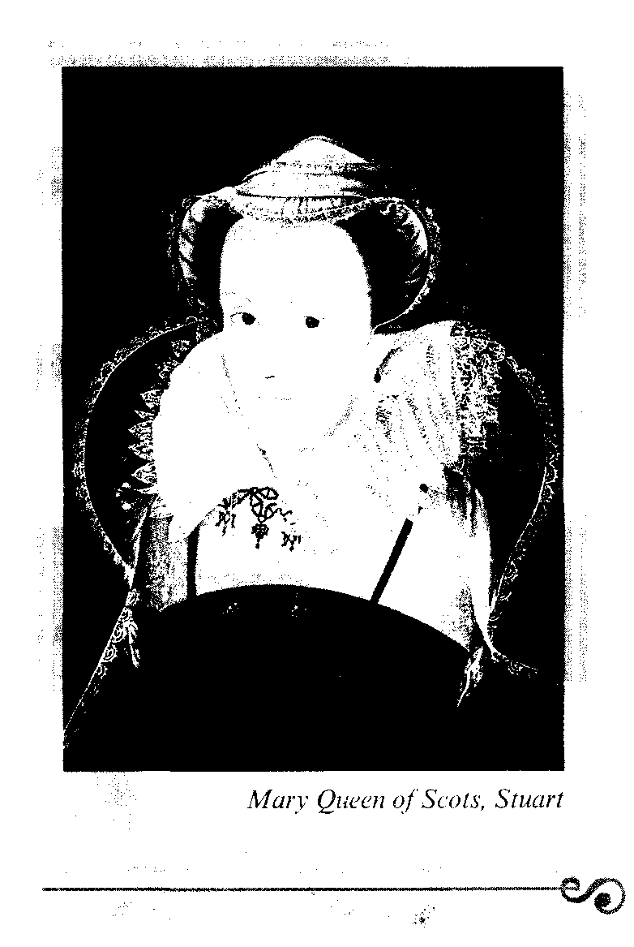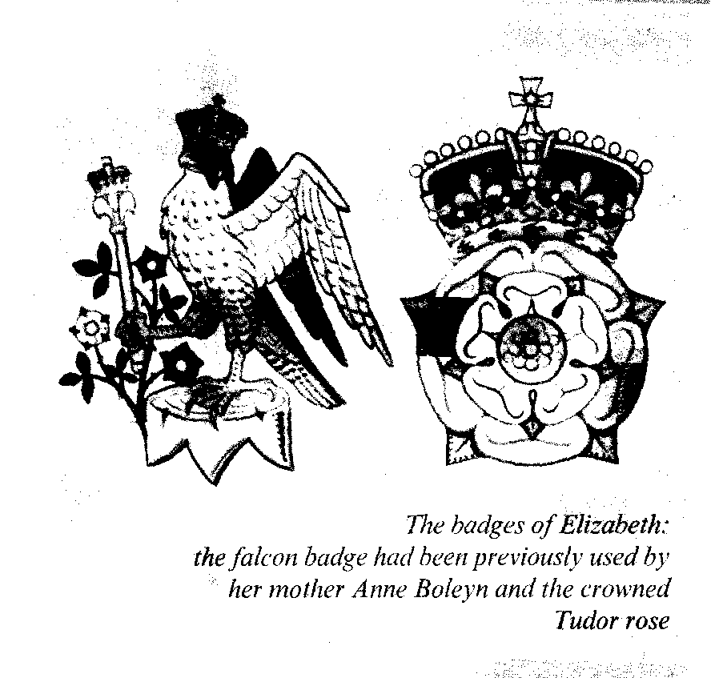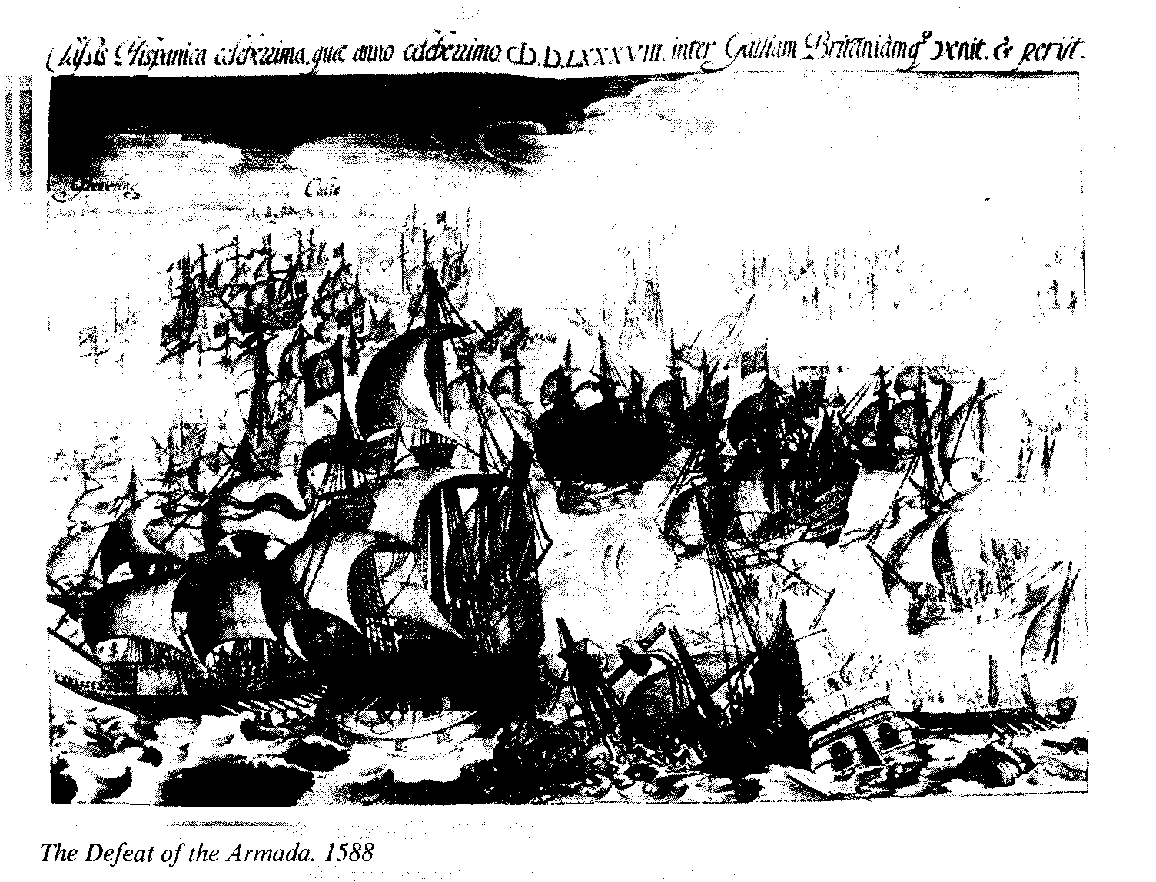

Mary's death and Drake's raid on Cadiz both took place in 1587. The next year was to be fateful for England.

In August 1588 the Armada, the Great Spanish fleet, was in the Channel preparing to launch a full-scale invasion.

Elizabeth was at the head of her na­tion. She went to the Camp other troups to encourage and inspire them with such words: "Let tyrants fear. I have always so behaved myself that, under God, I have placed my chiefest strength and goodwill in the loyal hearts and goodwill of my subjects...

I know I have but the body of a weak and feeble woman, but I have the heart and stomach of a King, and of a King of England too".

The Spanish attempted invasion be­gan in July, 1588. The heavy galleons of Philip's great Armada were rather awk­ward against the quick English ships.

The "Invisible Armada" was defeated by the English ships and the storm in the English Channel. Scattered by the winds, many of its ships were sunk or wrecked on the rocky coasts of Scotland and Ire­land. It was a glorious moment for Eng­land, and Elizabeth was the heroine of the hour. But that was not the end of the war with Spain. Peace was made only after the death of Elizabeth.

James VI of Scotland, the son of Mary Stuart, didn't support Spain as he had been given to understand that his right to the English throne would be honoured.

Ireland was another battlefield of Spain in the struggle against England and Elizabeth. It was only subdued by the time other death. The best lands were captured by English landowners.

England had economic problems: in­flation and unemployement. Enclosures of farm lands and wars, it produced ar­mies of beggars and thieves, and they roamed about the country in miseryand crime.

The government passed the Elizabeth an Poor Law in 1601. It aimed at putting an end to beggars of all kinds, the poor were put into workhouses.

In the 16th century the economic growth was getting faster, though still limited by feudal relations. Trade and Industry were growing. The Royal Ex­change was founded in 1571, East India Company – in 1600.

Education was further developing. Many Grammar schools were founded in the 16th century. New foundations like Harrow and Rugby admitted clever boys as well as rich ones, andcould rightly be called "public schools".

Elizabeth gave her name to the his­torical period, her reign (1558-1603) was described as "the Golden Age of Eliza­beth", the most colourful and splendid in English history. She was the embodi­ment of everything English, and the Eng­lish had found themselves as a nation.

The power of Spain was challenged on the seas and finally broken by the de­feat of the Armada. Elizabeth saw the foundation of the British Empire and the flowering of the Renaissance in England. The works of Christopher Marlowe, Edmund Spenser and William Shake­speare were the foundation of the Eng­lish literary and dramatic heritage. Spenser's the Shepheards Calendar (1579) was a landmark in the history of English poetry, his masterpiece was *The* *Faerie Queene* (1589, 1596) which mir­rored in allegories the age of his glorious sovereign the Queen, and her kingdom in Fairy-land.

In the last decade of Elizabeth's reign Shakespeare wrote about 20 plays, from *Henry VI to Hamlet.*

The English Renaissance has reached the greatest height in the field of theatri­cal Art. The Shakespeare's (drama) plays, his humanism and deeply popular real­ism were on the one hand produced on the basis of outstanding theatrical achievements of the period; on the other hand Shakespeare's drama made the English theatre an important contribu­tion, achievement of the world culture treasury.

The 16th century was the century of the further consolidation of bourgeois re­lations. During the Elizabethan age the ideals of Renaissance embraced a broad spectrum of the population, including the merchants and citizens.

The philosophical ideas of the period were to serve the further evolution and even the revolutionary changes that came later.

Francis Bacon (1561-1626) ("Novum Organum"), was the founder of English materialism and applicator of pragmatic sciences.

Literature, Art and Drama were play­ing an important role. In 1576 – the first theatre appeared. Public theatres were attended by aristocrats and Elizabeth I.

The 16th century was the age of tran­sition from the medieval twilight to a more progressive age.

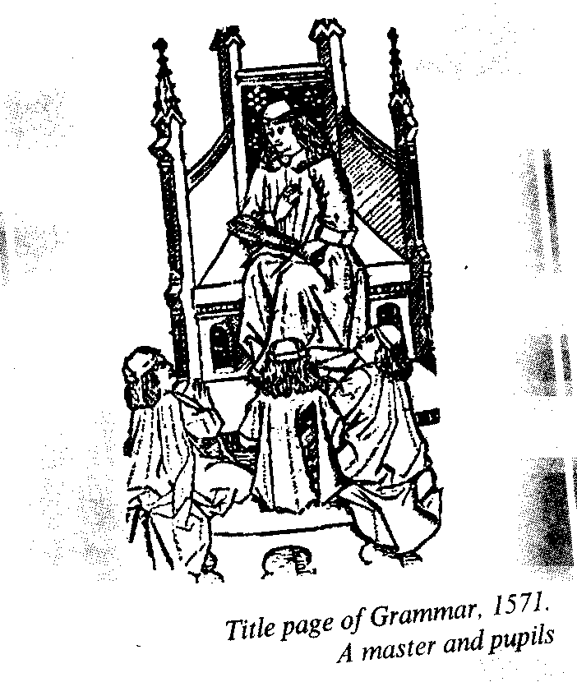

*Questions:*

*1. Who were the first and last monarchs of the**Tudor Dynasty?*

*2. What title was Henry VIII awarded with by the Pope?*

*3. What was the peculiarity of the Reformation in England?*

*4. What were the traits of continuity in the foreign policy of the Tudors?*

*5. Why was the reign of Elizabeth I called "the Golden Age"?*

*6. What threat was posed by Mary Queen of Scots to the rule of Elizabeth?*

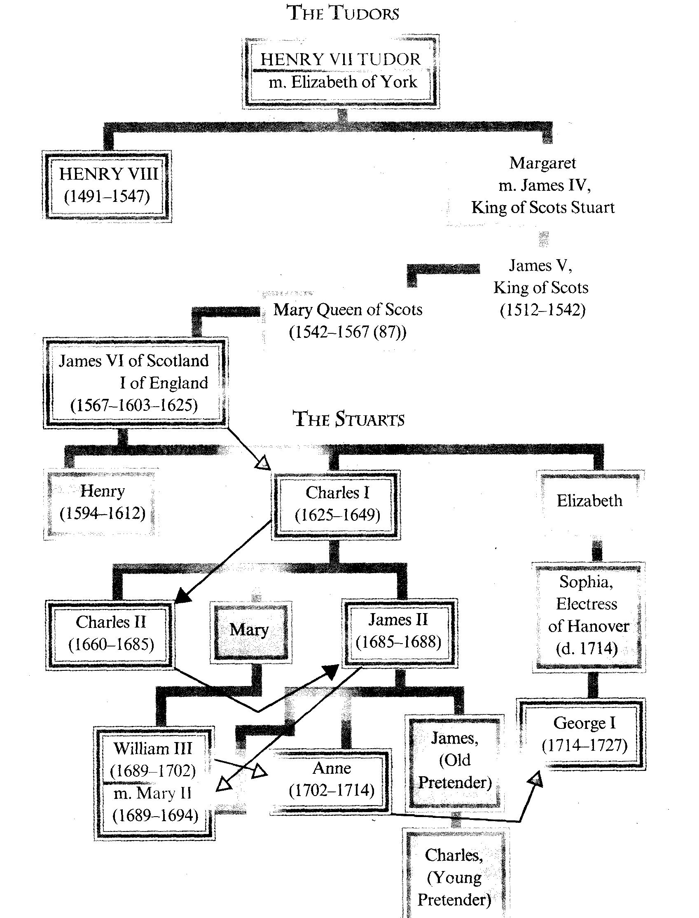

# THE STUARTS AND THE STUGGLE OF THE PARLIAMENT AGAINST THE CROWN

THE STUART KINGS AND THEIR CONFLICTS WITH THE PARLIAMENT. THE CIVIL WAR AND THE NEW MODEL ARMY. RELIGIOUS DIFFERENCES IN THE COUNTRY. OLIVER CROMWELL AND THE COMMONWEALTH.

THE RESTORATION OF MONARCHY. THE GLORIOUS REVOLUTION. TWO PROTESTANT MONARCHS

*Key words, terms and concepts:*

*1. Gunpowder Plot*–*Guy Fawkes (1605)*

*2. Puritans*

*3. Independents*

*4. Levellers*

*5. Diggers*

*6. New Model Army – Oliver Cromwell*

*7. High treason*

*8. The Rump*

*9. The Lord Protector (1653 -1658)*

*10. The Commonwealth – The Interregnum*

The ideology of the rising classes in England at the beginning of the 17th century was Puritanism, it was a form of democratic religion similar to the Calvinist views: denying the su­premacy of a man over religious faith, demanding a direct contact with God without any mediators, without anyone between Man and God, thus denying Church as an unnecessary institution. It was a challenge to the Church of Eng­land and the Monarch as its head, to the absolute Monarchy altogether.

The Puritan ideology was also a chal­lenge to the cultural achievements of Renaissance – the religious doctrines re­jected theatre, entertainment, pleasure, they preached and practised austerity, as­ceticism, adoption of puritan values against idleness. There were different va­rieties of puritan ideology and groups of people – the extremists, like **independ­ents** (1581), insisting on complete inde­pendence of their communities, and **moderates,** who believed in cooperation with monarchy.

The new forces, the developing bour­geoisie began to actively oppose the ab­solute monarchy, particularly using the Parliament. In 1601 the Parliament made the first declaration of protest, disapprov­ing of the Queen's sell out and distribu­tion of licences.

Those first seeds of discord were to grow up strong and dangerous during the reign of the Stuarts; James I and Charles I.

James VI King of Scots – born in 1566, crowned King of Scots in 1567, be­came James I (1603-1625) of England.

On the death of Queen Elisabeth I in 1603 he became the senior representative of the Tudor dynasty, being the great-grandson of Margaret, the eldest daugh­ter of Henry VII.

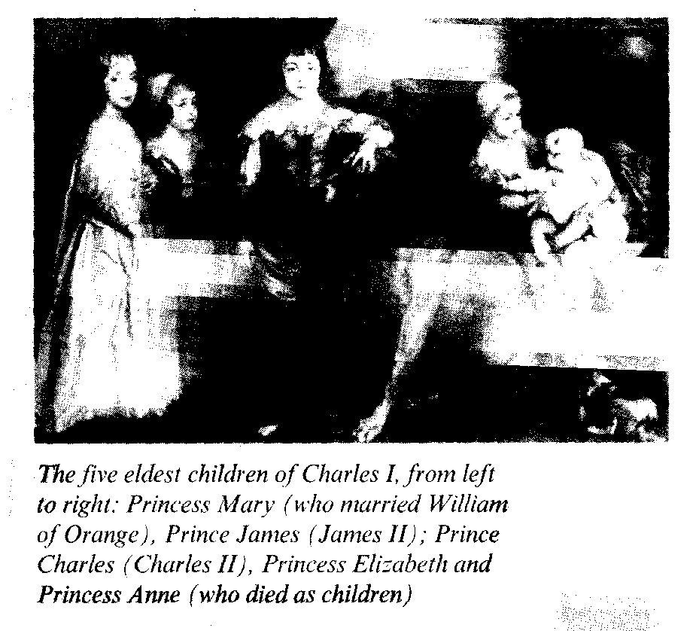

the cellar, and concealed a nice fat charge of gunpowder in the coal bin. Unfortunately for the leader, one of the conspirators warned a certain Lord by letter to stay away from a meeting at the House on the day set for the explosion. This led to the discovery of the plot and Guy Fawkes was tortured and hanged. On this day it is customary in England to dress up like Americans do on Halloween, and to carry an effigy of Fawkes through the streets and then to bum it.

"Remember, Remember,

the 5th of November,

The Gunpowder Treason

andPlot." – goes a well-known rhyme.

The King was noted for persecuting witches and writing books, principally about the devine rights of Kings.

James was closely connected with the international catholic reactionary pow­ers.

The first Stewarts had faced the alter­native: either to give up absolute power and cooperate with new gentlemen and bourgeoisie or to support reactionary no­blemen.

They preferred to struggle against the puritans, representatives of new revolu­tionary ideology.

JamesI, and later his son Charles I were extravagant and wasteful.

**Charles I Stuart** (1625-1649) was in a constant conflict with Parliament.

The Parliament, when convened, re­fused to give the King financial support, and Charles I ruled for 11 years without Parliament (1629-1640). That Period of Personal Government, during which the King did not receive the usual financial aid and had to raise money as best as he could: pawned Crown Jewels, gave out honours, etc.; came to an end when he became involved in a war with Scotland for which he couldn't pay.

The King (Charles I) was forced to convene a meeting of the Great Council and later to call a Parliament.

And he had to concede to this Parlia­ment almost all that it ashed, so badly he was in need of money. Later his attempts to go back on his word and revoke his concessions and his refusal to hand over to Parliament control of the Army brought about the Civil War which his policy and that of his father had made inevitable.

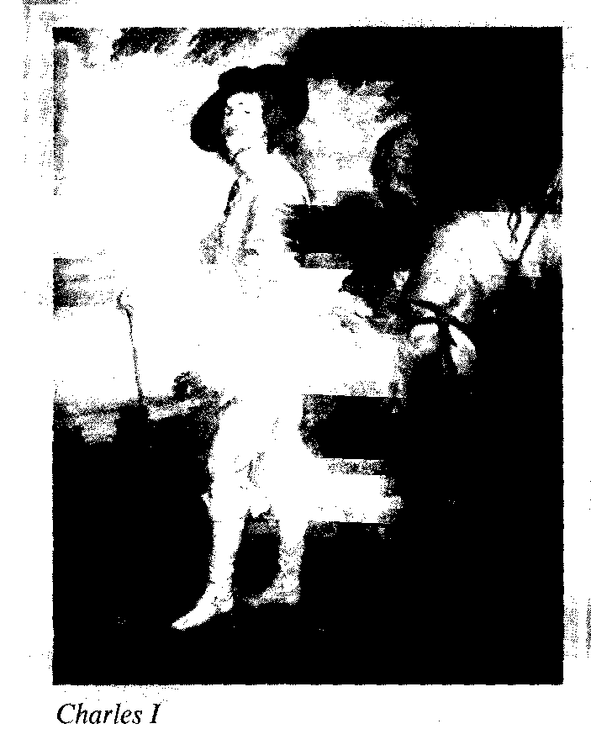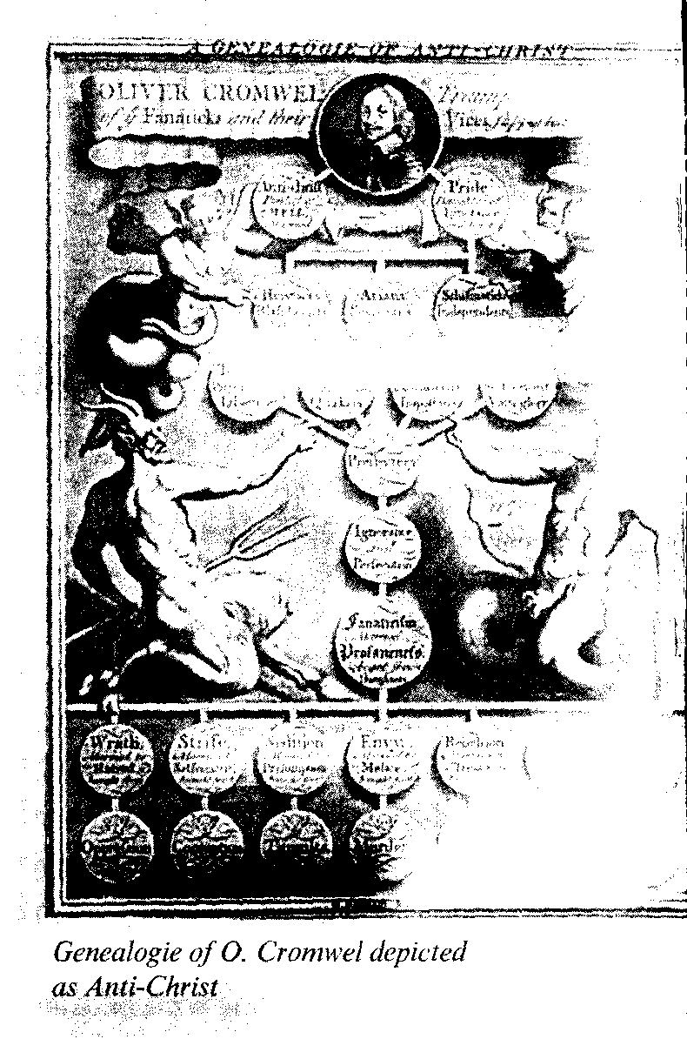

The battles of the Civil War, fought as three military campaigns took place not in London, but in the counties. The King's standard was first raised at Nottingham in 1642 and, when he could not get to London, Oxford became his tem­porary capital, with 70 peers and 170 Members of Parliament close at hand. Oxford fell in 1646, by which time Charles had already surrendered; he passed into the hands of the victorious **New Model Army** (22,000 strong after 1645), which went on to take possession of London and install their commander Sir Thomas Fairfax as Governor of the Tower. His second-in-command was **Oliver Cromwell,** a farmer in the past and a great military leader who had organ­ized the New Model Army. Charles I was captured by the Scots who handed him over to the Parliamentarians. He escaped and made agreements with the Scots who were later defeated by the Parliamentar­ian Army (1648). The English Army de­manded the death of the King.

Charles I was **brought to trial** for **High Treason,** his supporters were not allowed to be present. He was sentenced to death, "and in a hushed silence on a cold Janu­ary morning the King of England met his death with a courage and dignity that commanded respect." He was beheaded in Whitehall on the **30 of January 1649.**

The House of Lords was abolished, some famous Royalists were captured and beheaded.

A Council of State was created to gov­ern the country, which consisted of forty one members. The House of Commons reshuffled its members, and expelled those who had opposed the King's death.

But the troubles were not easy to stop. There was mutiny in the Army, a rebel­lion in Ireland, the Scots declared the son of the executed King – their King (1651) Charles II.

Oliver Cromwell ruthlessly crushed the Irish, checked the Scots, and estab­lished his authority in the Army and in the country. Admiral Blake defeated the Dutch and made England again the mis­tress of the seas.

In 1653 Oliver Cromwell together with the New Model officers expelled the **Rump** (the Remnants of the Parliament) and established a military dictatorship. On December 16th in Westminster Oliver Cromwell publicly accepted the title of **Lord Protector of a United Common­wealth of England, Scotland, Ireland and the colonies.**

He didn't dare to take up the title of King, as there was opposition to that in the Army.

All in all, in four years of struggle, around 100,000 Englishmen were killed. Feelings ran high and extraordinary radi­cal opinions were expressed both during and after the Civil War. There was a con­frontation of political and religious views within the ranks of the revolutionary forces. Presbyterians had become con­servative and royalist. Independents, who were represented in the New Model Army, were split.

The more extreme republicans in the New Model Army, the **Levellers,** as they were called, had a Manifest of their own, called the Agreement of the People, and they rallied together to defend the right of com­mon people, **they demanded the abolition of titles, and legal, political, etc.; equality in everything but property** (John Lilbern).

The **Diggers,** a far smaller and still more radical group, **opposed the private ow­nership of Property altogether** and strug­gled "to set the land free" they insisted, that "the poorest man hath as true a title and just right to the land as the richest man".

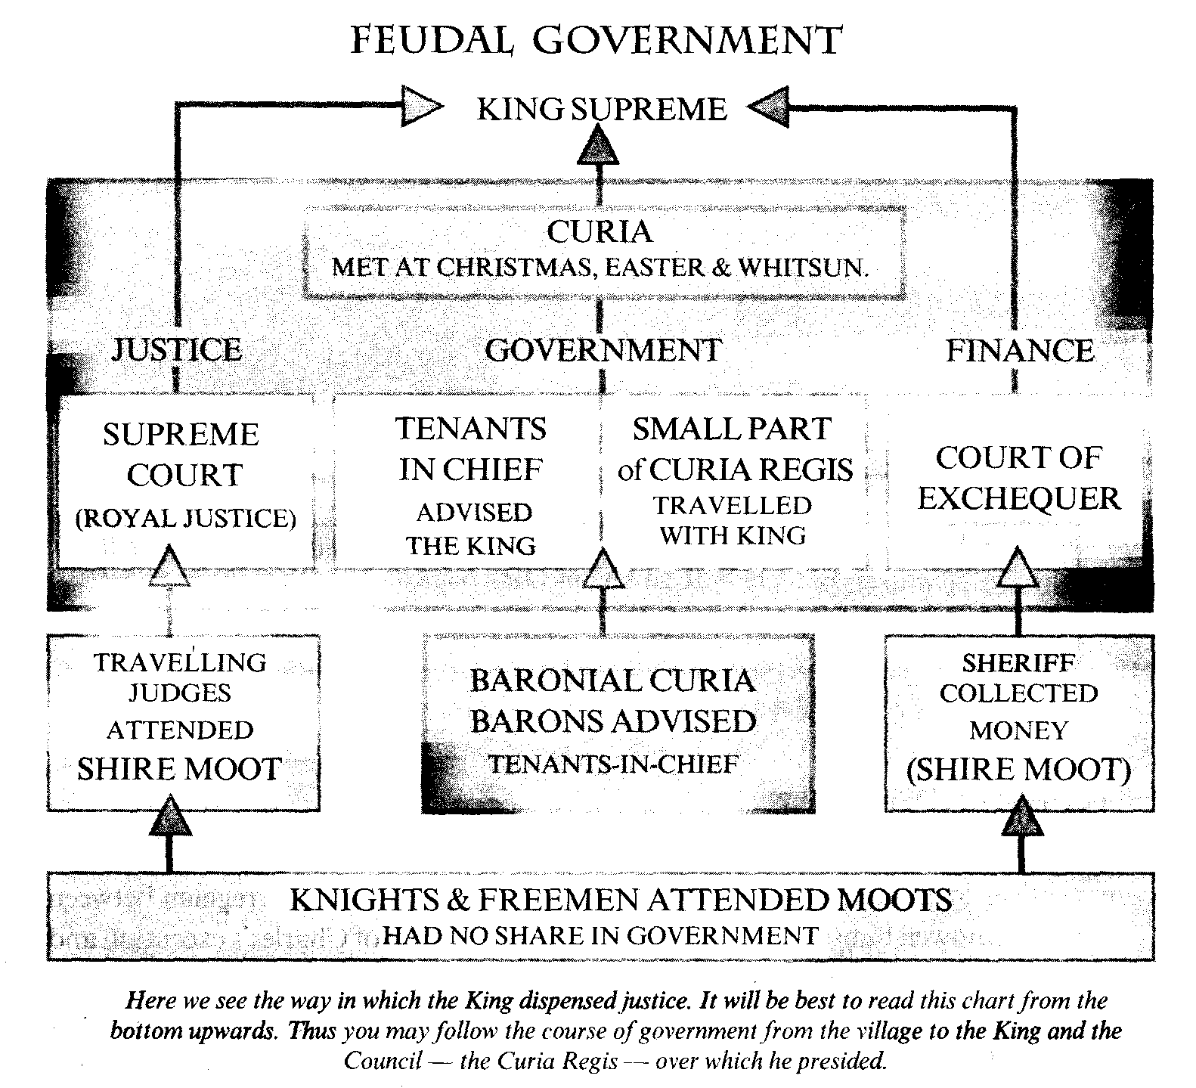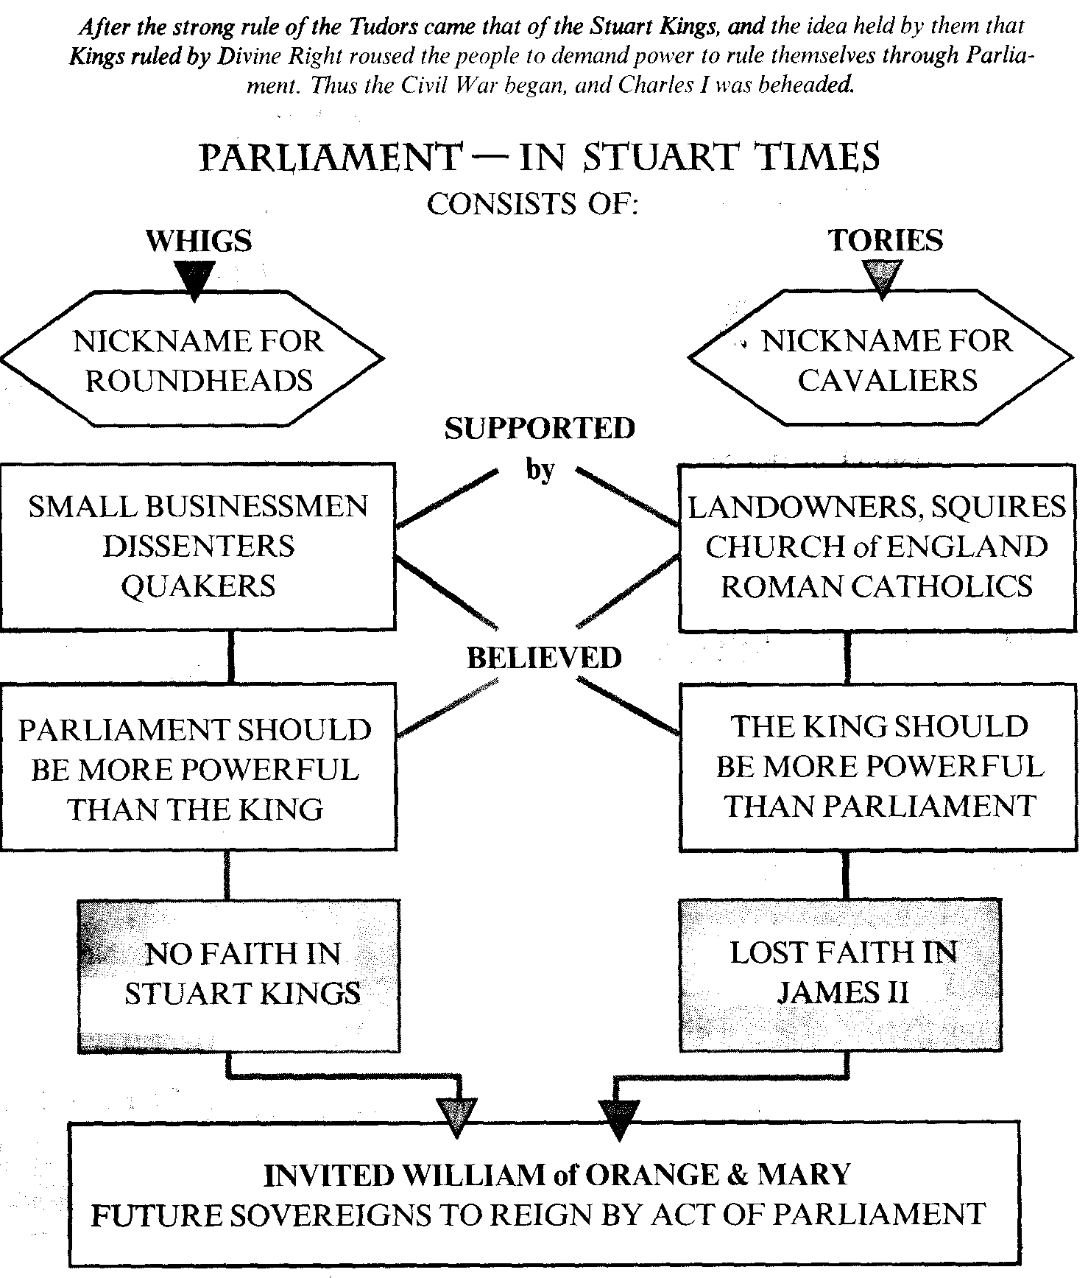

The language of radicalism which burst out between 1640 and 1645 alarmed conservatives of all kinds.

Oliver Cromwell himself was a reluc­tant republican anxious to preserve "the ranks and orders of men – whereby England hath been known for hundreds of years: a nobleman, a gentleman, a yeo­man."

However, it was the Nobility and Gentry who eventually profited from the Civil War and the **Interregnum** between 1649, the year of Charles's execution and 1660, the year of the Restoration of Monarchy. **The Diggers failed in their ventures** and the Levellers were supressed in 1649 after they rebelled against Cromwell and other army leaders. The Commonwealth, with Cromwell as Lord Protector, the period when England was a republic, is also described as Interregnum.

From 1655 England was divided not only into **parishes,** where the justices of the peace remained, but into **districts,** each with a soldier, **Major-General** exer­cising authority in the name of "godli­ness and virtue".

The Army was maintained by taxes imposed on the Royalists. From Decem­ber 1653 until his death in September 1658, **Oliver Cromwell** ruled England and Scotland, he imposed temporarily a single government on England and Scotland.

In the country and in the towns the new regime closed alehouses and thea­tres, banned race-meetings as well as cock-fights, severely punished those peo­ple found guilty of immorality or swear­ing and suppressed such superstitious practices like dancing round the May Pole or celebrating Christmas.

Oliver Cromwell was a unique blend of country gentleman and professional soldier, of religious radical and social conservative. He was at once the source of stability and the ultimate source of instability. With his death the republic collapsed as his son and successor Rich­ard lacked his qualities and was deposed 6 months after the beginning of his rule.

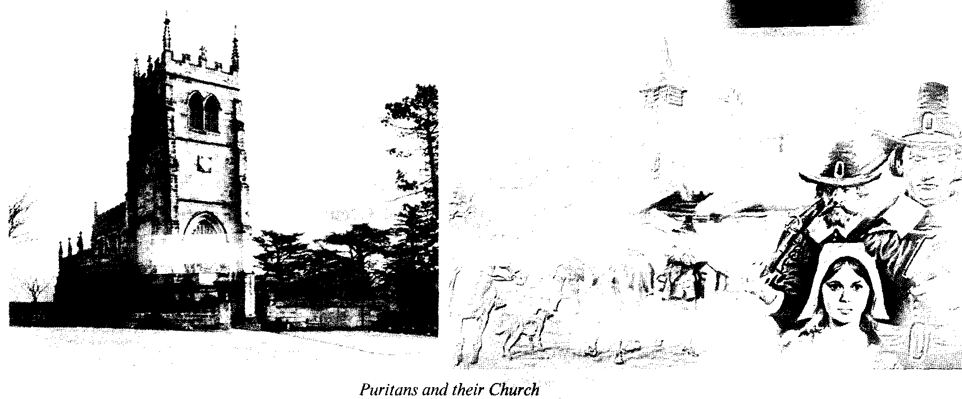

The generals began to fight for power, general **G. Monk's** influence brought about the dissolution of the Long Par­liament and the new convention Parlia­ment voted to recall Charles II and re­store the Monarchy in Britain.

**Charles II** landed in England in May 1660 and was enthusiastically greeted and welcomed by the people. He declared a "liberty of conscience" and demanded the punishment of his father's murderers.Hewas crowned in 1661, his ministers were mainly old Royalists who had served him during his exile.

The Puritan Republic had been a joy­less country, and the Restoration of Monarchy brought back the gaity of life: theatres were reopened, new dramatists wrote cynical plays to entertain the cor­rupt court. It was also the restoration of Parliament, House of Lords, Anglican church and Cavalier gentry (noblemen) with their old privileges and intolerance.

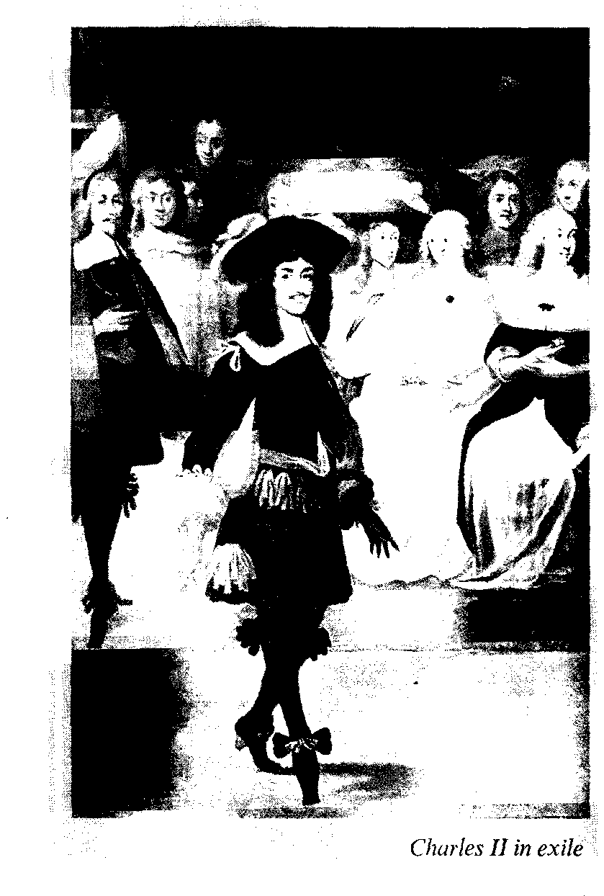

But the **Commonwealth** was dissolved. **Charles II** was the king of England and Ireland but all these countries now had their own Parliament again.

Charles II was more French than Eng­lish. He did his best to secure toleration for Catholics in England and also to es­cape the control of Parliament. The Par­liament and the Protestants wanted to keep their leading position.

The first years of the Restoration saw action of revenge on Cromwell's dead body, Acts against the Puritans passed by the Parliament of Cavaliers and the appearance of Milton's "Paradise Lost" in which the author tried "to justify the ways of God to men"; **New Amsterdam** was captured from the Dutch and re­named **New York,** after the King's brother, James, Duke of York (later James II).

The **Great Plague of 1665** and the **Great Fire of London** in **1666** were the calamities that brought a lot of suffering to the English people.

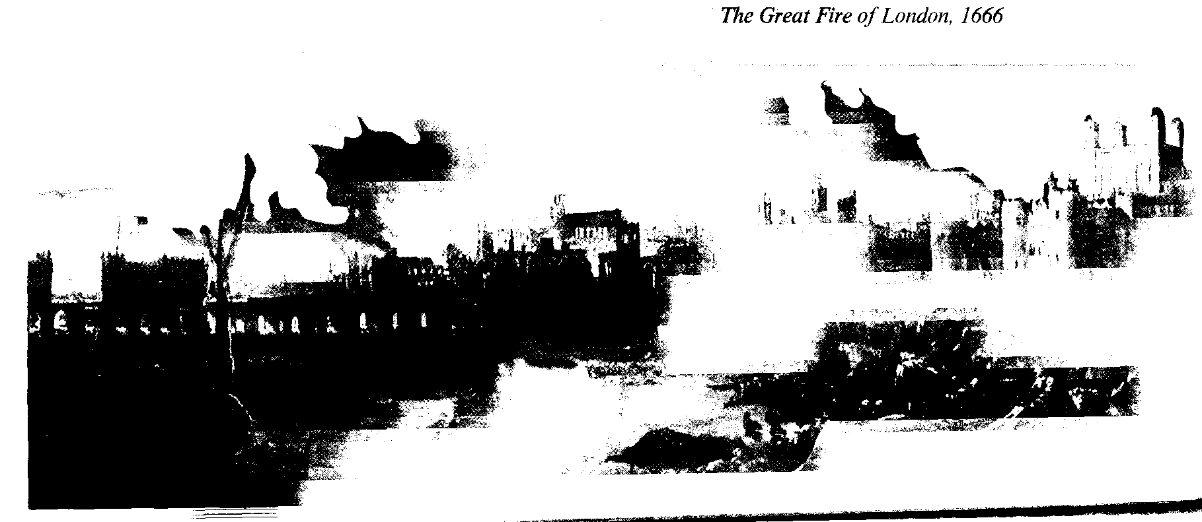

In the 1650s outstanding scientists gathered at Oxford and founded the first great learned society in England, "the Royal Society", whose patron was the King. They were dedicated to the ad­vance of knowledge in every subject and their society attracted many talented minds: **Christopher Wren,** the great de­signer, known later as the rebuilder of London after the Great Fire, **John Locke,** the political philosopher, the father of the Modern science of chemistry. One more name stands out about others – that of **Isaac Newton.** His greatest discoveries in­clude the spectrum and the basic law of the universe – the law of gravity.

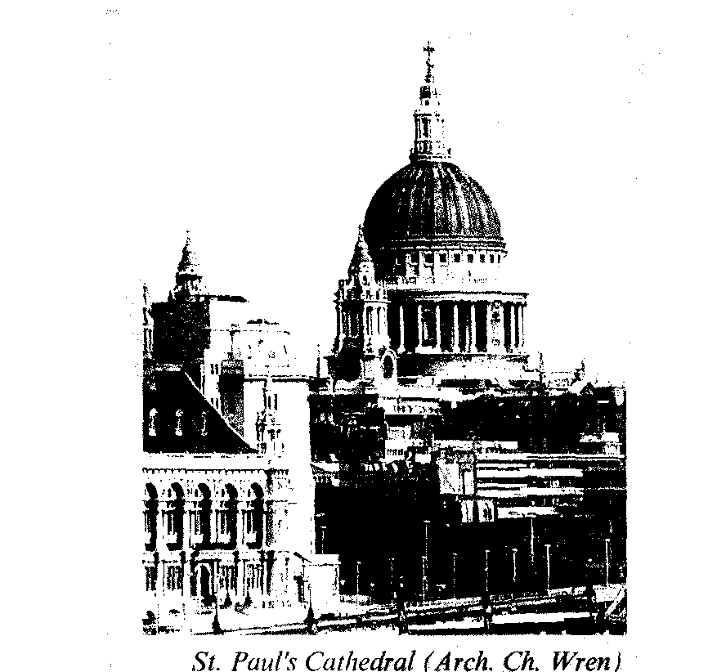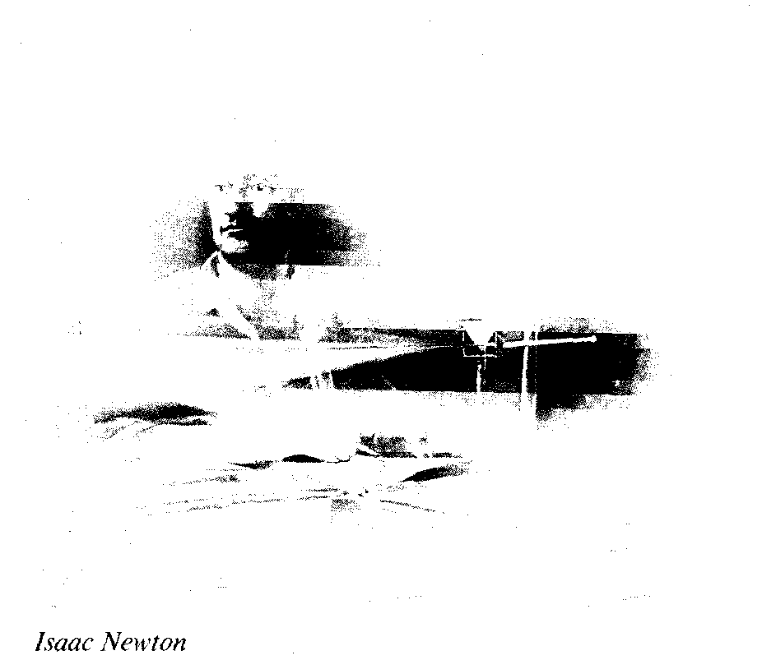

Charles II governed the country through the inner Council, or Cabal, which consisted of five men, two of them were Catholics and the other three were supporters of religious toleration. As a result Charles issued a Declaration of In­dulgence granting toleration to all – in­cluding Catholics. In their rejection of that Declaration the Parliament adopted the Test Act (1673) forbidding all Catho­lics to hold office for the Crown. It was also directed against James the Duke of York, the heir to the throne.

The Opposition to the King became organized into a party with a majority in the newly elected Parliament. They man­aged to pass the **Habeas Corpus Act** (1679), which provided a protection of human rights of the new bourgeoisie. Ibis Act, originally adopted against the arbitrary actions of CharlesII**,** has proved to the be an essential milestone in the legal system of Great Britain.

Newly coined nicknames became ap­plicable to the opposing groups in the political struggle: the opposition to the King which demanded a further curbing of the Monarch's prerogatives, was nick­named "The Whigs" by their opponents in Parliament. These opponents sup­ported the Catholic views of the King and the King himself; and they in their turn were also nicknamed as "the Tories" by the first group. It was another term of abuse originated for condemning the Irish Catholics who were fighting against the Protestant army of Cromwell. These two parties, the Whigs and the Tories became the basis of Britain's two-party parliament system of government (see Chart III, p. 46).

James II became the King of England after his brother's death in 1685. He had two daughters – Mary and Ann – from his first Protestant wife, and they were firm Protestants. Mary was married to her first cousin, William of Orange, a Dutch prince and a militant Protestant.

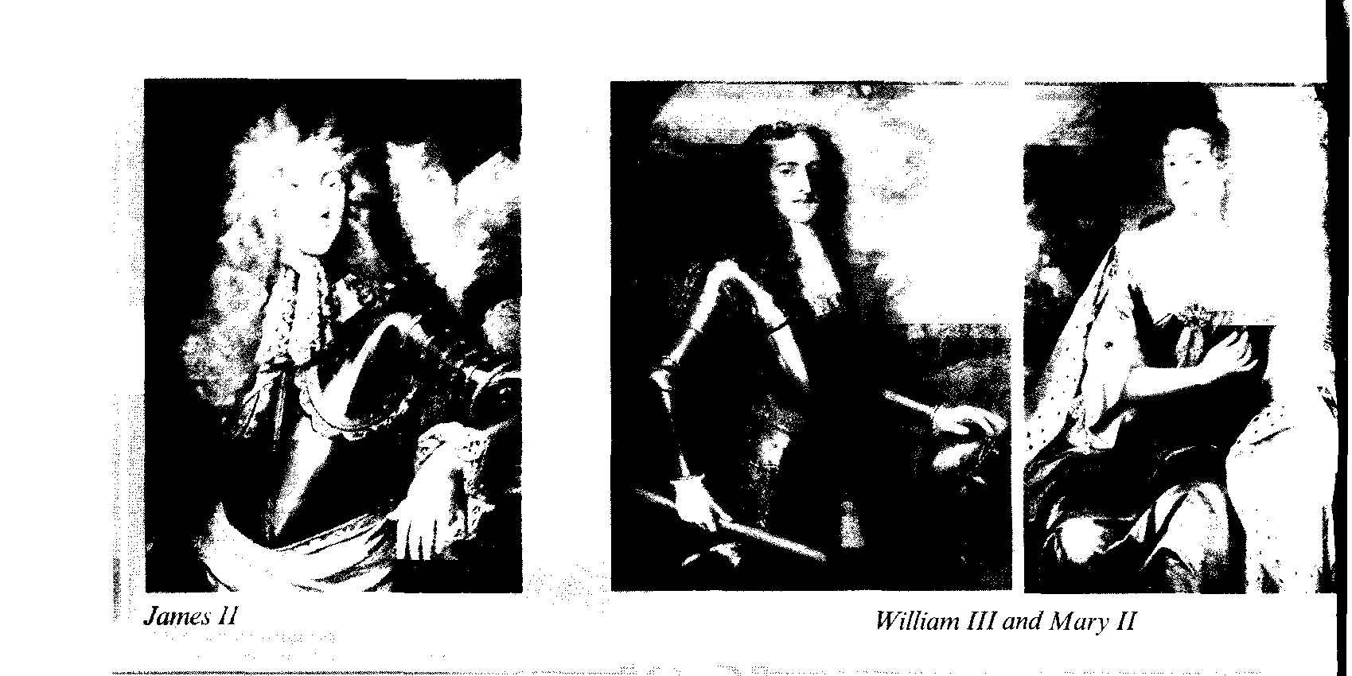

When the Catholic second wife of James II gave birth to a baby son, the English Parliament and the Protestant bourgeoisie were alarmed by the prospect of Catholic succession of Monarchs.

Tones, Whigs and Anglicans began to look for a Protestant rescue. They in­vited William of Orange to invade Brit­ain. The forces of William landed in Eng­land and that decided the issue: James and his family fled away from the coun­try. The Parliament decided that James II had lost his right to the Crown.

Mary and William began to reign jointly, moreover, the Parliament decided that William would rule on in the event of Mary's prior death.

The political events of 1688 were called "the Glorious Revolution" as they had realized the bourgeois theories of the nature of government (John Locke (1632-1704)) and the demands that the powers of the King should be restricted and that the Parliament should be over­all power in the state.

Though some historians insist on call­ing it a coup d'etat of the ruling classes, the changes are recognized as a historic turning point in the conception and prac­tice of government. In point of fact it can be justly regarded as a "glorious compro­mise" between the new bourgeoisie and the old feudal institutions like the Mon­archy, the House of Lords, etc, but also in imposing new bourgeois parliamentary privileges and relations. The Parliament secured its superiority by adopting the Bill of Rights in 1689 and the Monarchs – William III and Mary II accepted the conditions advanced by the Parliament:

the legislative and executive power of the Monarchs was limited. The Bills passed by the Parliament were to be sub­jected to the Royal Assent, but the Mo­narch could not refuse to sign there. The Monarchs could not impose taxes,

the Army could be kept only with the Parliament's **permission.**

In 1701 the Parliament passed the Act of Settlement that secured Protestant suc­cession to the throne of England and Ire­land, outlawing any Catholic Pretenders. The Act stipulated that if William and Mary had no children, the Crown should pass to Mary's sister Anne. And if Anne died childless too, the Crown should passto Sophia Electress of Hannover, the granddaughter of James I Stuart, or her Protestant descendant. The Act of Set­tlement is of major Constitutional impor­tance, it has remained in force ever since.

Praising the "Glorious Revolution" as "great and bloodless", historians have to admit, however, that it was bloodless only in England.

In Ireland there was a blood bath of war between the Protestants of London­derry and the Catholic Irish Parliament. King William III landed in Ireland with the British, Dutch, Danish and Hugue­not troops and defeated the Irish and French army of James II in the Battle of the River Boyne (1691).

James left Ireland for France and never returned to any of his kingdoms. The defeat in this Battle crushed the Irish hopes for independence, the Irish Catho­lics lost all the rights.

In Scotland William was recognized in the Lowlands. But in the Highlands a revolt rose and the loyalty of the High­land chiefs was bought with a large sum of money. The chiefs were to swear an oath of loyalty to the new King, but one or two were a few days late, among them Maclau MacDonald of Glencoe. This was severely and brutally punished by a company of troops, who were senttomurder all the MacDonalds of Glencoe under 70. 36 Men, women and children were killed as they slept, and their houses were set on fire. Those who escaped told the world of the Massacre of Glencoe.

The French and Jacobite gazettes con­demned the King's Government as cruel and Barbarous.

The "Glorious", "bloodless" revolu­tion was a political readjustment of the government in the interests of the ruling classes, but it did not involve the major­ity of the population.

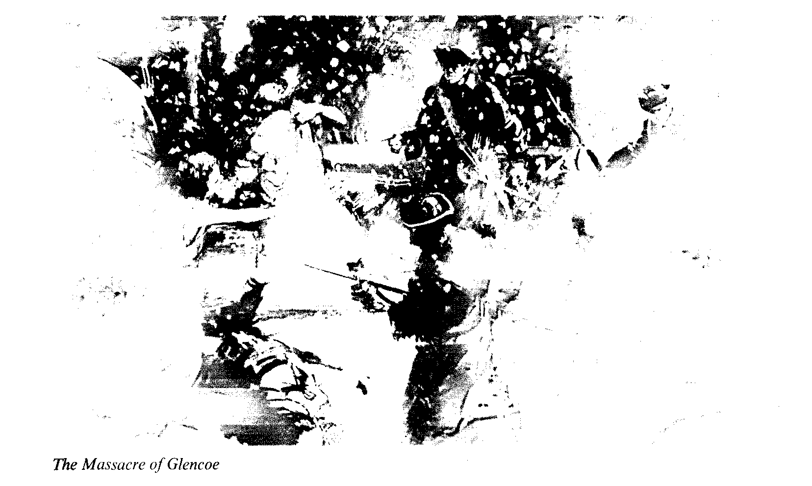

William of Orange used the strength of England in the interests of his native country – Holland in the wars against France**.** "King William's War" (as the English called it) prevented another threat of invasion of Britain, but it didn't bring peace to Europe.

*The seventeenth century was the age of the Stuarts – their rise in 1603, their trag­edy and defeat from 1648-1660, their res­toration in 1660, their constant struggle against the Parliament which resulted in their forced compromise and the victory of the Parliament, the victory of the new rul­ing classes.*

The Civil war and the United Com­monwealth, the rule of Oliver Cromwell as the Lord Protector and the leader of Independents and Puritans were the events in the middle of the century and are described as the Interregnum. It was a highly dramatic and tragic period of British history.

The economy of Britain by the end of the century was developing freely, new economic institutions like the Bank of Britain (1695) were founded. Trade and colonies were flourishing. The East In­dia Company was the greatest corpora­tion in the country.

The religious struggle and conflicts gave freedom to all Protestants.

After the Great Plague and the Great Fire of London came the efforts of Sir Christopher Wren and the achievements of science made by I. Newton and other members of the Royal Society.

By the end of the centuryBritain wasbecoming a prosperous country.

*Questions:*

*1. Why were the Stuarts inheritors of the English Crown?*

*2. What were the reasons for the conflict of the first Stuarts with the English Parliament?*

*3. How did the Civil war develop and end?*

*4. What social groups supported Cromwell?*

*5. What was the policy of the United Commonwealth in Europe and in the world?*

*6. What were the reasons for the Reformation of Monarchy in Britain?*

*7. What were the Acts of Parliament directed against the Kings and flow did they develop the social situation in Britain?*

*8. When did the political parties appear in Britain and how?*



# THE 18тн CENTURY–OF WEALTH, TECHNOLOGICAL REVOLUTION AND POWER

*Key words, terms and concepts:*

**A** *1. War for Spanish Succession*

*2. The Duke of Marlborough*

*3. Blenheim and Gibraltar*

*4. The Union with Scotland (1707)*

*5. The Hanoverian Dynasty*

*6. The National Debt*

*7. The South Sea Bubble*

*8. Robert Walpole*

9. *Jacobite revolts–the old Pretender and the Young Pretender*

*10. William Pin "the Elder"*

*11. George III, "the Patriot King"*

*12. Boston Tea Party*

*13. The Declaration of Independence*

*14. Adam Smith "The Wealth of Nations"*

**В** *1*. *Technological Revolution*

*2. James Watt*

*3. J. Wedgwood*

*4. Admiral Horatio Nelson, the Battle of Trafalgar (1805)*

*5. The Battle of Waterloo–the Duke of Wellington*

*6. Robert Owen*

7. *Wordsworth, Coleridge, Byron, Shelly, Keats*

*8. Turner, Constable*

The end of the 17th century and the start of the new century, were the periods of wars in Europe. Brit­ain was involved into the Nine Years War (1688-1697) and the War for Spanish Succession (1702-1713). France had be­come a permanent enemy, and the grand strategy of Britain was to stop the French expansionist policies: to struggle against the French competition in trade, and also to interfere in the affairs of the Spanish Empire.

The Whigs in the British Parliament supported the interventionist foreign policy of William III of Orange and his favourite general – John Churchill who was already the **Duke of Marlborough.** After the death of Mary and William they were succeeded by Anne (1702-1714). Marlborough was the commander of the Army and was successfully fighting against the French attempts to place a French prince on the Spanish throne. The established Church and also gained free trade with England.

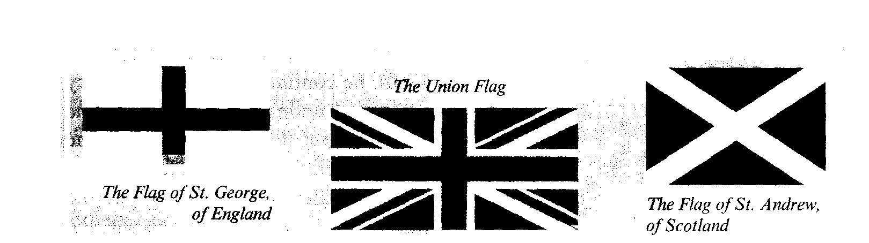

England, Scotland and Wales were united and became Great Britain.

The Tones opposed the military actions of their successful opponents, the Whigs.

**The Duchess of Marlborough,** who had been very friendly and close to Queen Anne, was replaced by a lady, support­ing the Tories. They came to power in 1712 and began negotiating peace with France. The Treaty of Utrecht was signed in 1713 according to which the Crowns of France and Spain were never to be united, Britain gained many advan­tages–new territories, such as Gibraltar, Minorca, Newfoundland and Nova Scotia, and the right to sell slaves to the Spanish colonies. Great Britain had be­came a great European power.

Queen Anne was the last Stuart monarch, she died in 1714; and according to the Act of Settlement, she was succeeded by Protestants of **Hanoverian Dynasty.** George I (1714-1727) was an elderly and unpreposessing German who could speak no English.

The consequences were thattheWhigs surrounding the King were handed over many of the royal prerogatives and their leader became the Chair man of the King's Council. That was the beginning of the Cabinet system of Government in Great Britain, with a Prim Minister presiding over the Cabinet.

The Whig domination lasted for half a century. It was troubled by the Jacobite Rebellion in 1715 and by the growing National Debt. It had been create to help to pay for war, and by 1713 it had risen to £54 million.

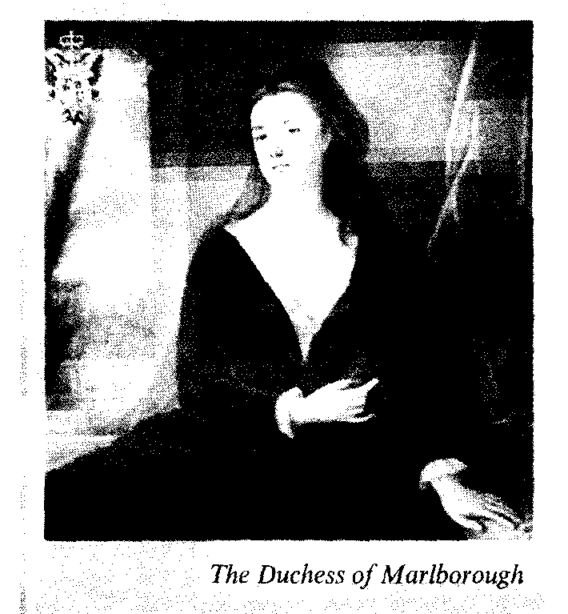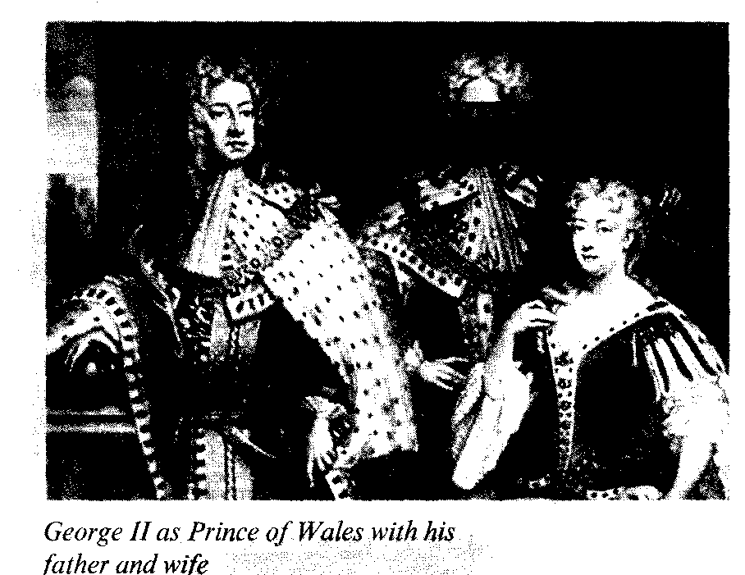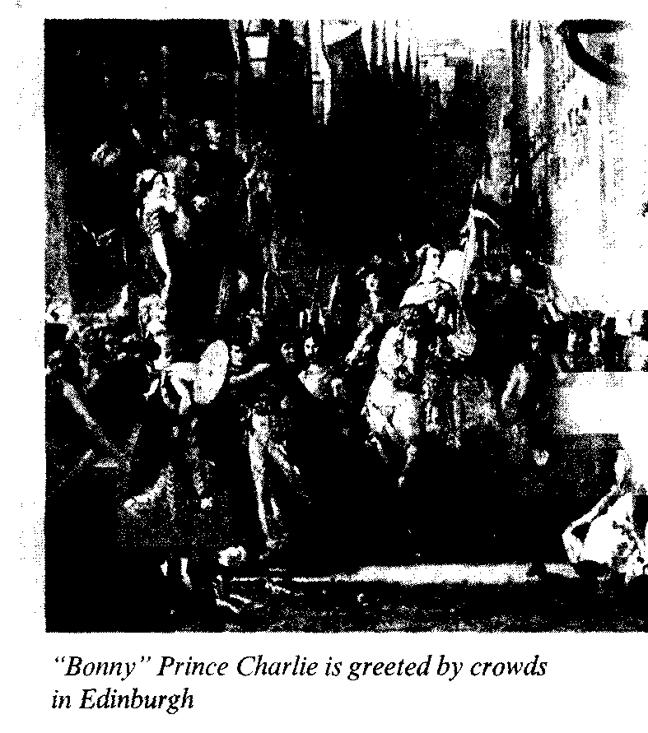

In 1717 one of the Whig ministers **Robert Walpole** (later known as the first Prime Minister) introduced "the sinking fund" to be used to paying off the Debt from the taxes.

The South Sea Company, founded in 1711 to trade in slaves, offered to take over a large part of the Debt which was followed by a great rise of the value of its shares. "The South sea bubble" burst up in 1720, collapsed like a pitched bubble and ruined many investors.

Robert Walpole was called to remedy the financial situation in the country. In 1721 he became the first Prime Minister and an outstanding statesman. The main objectives of his policy were peace and prosperity.

His motto was "let the sleeping dogs lie". He had been in office for twenty years and stabilized the financial situa­tion with the help of taxes imposed on goods sold within the country.

The taxes on tea and coffee were a success, but the taxes on wine and to­bacco aroused protests of his opponents and people in the country.

When George II became king (1727-1760), he continued his father's policy and relied upon R. Walpole as Prime Minister. But the opponents from the Tones were attacking Walpole, especially the young talented politician W. Pitt (the Elder), – and much against his will, the Prime Minister was forced to start a war against Spain. But he didn't direct it prop­erly in the opinion of his Parliamentary critics, and had to resign. But he contin­ued to have an influence on George II. Sir Robert Walpole became a very rich man, had a rich collection of paintings which was sold by his grandson to Ca­therine the Great of Russia.

1745 was the year of another Jacobite attempt to restore the Stuarts. James, the Old Pretender, had been recognized by the Scottish opposition as JamesIII**,** toasts had been drunk "for the King be­yond the sea", but James was passive and didn't undertake any steps. His son and the grandson of James II, Charles Edward or the Young Pretender, landed in Scotland together with his seven followers. They were enthusiastically greeted by the Highlanders, who revolted in support of this romantic handsome young man and called him **Bonny Prince Charlie.** The Jacobite rebels captured Edinburgh the capital of Scotland but failed to withstand the attacks of the regular English army, they were defeated at the Cullodon Moor and scattered. Charles Edward escaped back to France. **The Highlanders** were subjected to cruel punishments and repressions. The old clan system was destroyed, it was forbid­den to wear a kilt or to play bagpipes. Leaders were executed, many Highland families left the country. The Highlan­ders were brought under the control of the central Government.

The most important opponent of Sir R. Walpole was William Pitt "the Elder", later Lord Chatham who was determined to strengthen the economic power of Brit­ain and to defeat France in the trade com­petition overseas. He agreed with Daniel Defoe the author of Robinson Crusoe, who had written in 1728 "Trade is the wealth of the world, trade makes the dif­ference between rich and poor, between one nation and another".

When Lord Chatham became the sec­retary of state he directed British efforts at destroying French trade and driving the French from North America; that policy culminated in the capture of Que­bec, Montreal and other triumphs of the "Year of Victory" (1759). In India the British became the masters of Bengal. India became the "jewel of the Crown" of Britain's foreign possessions. In 1760 George II was succeeded by his grand­son **George III (1760-1820).** He was the first Hanoverian to be born in Britain. He declared himself Patriot King and was determined to take a more active part in the government of the country. His Go­vernment, his Cabinet included the To­nes who were described as King's Friends.

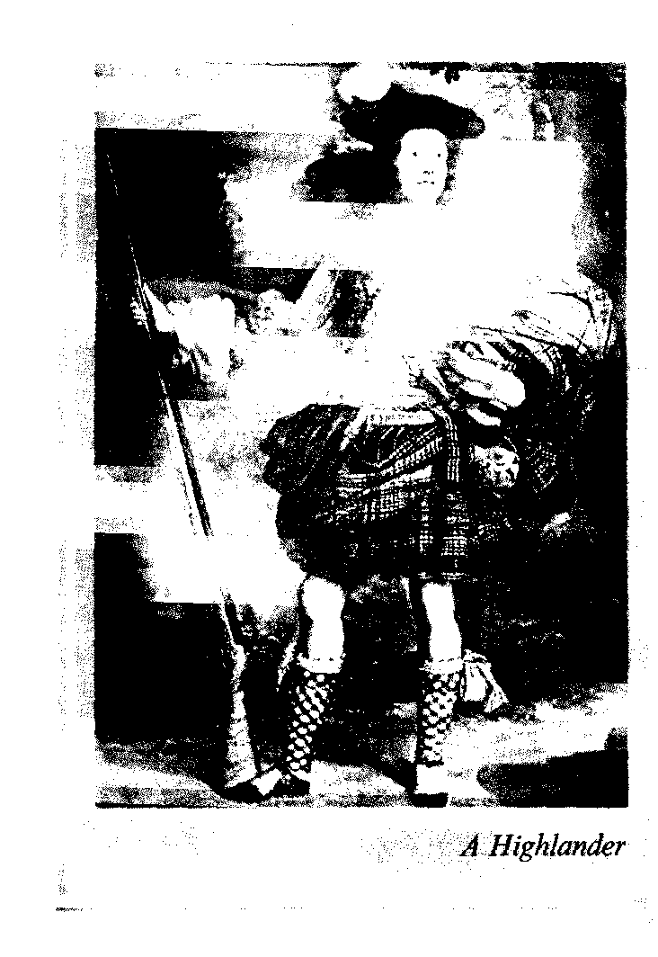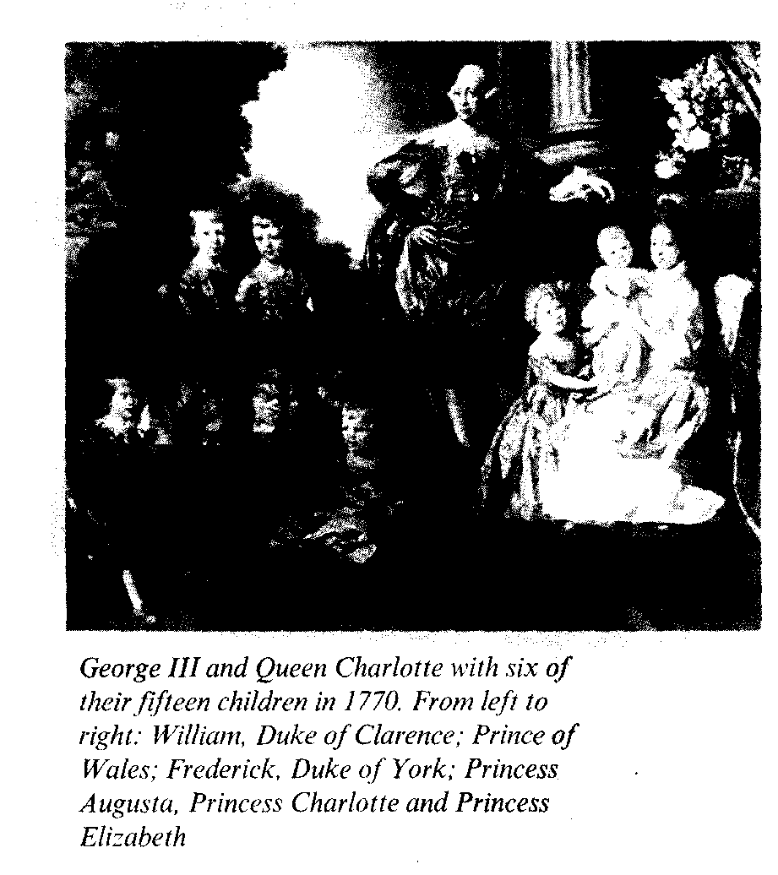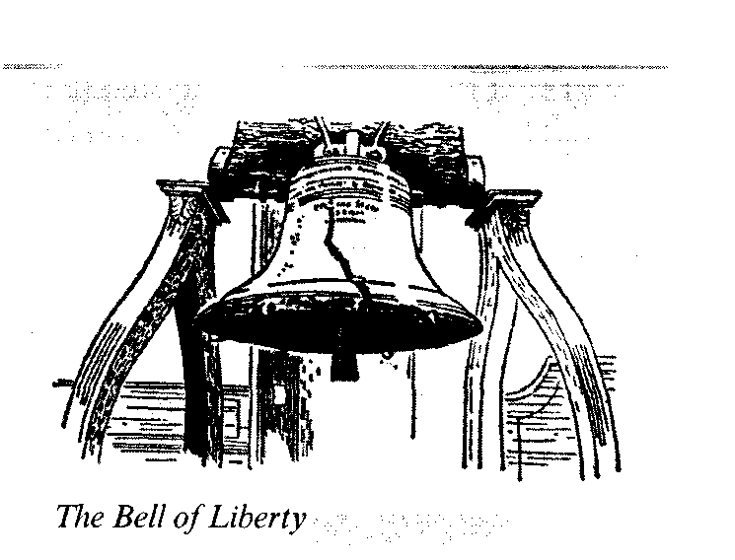

William Pitt, the Elder, had resigned as his new military plans did not find an understanding of the young King, who wanted to make peace with France (1763) and other European countries.

Meanwhile there were deteriorations in the relations with North American colonies. The colonists objected to the taxation from Westminster declaring their demands – "No taxation without representation". The King's new minis­ter Lord North didn't stop George III from mismanaging the affairs in North American colonies.

The Boston Tea Party in 1773 was the protest against the Stamps for tea taxes, when the colonists threw the East India Company'stea into the harbour. The Parliament undertook repressions though the opposition of Whigs were against this disastrous policy.

There were military conflicts near Lexington and Concord near Boston. The Congress of the United Colonies at Philadelphia elected **George Washington,** of Virginia commander of their armed forces (1775). A year later, on the 4 of July, 1776, the Congress adopted the Declaration of Independence.

The English army was defeated in the battle of Saratoga and was forced to sur­render. The war of Independence was won by the American forces supported by the French and when the Peace treaty was signed in 1782 in Paris, thirteen North American colonies transformed themselves into the United States of America with George Washington as their first President.

The defeat of Britain in North America ended the period of George III personal rule. The new Tories were his only hope, and in 1783 the King invited William Pitt, the younger, Lord Chatham's twenty-four year oldson toform a Cabinet.

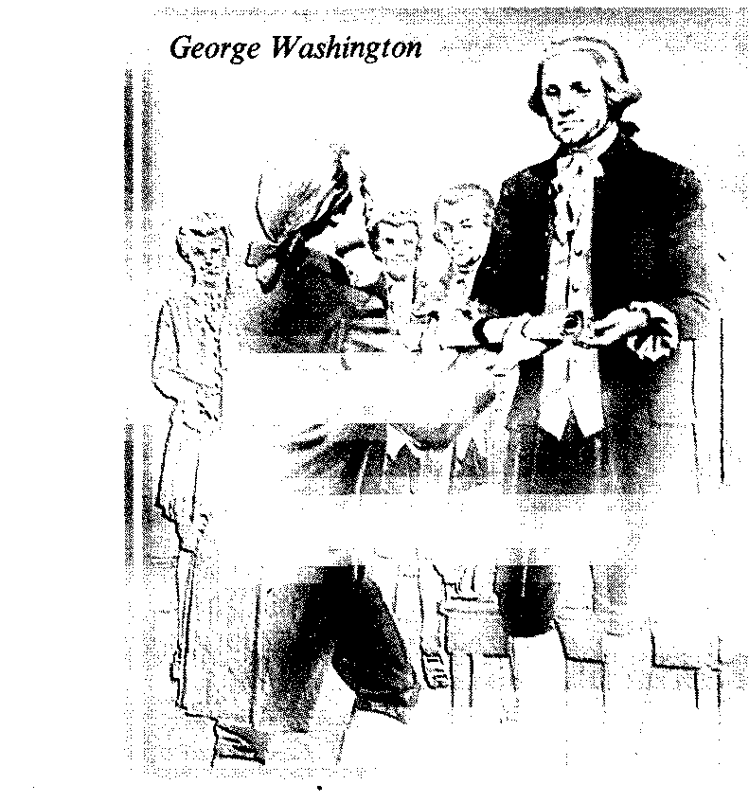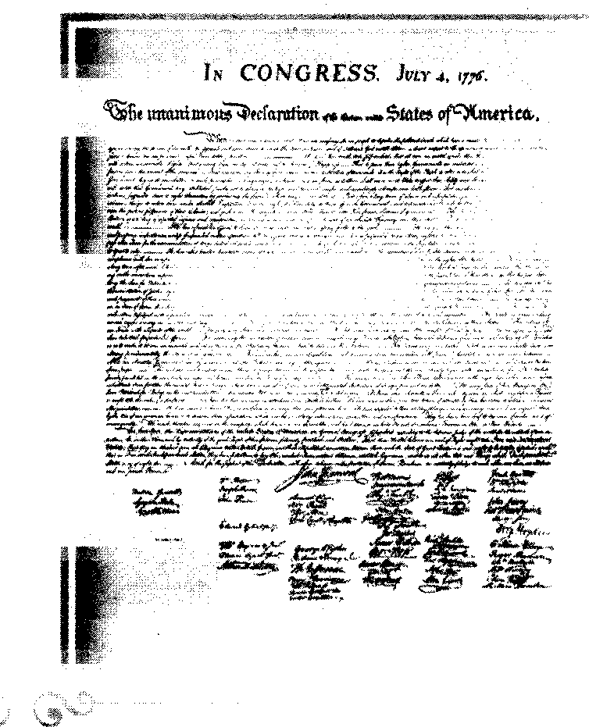

The reign of George III was the pe­riod of the great activity of the Literary Club, headed by the literary and linguis­tic dictator Dr. S. Johnson among whose members were Sir Joshua Reynolds, Goldsmith, Burke, Fox, Gainsborough, Sheridan and Adam Smith. The book by Adam Smith "The Wealth of Nations" appeared in the year of the Declaration of Independence; in it the great econo­mist presented the first classical system of economic activities of people. James Watt in 1782 improved the steam engines and his inventions made possible the In­dustrial Revolution.

*Questions:*

*1. What were the English gains in the War for Spanish Succession?*

*2. When did the United Kingdom of Great Britain appear and how?*

*3. Who was the first Prime Minister in Britain?*

4. In what way was George III different from his father and grandfather in his attitude to the government of the country?

*5. Speak of the reasons and the outcome of the War of Independence in North America.*

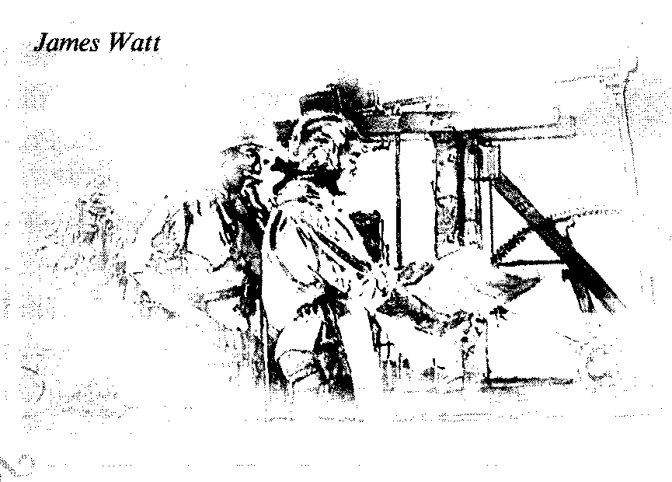

The technological Revolution was a new breakthrough in the eco­nomic and social development of Great Britain. It was a British way of bourgeois development, in contrast to the French Revolution. Chronologically its begin­ning is referred to the middle of the 18th century; and the first achievements were in the production of agricultural prod­ucts due to the new farming techniques.

Mechanical inventions facilitated the unprecidented growth of iron and coal production. By 1800 Britain was produc­ing four times as much coal as it had done in 1700 and eight times as much iron. John Wilkinson was making iron bridges, an iron chapel, iron boats.James Wattmade a steam engine in 1769. In 1764 a spinning machine was invented that could do the work of several people. The machines for spinning and weaving revo­lutionized the cloth making industry and transformed it from a cottage industry into a factory industry which was run and controlled by factory owners. Cotton tex­tiles played the leading part in Britain's economic expansion.

Britain was importing raw cotton from its colonies and exporting the fin­ished cotton cloth to sell in Europe and in the colonies as well. Manchester be­came the centre of the cotton textile in­dustry.

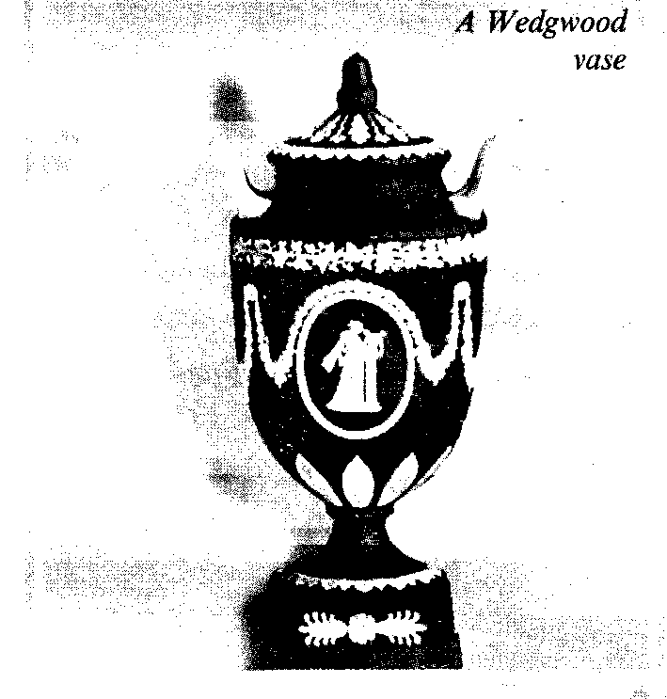

In the Midlands manufacturing of china goods was developing successfully and large quantities of bone china were exported. The most famous factory was one started by master potter Josiah Wedgwood. His high quality bone china and blue china became popular, and now Wedgwood is the trade mark of most exquisite English china. The area of this industry's location is known as "the Pot­teries".

The industrial revolution involved a revolution in transport. Man-made ca­nals together with rivers linked the main ports of England, roads were improved and a service of post coaches was started in 1784.

The end of the 18th century was the period of social disintegration – the wealth of the few was growing while the misery and poverty of the majority of people were increasing equally rapidly. Deprived of the means of production workers had lived in slums and worked long hours for very low wages in facto­ries and mines. The country was splitting into two nations – the rich and the poor.

There were many reasons for discon­tent in Britain, but the Revolution in France in 1789 was first welcomed in England by liberals, but it was becoming ferocious and bloody, the British ruling classes were frightened that similar events might happen in Britain. The Book by E. Burke "Reflections on the Revolution in France" was a serious warning of the dangers of radicalism. The Government took tough measures against the work­ing class movement and organisations that were appearing: mass meetings were forbidden, associations of workers were declared illegal.

Pitt had been Prime minister after 1784 almost all his life. But the King (George III) was an old sick man, who was not always in his right mind, so the position of the P. M. was extremely im­portant. Pitt was determined to maintain peace, but Revolutionary France de­clared war in 1793. The British troops were defeated in the Netherlands and the French West India, and the situation be­came more dangerous when a New French general appeared on the political scene – Napoleon.

The British were rescued by their Navy. The commander of the British fleet, admiral **Horatio Nelson** won bril­liant victories over the French navy, near the coast of Egypt, at Copenhagen and near Spain. At the Battle of Trafalgar in 1805 Nelson destroyed the French-Spa­nish fleet, but was killed by a sniper. He became one of Britain's greatest national heroes. His words to the English fleet be­fore the battle of Trafalgar "England ex­pects that every man will do his duty" are preserved in the memory of the na­tion as a historic example of partiotic duty in the time of danger.

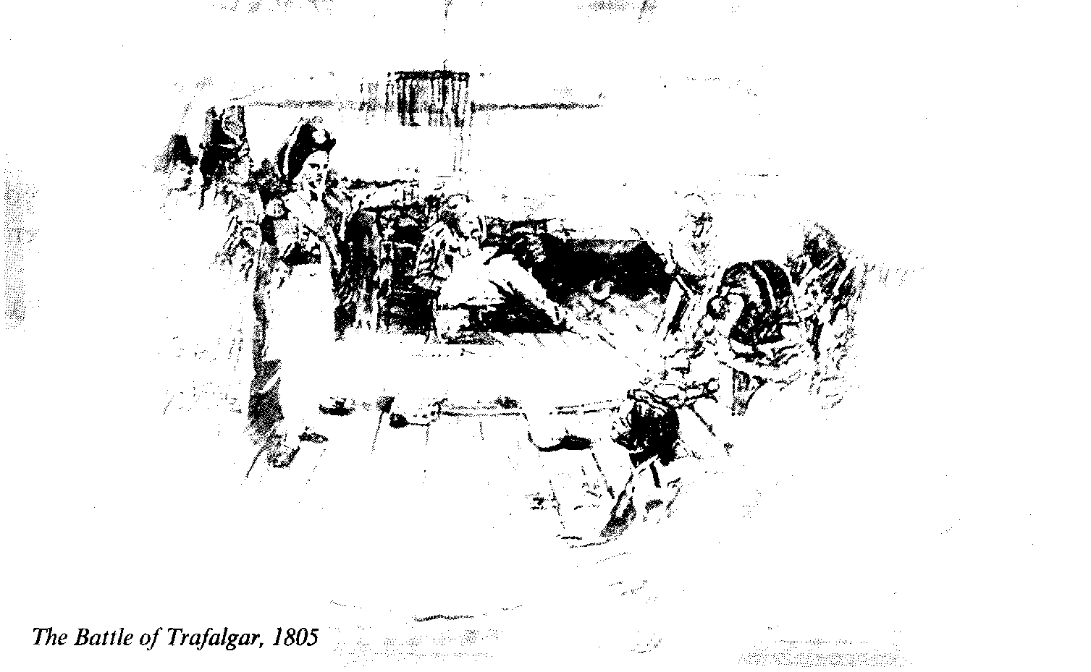

The greatest general of the British army in the actions against Napoleon be­came the Duke of Wellington (Sir Arthur Wellesley 1769-1852).

After the disastrous invasion of Rus­sia (1812) Napoleon was defeated by the European coalition in the Battle of Na­tions at Leipzig (1813), was imprisoned on the isle of Elba and escaped from it to reappear in Paris again. The last battle was fought in Belgium at a small place called **Waterloo** **(1815).** The British army led by Wellington and the Prussian army under Marchal Bluher defeated Napo­leon, he had to abdicate and was sent to

St. Helena in the South Atlantic and died there.

The Congress of the European Powers held at Vienna made peace and Britain emerged from the "Napoleonic Wars" a great empire: to Canada, Australia and most of India she added Cape Colony (South Africa), Ceylon and Guinea as well as a number of small provinces.

But this newly enlarged great power was suffering from internal problems: political and economic reforms had been long overdue, the years of the war had been a period of repressions, and the po­sition of the workers and the poor had deteriorated.

The first political measure of the Gov­ernment was a Corn Law prohibiting the import of cheap foreign grain. It was fol­lowed by riots and more repressions, some demonstrators were killed in the "Massacre of Peterloo" in Manchester. The people had their progressive cham­pions who criticized the established institutions and created "new settlements of the greatest happiness of the greatest number". **Robert Owen,** the philan­thropic factory owner and a theorist of Utopian socialism, who influenced the de­velopment of the working class move­ments–cooperative retail societies and trade unionism was one of them.

The social and political changes in the world involved a revolution in the arts. A brilliant galaxy of writers and poets looked for inspiration to nature, to emo­tions and to the spirit of freedom. Lyri­cal Ballads of Wordsworth and Coleridge were published in 1798. The works of Byron, Shelly and Keats were romantic and emotional. Jane Austen was not car­ried away by the Romantic Movement and in her domestic miniatures described the adventures of young lovers in the English country houses.

Painting was equal to the achieve­ments of poetry. Landscape painting pro­duced two greatbut very different gen­iuses – Turner and Constable.

The old King (George III, 1760-1820), blind, insane, died in 1820 and was succeeded by little respected George IV (1820-1830) who had been Prince Re­gent for the last nine years of his father's life (1811-1820).

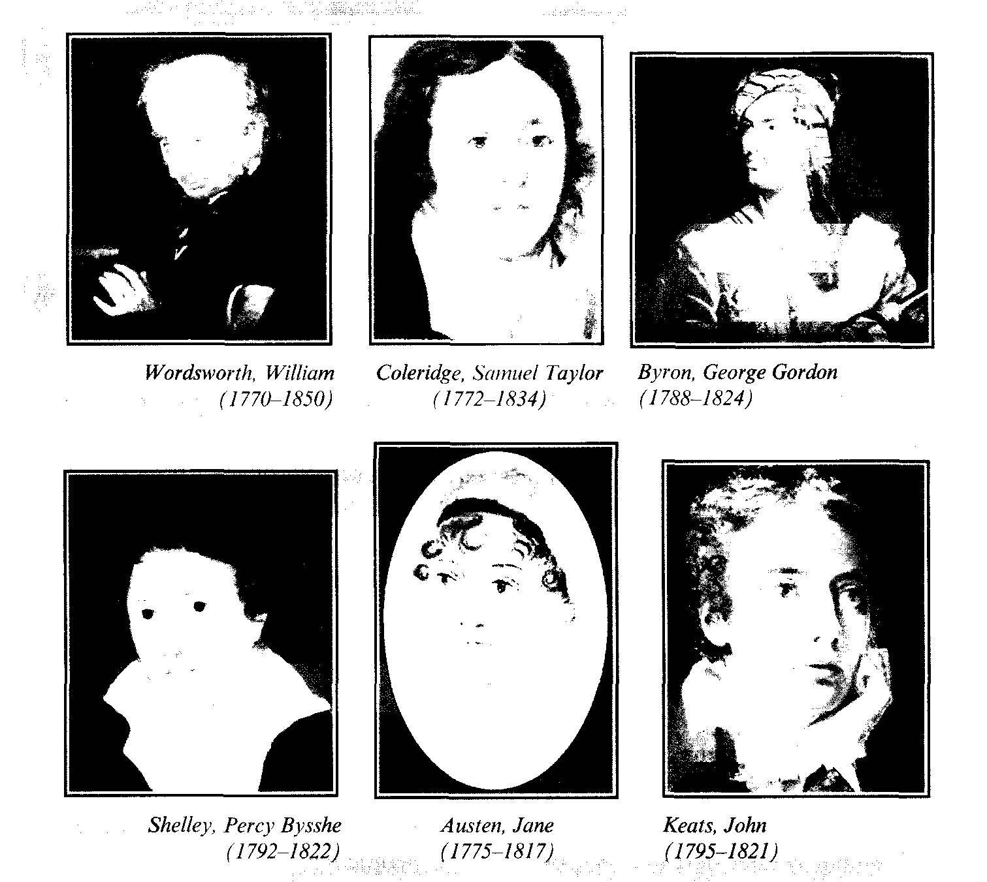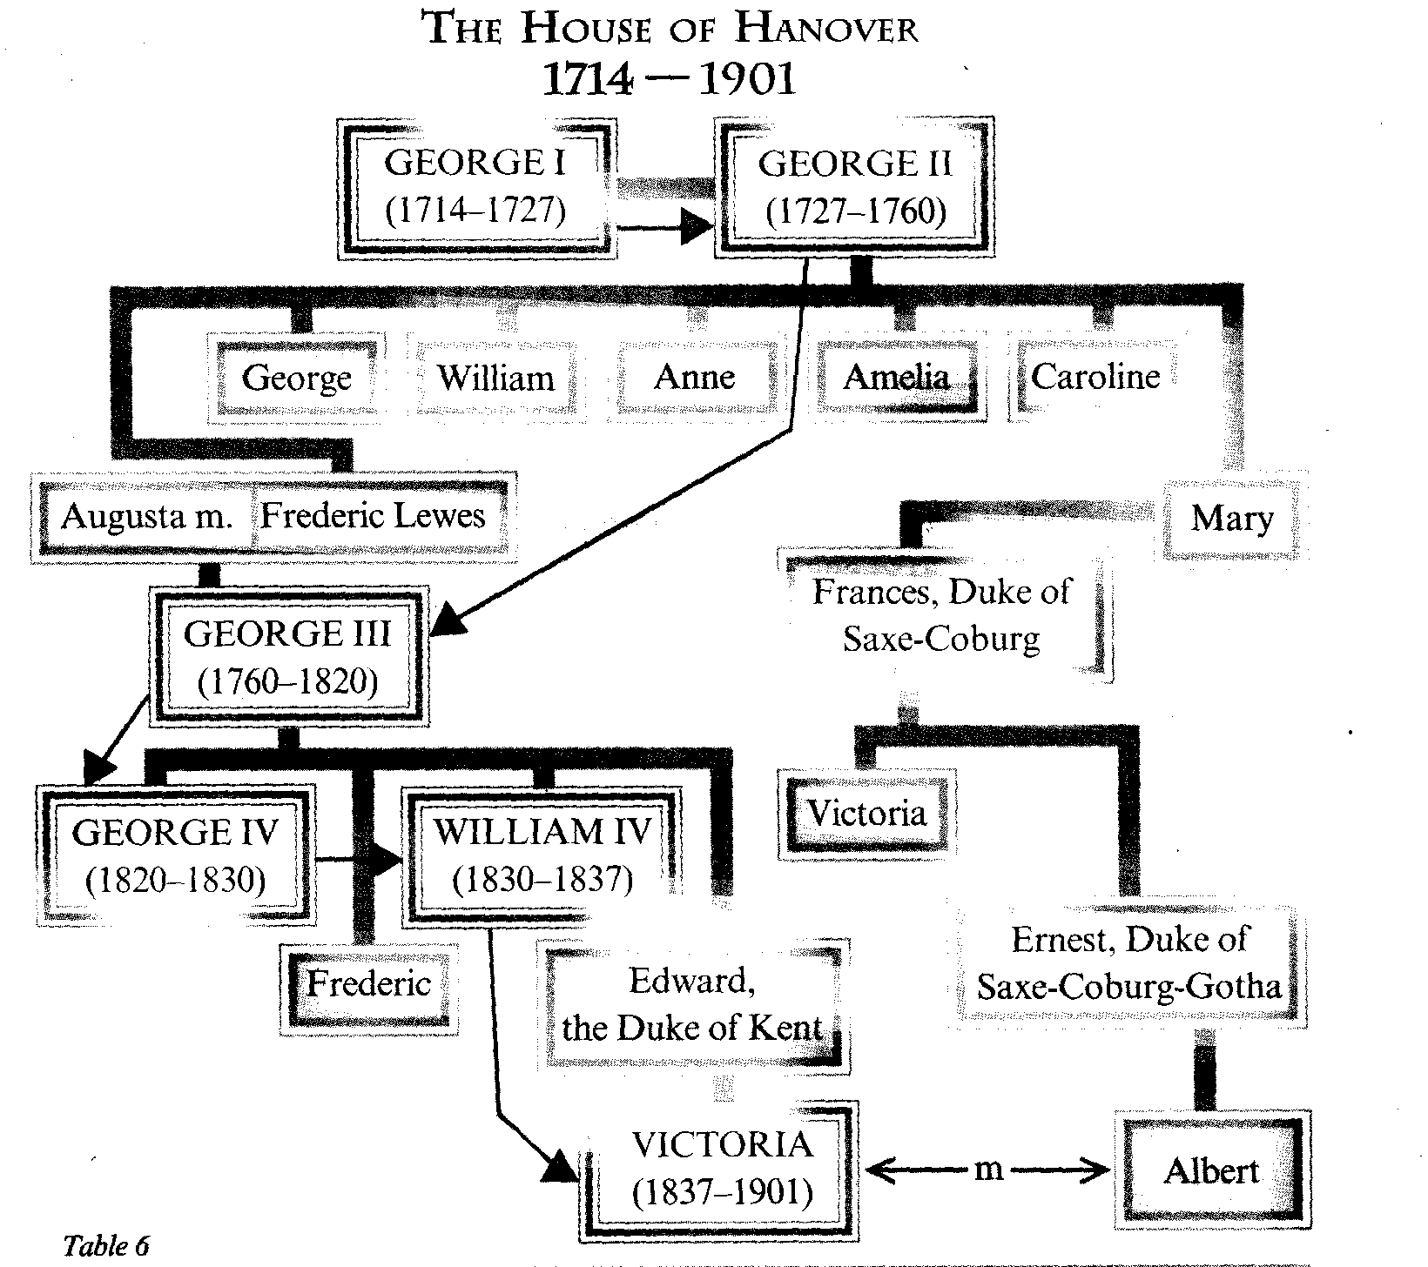

*Questions:*

*1. In what way is it traditional to compare the French bourgeois revolution and the Technological Revolution in Britain?*

*2. What branches of industry were progressing immensely**in the**Technological revolution?*

*3. What social situation was developing due to the technological revolution in Britain in the middle of the 17th century?*

*4. What were the military developments in the Napoleonic wars**against**France?*

*5. What were the victories of the Anti-Napoleonic coalition and what military heroes glorified Great Britain?*

*6. What territorial advantages did Great Britain gain out of the Vienna congress?*

*7. What were the internal problems of Britain at that time?*

*8. What were the revolutionary changes in arts?*



# THE 19тн CENTURY – THE VICTORIAN AGE OF THE BRITISH EMPIRE AND... THE NEW RIVALS

*Keywords, terms and concepts:*

*1. R. Peel, "Peelers or Bobbies"*

*2. Stephenson's "Rocket"*

*3. The electoral franchise reform (1832) and other Acts of Parliament*

*4. The Earl of Shaftesbury, friend of the oppressed*

*5. Queen Victoria (1837-1901)*

*6. Great English novelists*

*7. People's Charters (1838-1839, 1842, 1848). Chartism*

*8. Potato famine in Ireland, 1846*

*9. The Crimean War (1854-1856), Victorian politicians and their policies*

*10. The Education Act, 1870*

*11. Home Rule for Ireland*

*12. Britain and Ireland*

In the 19th century the post-Napoleonic wars period of reaction was being gradually reformed and more li­beral ministers were included in the Gov­ernment, more progressive policies and laws were adopted. Under ultra-con­servatory Wellington, who became Prime minister in 1828, some reforms were in­troduced: R. Peel, the Home Secretary created an efficient police force, and the policeman were called peelers or bobbies.

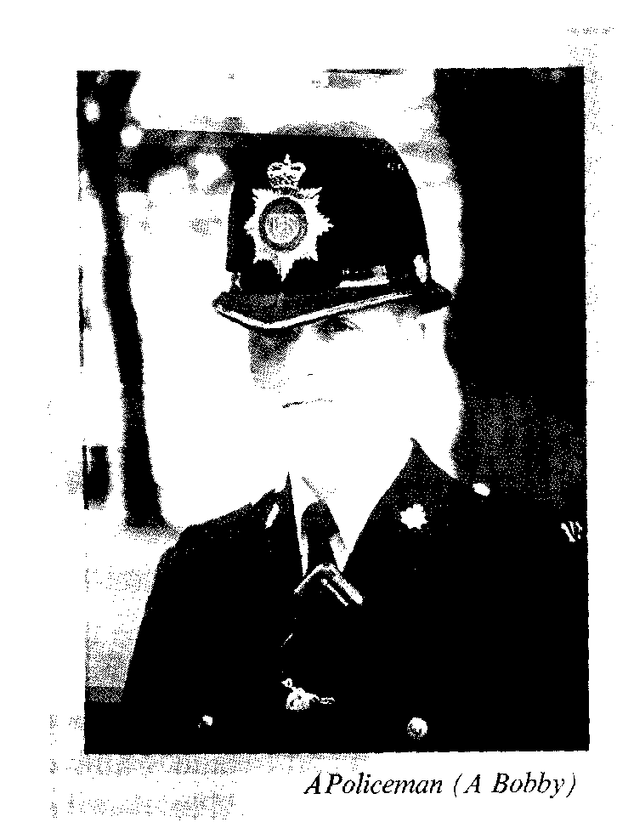

The Catholic Emancipation Act was a forced decision that split the Tory party and brought the Whigs to power in 1830. The Whigs were determined to reform the Parliament and the parliamentary fran­chise, which had not changed since the reign of Elizabeth I. The electoral fran­chise and distribution of seats in Parlia­ment were in a mess. Different parts of the country were represented in an un­even and unjust way. The county of Cornwall where the population was less than the population of Manchester or Birmingham elected 44 men to the House of Commons, but neither of these big industrial cities elected a single M. P. The voting was not secret, the whole system was corrupt and unrepresentative.

The confusion at Westminster re­flected the situation in the country. There were outbreaks of machinebreaking and riots: people exploited at the factoriesby factory owners and left unemployed by machines replacing them, were outraged; they smashed machines blaming Ned Ludd for it and bearing his name – Lud­dites, wearing masks and damaging the factories.

The Parliament Reform came to­gether with railways. The Manchester and Liverpool Railway was opened by the Duke of Wellington in 1830. George Stephenson built a locomotive **–** "theRocket", which reached a maximum speed of fourty eight kilometres per hour.

The technological revolution was go­ing on strengthened by social reforms that were obviously lagging behind.

The reformed Parliament passed a number of progressive acts, due to Lord Shaftesbury the first effective Factory Act was passed, limitting the hours worked ) by children in cotton factories to nine, prohibiting their employment under nine years of age, and appointing inspectors to see that the decisions were enforced.

The state assumed also some respon­sibility for the poor. According to the Poor Law all the able bodied poor were to go to the workhouses where the con­ditions were terrible. It was described by Ch. Dickens in his novel "Oliver Twist". The working classes were infuriated by the injustice and inhumanity of the Poor Law and demanded more radical re­forms.

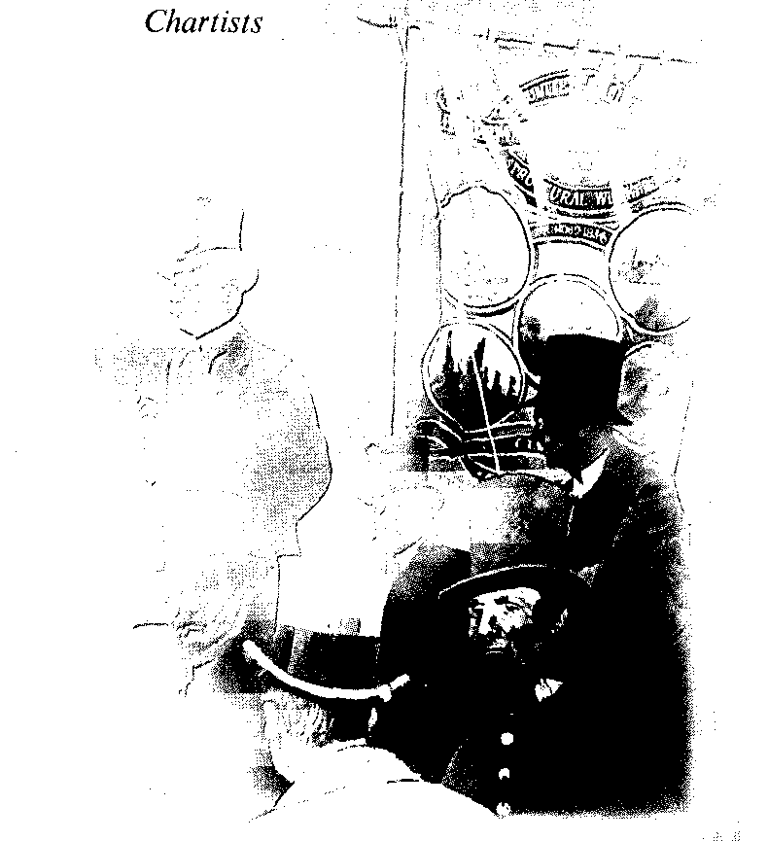

In 1838 the first petition was drawn up by leaders of first association of work­ers, which was called the **People's Char­ter.** It included six main demands for changes: the vote for all males, parlia­mentary constituencies of equal size, vot­ing by secret ballot, a salary for MPs, no property qualifications for MPs, annual Parliaments. All these reforms seemed revolutionary at that time.

The Chartist movement was sup­ported by the working people, but it had its ups and downs. The first Charter was rejected by Parliament in 1839, which was followed by protests of the working peo­ple and repressions by the Government. The Chartist leaders were arrested; the Movement was defeated when the second Petition was also rejected by Parliament in 1842.

The revival of Chartism in 1848 coin­cided with the Revolution in Europe and with nationalist demands of the Irish, but the third petition having been rejected, Chartism began to decline and grew into the cooperative and trade unionist move­ments.

The Parliamentary struggles of the Tories and the Whigs, the working classes struggle for social rights and a better life, were all developing against the back­ground of a drastic change in the Mo­narchy. The only daughter of the Hanoverian Duke of Kent turned out to be the only heiress to the British throne, and after the death other uncle William (William IV 1830-1837) 18 year old Vic­toria became Queen (1837-1901). Her first Prime Minister, Lord Melbourne, taught the young Queen the dutiesof the constitutional monarch. The accession of Queen Victoria came at a difficult time: the Whigs lost their popularity and the majority in the House of Commons; the Hungry Thirties passed into the Hungry Forties, and the alternative to the Whigs polices was the new Conservative Party, created by R. Peel. Peel's financial re­forms brought revival to the country (1844), and legislation to protect factory and mine workers improved their condi­tions, but the disaster came with the poor harvests in Britain and Ireland. Famine in Ireland (1845) convinced Peel that the Corn Laws should be repealed (in 1846). It was the greatest victory of the free trad­ers. But it destroyed the Tory Party and R. Peel was forced to resign.

The reforms brought cheaper food and exports from "the workshop of the world". And the Whigs inherited the ben­efits of Peel's reforms.

Queen Victoria's Prime Ministers fol­lowed one another due to the Political developments in Parliament: Lord Mel­bourne (1835-1841), Sir R. Peel, Lord John Russel, Earl of Derby, Earl of Ab­erdeen, Viscount Palmerstone, Benjamin Disraeli, W. E. Gladstone, Earl of Ro-sebery, Marquess of Salisbury.

In 1840 Victoria married her cousin (see Table 6) of Saxe-Coburg of Gotha. The marriage was happy, and the Royal family became a model for moral stand­ards in high society as well as for the mid­dle classes.

Prince Albert became deeply inter­ested in the British affairs, both foreign and home. He was the initiator of a great display of Victorian glory and progress in the country – the Great Exhibition of 1851. This international exhibition was quite a new idea, and Albert had to over­come a lot of opposition. The Exhibition building was an enormous glass-and-iron structure – the Crystal Palace in Hyde Park, it had on display machinery and products from Britain, the Empire and other countries.

"The Crystal Palace" was the symbol of Technological progress. The new poet-laureate Tennyson wrote an ode to it. All the Victorian writers, poets, painters glo­rified English culture. Tennyson and Browning dominated the poetry. Charles Dickens in his novels David Copperfield, Oliver Twist, Nicholas Nickleby exposed the social evils of the time. Thackeray exposed the middle class hypocracy in his "Vanity Fair". It was a great age for novels. Women writers – the Bronte sisters, Mrs Gaskell–flourished as never before.

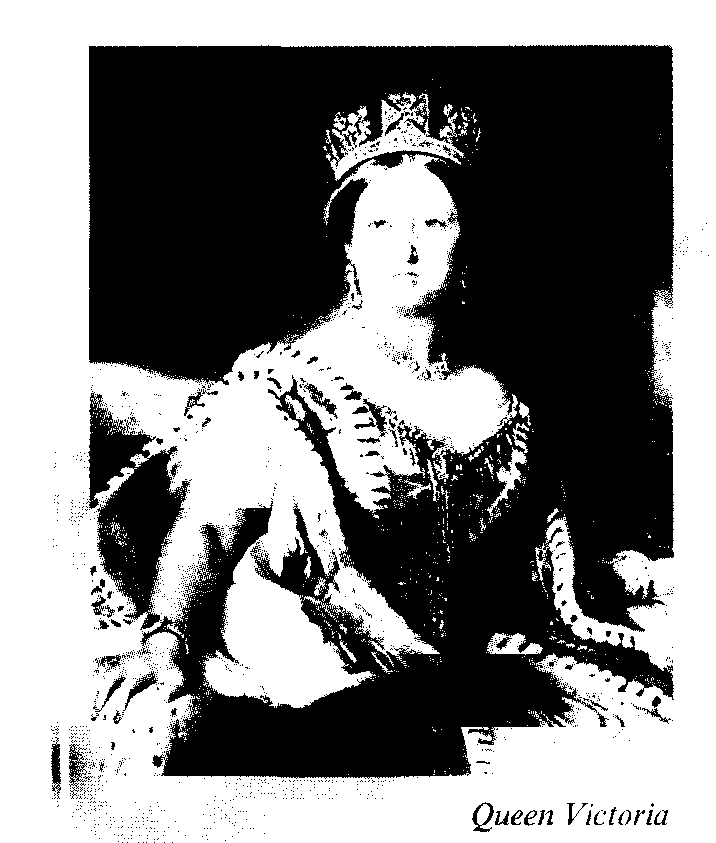

Thomas Hardy and Henry James were "Victorian" novelists too. The Eng­lish drama was brilliantly represented by Irish talents: Oscar Wilde wrote his bril­liantly entertaining comedies, Bernard Shaw's plays were more serious but ex­tremely witty.

Painters of the group called the Pre-Raphaelite Brotherhood expressed the great Victorian nostalgia for the Middle Ages.

Victorian science was to become greatly influential on the developments in the Modern Time. These three men: K. Marx (1818-1883) – the founder of Communism, Sigmund Freud (1856-1939) – the founder of psycho-analysis and Ch. Darvin – the founder ofthemodem theory of biological evolution – shocked the world.

Encouraged by Prince Albert, the Queen came into conflict with Palmerston. In 1854 the Crimean War broke out – when Britain and France declared war on Russia in support of Turkey. Prince Albert had supported the policy of preventing the war while Palmerston was given the Parliamentary support as the only Prime Minister ca­pable of winning the War, and the Queen was compelled to accept him as Prime Minister in 1855. Palmerston became the symbol of British superiority in every­thing: in fights, in trade, in politics.

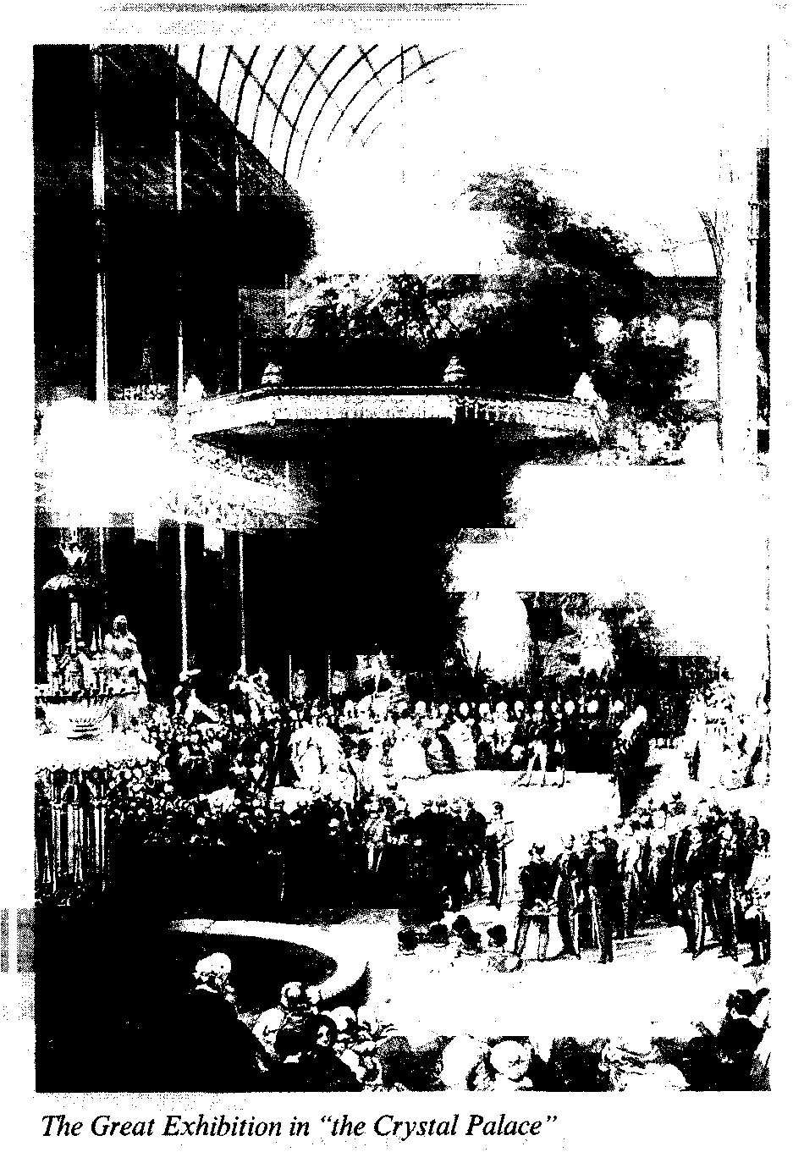

The Crimean War revealed the cou­rage of ordinary soldiers and the incom­petence of the command. Newspapers reported the shocking conditions in the army hospitals, the terrible organization of supplies: a load of army boots sent out from Britain turned out to be for the left foot. The war solved nothing but it brought a glory to the remarkable work of **Florence Nightingale,** "the lady with the lamp", who organized hospitals and treatment of the wounded.

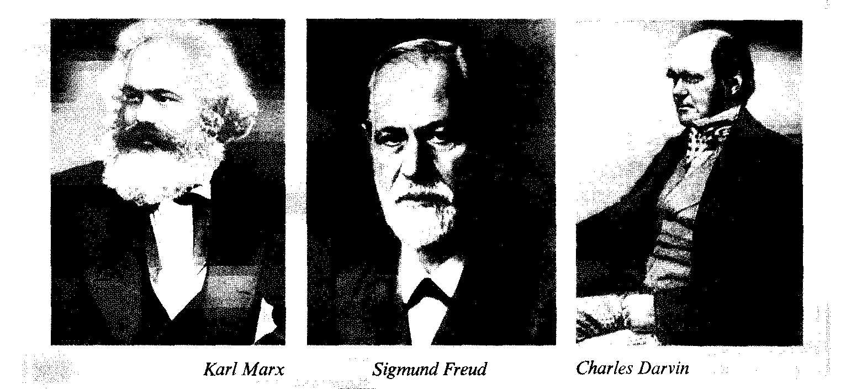

In India the British policies aroused a revolt in **1857**, it was known as the **In­dian Mutiny;** and it developed into a na­tional movement against foreign rule. There was much violence on both sides. The British brutally punished the de­feated rebels, which caused a feeling of animosity that later grew into the Indian Independence movement of the twentieth century.

Queen Victoria suffered a great per­sonal tragedy in 1861 – Prince Consort Albert died of typhoid – and the Queen went into deep mourning, withdrew from public duties and lived in isolation for a decade. Her last thirty-five years of reign were a period of struggle between the new **Liberal Party** led by W. E. Gladstone and **the Conservatives** who were headed after Palmerston by Benjamin Disraeli.

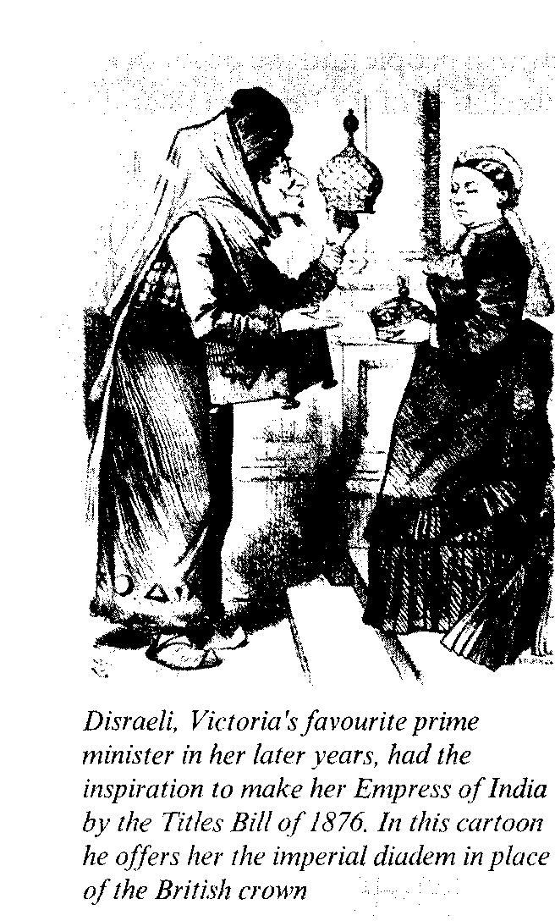

On the great issues which dominated British politics in the last quarter of the 19th century – the extension of the Par­liamentary franchise, the limitation of the Power of the House of Lords, social re­form, Home Rule for Ireland and the new aggressive imperialist policy abroad – Queen Victoria strongly sympathized with Conservatives and disapproved of **Gladstone** and Liberals.

**B. Disraeli** became Prime Minister in 1868 and first held the office for only nine months, but he managed to establish a very close relationship with the Queen and further developed it during his se­cond term of office (1874-1880). В. Disraeli pleased the Queen greatly by persuading Parliament to agree to grant her the title of Emperess of India.

The contest of Disraeli and Gladstone was in full swing, and the two-party sys­tem had been already firmly established.

Jingoism (the word for extreme, flag waving patriotism) was encouraged by B. Disraeli, but it was condemned by his rival, the Liberal Leader, William Gladstone.

The Empire, that Great Britain had gained by the middle of the 19th century, was the result of the greatest power that Britain possessed through its command of trade, finance and manufacturing. The colonies were united by English law and by trade, the forms of governing admin­istration varied. The whole population was growing due to the emigration from the British Isles: throughout the 18th, 19th centuries poor and disadvantaged people sought a new and a better life in the colonies. In 1850 New Zealand be­came the responsibility of the Crown. The population of Australia was expanding rapidly. There were four self-governing colonies: New South Wales, South of Australia, Victoria and Queensland. By the end of the century the Empire was spreading over the continents of Africa, Asia, North America, South America, Australia. The sun did not set on the Empire. The colonial office became a large and important ministry. Imperial­ism had become popular with the mid­dle classes. The patriots of jingoism sounded more and more aggressive: Cecil Rhodes (the founder of Rhodesia) spoke about the British as a race superior to their colonials. The actions of the impe­rialists were no less dishonourable: a chain of "small colonial wars" was caused by the aggression of the British imperialism. But the Anglo-Boer War proved to be an unsuccessful surprise to the British people and the proof of a cer­tain weekness of the Empire (1880-1881, 1899-1902).

There was the Irish Problem: the Irish MP's in Parliament demanded Home Rule for Ireland, and Irish extremists committed terrorist actions. Gladstone supported the idea of Home Rule for Ire­land – which meant the restoration of the Parliament, that they had lost by the Union with England in 1801 and the con­trol of the Irish local internal affairs. Gladstone's own Liberal Party voted against the Home Rule Bill. The Liberal Party was split and broken. It's role as one of the two major parties in the coun­try was over. The Liberals were to be re­placed by the forthcoming **Labour Party** in the constant struggle against the con­servatives.

Due to the Industrial Revolution and the strength of the Empire Great Britain was still the greatest power of the world in the last 30 years of the 19th century. Symbolic of its greatness and the expan­sion of the Empire were the jubilees of Queen Victoria (1887 and 1897), ce­lebrated with great pageantry and enthu­siasm of the crowds.

The nations of the New World and a strengthened Europe were becoming in­dustrial rivals of Britain. The European countries were partitioning the African continent, and Britain succeeded in ad­ding great African possessions to her Empire: Nigeria, Kenya, Uganda, New Zealand and Rhodesia; the Sudan was jointly administered by Britain and Egypt.

The United States since the end of the Civil War (1862-1865) had progressed greatly and rapidly, supplied the free-trade England with its food products and were developing into a great power.

The role of the United Kingdom at the end of the Victorian Era, at the end of the 19th century was highly important, jingoistic (shovinistic) imperialism and the financial strength spread over the world through the export of capital by the banks of the City, strongly influenced the internal development of the country: Anglo-Saxon shovinism and superiority complex in the upper spheres and the trade unionism, emigration to the colo­nies and Dominions, political parties struggle for power were the conse­quences.

Meanwhile the conflicts and contra­dictions among the European countries were bringing the world to the brink of the World War, which was destined to bring about great changes in the British role in the world.

*Questions:*

*1. What reforms were introduced by the Whigs and how did they influence the situation in the country in the 30th of the 19th century?*

*2. What were the repeated attempts of the people to introduce more radical reforms? Describe the programme and the demands of the movement.*

*3. Who was the Monarch of Britain for the greater part of the 19th century? What were the political affiliations of the numerous Prime Ministers of the century?*

*4. What can you say about the role of Prince Albert in British Affairs?*

*5. What were the greatest cultural achievements of the Victorian Age?*

*6. Why did the British start the Crimean War and who became the heroic figure of the War?*

*7. What was the policy of Britain in India?*

*8. What was the difference between the policies of B.Disraeli and Gladstone? How do you understand "jingoism "?*

*9. How did the overseas possessions of Britain expand? What was the situation in the British Empire?*

*10. What was the role and the status of Great Britain in the World at the end of the 19th century?*

В соответствии со статьей 19 пунктом 2 Закона РФ "Об авторском праве и смежных правах" в данном издании использованы иллюстрации из книг и журналов на:

обложке, стр. 37 -- Магу Queen of Scots.– London: Pitkin Piclorials Ltd. 1972;

стр.2, 14,32. 36,43,48,54, 55, 57. 69 – The lives of the Kings & Queens of England / Ed. A. Fraser– London: Weidenfeld and Nicolson, 1993, стр. 5, 6, 10, 11, 17.20.47.49, 51. 56.57, 58, 59, 61, 64, 66 – Grant N. Hamlyn Children's History of Britain from the Stone Age to the Present Day.– London: Hamlyn, 1989;

стр. 15, 24, 35, 37. 42. 48 – The Oxford Illustrated History of Britain / Ed. K. O. Morgan.– Oxford, New York. 1996;

стр. 19, 23. 38, 44 – A Social History of England.– London: Weidenfeld and Nicolson, 1983;

стр. 21 – Westminster Abbey.– London, 1993;

стр. 22, 29. 30, 50. 67 . Britain's Kings & Queens.– London: Pitkin Pictorials Ltd, 1990;

стр. 31, 34 – The Six Wives of Henry VIII.– London: Pitkin Pictorials Ltd., 1975;

стр. 38, 62 – Britain. Literary.–Heritage (Буклет), 1983;

стр. 54, 55–Blenheim Palace.– London: The Blenheim Estate Office, 1971;

стр. 68 – Детская энциклопедия. Том 4: Растения и животные.– М.: Из-во АПН РСФСР, 1960.

*Учебное пособие*

Гурьева Юлия Федоровна

A concise history of britain

"DEEP ARE THE ROOTS..."

*(Очерки по краткой истории Британии)*

**"ГЛУБОКИ КОРНИ..."**

Зав. редакцией учебных пособий по английскому языку К. И. Кауфман

Корректоры Г. А. Киселева, Г. П. Мартыненко

Дизайн макета и художественный редактор В. С. Жеребцов

Сканирование, цветоделение и коррекция изображений Л. Н. Новоселов

Лицензия № 070011 от 17.06.96. Подписано в печать 29.11.99. Формат 70 х 100/16. Печать офсетная. Бумага офсетная № 1. Гарнитура "Тайме". Усл. печ. л. 5,83. Усл. кр.-отт. 24,3. Уч.-изд. л. 5,4. Тир. 5 000. Зак. № 2907 Издательство "Титул". 249020, г. Обнинск Калужской обл., ул. Курчатова, 21, а/я 5055, телефон (08439) 4-82-82. Internet: www.titul.ru, e_mail: sales@titul.ru. Отпечатано с готовых диапозитивов в Калужской типографии стандартов. 248021, ул. Московская, 256.

Содержание

ANCIENT BRITAIN 3

BRITAIN IN MIDDLE AGES 12

Anglo-Norman Britan 12

Later Middle Ages 19

Britain in Late Middle Ages 24

THE TUDOR AGE (1485–1603) 26

THE STUARTS AND THE STUGGEE OF THE PARLIAMENT AGAINST THE CROWN 36

THE 18тн CENTURY– OF WEALTH, TECHNOLOGICAL REVOLUTION AND POWER 47

THE 19тн CENTURY – THE VICTORIAN AGE OF THE BRITISH EMPIRE AND... THE NEW RIVALS 55