Л. А. Куликовская

# КОНСУЛЬТАЦИИ

# ПО АНГЛИЙСКОЙ ГРАММАТИКЕ

## В помощь учителю иностранного языка

### Издание второе, исправленное

Москва

Издательство «Флинта»

Издательство «Наука»

2000

# УДК 802.0

ББК 81.2 Англ

#### К 90

**Куликовская Л. А.**

Консультации по английской грамматике: В помощь учителю иностранного языка. — 2-е изд., испр. — М.: Флинта: Наука, 2000. — 88 с.

ISBN 5-89349-119-х (Флинта)

ISBN 5-02-022579-7 (Наука)

В книге предлагается материал по некоторым малоосвещен­ным разделам английской грамматики с соответствующей си­стемой упражнений (снабженной ключами) для глубокого проникновения в суть описанных явлений и прочного их ус­воения.

Для учителей средней и высшей школы, а также для са­мостоятельной работы совершенствующихся в английском языке.

ISBN 5-89349-119-х (Флинта)

ISBN 5-02-022579-7 (Наука)

©Издательство«Флинта», 1999

# PREFACE

The book is intended for school EFL teachers. It gives clear explanations and useful practice of English grammar. Some of those grammatical pieces are included which are not always easy to find on the pages of grammar books. Very often teachers and then their students receive one and the same portion of grammatical information year in, year out and get an idea of the English language being too elementary to express a great variety of meanings. The purpose of the book is to bring to the attention of the reader certain allegedly simple grammatical topics, disclose their actual essence and show their place in communication. The grammatical items are presented not in their pure way, but are correlated with other linguistic notions. For example, number of nouns concerns the problem of conversion and agreement between the subject and the predicate. Comparison with the Russian language is made where necessary. The book is not a reference book, it includes the information which deserves a teacher's attention in the opinion of the author.

A selection of exercises from English teaching courses will provide the EFL teachers with various activities (mostly of a communicative character) to practise the described grammatical material. The given assignments help create the conditions in which the knowledge of a foreign language becomes a must and the only way of self-expression. They will help learners not only form correct sentences but also use them correctly in context. They are aimed at teaching students of different levels of knowledge and admit of replacement of a more difficult vocabulary for an easier one.

The material composed by native speakers was chosen because it presents pieces of real English culture, traditions and way of life and because it excludes errors so common in the books written by non-native speakers. The description of the similar conditions, circumstances of life in our country can be practised as a follow-up.

# INTRODUCTION. PARTS OF SPEECH

Man is not well defined as homo sapiens ("man with wisdom"). For what do we mean by wisdom? More recently anthropologists have talked about "man the tool-maker," but apes can make primitive tools. What sets man apart from the rest of the animal kingdom is his ability to speak; he is "man the speaking animal" — homo loquens. But it is grammar that makes language so essentially a human characteristic. For though other creatures can make meaningful sounds, the link between sound and meaning is for them of a far more primitive kind than it is for man, and the link for man is grammar. Man is not merely homo loquens; he is homo grammaticus.

*Frank Palmer. Grammar.*

The idea of the book is to bring to the attention of EFL teachers those areas of English Grammar which lie fallow and yield very poor results, if any, because the teachers in their strivings to get more in a very short while lose hold of extremely important things. The teachers imply that the learners are supposedly aware of quite a lot of linguistic knowledge if they are adults or are at the age of, say, ten (and they really are if we think in terms of their native language); or, on the contrary, they are too young to be given information which the previous education and upbringing have not yet put at their disposal. So, we leave our students (who happened to be less educated in a foreign language or are privileged to be younger, than we are) unequipped with the foundations of the language learning.

Ask your students what grammar (the word is repeated by them quite often) is and they will be surprised to hear this kind of question from you and most unexpected answers will be given you. 1 mean to say the following: try to find some time to discuss basic frequently used notions so that their meanings will become wholly understandable to your students, and they will cease saying them in a parrot-like way.After deciphering them the students will get an additional background and impetus in their linguistic education. They will become proud of themselves for being more educated. Sometimes we underestimate our students' abilities: teenagers as well as adult learners have acquired a lot about the Russian language system. Help them display their knowledge, make it work, be effective in the acquisition of another language. Your linguistic considerations will teach your students to generalize, to stop to think, to philosophize. By learning to do so with a foreign language they will transfer their abilities onto the native language and other subjects, and further on, to their everyday life. Just think of how much diversified their insight into life and how much deeper their understanding of the word system will be!

You may contradict me by saying that the learners will not need this philosophizing and can do without it. That's not true. Learning a foreign language is a lasting effort which requires a lot of time and work. For instance, some practical manuals may seem discouraging to the learner, since the explanations can contain not the well-accustomed formulations but unusual wording unheard of before. A successful foreign language speaker is an indefatigable labourer, a great user of books, a constant improver of his/her speech habits, a wise decipherer of all new information, an ingenious reader keenly reacting to any nicety of thought expression.

An attempt to highlight several linguistic notions has been made, ways how to teach them have been sought.

What is grammar? Grammar is part of linguistics (the learning about a language) which studies changes of words (in other words, forms of words) and the connection of words into word combinations and sentences. Hence, grammar consists of morphology and syntax.

As a result of such a study we receive a collection of rules since rules are practical directions given to people by previous generations. The rules are about how to form the plural number of nouns and verbs, the past tense of verbs, the degrees of comparison of adjectives, etc. The rules reflect the actual processes that a language undergoes. Rules are secondary, while language behaviour is primary. That is why it is incorrect to define grammar as a set of rules. Grammar is self-contained, abstract and independent. Certainly, grammar reflects processes developing in human society, there would be no grammar without language bearers, people, but it alienates itself, becomes a kind of philosophy granted to people, so a set of rules is nothing but a bridge between philosophical matter (as grammar is) and a human being.

It is wrong to say that physics is a set of rules of how to use electricity, for example, nor is it correct to say that chemistry studies how to make use of chemical elements. In the same way, grammar is not a set of rules, but a study of language processes to create a verbal thought.

Grammar is a high degree of abstraction, a subconscious mechanism which is stuck in the native speaker's mind as a kind of reflection of what they have seen and heard since infancy.

The similar foreign language mechanism can develop in you in the same subconscious way if you live among the people speaking the language you want to learn. If not, you have to develop that mechanism purposefully, making one step after another, understanding that this is a mechanism unlike the one you have already developed in your mind, which still has coincidences and discrepancies and which should become the core of your foreign language speaking abilities. That is why it is almost impossible to overestimate the role of grammar as an impetus in your understanding language. No time devoted to teaching what grammar is and teaching grammar itself is considered wasted. But teaching grammar is a sophisticated process, it shouldn't overload the students' mind and should be skilfully incorporated in all areas of knowledge and rationed in proportion to speaking, listening, writing and reading.

Grammar like any other part of linguistics (phonetics, lexicology, spelling, punctuation, etc.) deals with words. All words in a language are subdivided for convenience into groups called parts of speech.

Alongside grammatical features such as number, case, tense, mood, etc. and interaction between words of different parts of speech, the notion of a part of speech includes some lexical features: meaning, word-building elements, and some phonetical ones. That is why, parts of speech subdivision is valid not only for grammar; it is referred to in phonetics, lexicology, etc.

A part of speech is a group of words united together by the common lexical meaning (thingness, action, property, characteristic of an action, property or another characteristic; connection, relation, definiteness/indeflniteness, emphasis, human emotions, human attitude, affirmation/negation); by the common changes of words to express number, case, degrees of comparison, tense, person, mood, etc.; by the common ways of connection with words of other parts of speech; by the common functions in a sentence (subject, predicate, predicative, object, attribute, adverbial modifier), by the common word-building elements (suffixes, word structure).

If a group of words have the common lexical meaning of thingness (in a wide sense of the word); have the forms player — players, player — player's, players — players'; are connected with adjectives, verbs, articles, prepositions, and can be subject, object, predicative, attribute and adverbial modifier in a sentence, they are united together under the name of nouns (N for short).

If the words have the common lexical meaning of action (in a wide sense of the word), have the forms play — plays, play — played — will play, plays — is playing, plays — is played, play — have played, etc.; are connected with nouns, adjectives and adverbs; can be predicate in a sentence, they are united together under the name of verbs (V for short).

If the words have the common lexical meaning of property, have the forms kind — kinder — kindest; are connected with nouns, adverbs, verbs; and can be attribute or predicative in a sentence, they are united together under the name of adjectives (A for short).

If the words have the common lexical meaning of characteristic of a property or of an action, if they are unchangeable in form or can have the forms fast — faster — fastest; if they are connected with adjectives and verbs and can perform the function of adverbial modifier in a sentence, they are united under the name of adverbs (Adv for short).

The study of the language resulted in naming certain parts of speech, they are presented in the following chart.

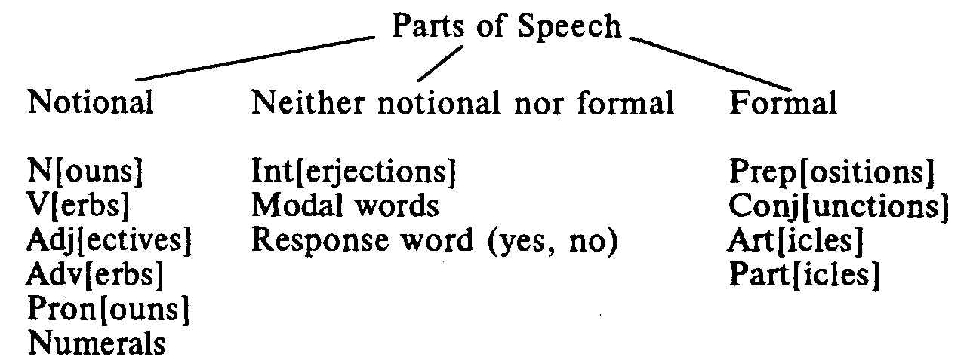

The symbolic presentation of parts of speech will make the process of teaching and learning the language more economizing and more enjoyable. It will also make the process of learners' looking up words in the dictionary easier. The symbols will allow students to take quick notes. Symbols are part of linguistic literature and knowing them will pave the way to understanding further reading on linguistic topics.

The parts of speech picture should necessarily be compared with what exists in the Russian language.

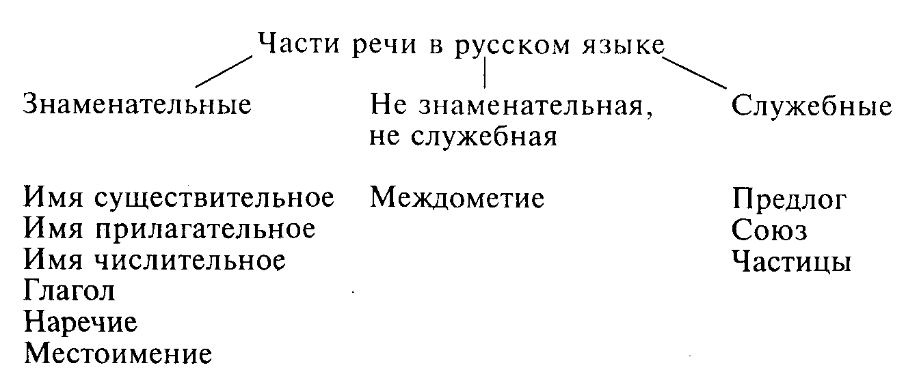

The comparison of the English and Russian parts of speech systems shows that they are identical with one substantial difference: there's the article in the English language, and no articles are to be found in the Russian language. As to modal words, they can be treated as a group of adverbs (some linguists do so), the words Yes and No are only two in number and may be moved to Interjections.

English notional parts of speech have been attended to so far. Now we'll mention most important features of formal words and those words which are neither notional nor formal.

Formal words are subdivided into connecting and determining. The connecting formal words are prepositions (prep) and conjunctions (conj). Prepositions show the relation of the noun to words of other parts of speech in a sentence. They are unchangeable words connecting the noun, the pronoun, the gerund, infinitival and gerundial phrases, noun-clauses with the noun, adjective and the verb in a sentence. Being formal words they do not perform any function in a sentence.

Conjunctions (conj) have the meaning of connection, they are unchangeable and connect words of the same parts of speech: N conj N, A conj A, V conj V, Adv conj Adv, N/Pron conj N/Pron, etc. No syntactical function is performed by them.

The determining formal words are articles (art) and particles (part). They have a peculiar meaning and are unchangeable. They determine notional parts of speech: the article determines nouns (art + N) and particles determine any notional part of speech for emphasis, e.g. Only he did so. He did only this. He only listened but did nothing. They do not perform the functions of subject, predicate, object, etc. in a sentence, they emphasize the meaning of the word they modify.

Interjections (int) express human emotions, they are unchangeable, they make a sentence in themselves, e.g. Oh, how happy I feel, and are often homonymous with notional words, e.g. My God, here you are at last.

Words Yes and No express affirmation and negation; they are unchangeable and make a sentence in themselves.

Modal words express the attitude of the speaker to what is said and are used as parentheses. E.g. Luckily, no one suffered from it. Honestly, you are making the most of it.

Here is a poem written by someone unknown about the parts of speech in English.

**Grammar in Rhyme**

Three little words you often see,

Are Articles A, An and The.

A Noun is the name of anything,

As School, or Garden, Hoop, or Swing.

Adjectives tell the kind of Noun,

As Great, Small, Pretty, White, or Brown.

Instead of Adjectives the Pronouns stand,

Her head, His face, Your arm, My hand.

Verbs tell of something being done —

To Read, Count, Laugh, Sing, Jump, or Run.

How things are done the Adverbs tell,

As Slowly, Quickly, Ill, or Well.

Conjunctions join the words together —

As men And women, wind And weather.

The Preposition stands before

A Noun, as In or Through a door.

The Interjection shows surprise,

As Oh! How Pretty! Ah! How Wise!

The whole are called nine parts of speech

Which reading, writing, speaking teach.

Nine parts of speech are mentioned in the poem against thirteen indicated in the chart. Among notional parts of speech numerals are not mentioned in the poem since they may be regarded in the group of adjectives due to the similarities of their characteristics and are often treated as such. Particles are easily comparable with adverbs, the same refers to modal words; words of affirmation and negation can with a certain degree of proximity be considered to be referring to the group of interjections. So, nine parts of speech is good enough for teaching purposes.

A chart like the one presented above would orientate the learners about the section of grammar they are in every time a grammar point is being taught facilitating them to overlook the complete picture of grammar.

The information about parts of speech may be helpful in teaching how to use an English-English, English-Russian, Russian-English dictionaries. It is taken for granted that students should make use of dictionaries and do make use of them successfully. That is why very little attention is given by EFL teachers to teaching the procedure of rinding a word in a dictionary. It is worthwhile remembering that the dictionary does not only name the word but also bears the information about what part of speech it is and, depending on it, some more data about the word in question.

Here is one other poem, this time about a dictionary.

##### Dictionary

###### William Jay Smith

A Dictionary's where you can look things up

To see if they're really there:

To see if what you breathe is Air,

If what you sit on is a Chair,

If what you comb is curly Hair,

If what you drink from is a Cup.

A Dictionary's where you can look things up

To see if they're really there.

Let us try to see how much information the verb "to explain" as a dictionary entry contains (the information comes from the Oxford Advanced Learner's Dictionary of Current English by A.S.Hornby).

explain vtl VP6A, 9, 8, 10, 14

2 VP6A, 15B

The symbols are deciphered in the dictionary as follows:

VP6A S + vt n/pr A dictionary tries to ~ the meanings of words.

VP8 S + vt inter.pr/adv + to-infinitive

He ~ed what to do.

VP9 Subject + vt that clause

He ~ed that he .had been delayed by the weather.

VP10 Subject + vt dependent clause/question

Please, ~ what this means.

VP14 Subject + vt DO prep noun (phrase/clause)

Please, ~ this problem to me.

#### Subject + vt prep + noun DO

I ~ed to him the impossibility of granting his request

As is seen from the presented material, a lot of terms and shortenings are used. They may seem elementary for those who have a good command of the language, but they will probably cause beginners and students of intermediate level a lot of trouble. Try to make this process easier for them, help the students, explain what the terms and symbols mean and how to use them.

Another example.

experience n 1 U process of gaining knowledge or skill by doing and seeing things; knowledge or skill so gained. We all learn by ~. Has he had much ~ in work of this sort? He has not enough ~ for the position. A man of your ~ ought to do well. Only women with ~ of office work need apply for the position. 2 С event, activity, which has given one ~ (1); event that effects one in some way: an unpleasant/ trying/unusual ~.

We understand from the explanations that "experience" in meaning 1 is used only in the singular and can be associated with "much" and can't be used with the indefinite article. "Experience" in meaning 2 may be used in the singular and in the plural, with the indefinite article if required, with the adjective "many."

One other example.

ill adj 1 (usu pred) in bad health; sick. She was ~ with anxiety. 2 (attrib) bad: ill health, in an ill temper/humour; ill repute; do sb an ill turn; have ill luck; a bird of ill omen.

A conclusion is that when "ill" is used as a predicative, it has one meaning; but when it is used attributively, its meaning will be different.

Seemingly easy words have been chosen, often used and learnt at the beginner's level, which differ from corresponding Russian words and may, therefore, be difficult to learners.

A teacher can use a dictionary asking students to correct their own written work. The teacher doesn't correct it, but returns the test-books with the incorrect places underlined in red. Provide the students with dictionaries, ask them to do correction work in class. Teach the students to work on their own, without the teacher's guardianship.Teach them to be responsible for their knowledge. They will understand then that dictionaries are not for the meaning only, they are perfect grammar books containing wells of exciting information. That will teach your learners to understand that languages are not each other's substitutes, they are different living organisms and should be treated as such.

Certain class activities may be helpful in the students' endeavours to master different aspects of the English parts of speech system.

Mime actions, substances, properties, emotions, etc. Describe them using words. Draw them on the board with crayons.

Read the story and say what parts of speech the words in it are.

**The Stag's Antlers**

A stag admired his reflection in a pool of water one day. "My! But my antlers are very handsome," he thought. "Just look at my poor skinny legs, though. They look as if they could hardly bear my weight." Just then a lion leaped from the bushes at the edge of the water hole, and the frightened stag ran across the open field. He could run much faster than the lion, who was quickly left behind. But when the stag ran into the forest at the other side of the field, he ran into trouble. His antlers became tangled in some vines hanging from a tree. As the lion was catching up with him, the stag struggled frantically to free himself, and thought: "What a fool I am! As long as I could use my skinny legs, I could outrun that lion. But here I am now, trapped by the antlers I admired so much."

A TPR activity: Practise the conjunction "and" showing that it can connect words of the same parts of speech.

Listen

1. Listen.

2. Jump and hop.

3. Hop and clap.

4. Clap and run.

5. Run and sing.

6. Sing and sit down.

7. Clap and rest.

8. Get up and walk.

9. Walk and clap.

10. Run and sing.

11. Sit and rest.

In this activity you need pictures of a cat, fish, dog and bird.

Pick the Animal Up

1. Look at the cat and the dog.

2. Pick up the cat and the dog.

3. Put the cat and the dog down.

4. Pick up the fish and the cat.

5. Don't let the cat get near the fish.

6. Put the cat and the fish down.

7. Pick up the fish and the bird.

8. Put the fish down.

9. Pick up the cat.

10. Look at the cat and the bird.

11. Don't let the cat eat the bird!

12. Put the bird and the cat down.

13. Oh, that's better.

Write a sentence on the board. Write symbols of parts of speech of which the sentence consists.

Write a model of a sentence including as many symbolic presentations as you can. Decipher it. Use concrete words instead of symbols.

Play a game. You need a playing board, a dice and a set of rules for a group of four students.

The Rules. 1. Put all your counters on START.

2. Decide who is going to begin and in which order you are going to play.

3. If you are the first player, roll your dice and move forward the number of squares indicated.

4. If you land on a symbol or a term, say what it means.

5. Your group must decide if you are right or not. Ask your teacher only if you are completely unable to arrive at a decision. If your group agrees with you, roll your dice again and make another move forward. If they disagree, move back three squares. (Your turn is now finished, so if you have now landed on another symbol/ term, you may not give an opinion on its correctness).

6. If you land on a blank square, you simply stay where you are until your next turn. If you land on a square where another person's counter is already standing, move on one square. This rule applies whether you land on a symbol/term or on a blank square.

7. Each player proceeds the same way, starting always at square 1 (START).

8. To finish, you must land directly on square 64. If you are on square 62 and throw a six, count two forward and four back to land on square 60 (and hope you throw a three on your next turn).

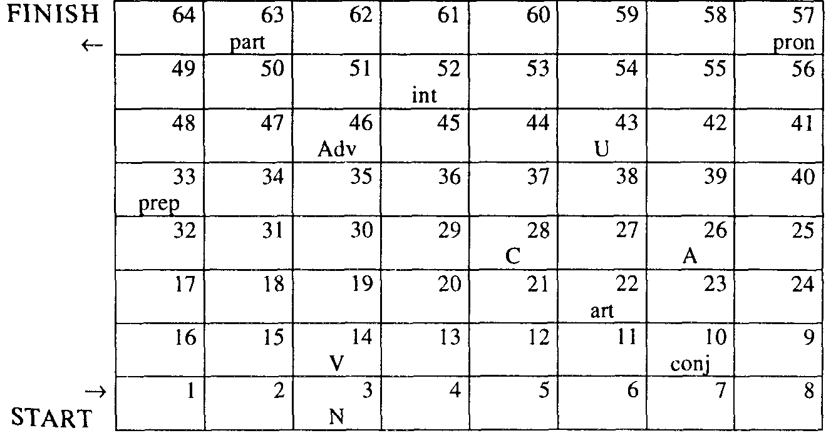

Ask the class to write grammar terms on pieces of paper, collect them, jumble and ask each student to draw one and explain what it means. The class will guess what term it was.

Test yourselves as to whether you can use the indefinite article with the following. Consult an English-English dictionary:

advice, author, barley, bath, beef, birth, bread, care, chalk, crayon, chat, felicity, geography, work, interest, trunk, surprise, vase, news, patience, principle, repair, weather.

Test yourselves and say whether the following verbs can be used in the active and passive voice:

belong believe

contain know

consist love

cost mean

depend need

exist own

happen understand

lack want

possess

resemble

seem

The deep understanding of the features of parts of speech helps people foresee what the speaker will say next. This ability of ours may be realized in the assignment of the restoration of the text/ story/conversation from which some notional or all formal words have been deleted. This type of activity is called a cloze and is based on the natural ability of the listener to fill in the following word if you are an attentive listener and are aware of the topic. The assignment can be looked upon as a teaching exercise or a test to see whether or not the learners have acquired the offered material. It has a number of variations. This test is always included in the EFC and its value may be high only because of it.

Complete this text. Use only one word in each gap. There is an example at the beginning 0.

**Are You a Lark or an Owl?**

Do you read the newspaper 0 while you have breakfast? If you do then you 1 ... be a "lark," or morning type of person. "Owls," or evening types, tend not to spend much time over breakfast. They 2 ... little appetite then, and, 3 ... they are usually late risers, they are short 4 ... time anyway. Around half of the adult population are either morning 5 ... evening types; the rest fall somewhere 6 ... the middle. 7 ... can be up to a twelve hour difference in the time of the day when the two types reach the point when they are most alert and mentally at their 8 .... Larks tend to reach this point in the late morning, while owls 9 ... it around 10 pm. For reasons 10 ... are unknown, evening types tend to be more adaptable 11 ... morning types. For example, evening types can usually cope much better with shift work and jet lag, and 12 ... is easier for an evening type to become a morning type than the other way 13 ... . Are we born 14... these differences, or are they just formed 15 ... habit? We don't really know.

Key: 1 may/must; 2 have; 3 because/since/as; 4 of; 5 or; 6 in; 7 There; 8 best/peak; 9 reach; 10 which/that; 11 than; 12 it; 13 round; 14 with; 15 by/from.

Fill each gap in this story with one word only. The first is done as an example:

We were late as 1 usual. Michael had insisted on doing *his* packing by 2 ... , and when he discovered that he couldn't manage he'd asked me for help at the last 3 ... . So now we had an hour to get to the 4.... Luckily, there wasn't much traffic on the 5 ... and we were able to get there just in 6 ... . We checked in and went straight to the departure 7 ... to wait for our 8 ... to be called. We waited and waited but no announcement was 9 .... We asked at the information 10 ... and the girl there told us that the plane hadn't even arrived yet. In the 11 ... there was another announcement telling us that passengers waiting for Flight LJ 108 could collect a 12 ... meal voucher and that the plane hadn't left Spain because of 13 ... problems. We thought that meant that it wasn't safe for the plane to 14 ... . We waited again for 15 ... until late evening when we were asked to report to the 16 ... desk again. They told us we would be spending the 17 ... in a hotel at the airline's 18 ... .

The next morning after a sleepless 19 ... because of all the planes taking off and landing, we reported back to the airport. Guess what had 20 ... while we were 21 ... ! Our plane had arrived and taken off again leaving us 22 .... All the other 23 ... had been woken up in the night to catch the plane, but for some 24 ... or other we had been forgotten. You can imagine how we felt!

Key: (some variations are possible): 1 usual; 2 himself; 3 moment; 4 airport; 5 road; 6 time; 7 lounge; 8 flight; 9 made; 10 desk; 11 end; 12 free; 13 technical; 14 fly; 15 ages; 16 information; 17 night; 18 expense; 19 night; 20 happened; 21 asleep; 22 stranded; 23 passengers; 24 reason.

Fill each gap with one word only.

The first thing you notice 1 ... him is his smile. He's slim, quite tall and very athletic. He talks fast and is very funny. He's 2 ... actor, but he usually plays the same kind 3 ... roles. 4 ... fact, it's difficult to separate the character 5 ... the man 6 ... the characters he plays 7 ... his films. You know that he's going to win every argument and get 8 ... of any difficult situation 9 ... getting hurt. He's 10 ... of today's most popular American film stars.

You can't help 11 ... impressed by her good looks and her voice. Her style is modern and 12 ... clothes are very unusual: she sets the fashion 13 ... than following it. She's not only 14 ... popular with young people, but she's so talented 15 ... even older people appreciate her. The break-up of her 16 ... came as no surprise to anyone — she 17 ... so much publicity that it's impossible for someone 18 ... her to have a private 19 ... . When ordinary people have similar problems, it's only their friends and 20 ... who get to hear about it.

Key: 1 about; 2 an; 3 of; 4 In; 5 of; 6 from; 7 in; 8 out; 9 without; 10 one; 11 being; 12 her; 13 rather; 14 very/extremely/terribly etc.; 15 that; 16 marriage; 17 gets/receives/has; 18 like; 19 life; 20 relations/relatives/acquaintances/colleagues.

Fill each of the numbered blanks in the following passage. Use only one word in each space.

Many years ago when summers seemed longer and life was 1 ... complicated, we had rented a cottage by a river in the heart of the country where we were going to 2 ... three weeks' holiday. There were four of us: me (age 9), Mum and Dad and Mum's 3 ..., Auntie June. Oh, and I mustn't forget to 4 ... Spot, our little dog. I was allowed to go off by 5 ... all day, 6 ... that I promised to be careful and took Spot with me for 7 ... .

One day I was out fishing with Spot when we heard a lot of shouting in the 8 ... followed by a scream and a splash. I was a bit 9 ... so I called Spot and we both hid 10 ... a bush where we could see but not be 11 ... . After a few moments a straw hat came floating down the river, followed by an oar, a picnic basket and 12 ... oar. Then came the rowing boat itself, but it was floating 13 ... down. A few seconds later my Dad and Auntie June came running 14 ... the river bank, both wet 15 ... . Spot started 16 ... so I came out of hiding and said hello. My Dad got really angry with me for not 17 ... to catch the boat as it went past. Luckily, however, the boat and both oars had been caught by an overhanging tree a little further downstream, but not the hat or the picnic basket. So I had to let them 18 ... my sandwiches. Dad and Auntie June both made me 19 ... not to tell Mum what had happened in 20 ... she was worried.

Key: 1 less; 2 spend; 3 sister; 4 mention; 5 myself; 6 provided/ providing; 7 company/protection; 8 distance; 9 scared/frightened; 10 behind; 11 seen/observed; 12 another; 13 upside; 14 down/ along; 15 through; 16 barking; 17 trying/managing; 18 share; 19 promise; 20 case.

Read the text below. Use the word at the end of each line to form a word that fits in the space in the same line. There is an example at the beginning 0. Write your word on the separate answer sheet.

Example: 0 professional

**Translation Work**

Usually, 0 ... translators work from a foreign profession

language into their mother tongue to reduce 1 ... accurate

translation and for better style. Much translation science

is of 2 ... or commercial material and this kind of understand

work often requires an 3 ... of technical vocabulary special

and 4 ... language, employ

Not all translators are in full-time 5 ... but those industry

who are usually work for large 6 ... concerns or

for public organizations.

The main personal characteristic needed to be success,

a 7 ... translator is a 8 ... to attend to detail. In willing

addition, it is 9 ... for translators to know at least desire

two foreign languages. The wider the 10 ... of vary

languages they can offer, the greater the likelihood

that work will be available.

Key: 1 inaccurate; 2 scientific; 3 understanding; 4 specialized; 5 employment; 6 industrial; 7 successful; 8 willingness; 9 desirable; 10 variety.

Read the text below and think of the word which best fits each space. Use only one word in each space. There is an example at the beginning (0). Write your word on the separate answer sheet.

Example: 0 of

**Keeping Fit**

Bodies are made to move! They are not designed for sitting around in front 0 … the television or reading magazines. Keeping fit doesn,t 1 … you have to be a super- athlete, and even a 2 exercise can give you a lot of fun. When you're fit and healthy, you'll find you look better and feel better. You'll 3 ... more energy and self-confidence.

Every time you move you 4 ... exercising. The human body is designed to bend, stretch, run, jump and climb. The 5 ... it does, the stronger and fitter it will become. Best of 6 ..., exercise is fun. It's 7 ... your body likes doing most — keeping on the move.

Physical exercise is not only good 8 ... your body. People who take regular exercise are usually happier, more relaxed and more alert 9 ... people who sit around all day. Try an experiment — next time you're 10 ... a bad mood, go for a walk or play a ball game in the park. See how 11 ... better you feel after an hour.

A sense of achievement is yet 12 ... benefit of exercise. People feel good 13 ... themselves when they know they have improved 14 ... fitness. People who exercise regularly will 15 ... you that they find they have more energy to enjoy life. So have a go — you'll soon see and feel the benefits!

Key: 1 mean; 2 little; 3 have/develop; 4 are; 5 more; 6 all; 7 what; 8 for; 9 than; 10 in; 11 much; 12 another; 13 about/in; 14 their; 15 tell.

Read the text below. Use the word at the end of each line to form a word that fits in the space in the same line. There is an example at the beginning 0. Write your word on the separate answer sheet.

Example: 0 scientists

**A Risky Activity**

According to some 0 ..., high-risk sports can science

be particularly 1 ... for certain types of people, value

Such activities help them to learn that being

2 ... doesn't mean that they have to lose control, fright

The recent fashion for jumping from bridges

attached to a 3 ... of elastic rope, known as "bungee long

jumping", has now been tried by over one million

people 4 ... , and interest in it is continuing to world

grow.

Before the special elastic rope 5 ... around them, tight

jumpers reach speeds of nearly 160 kph. First-timers

are usually too 6 ... to open their mouths, and terror

when they are finally 7 ... safely to the ground, low

they walk around with broad smiles on their faces,

saying 8 ... how amazing it was. However, for some repeat

people, it is only the 9 ... of refusing to jump at embarrass

the last minute that finally persuades them to

conquer their fear of 10 ... and push themselves high

off into space.

Key: 1 valuable; 2 frightened; 3 length; 4 worldwide; 5 tightens; 6 terrified; 7 lowered; 8 repeatedly; 9 embarrassment; 10 height.

Read the text below and think of the word which best fits each space. Use only one word in each space. There is an example at the beginning 0. Write your word on the separate answer sheet.

Example: 0 like

**Electronic Intelligence**

Science fiction films and books are full of robots that look, and even think, exactly 0 ... humans. Some people believe it will not be long 1 ... such machines become a reality. However, most advanced electronic machines still look 2 ... like people. These machines cannot yet think in the same way 3 ... a person; some say they never 4 ... . But they are able to make decisions and solve problems. An airliner's automatic pilot, for example, can control 5 ... plane, even during take-off and landing.

Computers issue detailed instructions in order 6 ... control the way robots act. The simplest robots just follow a set 7 ... instructions and repeat the same movements again and again. Many factories rely 8 ... such robots to carry out the sort of tasks that a human worker 9 ... certainly find very boring and they can do many jobs more rapidly and with great accuracy. Very advanced robots have sensors with 10 ... they can collect information 11 ... their surroundings. These robots can move 12 ... place to place, using tiny television cameras to find 13 ... way.

Many scientists are convinced that robots will soon be intelligent 14 ... to explore other planets more effectively 15 ... humans.

Key: 1 before/until; 2 nothing; 3 as; 4 will; 5 the/a; 6 to; 7 of; 8 on; 9 would/could; 10 which; 11 about; 12 from; 13 their; 14 enough; 15 than.

# NUMBER OF NOUNS

Number of nouns is another elementary topic of English grammar much disregarded in the EFL teaching. Teachers shouldn't confine themselves to saying that the plural number is formed by adding the -s inflexion to the singular form. In fact number of nouns constitutes a vast problem embracing such notions as policemy, transition of meaning, use of determiners, agreement between the subject-noun and the predicate-verb.

Number shows the difference between one and more than one. If one thing ("thing" in a wide sense of the word) is meant, we use the singular number, if more than one — we use the plural number. It is wrong to say that the plural expresses number, it does not, it signals the meaning of "not one."

More attention should be given to the formation of the plural number of nouns since it is far more difficult a problem than we think and it should be treated accordingly.

The plural number is formed with the help of the ending -s or -es.

bees dogs looks watches

days pencils maps boxes

flowers spoons seats wishes

In the following fourteen nouns the final -f is changed into -v and -es is added:

calf knife loaf shelf wharf

elf life seat thief wolf

half leaf self wife

E.g. calves, elves, halves.

All the others have -fs: proofs, cliffs, gulfs.

Some nouns may have either -ves or -fs in the plural number: scarf, dwarf, hoof.

If a noun ends in -o, -es is added in the plural number: tomatoes, potatoes, vetoes. Only -s is added if a noun ends in a vowel + o: bamboos, studios, zoos; in proper names: Romeos, Eskimos, Philipinos; in abbreviations: kilos, photos, pros (professionals); also: stereos, discos, videos, pianos, solos. Some other nouns take -s or -es: cargo, banjo, halo.

If a noun ends in -y, it is changed into -i- and -es is added: armies, duties, stories. If a vowel precedes -y, just -s is added: boys, keys, plays.

Some old English plural forms are still used:

man — men goose — geese child — children

woman — women louse — lice ox — oxen

foot — feet mouse — mice brother — brethren

tooth — teeth

Some English nouns keep foreign plurals, sometimes English and foreign plurals are used side by side:

alumna — alumnae

alumnus — alumni

formula — formulae, formulas

index — indices, indexes

crisis — crises

criterion — criteria

phenomenon — phenomena

datum — data

nucleus — nuclei

syllabus — syllabi, syllabuses

Compound nouns have three ways of spelling: two components are separated by a hyphen, written in one word or written separately. To form the plural of compound words spelled with a hyphen -s is added to the principal word:

daughters-in-law passersby

editors-in-chief girlfriends

lookers-on watchmakers

When compound singular nouns are spelled as one solid word, they are pluralized by adding -s to the last word:

airships bookcases

baseballs bywords

beefsteaks churchgoers

The plural of compound words with vowel-changing words in them will be:

airmen

mailmen

womendoctors

Compound nouns consisting of two separate components add -s for the plural number to the last component:

apple trees ocean liners

bank books post officers

car fares water jackets

leaf buds wind gauges

Note even: trouser pockets, pyjama jacket.

Proper names form their plurals by adding -s or -es: Adams, Georges, Henries, Dickenses. When a proper name is accompanied by a title, either the proper name or the title may be made plural:

Doctor Hills Mrs Thomases

Doctors Hill Mesdames Thomas

Letters, numerals and symbols are preferably pluralized by the addition of's:

three r's and four s's

my four's and five's

your etc.'s and i.e.'s

all M.P.'s

Some nouns have the same form for the singular and for the plural: cod, deer, grouse, sheep, trout, quail, aircraft;

dozen (twelve), score (twenty), stone (6,35 kg);

means, series, species, works, barracks, headquarters.

Some nouns have two plurals, each plural form differs in meaning from the other:

colour — цвет

colours — цвета

colours — флаг

cloth — ткань; лоскут

cloths — куски материи

clothes — платье, одежда

custom — обычай

customs — обычаи

customs — таможенные пошлины

die — штамп, матрица; игральная кость

dies — штампы, матрицы

dice — игральные кости/ АЕ игральная кость

genius — дух, гениальная личность

geniuses — гениальные личности

genii — гении, духи

penny — пенни

pennies — монеты

реnсе — сумма в несколько пенни

The irregularities of the formation of the plural number of English nouns are ridiculed in the following poem by an unknown author.

The English Language

We'll begin with box, and the plural is boxes.

But the plural of ox should be oxen, not oxes.

The one fool is a goose, but two are called geese,

Yet the plural of mouse should never be meese.

You may find one mouse, or a whole nest of mice,

But the plural of house is houses, not hice.

If the plural of man is always called men,

Why shouldn't the plural of pan be called pen?

The cow in the plural may be cows or kine,

But bow, if repeated, is never called bine

And the plural of vow is vows, never vine.

If I speak of a foot, and you show me your feet,

And I give you a boot, would a pair be called beet?

If one is a tooth and a whole set are teeth,

Why shouldn't the plural of booth be called beeth?

If the singular is this and the plural is these,

Should the plural of kiss ever be nicknamed keese?

Then one may be that and three would be those,

Yet hat in the plural would never be hose,

And the plural of cat is cats, not cose.

We speak of a brother and also of brethren,

But though we say mother, we never say methren,

Then the masculine pronouns are he, his, him,

But imagine the feminine she, shis, and shim!

So English, I think you all will agree,

Is the greatest language you ever did see.

*Unknown*

Sometimes the noun in the plural acquires a different meaning:

authority — власть, полномочие

authorities — начальство, руководство, власть

damage — вред, повреждение

damages — убытки, компенсация за убытки

development — развитие, эволюция, рост

developments — события

humanity — человечество

humanities — гуманитарные науки

power — сила, мощность, энергия

powers — полномочия, власть; державы

work — работа

works — собрание сочинений; промышленные здания, строи­тельное сооружение

Nouns that can be either singular or plural are called countable. Some nouns can't be used in the singular and in the plural, they are called uncountable. There are uncountable nouns used only in the singular and uncountable nouns used only in the plural.

COUNTABLE NOUNS: UNCOUNTABLE NOUNS:

have singular and plural forms have only one form

take verbs in the singular or in take verbs only in the singular/

the plural only in the plural

can have "a," "an," or "one" cannot have "a," "an," or "one"

before them before them

can have "few," "many" as can have "little," "much" before

modifiers them as modifiers

can be modified by a numeral —

can be substituted by "one" —

can have "some" before them can have "some" before them

only in the plural

can have "number of" before can have "amount of " before them

them only in the plural

Certain kinds of nouns are usually countable.

1. Names of persons, animals, plants, insects, and the like, and their parts:

Persons Animals Plants Insects Parts

a boy a cat a cactus an ant an ankle

a girl a dog a bush a butterfly a bone

a man a horse a flower a caterpillar a face

a student a mouse an oak a fly a head

a teacher a tiger a potato a mite a nose

a wife a wolf a rose a tick an ear

a woman a zebra a tree a wasp a wing

2. Objects with a definite shape:

a ball a mountain

a building a street

a car a tent

a door a typewriter

a house an umbrella

3. Units of measurement (for length, area, weight, volume, temperature, pressure, speed and so on) and words of classification (often used as measurement and classification with uncountable nouns):

a basket a drop

a gram a degree

an inch a kind

a foot a type

a meter a piece

a pound a bit

a square foot, meter an item

a cubic inch, centimetre a part

4. Classifications in society:

a family a country a language

a clan a state a word

a tribe a city a phrase

5. Some abstract nouns:

a help a plan

a hindrance a rest

an idea a scheme

an invention a taboo

a nuisance

Certain kinds of nouns are uncountable.

1. Names of substances and materials:

Food Materials

bread copper

cake cotton

chocolate concrete

meat grass

spaghetti iron

spinach steel

butter wood

cheese wool

2. Names of liquids, gases, and substances made of many small particles:

Liquids Gases Grains and other solids made

of many small particles

coffee air barley

milk carbon dioxide rice

oil oxygen sugar

tea smoke popcorn

3. Names of languages: Arabic, English, Chinese, French, Japanese, Russian, Spanish, Welsh.

4. Most nouns ending in -ing. Exceptions include "building," "feeling," "dealing," "wedding" and "helping" when it means a portion of food; "a saving" is economy, but "savings" is an amount of money;

"furnishings" is always plural.

camping parking

clothing shopping

dancing smoking

hiking studying

learning trying

lightning waiting

5. Many abstract nouns including those ending in -ness, -ance, -ence, -ity:

beauty peace

equality plenty

happiness sanity

ignorance serenity

importance selfishness

obsolescence verbosity

6. Names of branches of human learning ending in -ics:

acoustics politics

linguistics

mathematics physics

phonetics statistics

Another group of uncountable nouns occurs only in the plural form. They can take the definite article or no article at all in front of them; no numerals can be used with them. Here is a list of common plural nouns:

archives particulars

congratulations proceeds

contents remains

goods surroundings

odds thanks

outskirts whereabouts

Some plural nouns refer to items of clothing and other objects consisting of two parts:

braces binoculars

breeches glasses

jeans pincers

knickers pliers

leggins scales

pants scissors

pyjamas shears

shorts spectacles

tights tongs

trousers tweezers

"A pair of is used to show that one item is meant.

Many nouns are countable (C) in one meaning and are uncountable (U) in another.

paper n 1 U substance manufactured from wood fibre, etc.

2 С newspaper

3 U ~ money, banknotes

4 pi documents showing who sb is

5 С set of printed examination questions on a given subject

6 С essay, esp one to be read to a learned society

room n 1 С part of a house or a building enclosed by walls or parti­tions, floor, ceiling

2 pi apartments

3 U space that is or might be occupied

4 U scope, opportunity

language n 1 U human and noninstinctive method of communicat­ing ideas

2 С form of ~ used by a people

3 U manner of using words

4 U words, phrases, etc. used by a profession

Of special interest in the EFL teaching should be those English uncountable nouns whose Russian equivalents have a different reference to number since students' errors can be predicted each time they will be used.

English uncountable singular Russian uncountable plural

applause аплодисменты

cash наличные

cutlery режущие столовые предметы

hair волосы

money деньги

English uncountable singular Russian countable

advice совет, -ы

gossip сплетня, -и

jewellery драгоценное украшение, -я

knowledge знание, -я

research исследование, я

work работа,-ы

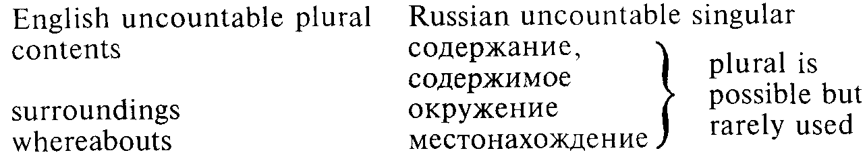

English uncountable plural Russian countable

archives архив, -ы

congratulations поздравление, -я

goods товар, -ы

outskirts окраина, -ы

proceeds выручка, -и

pyjamas пижама, -ы

remains остаток, -и

Nouns can be converted from uncountable to countable, and vice versa

The uncountable form always has a more generalized meaning, whereas the countable form has a more specified meaning Changing uncountable nouns into countable form usually requires some kind of container or package or unit measure: water → a glass of water, advice → a piece of advice, Life is hard → He had a hard life. On the other hand, changing countable nouns into uncountable forms usually requires changing them into a more abstract or generalized form: a chair → furniture, a book → literature, printed matter, a fact →-> knowledge, data

Many nouns meaning materials can become countable nouns when they are used to refer to an amount of something in a container:

a coffee, a beer, a whisky

beer rum

brandy sherry

coffee sugar

Coke vodka

gin whisky

lager yoghurt

Some of these words are used in restaurants and cafes but not in people's homes. For example, you might ask for "two teas" in a cafe, but someone in their own home would probably say, "Would you like some tea:" or "Would you like a cup of tea:" rather than Would you like а tea? "

Uncountable nouns can also be converted into countable nouns when "a type of" or "a variety of is meant

a local cheese, a very fine jam

beer metal

brandy paint

cheese perfume

coffee sauce

detergent soup

jam tea

lager whisky

meat wine

medicine wood

To express measure of the substance expressed by an uncountable noun the following is used:

a piece of cake

a slice of bread, cake, meat

a loaf of bread

a bar of chocolate

a lump of sugar

a carton of milk

a tin of lemonade

a tube of toothpaste

a bottle of milk

a jar of jam

a grain of rice, barley, wheat

a pinch of salt

a piece/stick of chalk

five pounds of sugar

a blade of grass

a bag of flour

a packet of tea, sugar

a spoonful of sugar, flour, etc.

an amount of leasure

a stroke of luck

a fit of temper

a means of transport

an item of news

a sheet of paper

a yard of cloth

a state of health, disorder, uncertainty

Proper nouns being uncountable by nature can convert into countable nouns and be used in the plural number. There are a number of predictable ways in which proper nouns are used as countable.

1. When we want to suggest that someone or something is similar to someone or something famous:

All his children are Einsteins.

2. When we are talking about a copy or instance of something, especially a newspaper or magazine:

He bought a Times.

3. When we are referring to a product or work by someone:

The trip had taken two days in the shining new Ford.

Would you recognize a Renoir?

Sometimes a trademark for a product is used for all products of the same kind. For example, many people would call any vacuum cleaner a "Hoover," though "Hoover" is a trademark of one particular make.

4. When you want to talk about one branch of a shop or business:

They are making room for the new Woolworth's.

5. When you want to pick out a particular version of something:

This isn't the London I used to know.

6. Proper names are used in the plural to express several or all members of the same family:

The Browns were all present.

Collective nouns are quite special in their reference to number. They express groups of people or animals. Most collective nouns have both singular and plural forms: family — families. The plural form always takes a plural verb. But the singular form may take a singular or a plural verb. The singular verb shows that the noun is acting as a unit, the plural verb shows that the members of the group are acting separately:

The family is large. The family are all at home.

Most common collective nouns are:

army company majority

audience council minority

band crew orchestra

cast crowd population

choir enemy press (= newspapers)

chorus family school

class firm staff

club gang team

college government union

committee group university

community management

Also: the ВВС, the Congress, England (= the English team), Harrod's, the United Nations, The United States, the Vatican, the Kremlin.

The following collective nouns also called nouns of multitude are used with the plural verb only: cattle, clergy, gentry, people, police, poultry, vermin, youth. Reference to individual members of the group is made thus: twenty people, fifty police or fifty policemen, ten head of cattle.

Many collective nouns exist for groups of animals and birds:

a covey of quail — выводок, стая куропаток;

a flock of birds, chickens, geese, pigeons — стая птиц, цыплят, гусей, голубей;

a herd of cattle, sheep, cows, goats, deer— стадо скота, овец, коров, коз, оленей;

a hive of bees — улей пчел;

a pack of dogs, hyenas, wolves — свора собак, стая гиен, волков;

a pride of lions — стая львов;

a shoal of herring, mackerel — косяк сельдей, скумбрий;

a swarm of ants, bees, flies — рой муравьев, пчел, мух.

Some nouns expressing animals, birds and fish keep the singular form in a collective plural meaning:

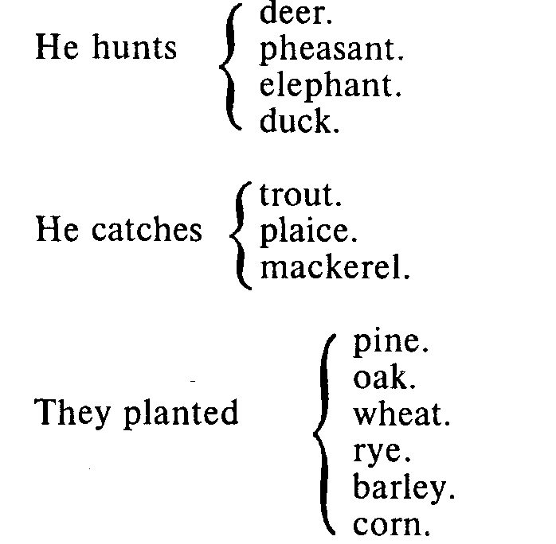

EFL teachers should teach their students to differentiate between nouns with -s at the end. -S marks the plural number in countable nouns and nouns used in the plural and may be part of the stem of the noun (which in some cases developed from the former plural number) that may be a marker of the plural number or not.

On other hand, the absence of -s at the end of the word is not necessarily a marker of the singular number.

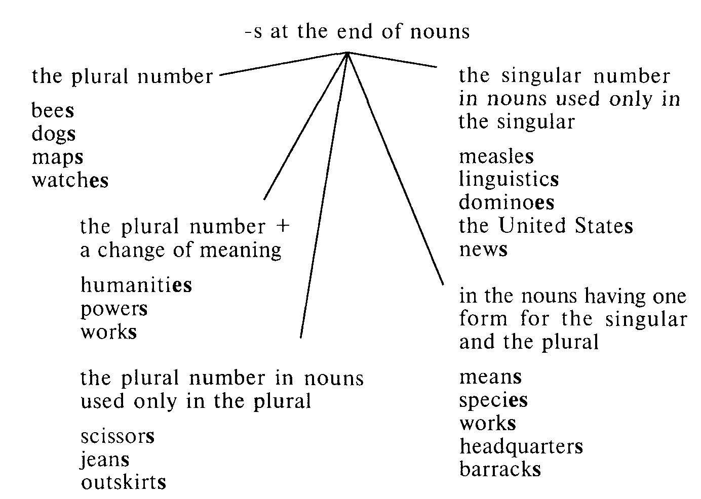

One other problem in connection with number of nouns should be given considerable attention to in the teaching process. This is concord or agreement between forms of the subject-noun and the predicate-verb. The general rule is well-known: the subject-noun in the singular requires the predicate-verb in the singular and the subject-noun in the plural requires the predicate-verb in the plural if the verb form admits of the expression of the singular and the plural. In other words, if the subject is a singular proper name, a singular common noun, a mass noun, or a third person singular pronoun the third person singular inflection is used with the predicate-verb in the present tense or the form "was" is used for the past tense if the verb "to be" is required by the sense. No inflection is used in the present tense and the form "were" in the past (if it is required by the sense) with subjects proper or common plural nouns, or plural pronouns. However, there are many special and difficult cases concerning this rule.

1. Collective nouns can take either a singular or plural inflection depending upon the meaning:

government has

have

crowd it, they

committee itself its which was

themselves their who were

2. Special care should be taken when the learners deal with nouns ending in -s, since, as is known, they can be considered to be either singular or plural:

No news is good news.

The scissors are on the table.

3. "A number of N" takes the plural, but "the number of N" takes the singular.

4. Fractions and percentage take the singular verb when they modify an uncountable noun and the plural when they modify a countable noun; either a singular or plural verb may be used when they modify a collective noun:

Thirty per cent of water is wasted nowadays.

Thirty per cent of books were sold out.

Thirty per cent of population was/were present.

5. Plural unit words of distance, money, time, etc., take the singular:

distance: Two kilometres is a long distance.

money: Two hundred pounds is to be paid for it.

time: Three years is a long time to do it.

6. Arithmetic operations take the singular:

One plus one is two. Four minus one is three. Two times three is six. Twelve divided by two is six.

Problems may arise when the subject is expressed by a noun-phrase:

Either my friend or my relatives are going to see me soon.

Neither my relatives nor my friend is going to see me soon.

The proximity principle works here: the predicate agrees in number with the closest part of the subject. The same rule is applied in "there is/are" structures.

There is a book and two notebooks on the table.

There are two notebooks and a book

The principle of non-intervention is observed when the subject is a prepositional phrase including "together with," "along with," "as well as," etc.

Nick, together with his friends, is going for a trip.

The subject predicative agreement is problematic in certain types of relative clauses.

She is one of those people who never ceases to work hard.

**Practice Activities**

TPR Activities

A Monster

1. Make a monster.

2. Pick up the orange crayon.

3. Draw three eyes.

4. Put the orange crayon down.

5. Pick up the blue crayon.

6. Draw four mouths.

7. Put the blue crayon down.

8. Pick up the purple crayon.

9. Draw eight legs.

10. Put the purple crayon down.

11. Pick up the green crayon.

12. Draw three noses.

13. Look at the scary monster.

Lunch

(Use relevant pictures of: a plate, two hot dogs,

three cherries, three French fries)

1. I'm hungry.

2. I want some lunch.

3. Pick up a hot dog.

4. Pick up another hot dog.

5. Put the hot dogs on the plate.

6. Pick up the cherries.

7. Put the cherries on the plate.

8. Put up two French fries/chips.

9. Put the French fries on the plate.

10. Pick up another French fry.

11. Put it on the plate.

12. That is a funny lunch!

The Dice Game

(Use a dice, a piece of chalk)

1. Pick up the dice.

2. Throw the dice.

3. What did you get?

4. Pick up the chalk.

5. Write the number on the board.

6. Put the chalk down.

7. Pick up the dice.

8. Throw the dice.

9. What did you get?

10. Are you sure?

11. Count it again.

12. Pick up the chalk.

13. Write the number on the board.

14. Put the chalk down.

15. Ask a friend to play with you.

Complete these paragraphs from a geography book. Put the words in brackets into the plural.

This small country is mostly farmland. The (animal) seen most often are (cow) and (sheep). Most (farm) have a few (goose), too. There are (donkey), but not many (horse). There's a lot of wheat and (potato), and there are (tomato) on the south side of the hills. In summer the (man), (woman) and (child) work together in the (field) seven (day) a week. The (person) work hard all their (life).

The only two (factory) in the country are in the capital. One makes (toy) and (game), and the other makes (knife) and (fork). All these (thing) are for export.

The east of the country is thick forest, the home of wild (pony), (deer) and (wolf).

(Photo) of the (cliff) along the coast show how beautiful the country is. But not many (tourist) visit it because the airport is too small for most (aircraft).

Key: animals, cows, sheep, farms, geese, donkeys, horses, potatoes, tomatoes, men, women, children, fields, days, lives, factories, toys, games, knives, forks, things, ponies, deer, wolves, photos, cliffs, tourists, aircraft.

Complete the following sentences with a countable noun converted to an uncountable noun, as in the first sentence, which has been completed for you. Choose from these words:

bird insect

cat spider

dog truck

flower vehicle

1. Cars, lorries and buses are different kinds of vehicle.

2. Ducks are a type of... .

3. Bees, ants and mosquitoes are varieties of ... .

4. Alsatians are a breed of ... .

5. Lions and tigers are both types of big ... .

6. Roses and carnations are types of ... .

Key: 1 vehicle; 2 bird; 3 insect; 4 dog; 5 cat; 6 flower.

Complete the definitions below, choosing from the words given below, together with "a" where needed. The first one has been done for you.

faith reason

a faith a reason

glass rubber

a glass a rubber

memory study

a memory a study

1. Memory is the faculty which we use to remember.

2 ... is the process of learning actively.

3 ... is a cause or explanation for something.

4. ... is something we use to erase or remove a mistake.

5. ... is a set of beliefs like a religion.

6. ... is something remembered.

7. ... is a substance used for making tyres and other objects.

8. ... is having confidence in, or believing in, something.

9. ... is a room where people can read and work quietly.

10. ... is the process of working things out rationally.

Key: 1 memory; 2 study; 3 a reason; 4 a rubber; 5 a faith; 6 a memory;

7 rubber; 8 faith; 9 a study; 10 reason.

In the following sentences the underlined nouns can be countable or uncountable depending on the meaning. Decide which meaning is being used in each sentence, and cross out the incorrect noun group. The first one has been done for you.

1. To press clothes you need iron/аn iron.

2. Language/A language is unique to humans.

3. In her youth she was beauty/a beauty.

4. We are looking for people with experience/an experience.

5. He kept his money in tin/a tin.

6. She's been looking for work/a work for ages.

7. You should study law/a law at university.

8. Then everybody called for him to make speech/a speech.

9. Plav/A play is more natural for children than adults.

10. Charitv/A charity begins at home.

Key: 1 an iron; 2 Language; 3 a beauty; 4 experience; 5 a tin; 6 work;

7 law; 8 a speech; 9 Play; 10 Charity.

In the expressions below decide if you can cross out the two middle words and in this way convert an uncountable noun to a countable noun. If you can, write "yes." If you cannot, write "no." The first one has been done for you.

1. a cup of coffee **yes**

2. a pair of scissors

3. a piece of string

4. a sort of cheese

5. a bit of chalk

6. a piece of cake

7. a piece of news

8. a type of beer

9. an item of information

10. a loaf of bread

11. a lump of sugar

12. a bar of soap

Key: 1 yes; 2 no; 3 yes; 4 yes; 5 no; 6 yes; 7 no; 8 yes; 9 no; 10 yes; 11 yes; 12 yes.

Put one of these counting expressions in front of each of the uncountable nouns below. There may be more than one possibility. The first one has been done for you.

a drop of, a grain of, a lump of, an item of, a pair of, a piece of

1. a drop of water

2. ... sugar

3. ... iron

4. ... scissors

5. ... music

6. ... news

7. ... shorts

8. ... meat

9. ... rice

10. ... research

11. ... information

12. ... sand

Key: 1 a drop of; 2 a lump of; 3 a piece/lump of; 4 a pair of; 5 a piece of; 6 an item/ piece of; 7 a pair of; 8 a piece of; 9 a grain of; 10 a piece/item of; 11 a piece/item of; 12 a grain of.

Say whether these sentences need "a(n)" or not. Use the dictionary to check whether the nouns are uncountable.

1. He gave us all ... advice on what to take with us.

2. I'm sorry. I can't come. I have ... homework to do.

3. She's doing ... investigation of teenage slang in English for her university project.

4. You'll need ... rice if you want to make a Chinese meal.

5. Paula getting divorced? That's ... interesting news!

6. I have to by ... film for the holiday. I think I'll get about five rolls.

7. We saw ... beautiful silk and ... cotton on Thailand.

Key: 1 -; 2 -; 3 an; 4 -; 5 -; 6 -; 7 -; -.

Imagine you are going away for a week's holiday and you pack a suitcase with a number of things. Make a list of what you would pack.

Suggestions: soap, a tube of toothpaste, a box of make-up, some writing paper, film, medicine.

Solve a Word Puzzle. The purpose of the game is to learn spelling and pronunciation of school subjects. You have to make copies of the word puzzle for a group of students. Put them in envelopes and distribute puzzles to each team. The team that will make the puzzle first wins.

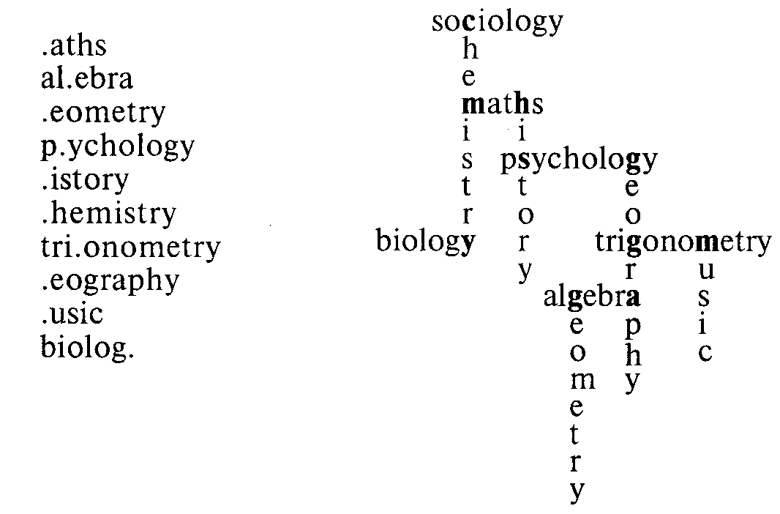

Fill in the gaps in the sentences below. Use "some," "any" or "no."

0. I'm really thirsty. I'd like some water, please.

1.1 went to the library today, but I couldn't find ... interesting books. They all looked very boring.

2. A: What would you like to eat? Eggs? Toast? Fruit?

B: Could you give me ... toast, please?

3.1 bought ... coffee this morning, but it's too strong for me.

4. A: Would you like something to read?

B: Yes. Could you give me ... magazines, please?

5. A: I've invited some friends for a party tonight, but I've got ... music.

B: Don't worry. I'll bring ... cassettes this afternoon.

6. Could you go to the shop, please? We haven't got ... milk.

7. A: Can you tell me what's happening at the airport?

B: Yes. I'm sorry, but there are ... flights today.

8. I'm going to the shop. I'm going to buy ... bread.

9. A: Would you like to go to the cinema this evening? B: Yes, but I haven't got ... money.

10. A: I've got bananas, apples and pears. What would you like? B: It doesn't matter. I like ... fruit.

Key: 1 any; 2 some; 3 some; 4 some; 5 no; some; 6 any; 7 no; 8 some; 9 any; 10 any.

The same may be practised with nouns ending in -ics: phonetics, politics, statistics, linguistics, acoustics, physics.

Read the story about the Ancient Egyptians.

Do you know these facts about them? Cross out the wrong words.

We have found a lot of interesting ~~information/mfermations~~ about life in Ancient Egypt.

Most Egyptian children went to school when they were eight. There was sport for the boys only, which wasn't a/much fun for the girls. The teachers were very strict, but the Egyptians liked

I musics/music and most children learned to play an instrument.

Egyptian houses didn't have as 2 much/many furniture as our houses. The furniture 3 was/were usually made of 4 —/a wood, but rich people had furniture decorated with 5 an/— ivory or gold.

Their clothes were made of linen but in winter some people wore 6 a/— wool. Because of the heat, most people wore their 7 hair/hairs short. Rich people sometimes wore wigs.

Women wore 8 —/a beautiful jewellery. Egypt had gold mines, so 9 a lot of/many jewellery was made of 10 —/a gold. All men and women, whether rich or poor, wore make-up and perfume. They got milk and

11 meat/meats from goats, and they ate a lot of 12 fish/fishes. They sweetened their 13 food/foods with honey. They baked their 14 bread/breads in mud-brick ovens. They also ate 15 a lot of/many fruit.

Key: 1 music; 2 much; 3 was; 4 —; 5 —; 6 —; 7 hair; 8 —; 9 a lot of; 10 -; 11 meat; 12 fish; 13 food; 14 bread; 15 a lot of.

Say if the sentences are true or false. Correct the false ones. The Ancient Egyptians had a lot of furniture in their houses. *False. They didn 't have much furniture in their houses.* They didn't wear their hair long. *True.*

1. We haven't found much information about life in Ancient Egypt.

2. Not much Egyptian jewellery was made of gold.

3. They didn't eat much fruit.

4. They ate a lot of fish.

5. The men wore make-up and perfume.

6. The children had a lot of fun at school.

Key: 1. False. We've found a lot of interesting information about life in Ancient Egypt.

2. False. A lot of Egyptian jewellery was made of gold.

3. False. They ate a lot of fruit.

4. True.

5. True.

6. False. They didn't have much fun at school.

Work with a partner. Ask and answer four questions about the Ancient Egyptians. Ask about their furniture, their clothes, their jewellery, their hair or their food.

*You:* Did the Ancient Egyptians wear their hair long?

*Partner:* No, they wore their hair short.

Find the mystery word

Which words are uncountable?

Ring the uncountable words and fit them into the puzzle (across) in order to find the mystery word (down).

suitcase gold furniture

coin fact money

progress luggage story

music news fun

answer chair knowledge

week sandwich song

Key:

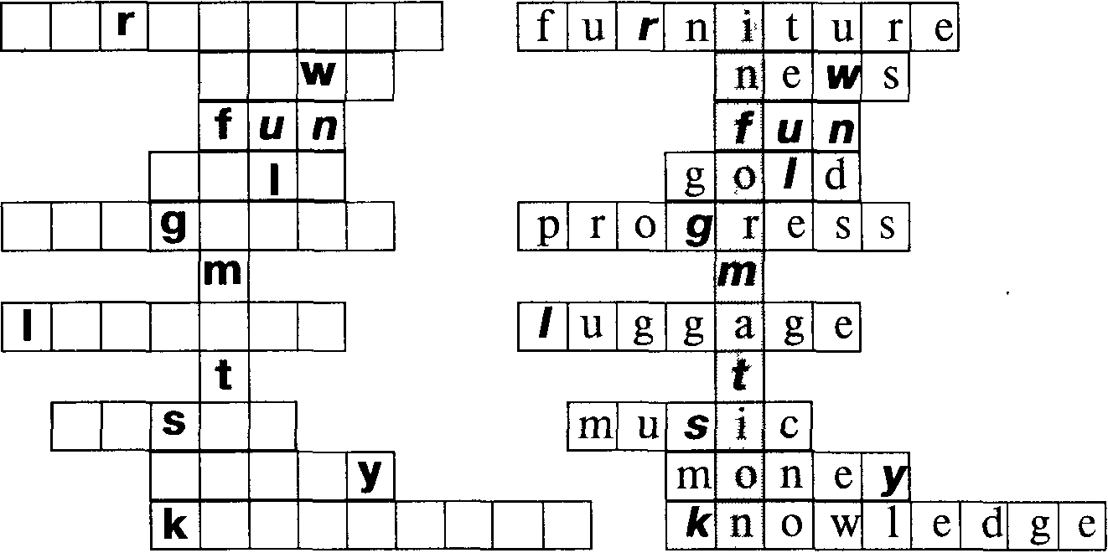

The mystery word is: ... The mystery word is: information.

Choose the correct word:

Do you know when women first started wearing l.a/—- trousers? The first woman to wear 2 —/a trousers was the French actress Sarah Bernhardt. She shocked everyone when she wore 3 a pair of/a men's trousers in 1876. She was brave enough to wear 4 it/them in public. Trousers for women 5 was/were not acceptable. It was another forty years before women dared to wear their 6 hair/hairs very short. But Anette Kellerman was even braver than Sarah Bernhardt. Men and women used to wear swimsuits that looked like 7 —/a pyjamas, with long sleeves and long legs. In 1909 Annette wore the first swimsuit with short sleeves and she wore 8 a/— shorts ending above the knees. But the police came and 9 it/they arrested her!

Key: 1 —; 2 —; 3 a pair of; 4 them; 5 were; 6 hair; 7 —; 8 —; 9 they.

Jane and Amanda are shopping. Decide if the words in brackets should be singular or plural and cross out the wrong word.

*Jane:* Is/Are those new sunglasses?

*Amanda:* Yes. 1 They/It 2 is/are nice, 3 aren't/isn't 4 it/they? Nick gave 5 it/them to me. It's a shame I can't see very well out of 6 it/them. Everything looks funny.

*Jane:* Look at 7 that/those red trousers.

*Amanda:* The 8 one/ones beside the T-shirts?

*Jane:* No. 9 Those/That 10 is/are a pair of yellow pyjamas.

*Amanda:* Oh. What a lovely blue skirt that is.

*Jane:* 11 That/Those 12 is/are a pair of pink shorts.

*Amanda:* 13 They/It would go well with 14 those/that striped tights. And look at 15 that/those jeans! I would love 16 a/some pair of them.

*Jane:* 17 This/Those 18 is/are the yellow pyjamas again! Amanda, did Nick tell you what kind of sunglasses 19 they/it 20 is/are?

Key: 1 They; 2 are; 3 aren't; 4 they; 5 them; 6 them; 7 those; 8 ones; 9 That; 10 is; 11 That; 12 is; 13 It or They; 14 those; 15 those; 16 a; 17 Those; 18 are; 19 they; 20 are.

Choose the correct word:

*Ben:* We need 1 some/an information about bus times. If we miss the last bus we'll have to sleep in a field.

*Jane:* We ought to take 2 some/a warm clothing, just in case. It would be 3 —/a fun to sleep in a field. We could collect 4 a/some wood and make a camp fire.

*Nick:* Yes, and we could tell each other ghost stories. Let's take 5 some/an extra food. We had better not take too much. Walking uphill is 6 —/a hard work. We can't carry 7 any/an unnecessary luggage.

*Jane:* I agree. I'm going to take out my carton of 8 a/— orange juice It's too heavy.

*Nick:* I hope we'll have 9 a/some good weather. Did anyone listen to the weather forecast?

*Ben:* Yes, I did. There will be 10 a/some fog on the hills at first, but there will be 11 a/some sunshine later.

*Tom:* Will there be 12 a/any rain?

*Ben:* No rain, just 13 a/— hurricane on the hills in the evening

Key: 1 some; 2 some; 3 —; 4 some; 5 some; 6 —; 7 any; 8 of; 9 some; 10 some; 11 some; 12 any; 13 a.

Uncountable nouns are used to describe personal qualities and skills Choose from the list and say what qualities these people should have Say. whether they need "some," "a lot" or "a bit" of the quality Use a dictionary for any difficult words.

Jobs: soldier, nurse, teacher, explorer, actor, athlete, writer, surgeon, receptionist, driver, engineer

Qualities: patience, courage, determination, goodwill, charm, stamina, reliability, loyalty, energy, experience, commitment, talent creativity, intelligence, training.

E. g. soldier a lot of courage, determination, stamina, loyalty and a lot of training.

Could I have … ? Practise asking for these everyday items and decide whether you must say "a" or "some":

vinegar butter

duster egg

needle serviette

thread helping

sellotape cup

teabag water

polish fruit

Key: some vinegar, a duster, a needle, some thread, some sellotape, a teabag, some polish, some butter, an egg, a serviette, a helping, a cup, some water, some fruit.

What things which are always plural can be used to:

1. cut a hedge?

2. weigh something?

3. cut paper?

4. see better if you are near-sighted?

5. get a splinter out of your skin?

6. look at distant objects?

7. get a nail out of a piece of wood?

8. pull out a tooth?

Key: 1 shears; 2 scales; 3 scissors; 4 glasses; spectacles; 5 tweezers; 6 binoculars; 7 pincers; pliers; 8 tongs.

Put in the correct words

I'm long-sighted, I wear glasses to read. a glass/glasses

1. You can't wear… to a Job interview. a jean/jeans

2. There must be two… in the wash. shorts/pairs of shorts

3. I need a… to spread the butter. knife/pair of knives

4. I need… to cut this article out. a scissor/some scissors

5. I found a… in the drawer. tights/pair of tights

6. I'm going to buy… . a pyjama/some pyjamas

Key 1 jeans, 2 pairs of shorts, 3 knife, 4 some scissors, 5 pair of tights, 6 some pyjamas

In each case, one of the examples is wrong. Which?

1. Company is often used for: actors, opera singers, swimmers

2. Cast is often used for people in: a play, a book, a film

3. Crew is often used for the staff of: an ambulance, a plane, a hospital

4. Team is often used for: doctors, scientists, passengers

5. Staff is often used for people working: in a school, on a train, in an office.

Key: 1 swimmers; 2 a book; 3 a hospital; 4 passengers; 5 on a train.

Match the words in the list on the left with their partner on the right

1. a hive of quail

2. a pack of lions

3. a shoal of wolves

4. a pride of bees

5. a swarm of herring

6. a herd of ants

7. a covey of cows

8. a flock of chickens

Key: 1 a hive of bees; 2 a pack of wolves; 3 a shoal of herring; 4 a pride of lions; 5 a swarm of ants, bees; 6 a herd of cows; 7 a covey of quail; 8 a flock of chickens.

Complete the conversation. Put in the correct form of the verb.

*Keith:* These trousers 1 feels/feel a bit tight. And I think the blue ones 2 goes/go better with the jacket.

*Jill:* That jacket 3 is/are too long.

*Keith:* Well, the jeans 4 fits/fit all right Peihaps I'll buy the jeans instead.

*Jill:* Yes, the jeans 5 looks/look good on you. I like the style. They really 6 suits/suit you.

Key: 1 feel; 2 go; 3 is; 4 fit; 5 look; 6 suit.

Organize a role play called "Shopping " Review names of common shop goods, names of shops selling them, names of amounts (half a kilo, etc ), names of packaging (a packet, a Jar, etc ), difference between number and amount (much/many), the English/Russian monetary systems, polite requests for goods, the question "How much/many?"

It is assumed that the students know numbers, greetings, partings, "please," "thank you," "here you are," "What's this called in English?", "Can you show …?"

You will need pictures or realia of common shop goods, price tags, real or toy money, pictures of the shops to be mentioned, role play cards. You will also need several dialogues on tape or read out loud for listening comprehension as examples of possible conversations.

S1: Hello, I'd like a pound of apples.

S2: Here you are, anything else?

S1: No, thank you.

S2: 40p, please.

S1: Here you are.

S2: Thank you, goodbye.

Sl: Goodbye.

S3: Hello, can I help you?

S4: I'd like tea.

S3: How much tea?

S4: A pound.

S3: This tea or that tea?

S4: This tea.

S3: Here you are Anything else?

S4: A pound of coffee.

S3: Here you are Anything else?

S4: No, thank you How much is that?

S3: 3,50.

S4: Here you are Goodbye .

S3: Thank you Goodbye.

Т: Which shop will we go now?

S: The greengrocer's .

Т: What do you want to buy?

S: I'd like a pound of tomatoes.

The students work in pairs. Each pair is given a card like the following:

Go into the grocer's and buy three things.

Begin:

A: Good morning, can I help you?

В: I'd like …

Continue the dialogue.

When the dialogues have been completed, each pair practises their dialogue orally, accompanying their conversation with the handling of appropriate goods and money.

If a suitable tape is available, it can now be used for listening comprehension to give the better students some ideas of how they can expand the situation.

A: Good morning, Mrs MacDonald.

В: Good morning.

A: Lovely day, isn't it?

В: Yes, very warm for April.

A: What can I do for you today?

В: I'd like half a dozen eggs, some bacon …

A: Er Danish or English?

В: Danish, I think About a pound, please, and some strawberry jam.

A: Here you are, anything else?

В: No, thanks, that's all.

A: That'll be 2, 11.

В: The price of things! Here you are.

A: Thank you, and here's your change.

В: Goodbye.

A: Goodbye, Mrs MacDonald.

Expanded versions of the dialogues can be recorded and listened to later on or written down in the notebooks

Give instructions how to boil an egg

make a cup of coffee

make a cup of tea

make a salad

make soup

make an omelette

Complete the conversation. Put in the correct form.

A: This table is lovely, look. The wood is/are beautiful.

В: Yes, these chairs looks/look very stylish too.

A: But they is/are rather expensive.

В: And has/have the table got a price on it?

A: Yes, it cost/costs 300 pounds.

В: I'm sure prices has/have gone up. Things wasn't/weren't so expensive last year.

Key: is, look, are, has, costs, have, weren't.

Put in "was/were "

We really enjoyed the party. All the rooms 1 … crowded with people Everyone 2 … enjoying themselves. A lot of people 3 … dancing All the people. 4 … very smart. One of the guests. 5 … quite well-known; he was the actor Melvyn Harper. Each guest 6 … welcomed by the hostess in person. It's a lovely house, you know. A number of people 7 … swimming in the pool in the garden. I didn't know many of the guests. None of my friends 8 … there.

Key: 1 were; 2 was; 3 were; 4 were; 5 was; 6 was; 7 were; 8 was/ were.

A policeman is talking about his job. Put in the correct form.

1. Every policeman is/are given special training for the job.

2. Each day is/are different from the other one before.

3. A number of police officers here works/work with dogs.

4. A lot of people has/have a wrong image of police work.

5. Not all policemen is/are allowed to carry guns.

6. None of the officers here is/are allowed to have guns.

7. Crime isn't/aren't exciting or glamorous.

8. One of our jobs is/are to help prevent crime.

9. A lot of crime is/are caused by people being careless.

10. I must go. Someone has/have just reported a robbery.

Key: is; is; work; have; are; are; isn't; is; is; has.

Complete the conversation by putting in "a," "an" or "some "

*Martin:* Hello, Geoffrey. How are you?

*Geoffrey:* OK, thanks, but I'm fed up with this rain.

*Martin:* Yes, let's hope we get … better weather soon.

*Geoffrey:* And how are you?

*Martin:* I'm fine, thanks. You're at college now, aren't you?

*Geoffrey:* Yes, I'm doing … course on farming. I'm just going to the library, actually. We've got … homework, … essay on farm management, and I have to do … research.

*Martin:* And how is the course going?

*Geoffrey:* Oh, fine. I made a rather bad start, but my tutor gave me … good advice. I think I'm making … progress now.

*Martin:* Good.

*Geoffrey:* And where are you going?

*Martin:* To the travel agent's. I need … information about flights to Malrovia. My brother's out there at the moment.

*Geoffrey:* How is he getting on?

*Martin:* Very nicely I had letter from him yesterday with news He's got job drilling for oil

*Geoffrey* That sounds exciting job

*Martin* Well, I must go I've got lots to do I'vejust moved into new flat It's very nice, but I need new furniture — I haven't even got table

*Geoffrey* Well, good luck

Key: some better weather, a course, some homework, an essay, some research, some good advice, some progress, some information, a letter, some news, a job, an exciting job, a new flat, some new furniture, a table.

Put in the nouns and add -s if necessary

1. Please accept this gift as an expression of our … . 1 thank

2. The woman is demanding … for her injures. 2 damage

3. The was so bad I called the doctor. 3 pain

4. The old man carried his few in a plastic bag. 4 belonging

5. The man twisted Tim's left behind his back. 5 arm

6. If you pay in cash, you make a … of 10%. 6 saving

7. More … should travel by train instead of by road. 7 good

8. The explosion caused some … . 8 damage

9. We're going to spend all our … on a new car. 9 saving

10. The company always takes … to protect its image. 10 pain

Key: 1 thanks; 2 damages; 3 pain; 4 belongings; 5 arm; 6 saving; 7 goods; 8 damage; 9 savings; 10 pains.

Put in the correct form of the nouns and verbs.

Dear Maureen,

Thanks for your letter. We're living in 1 outskirt/s,

the 1… of the 2… about three 3… from the 2 town/s, 3 mile/s,

4… Our new house is quite nice, but the 4 centre/s,

surroundings 5… very pleasant We're on a 5 isn't/aren't,

busy 6 ..., near a paint 7 ... and a steel 8 .... 6 crossroad/s,

I'm back at the University doing the course 7 factory/ies,

I told you about. Statistics 9 ... an easy subject, 8 work/s, 9 is/are,

I find, but 10 ... is very difficult! 10 economic/s,

The other students are all very nice. There's

a good sports and social club. Lots of people

do 11 .... We play tennis at weekends. Mike 11 athletic/s,

works at the company 12 .... He sometimes 12 headquarter/s,

has a game of 13 ... . Come and see us soon. 13 billiard/s

Love. Kate.

Key: 1 outskirts; 2 town; 3 miles; 4 centre; 5 isn't; 6 crossroads; 7 factory; 8 works; 9 is; 10 economics; 11 athletics; 12 headquarters; 13 billiards.

Complete this newspaper article. Choose the correct singular or plural forms in the brackets.

Clayton Factory for Milchester

The Clayton Clothing company is going to build a new factory in Milchester. (This/These) (new/s) (was/were) announced by company chairman Mr David Clayton yesterday. Mr Clayton spent the morning in Milchester before returning to the Clayton (headquarter/s) at Granby.

The Clayton company (has/have) been in existence for 130 years and (is/are) famous for its "Polymode" (good/s). The slogans "You're never alone with a pair of Polymode (trouser/s)" and "Polymode (jean/s) (is/are) the (one/s) for you" are well-known. The company's profit last year of 2 million (was/were) the highest in the clothing business.

Mr Clayton will not say now how (much/many) new (job/s) there will be, but my (information/s) (is/are) that there will be about 500. The (new/s) (is/are) very welcome because (work/s) (is/are) hard to find at the moment, and 2,000 unemployed people (is/are) a high figure for a small town.

Key: This news was announced, to the Clayton headquarters, has been in existence, is famous, its "Polymode" goods, Polymode trousers, Polymode jeans, the ones, was, how many new jobs, my information is, work is hard, is a high figure.

A Milcherster company called Welton Engineering, which produces spectacles and binoculars, is going to close with a loss of 200 jobs. Write a short newspaper report about this news. You can invent details.

# GENDER OF NOUNS

Gender is given very little attention to by EFL teachers in the classroom. It is thought to be too elementary to be attended to properly. In fact, gender relating the person/thing to "he," "she" or "it" does not excite much interest because purely grammatical means for its expression are absent. Gender is inbuilt in the nounal semantics, that is why some nouns such as boy, man, husband have "he" in their semantic structure; girl, woman, wife have "she" in their semantic structure; that is, "he" and "she" are inbuilt in the meaning of names of human beings of a certain sex and only English person nouns are subject to gender expression. All other nouns, names of inanimate things and names of living beings of a lower organization, such as birds, animals, insects, etc. are associated with "it" as part of their semantics.

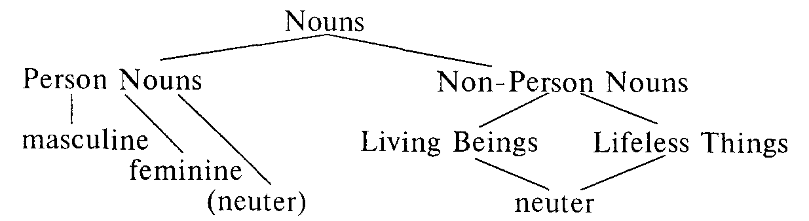

There are traditional cases of association of certain nouns with certain genders. We can use "he—she" for an animal if we know the animal's sex and feel sympathy or interest. E.g. Go and find the cat and put him out.

"She" can be used for a country, a city in myths, poetry or politico-economic contexts. E.g. England is proud ot her poets. "Nature" is "it" in a neutral context and "she" in an emotionally coloured text. E.g. If Nature is to be commanded, she must be obeyed.

"Ship," "plane," "boat," "hovercraft" are referred to as "she" ("shuttle" - "it"), e.g.What a lovely ship! What is she called?

"Car," "automobile" are referred to as "it," however, they, especially those in which the speaker takes a personal pride, can be referred to as "she" or "he" by men or women respectively.

"It" may be used for person nouns if we mean not a person but the social position, status, rank. E.g. She's the managing director and looks it.

"It" is closely associated with the absence of individuality and is often used scornfully.

There are various ways of indicating the belonging of the noun to the feminine gender as opposition to the non-expression of the feminine gender is understood as belonging to the masculine gender. They are: suffixes, compound words of a certain structure, different words.

The suffixes -ess, -ine, -ix, -ina, -ette mark the feminine gender:

administrator — administratrix

czar — czarina

executor — executrix

heir — heiress

hero — heroine

host — hostess

tiger — tigeress

testator — testatrix

usher — usherette

The suffix -er marks the masculine gender: widow — widower. Gender is expressed in compound words with the second component -man, -woman, -boy, -girl, -lord, -lady, -cock, -hen:

salesman — saleswoman

washerman — washerwoman

cashboy — cashgirl

landlord — landlady

peacock — peahen

The masculine noun "bridegroom" is opposed to the feminine noun "bride."

There are different words for creatures of male and female sex:

man — woman

lad — lass

brother — sister

bachelor — spinster

father — mother

husband — wife

son — daughter

nephew — niece

uncle — aunt

gentleman — lady

sir — madame

wizard — witch

king — queen

monk — nun

lord — lady

Students have to be aware of different connotations of meanings of apparent pairs. Witch/wizard, manager/manageress, governor/ governess, lord/lady, master/mistress and others are not equal in status and meaning in some or all contexts. As a rule the feminine noun differs from the corresponding masculine counterpart not only in the expression of another sex, but has other overtones and even meanings. Here are some of the meanings of the nouns in the mentioned pairs:

lord — supreme male ruler; God;

lady — woman belonging to upper classes; woman who has good manners and some claim to social position; (GB) used of and to wives or daughters of some nobles;

master — man who has others working for him and under him;

male head of the household; captain of a merchant ship; male teacher;

male owner of a dog; the Master — Jesus Christ;

mistress — woman at the head of the household or family; woman in authority who gives orders to servants; woman school teacher;

woman having regular sexual intercourse with one man to whom she is not married;

governor — person who governs a province or a colony or (US) state;

governess — women who is employed to teach young children in a private family;

witch — woman said to use magic, esp. for evil purposes; (fig) fascinating and bewitching woman;

wizard — magician; person with amazing abilities.

To express some male or female animals different words are used. There is often a quartet: the name of the male, the name of the female, the name of the young and the common name.

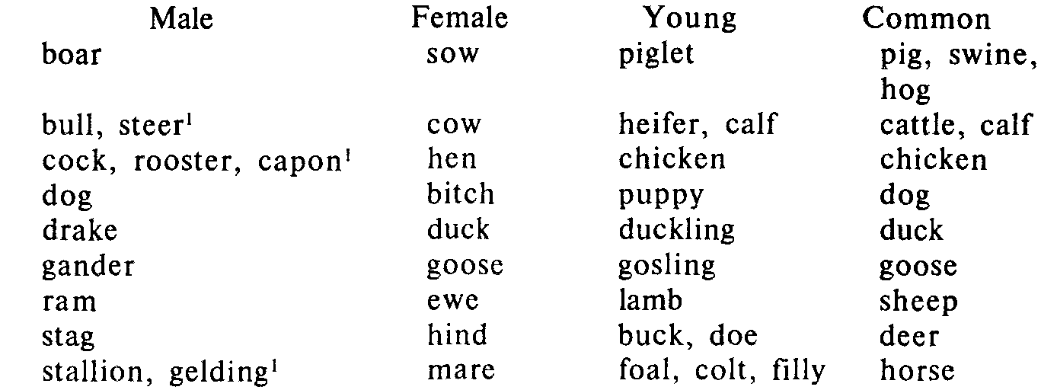

* Used for a male that has been castrated.

Specific references in the text can clearly imply the gender in a given case.

Next day he went walking in the forest. And as he was walking he met a fox, a vixen, a very pretty young thing, gay and giddy like all girls. And the fox saw the cat, and was very much astonished.

"All these years," she said, — for though she was young she thought she had lived a long time, — "all these years, I've lived in the forest, but I've never seen a wild beast like that before. What a strange-looking animal! And with only one ear. How handsome!"

*A Ransome. Old Peter's Russian Tales*

A great many person nouns in English can express both feminine and masculine person genders These nouns are referred to as nouns of the common gender, or dual gender, person, parent, friend, cousin, neighbour, student, doctor, teacher, professor, librarian, etc.

If there is no need to indicate the sex distinctions of the person expressed by the noun, it is used as masculine Besides, lexico-grammatical distinctions as the first component of a compound formation such as man/woman, male/female, boy/girl, for birds and animals — cock/hen, he/she can be used:

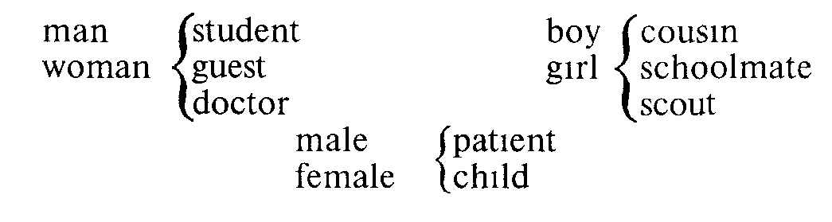

Students ought to be cautious when they choose the first noun. "A nurse" was traditionally treated as feminine, to indicate a man doing this kind of job "a male nurse" should be used. "Engineer" was traditionally meant as masculine, "a woman engineer" is used for a lady. "Boyfriend," "girlfriend" have specific connotations.

Lower animals do not differ from inanimate nouns in terms of gender and will be referred to as "it." If required, the sex differences can be indicated by certain gender markers: she-goat, male frog, he-pheasant.

The speech device enabling us to present lifeless things as living beings is called personification. It is also called "gender of animation." Personification gives nonhuman things the qualities, abilities, or emotions of people. Personification also uses abstract ideas; these abstract ideas are often capitalized.

How rarely Reason guides the stubborn choice

*Samuel Johnson*

*…* earth took him to her stony care.

*W.B. Yeats*

In fairy tales animals, fish and birds can be associated with any gender required by the sense. The extracts below are a good illustration of references of names of birds to different genders.

One night there flew over the city a little Swallow. His friends had gone away to Egypt six weeks before, but he stayed behind for he was in love with the most beautiful *Reed.* He had never met *her* early in the spring as he was flying down the river after a big yellow moth, and had been so attracted by *her* slender waist that he had stopped to talk to *her.*

*0. Wilde. The Happy Prince.*

The parrot. Polynesia, was sitting in the window looking out at the rain and'singing a Sailor-song to herself . She stopped singing and started to listen

*Hugh Lofting. The Story of Doctor Dolittle*

But one day when the Princess September went to say good morning to her parrot she found it lying dead at the bottom of its gold cage.

*W. S. Maugham. Princess September*

September felt her heart go thump, thump against her chest, and she made up her mind to take no more risks She put her hand and took hold of the bird. This he was quite used to, she liked feeling his heart go pit-a-pat, so fast, in the hollow of her hand, and I think he liked the soft warmth of her little hand

*W. S. Maugham. Princess September*

People object to words for occupations and professions that are marked to indicate sex differences since they think that men and women are not treated in the same way.

Speech and writing that make unnecessary distinctions based on sex are called sexist language. The word "Mr" does not show whether or not a man is married whereas "Mrs" is used for a married woman and "Miss" for a single woman making the distinction of a woman's social position. The term "Ms" was suggested as a compromise.

"He," "him," "his" can refer to a male or a female or to someone whose sex is unknown

The child has lost his toy.

The student paid his subscription fee.

To avoid the use of the masculine marker for someone who may be a female, an article or another determiner can be used instead.

The child has lost the toy.

The student paid that subscription fee.

Sometimes either "he/she" or "his/her" is used.

Every student has to pay his/her subscription fee.

Or: All student fees have to be paid.

There are three possible ways to indicate gender of the noun of a dual gender.

1. When a relative arrives, he will be let in and his arrival will be welcome by everyone.

2. When a relative arrives, he or she (he/she) will be let in and his or her (his/her) arrival will be welcome by everyone.

3. When a relative arrives, they will be let in and their arrival will be welcome by everyone.

The use of "he" in the first sentence is considered sexist; the use of "he and she," etc. is a bit awkward, especially in speech; in the third case "they" is used with a singular meaning which is incorrect, but still quite common, especially in informal English.

The language reflects the situation in society. Societal change and language change go hand in hand. This explains the possibility of one sentence and the impossibility of the other one:

I pronounce you man and wife (not: man and woman, husband and wife, woman and husband), the pronouncement gives a picture of woman as man's possession.

Mary is a divorcee (not: John is a divorce).

Mrs John Smith (not: Mr Mary Smith).

She is John's widow (not: He is Mary's widower).

They indulged in wife swapping (not: They indulged in husband swapping).

"Man" was originally fully generic (Man breakfasts his young;

One man, one vote) but over years it stopped being felt as such and this masculine bias can sound odd to a speaker of English.

"Lady" is used out of exaggerated politeness since a woman of high station and breeding was traditionally meant. Some people dislike to use "lady" because of its connection with class distinctions. To some people "lady" is synonymous with good manners. "Female" is used in an official, scientific or clinical contexts for a person, plant, animal that bears young.

Traditional social roles were formerly expressed by compound nouns with -man or -woman as the second component of the noun. A neutral form for both sexes is preferred by most people now as they object to terms that show the sex of the person who is doing the work.

Traditional male Traditional female Non-sexist neutral

chairman chairwoman chair (person)

barman barmaid bartender

businessman businesswoman businessperson/executive

fireman — fire fighter

headmaster headmistress head (teacher)

postman postwoman postie/postal worker

salesman saleswoman salesperson/sales representative

spokesman spokeswoman spokesperson

steward stewardess/air flight attendant

hostess

bachelor1 spinster1 unmarried/single man/woman

fiance fiancee partner

mankind — human beings

man and wife — man and woman,

husband and wife

all men everywhere — all people everywhere

boys and girls (as — people

an address in a class)

1May have negative associations.

Some words will still be used in the traditional way, such as "fisherwoman" was never thought of.

Look at this rather sexist advertisement for an airline. Change the wording to make it neutral.

Now! Eagle Airlines offers even more to the businessman

who needs comfort.

Let us fly you to your destination in first-class comfort, looked after by the best-trained air hostesses in the world. Any businessman knows that he must arrive fresh and ready for work no matter how long the journey.With Eagle Diplomat-Class you can do just that. And, what's more, your wife can travel with you on all intercontinental flights for only 25% of the normal fare! Your secretary can book you on any flights 24 hours a day on 0557-465769. All she has to do is lift the phone.

Key: Now! Eagle Airlines offers even more to the business

traveller who needs comfort.

Let us fly you to your destination in first-class comfort, looked after by the best-trained cabin attendants (or cabin staff) in the world. Any business person knows that they must arrive fresh and ready for work no matter how long the journey.With Eagle Diplomat-Class you can do just that. And, what's more, your partner/spouse can travel with you on all intercontinental flights for only 25% of the normal fare! Your secretary can book you on any flights 24 hours a day on 0557-465769. All he or she has to do is lift the phone.

These words include some that many people consider sexist. Put the words into appropriate pairs with their neutral alternatives:

cabin attendant spinster

man-hours human beings

unmanned single woman

air hostess mankind

unstaffed person-hours

Key: air hostess — cabin attendant, man-hours — person-hours, unmanned — unstaffed, spinster — single woman, mankind — human beings.

Make this letter neutral.

The Manager

Frinstowe Engineering Ltd

7/11/97

Dear Sir,

I am a spinster aged 22 and am seeking employment. I saw your advertisement for part-time workers in the Globe last week. However, your 24-hour answering service seemed to be unmanned when I tried it. Could you please send me application forms by post? Thank you.

Yours sincerely,

Sally Hewings (Miss)

Key: The Manager

Frinstowe Engineering Ltd

7/11/97

Dear Sir,

I am aged 22, single, and am seeking employment. I saw your advertisement for part-time workers in the Globe last week. However, your 24-hour answering service seemed to be unstaffed when I tried it. Could you please send me application forms by post? Thank you. Yours sincerely,

Sally Hewings (Ms)

Russian gender differs from English gender.

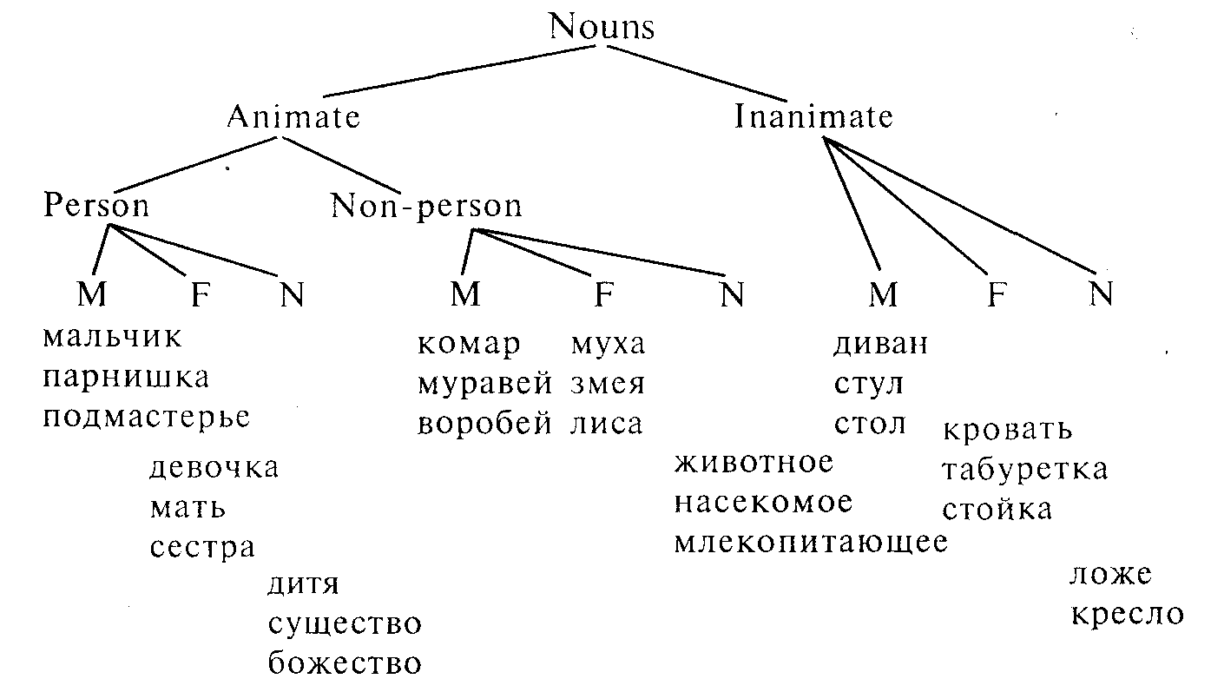

All Russian nouns are referred to the masculine, feminine or neuter genders; person nouns — due to the natural sex distinctions of creatures they express, non-person nouns — because of the form of the noun ending in -a, a consonant, -o, -e, etc.

There are nouns of the common gender in the Russian language, such as брюзга, задира, невежа, недотрога, ровня, etc. There are also nouns of the masculine gender which are widely used to denote both males and females: судья Иванова, врач Петрова, доктор, доцент, педагог, профессор, мастер, etc. Some of them have the corresponding feminine noun: профессорша, докторша, врачиха, but they are used to denote the wife of the person of the profession or are used in the colloquial style.

Russian adjectives, pronouns, numerals and verbs in the past tense agree with the noun in gender.

m м ж ж ж

Он купил своей второй маме цветы.

ж ж м м

Она застала своего брата в библиотеке.

English adjectives do not change to show gender, possessive pronouns, however, must show the sex of the person they stand for, never the gender of the noun they modify.

m f

Ralph brought his mother some roses ("his" refers in gender to Ralph not to "mother").

f m

Lucy found her brother in the library ("her" refers in gender to Lucy, not to "brother").

To bring in the topic of gender into the classroom arrange a talk about boys and girls. Show pictures or bring samples of toys. For whom are these toys designed?

Discuss basic differences between boys and girls. Are these differences something we are born with or are they bred by society?

How do your mum and dad and your school treat the two sexes? Do you like the treatment?

Do boys and girls differ in their perception of the world? How do boys and girls treat each other?

Write adjectives on the board and ask the class to use them describing the classmates or their photos (in which case there'll be more interest). You may also ask the students to think of adjectives you associate with boys, girls or both. These can be: quiet, thoughtful, noisy, ambitious, gentle, kind, cruel, fast, sympathetic, clever, strong, nice, talkative, better-behaved, hard-working, etc.

Discuss recommendations to the teacher on how to get on with boys and with girls and how to counter sexism in the classroom.

# PREPOSITIONS

Prepositions are one of the four formal parts of speech (also conjunctions, articles, particles). They are formal parts of speech because of their peculiar meaning, unchangeability, ability to perform specific functions in the sentence, inability to construe sentences without notional parts of speech (except elliptical ones).

There are over one hundred prepositions in English. This is a very small number compared with the vast number of nouns, adjectives and verbs in the English vocabulary. Most sentences that people produce contain at least one preposition; indeed, three out of ten most frequent English words are prepositions: "of," "to" and "in." This means that the number of times you need to use a particular preposition is much higher than an ordinary word such as a noun, an adjective, or a verb.

Prepositions provide information about place and time, or in a more abstract way, about relationship between people or things. In some cases the meaning of a sentence can still be understood even if the prepositions are taken out:

We'll concern ourselves ... the systematic uses ... some ... the more frequent English prepositions.

In other cases the prepositions provide essential information:

He put it back ... the table.

In this example the missing preposition could be "on," "behind," "next to," "under," "into," "above," or several other prepositions and the choice here is important for the meaning of the sentence.

Prepositions have a peculiar lexical meaning; they denote concrete instances of concrete or abstract notions. The following two poems vividly illustrate some peculiarities of prepositional meaning.

The Naughty Preposition

I lately lost a preposition;

It hid, I thought, beneath my chair.

And angrily I cried: "Perdition!

Up from out of in under there!"

Correctness is my vade mecum,

And straggling phrases I abhor;

And yet I wondered: "What should he come

Up from out of in under for?"

*Morris Bishop*

Who's In?

"The door is shut fast

And everyone's out."

But people don't know

What they're talking about!

Says the fly on the wall,

And the flame on the coals,

And the dog on his rug,

And the mice in their holes

And the kitten curled up,

And the spiders that spin —

"What, everyone's out?

Why, everyone's in!"

*Elizabeth Fleming*

In order to produce acceptable and natural English, you need to be able to select the right preposition. English prepositions are unpredictable and specifically used. The Russian learners of the English language find it difficult to use the correct preposition because the same relations in the Russian language will often be signalled by an inflection of a noun and because sometimes a preposition different from the expected one is used (характерный для — characteristic of, сердитый на— angry with, etc.).

Structurally prepositions can be simple, or one-component prepositions; compound, incorporating two prepositions in one;

phrase, or two or more-component prepositions; there are also prepositions that co-occur. Some prepositions are incorporated in the verb.

Simple Compound Phrasal Co-occurrence

about inside according to from ... to

above into apart from from ... until/till

across onto because of out of... into

after without in case of off (of) ... on (to;

before in favour of

between in front of

during in want of

in instead of

over with regard to

past

Below are some verbs in whose structure a preposition is incorporated:

outdo overdo underestimate

outrun overrate underrate

outlast overeat underline

outgrow overcome underscore

Some prepositions can be homonymous with words of other parts of speech. Compare: She waited for me outside the house. — She waited for me outside. He climbed up the ladder. — We had to go up. It happened before their arrival. — It happened before they arrived.

Prepositions can be modified by other words: almost at the end,

all over the floor, right in front of me, just off the motorway, halfway up the hill, directly after your lesson.

The nine most frequently used prepositions in English (in alphabetical order) are: at, by, for, from, in, of, on, to, with.

Prepositions occur in the following position in a sentence:

Noun

Noun Pronoun

Adjective Preposition Gerund

Verb Infinitival or Gerundial Phrase

Noun clause

Prepositions follow their objects in:

who-questions: Who did you go there with?

infinitive phrases: She is nice to speak to.

passive structures: A doctor was sent for.

relative clauses: That's the book I told you about.

Prepositions can be grouped due to their common meaning and can be studied through comparison and specific linguistic structures in which they are used.

As a rule the following groups of prepositions are singled out:

prepositions of place and direction, prepositions of time, prepositions of cause and purpose, other groups of prepositions. The use of prepositions is studied in idiomatic phrases, in passive structures, in various functions in a sentence, through comparison with similar structures, e.g. N's N.

Charts summarizing several meanings of the same prepositions may be beneficial for teaching purposes.

Meanings related to the concepts of space, time, degree.

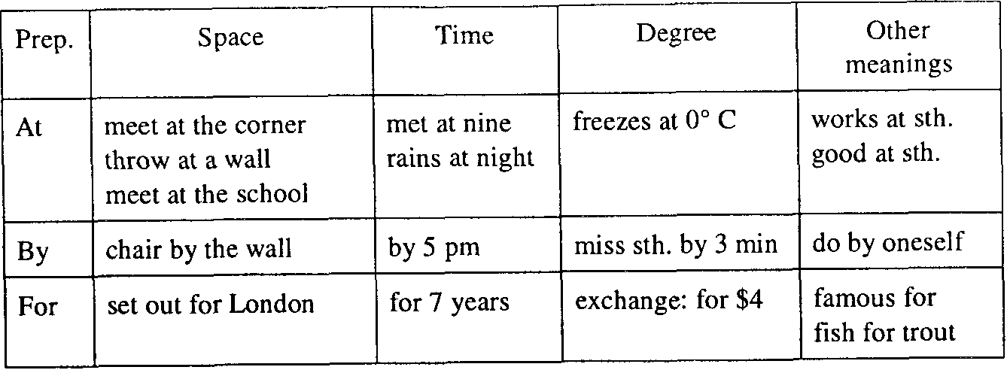

For systematization of prepositions of direction and position the following indications can be used:

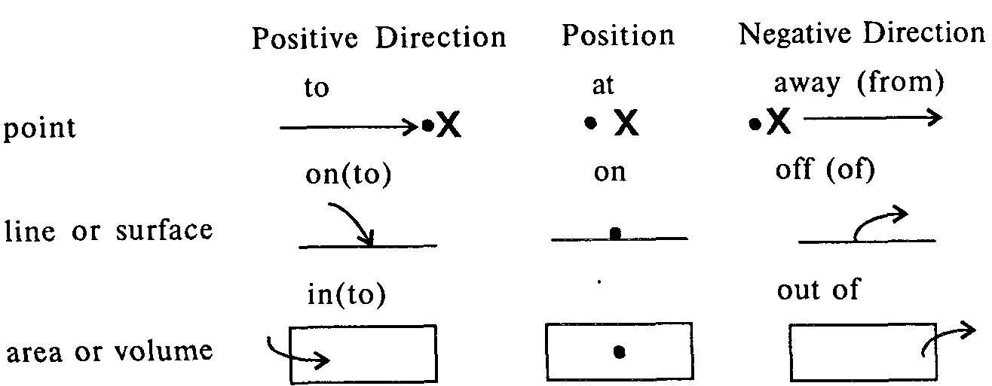

Such visual symbols, when used to reinforce semantic concepts, can be effective in teaching purposes.

Spacial meanings are one-dimensional (point, intersection) — at the corner, two-dimensional (line, surface) — on the sidewalk, three-dimensional (area, volume) — in the house.

Temporal meanings can be presented as circumferences:

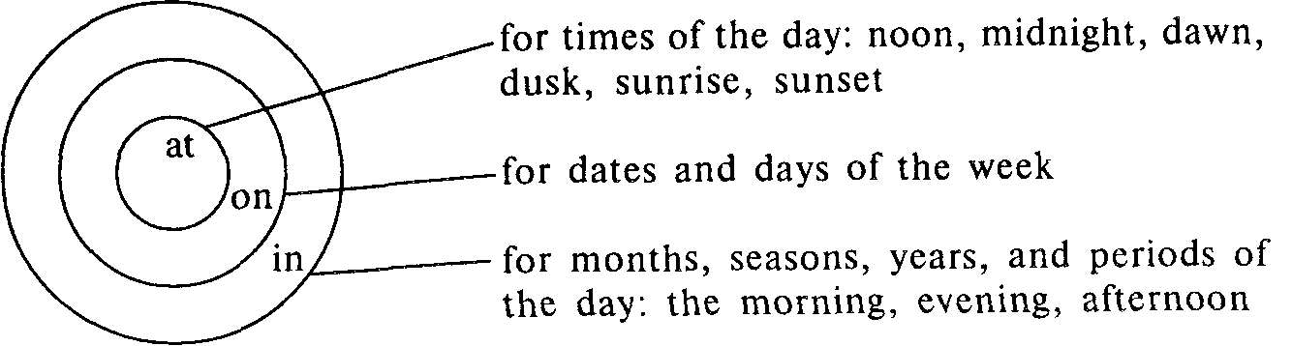

Prepositions mark the slightest subleties in the meaning.

Paper is made of wood. (the source is not visibly obvious)

The table is made out of wood. (the source is obvious)

He planted beans in his yard. (somewhere in the yard)

He planted his yard with beans. (all over the yard)

She took the groceries out of the bag. (one by one, no rush rs

implied)

She emptied the bag of groceries. (quickly, all at once)

In case of emergency, dial 999.

The teacher said the essays were mostly very good, but in the

case of Jane's and Tom's, there was still much room for improvement. Many crops and trees have already died from want of rain. I'm badly in want of a pair of new shoes.

Prepositions of place: position and movement

in/inside/outside, up/down, at, from, to, on, on top of, under(neath), over/above, under/below, through, in/into, out of, away from, towards, off, on/onto, next to, by/beside, close to/ near, etc.

The type of exercise suggested in "The Children's Response. TPR and Beyond" by Caroline Linse is very good for practising prepositions of place.

Fish in a Fish Bowl

1. Pick up a black crayon.

2. Draw a fish bowl.

3. Put the crayon down.

4. Pick up a green crayon.

5. Draw a fish in the fish bowl.

6. Put the green crayon down.

7. The green fish is in the fish bowl.

8. Pick up an orange crayon.

9. Draw a fish in the fish bowl.

10. Draw another fish in the fish bowl.

11. Put the orange crayon down.

12. The orange fish are in the fish bowl.

13. Pick up a purple crayon.

14. Draw a fish in the fish bowl.

15. Put the purple crayon down.

16. A purple fish is in the fish bowl.

17. Draw some water in the fish bowl.

18. The fish like the water.

Setting the Table

1. Pick up the cup. (Note: after **lay, place, sit** and **put**

2. Put it on the table, **into/onto** are not used, **in** and **on** are

3. The cup is on the table, used instead)

4. Pick up the plate.

5. Put it on the table.

6. The plate is on the table.

7. Pick up the fork.

8. Put it on the table.

9. The fork is on the table.

10. Pick up the knife.

11. Put it on the table.

12. The knife is on the table.

13. Pick up the spoon.

14. Put it on the table.

15. The spoon is on the table

16. The table is set.

Funny Positions

1. Put your foot on your knee.

2. Take your foot off your knee.

3. Put your foot on your chin.

4. Put your hand on your back.

5. Take your hand off your back.

6. Take your foot off your chin.

7. Put your chin on your hand.

8. Take your chin off your hand.

9. Put your chin on your knee.

10. Take your chin off your knee.

11. Pretend to put a hat on.

12. Pretend to put a ring on.

13. Pretend to take the hat off.

14. Pretend to take the ring off.

Under the Table or Chair

1. Pick up the book.

2. Put it under the table.

3. Pick up the pencil.

4. Put it under the table.

5. Pick up the book.

6. Put it under the chair.

7. Pick up the piece of paper.

8. Put it under the chair.

9. Pick up the piece of paper.

10. Put it under the table.

11. Put it under the chair.

12. The piece of paper is under the chair.

13. Pick up the crayon.

14. Put it under the piece of paper.

The Rope Game

1. Pick up the rope.

2. Put the rope on the floor.

3. Step over the rope.

4. Pick two helpers.

5. Each helper holds an end of the rope.

6. Step over the rope.

7. Helpers, lift the rope a little.

8. Step over the rope.

9. Helpers, lift the rope a little.

10. Step over the rope.

Paper Chains

1. Pick up a paper strip.

2. Put some glue on one end.

3. Glue both ends together.

4. Pic kup another strip.

5. Put some glue on one end.

6. Put the strip through the circle.

7. Glue both ends together.

8. Pick up another strip.

9. Put some glue on one end.

10. Put the strip through the circle.

11. Glue both ends together.

12. Pick up another strip.

13. Put some glue on one end.

14. Put the strip through the circle.

15. Glue both ends together.

16. That's a pretty paper chain.

Bring a picture with many people going around, doing things, etc., pin the picture on the chalkboard. Provide sentences from which the prepositions have been deleted and ask the students to fill in the gaps. Then ask someone to describe the picture as a whole.

Describe your daily journey to school or work, giving full details of your route.

Pin the local map on the wall, ask the students to describe the location of each place on it using a preposition.

Look at the picture and fill in the blanks with one of the following prepositions. Each preposition may be used only once: down, through, from, around, up, past, to, along, across, into, of, at.

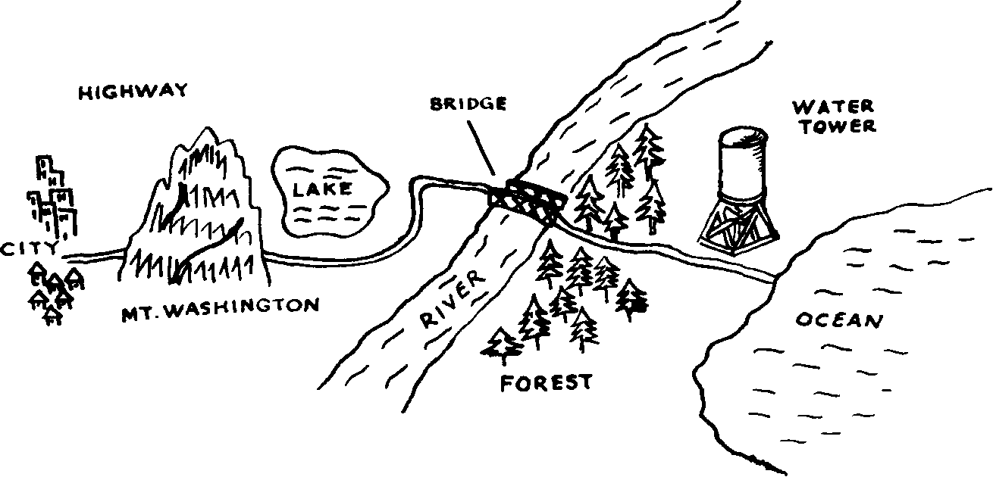

One hot summer morning, we decided to take a trip in our car ... the city ... the ocean. We got ... the car and drove ... the highway. We went... one side ofMt. Washington and ... the other side. The highway went... the lake and ... the bridge. Then we drove ... the forest and ... the big water tower. We arrived ... the beach and the climbed out... the car.

Look at the local map and describe how to go from one place to another: from the park to the cleaner's, from the militia station to the drugstore, from the bookstore to the library, from the post office to the railway station, from the department store to the church.

Where did the fly go? Put in prepositions: around, into, on, out of, through, under, up.

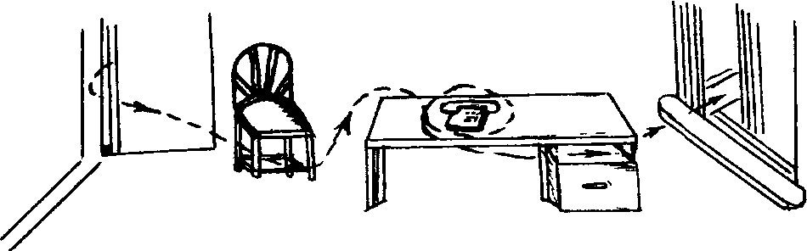

The fly came in through the door.

1. It flew ... the chair.

2. It crawled ... the chair leg.

3. It stopped ... the desk for a moment.

4. It went ... the telephone.

5. It flew ... the drawer.

6. It went ... the window.

Key: 1 under; 2 up; 3 on; 4 around; 5 into; 6 out of.

Teach a whole set of related prepositions simultaneously using a situational game approach. You will need a large chart with the following objects and locations represented in a line or circle:

school supermarket

street street

lamppost bridge

mailbox corner

parking lot home

The relationship of the person's movement with respect to these objects is marked with arrows.

When John gets out of school he goes across the street, under the lamppost, past the mailbox, through the parking lot, into the supermarket, out of the supermarket, along the next street, over the bridge, around the corner, and then he's (at) home.

Practise with the first and third person singular and with the plural.

Prepositions of time

at, on, in, for, since, during, over, from ... to/till/until,

between, by, before.

The following activities can be recommended to practise the use of prepositions of time.

Look at an English story and choose a paragraph with some prepositions in it. Copy the paragraph, living blanks instead of prepositions. Ask the students to put in the prepositions.

Have a look at the calendar and insert the appropriate prepositions.

January 1997

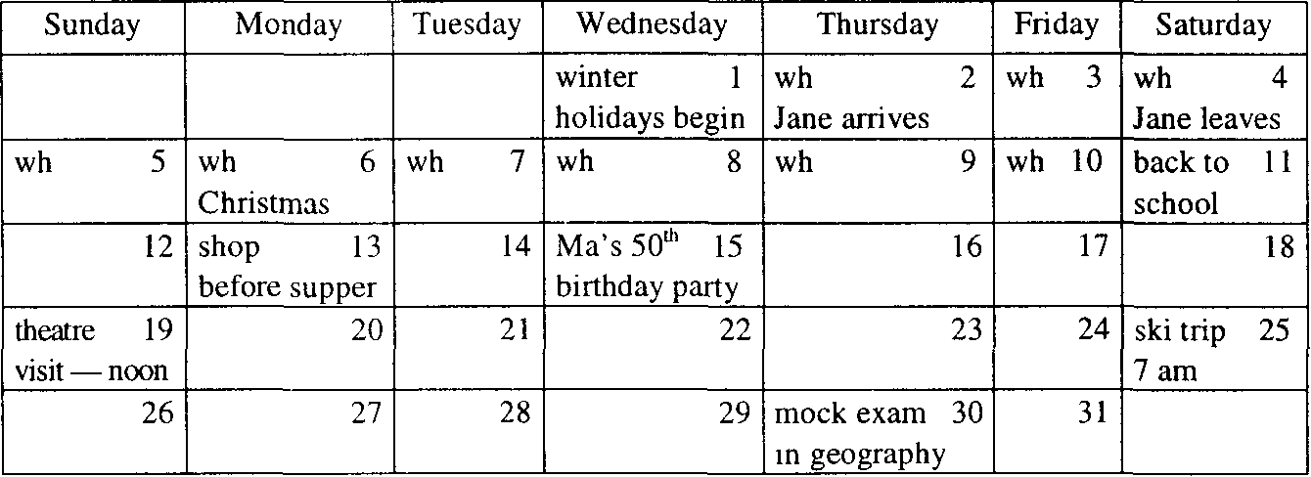

1. Winter holidays will begin ... the 1st of January and last ... the 10th.

2. Jane will arrive ... the 2nd of January and will leave ... the 4th. She will stay ... four days and will sleep in the sitting room ... her stay.

3. The Christmas service in the church will start ... midnight and go on all ... the night.

4. The third term will begin ... the llth ... Saturday.

5. I'll do shopping ... the afternoon ... Monday.

6. My Ma's birthday party will be arranged ... the 15th of January. She was born ... 1947.

7. The theatre performance will begin ... noon. We'll have to gather an hour ... it.

8. I'll get up early ... the morning ... Saturday the 25th. We'll travel home by train ... the ski trip.

9. A mock exam in geography will take place ... Thursday the 30th.

Ask a student to report on your life in January 1997.

Explain when school holidays and public holidays occur in your country.

Explain what the dates in brackets mean.

William Shakespeare (1564-1616)

Alexander Pushkin (1799-1837)

The Bicentenary of American Independence (1976)

The Eight Hundred Fiftieth Anniversary of Moscow (1147)

Say what you do and how you feel before, during and after an important exam.

Answer the questions using prepositions given.

1. When is your birthday? (on)

2. When is the summer, winter in your country? (from, to)

3. When does your English class begin? (at)

4. How long does it last? (for)

5. When do you have breakfast? (in)

6. How long do you sleep at night? (for)

7. What day of the week is your English class? (on)

8. How long have you been studying English? (since)

9. What is the work week in your country? (from, to)

10. What year did you begin school? (in)

Use the information in brackets to finish the sentences.

О (2→3) The shop will be closed from 2 to 3.

0 (Friday→) She will be on holiday from Friday.

1 (June→August) The beach is busy ...

2 (10 o'clock) I'll be at the sports centre ...

3 (March→) The new motorway will be open ...

4 (Monday→Friday) We work ...

5 (1991→1994) He lived in Kenya ...

6 (January→) She will be in Hong Kong ...

Key: 1 from June to August; 2 from 10 o'clock; 3 from March;

4 from Monday to Friday; 5 from 1991 to 1994; 6 from January.

Have students practise the specific-to-general or general-to-specific sequences typically signalled by **at—on—in** in English for addresses and dates:

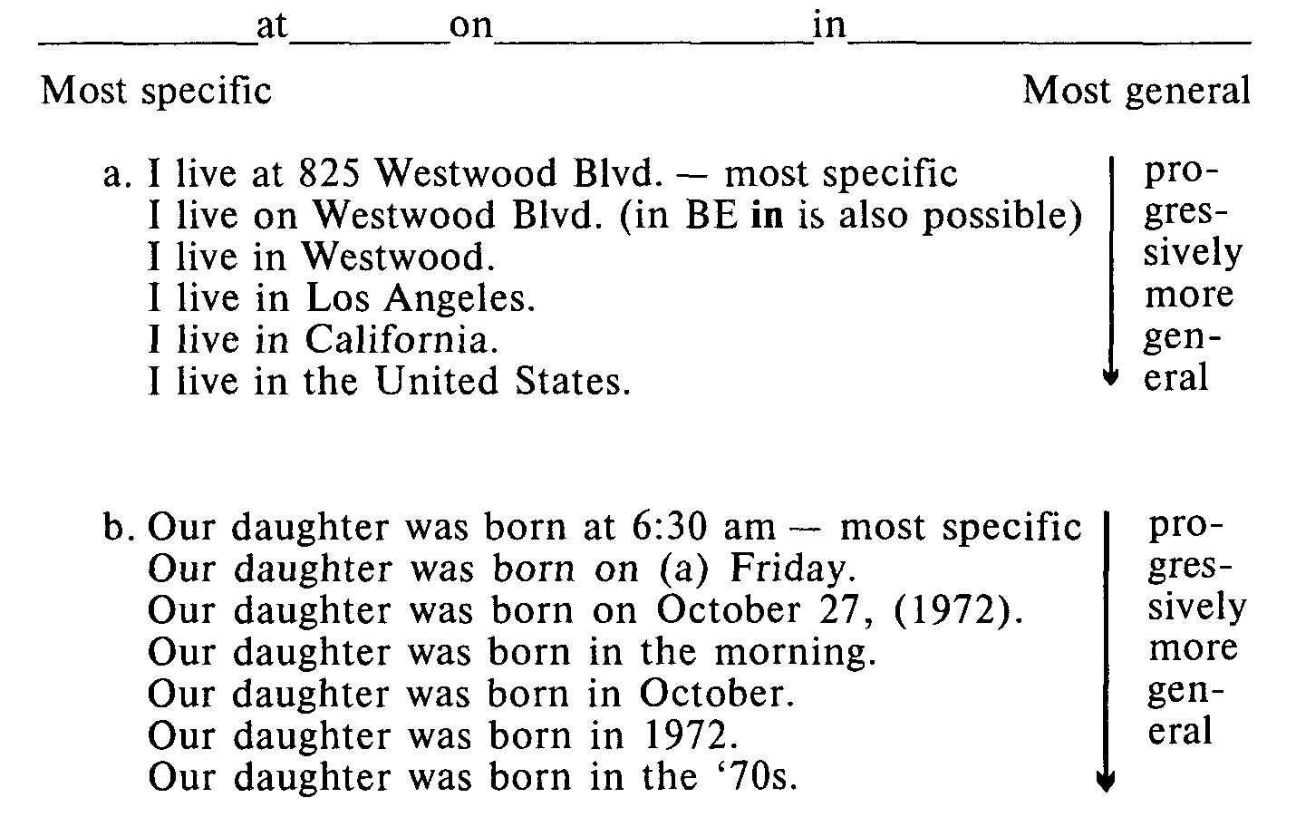

Two business people are arranging a meeting. Use "in," "on," or "at."

A: I'm free on the 15th March. Can we meet then?

B: That's Friday, isn't it? No, I'm afraid I can't see you I... Friday. I'll be in Brighton.

A: I'd like to have a meeting this month. I shall be very busy 2... April.

B: I'm having an extra couple of days' holiday 3... Easter, so perhaps the week after. Shall we meet 4... the 27th? That's Wednesday.

A; Well, I've got an appointment 5... the morning but nothing 6... the afternoon. How about 7*...* Wednesday afternoon 8... about half past two?

B: Yes, that'll be fine.

Key: 1 on; 2 in; 3 at; 4 on; 5 in; 6 in; 7 on; 8 at.

Put in "for" or "since."

A: How long have you been learning English?

B: Well, I did it 1 ... five years at school, and I've been having evening classes 2 ... then.

A: And you're staying here 3 ... three months?

B: That's right. I've been here 4 ... the end of April. Then I'm going to London 5 ... a week afterwards.

Key: 1 for; 2 since; 3 for; 4 since; 5 for.

Clair is talking to her teacher. Put in "by" or "until." *Clair:* I'm supposed to finish my project this week, aren't I? *Mrs Lewis:* Yes, you should give it to me by the end of the week. I'd like to have it 1 ... Friday, ideally.

*Clair.* I'm afraid that's going to be difficult. I'm going on a three-day study trip tomorrow. I'll be away 2 ... Thursday. I think the project is going to take me 3 ... the middle of the next week. I can't finish 4 ... the end of this week.

*Mrs Lewis:* Well, let me have it 5 ... Wednesday of next week.

Key: 1 by, 2 until, 3 until, 4 by, 5 by.

Prepositions of Cause and Purpose

of, from, because of, due to, for, in

Complete each sentence using a preposition showing cause or purpose.

1. The drivers were hurt ...

2. The people were victims ...

3. The man was angry ...

4. The man was tired ...

5. The thief broke into the safe ...

6. The man died ...

7. The patient died ...

Key: 1 in/because of the accident; 2 of a flood; 3 because of the broken window; 4 from exertion; 5 for money; 6 in/due to/ because of the fall; 7 from the operation.

Speak why a person can be in a sad or happy state of mind.

Idiomatic phrases with prepositions are supposed to be learned by heart: at risk, at top speed, by mistake, for sale, from sb's point of view, in advance, in a hurry, on average, on holiday, on business, on leave, on the market, on television, on the radio, out of order, in time/on time, in the end/at the end, in the beginning/ at the beginning, on the way/in the way, etc.

Prepositions in Action The directions are given to draw each figure as directed.

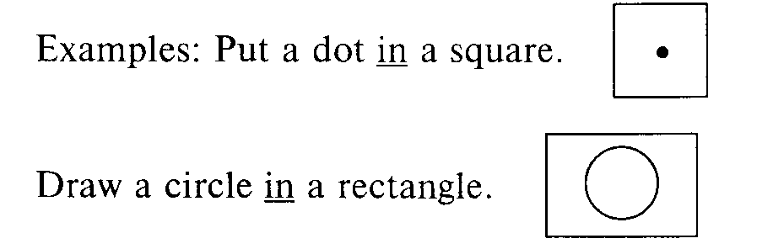

1. Put a triangle next to a circle.

2. Draw a dot below a rectangle.

3. Put a square between two circles.

4. Draw a circle with a dot in the centre.

5. Put an X on the middle of a line.

6. Draw six circles around a square.

7. Put a circle with a dot in the centre of a triangle. This game can be played in different ways: directions can be given by a teacher to the class with someone drawing the figure on the chalkboard, by the class to a student; it can be played in pairs (like the well-known "Sea Battle").

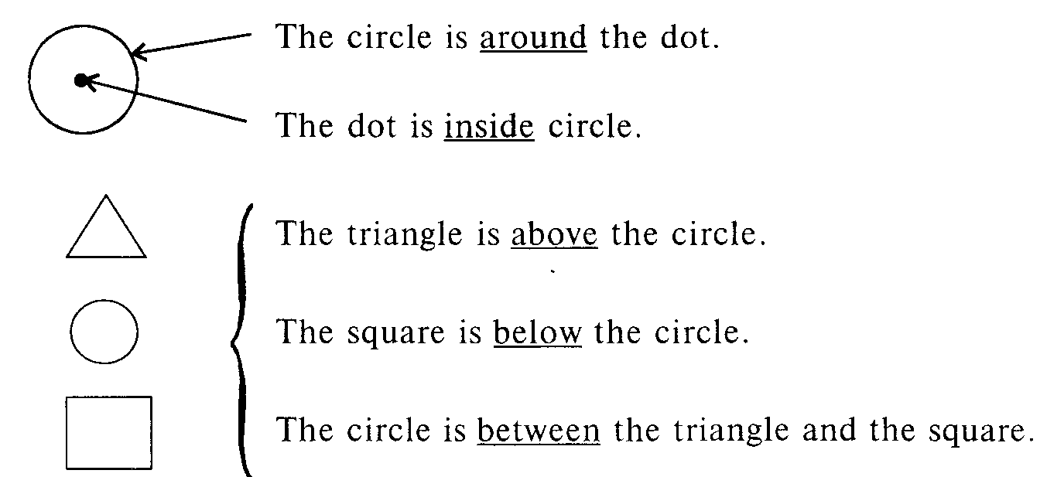

Teach using contrasts in context using real objects or pictures:

in vs. on; through vs. on, etc., e.g.:

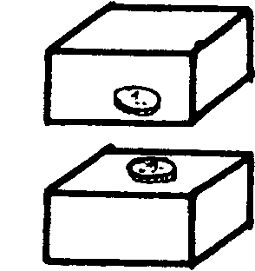

The coin is in the box.

The coin is on the box.

He walked on the grass (i.e., a lawn).

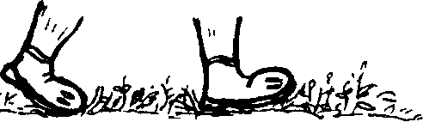

He walked in/through the tall grass (i.e., in a field).

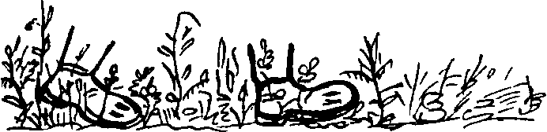

Teach and test prepositions using a modified cloze technique. I met John 1 ... the corner of Fifth Avenue and 48th Street 2 ... 9.30. He had come 3 ... foot, whereas I had come 4 ... subway. We both wanted to buy books 5 ... New York. One bookstore had news of a sale painted 6 ... the front window.We decided to go 7 ... that bookstore.

Key: 1 on; 2 at; 3 on; 4 by; 5 in; 6 on; 7 into.

Practising preposition in certain syntactical positions, i.e. in grammatical structures in which they are used, is very useful.

Some verbs can have two objects: an indirect object (the person receiving sth or for whose benefaction sth is done) and a direct object (the thing that someone gives).

Kate gave me this cassette.

I'll send my cousin a present. We bought all children an. ice cream, The same can be expressed with a different pattern.

Kate gave the cassette to someone else.

I'll send a present to my cousin.

We bought ice creams for all the children.

Two problems arise here: (1) the problem of word order, i.e. whether or not the object movement is permissible, whether or not the indirect object may be placed near the end of the sentence;

(2) by what preposition the indirect object being placed at the end of the sentence may be preceded, by the preposition "to" or "for."

No preposition is used with the indirect object preceding the direct object. The choice of the preposition "to" or "for" depends on the predicate-verb. We can use the "to" pattern with the so-called "dative" verbs: bring, give, hand, leave, lend, offer, owe, pass, pay, post, promise, read, sell, send, show, teach, take, tell, throw, write.

Jill paid the money to the cashier.

Jill paid the cashier the monеу.. Or:

We showed the photos to Simon.

We showed Simon the phptos_ Or:

Let me read this item of news. to you.

Let me read you thisjtem of news.. Or:

We can use the "for" pattern with an indirect object with the so-called "benefactive" verbs: book, bring, buy, build, cook, choose, fetch, find, get, leave, make, order, pick, prepare, reserve, save.

They found a spare ticket for me. Or: They found me a spare ticket.

I've saved a seat for you. Or: I've saved you a seat.

I'm making a cake. for our guests. Or: I'm making our guests a cake;

The position of the object at the end of the sentence marks the

new and important information. Compare:

— Kate gave me this cassette for my birthday. But I have it.

— Never mind. You'll have to give it to some one else then. The duchess was rich. She gave her daughter a million pounds. The duchess was very old. She gave her money to complete strangers.

Some verbs can have different meanings:

I'll get this to him (dative) = "deliver."

I'll get this for him (benefactor) = "take, obtain."

To develop the students' sense of when indirect object movement

is appropriate or inappropriate, group the students in pairs to

manipulate and discuss sentences consisting of words written on cards

or on strips.

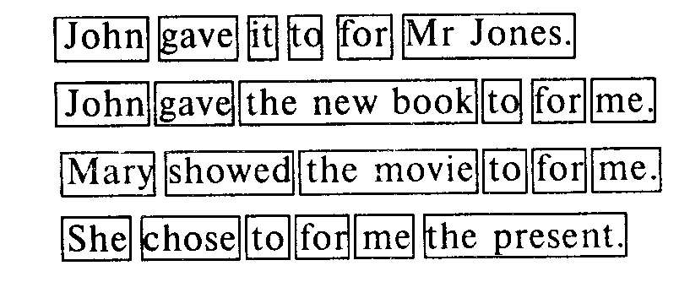

Compose dialogues using the picture. Teacher: What is Jill doing? Student: She is giving Nancy flowers. T: Do you think Nancy is happy? S: Yes. T: Why? S: Because Jill gave her flowers. Or:

Nansy

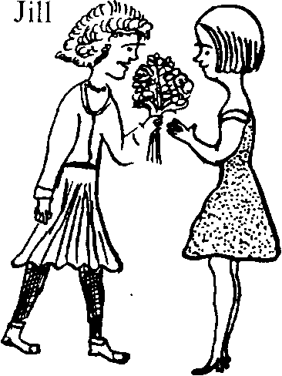

gave flowers to her, not to Peter!

Try a drill like this:

Sl: Would you lend me your car? S2: I can't. I've already promised to lend if to Harry. Sl: Would you lend me your textbook? S2: I can't. I've already promised to lend it to Judy. Or:

T: John bought some candy. Sl: Who did he buy it for? T: Himself. Sl: Oh, he bought it for himself.

The verbs "explain" (I explained the answer to her) and "open" (Open the door for me) do not accept the movement rule.

Write the information in one sentence. Put the underlined part at the end of the sentence. Sometimes you need "to." E.g. Tim lent sth to Sarah. It was his calculator.

Tim lent Sarah his calculator.

Brian sent a message. It was to his wife.

Brian sent a message to his wife.

1. I sold my bike. My brother bought it.

I___________________________________

2. The boss promised something to the workers — a pay rise.

The boss______________________________

3. Someone passed the sugar. Dave wanted it.

Someone _____________________________

4. Sam told the joke. He told all his friends.

Sam_________________________________

5. Jeremy gave some help. He helped his flatmate.

6. I wrote to my teacher. I wrote a le.tter of apology.

7. Sarah threw the ball. Kirstv caught it.

Key: 1. I sold my bike to my brother.

2. The boss promised a pay rise to the workers.

3. Someone passed the sugar to Dave.

4. Sam told the joke to all his friends.

5. Jeremy gave his flatmate some help.

6. I wrote my teacher a letter of apology.

7. Sarah threw the ball to Kirsty.

The boss of a big company is telling people to do things. Put in "to" of "for."

E.g. Give these papers to my secretary.

Make some coffee for us, could you?

1. Book a seat on the plane ... me.

2. Can you post the key ... the hotel?

3. Don't show these plans ... anyone.

4. Leave a message ... my secretary.

5. Fetch the file ... me, please.

6. Write a memo ... all managers.

Key: 1 for; 2 to; 3 to; 4 for; 5 for; 6 to.

Of special interest are pairs of verbs antonymous in meaning taking objects with different preposition "to" or "from."

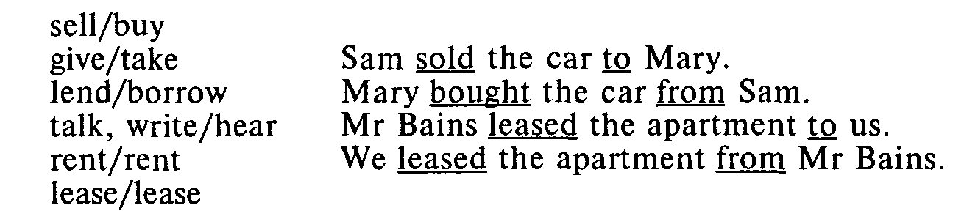

Arrange a game in which a player has to say (1) the end of a sentence, (2) the beginning of it.

One player says, "I gave Nick a pen," another player says, "Nick took the pen."

Or: One player says, "I borrowed some money from Ralph," another player says, "Since Ralph is generous and kind he lent you some money and you borrowed it from him."

Complete the conversation. Put in the two phrases on the right and decide which pattern to use. Put the new information at the end.

A: When I got some petrol at the garage, they gave me this card. You can buy things with it, it says here. this card — me

В: Yes, when you buy petrol, they give 1 ... l a little sticker— you

to stick on the card. When you've filled all

the spaces on the card, you take 2 ... and 2 the card — the garage

hand 3 ... . He'll give 4 ... from the catalogue. 3 it — the cashier

The more cards you fill, the better. Twenty 4 something — you

cards will buy 5 .... 5 a sports bag — you

A: I haven't got a catalogue.

B: Well, I'll show 6 ... then. 6 mine — you

Key: 1 you a little sticker; 2 the card to the garage; 3 it to the cashier;

4 something to you; 5 a sports bag for you; 6 you mine.

The agent in sentences with a passive structure is expressed by "by" + N. The majority of passive sentences that occur in speech and writing (85%) do not have an explicit agent. The EFL teacher has to tell the students when and why to retain the agent in those 15% of passive sentences rather than trying to give them rules for omitting the agent in those 85% of passive structures. It happens in one of the following cases:

1. The agent is a proper name, a renowned artist, poet, inventor, etc. who is too important to be omitted in the context. Radio was invented by Popov.

2. The agent is an indefinite noun phrase, i.e. new information for which sake the sentence was construed.

The details were given by a secretary, not by the senior staff.

3. The agent is an inanimate noun phrase which gives unexpected information.

The effect was achieved by a change of tactics.

The agentless passive structures should be more emphasized by the EFL teacher.

In a passive sentence the point of interest can be other information such as time, place, manner or instrument. The instrument, tool with which something is done is rendered by a noun phrase with the preposition "with."

The window was broken by Jack. (agent)

The window was broken with a hammer, (instrument)

The passive structure should not be confused with "be" +A structures in which A is a participial adjective having the form of participle II.

"At" is used to indicate a reaction to someone or something after the following adjectives:

amazed disappointed

amused embarrassed

annoyed irritated

astonished pleased

surprised

E.g. They were annoyed at being disturbed. With some of these adjectives dis/pleased, disappointed, bored, dis/satisfied, annoyed, etc. the preposition "with" is quite common. "With" indicates what a state, quality or action relate to.

It is used with

acquainted infected mixed up

confronted intoxicated occupied

connected

E.g. The prisoner was confronted with accusers. He is connected with the Smiths by marriage. He is occupied with a translation of a French novel.

"With" is also used to indicate that something is filled or covered with a substance or with things after the following adjectives:

adorned embroidered inlaid packed

covered engraved littered patterned

draped filled loaded stuffed

edged furnished overgrown suffused

E.g. The walls were covered with bookshelves. A dark veil was embroidered with lace.

One other grammatical structure with a preposition that may cause a difficulty with non-native speakers is an of N phrase.

Of N is common with inanimate nouns: the topic of the lecture, the roof of a shed.

In measure, partitive and appositive expressions the of N phrase is usual except for temporal measure (a month's rest) and in idioms such as "his money's worth," "at arm's length" (note: for the life of me/him).

The of N and N's N phrases are sometimes interchangeable, we can say: my friend's name — the name of my friend, but: your father's car and the beginning of the term.

We use an of-pattern with people when there is a long phrase or a clause. E.g. In the hall hung photos of well-known sportsmen of this area.

Both patterns are used with nouns that do not refer directly to people but suggest human activity or organization:

Scotland's rivers — the rivers of Scotland

the company's head office — the head office of the company.

Double possessives incorporating "of" and N's are common with proper nouns when the reference is definite and personal:

a novel of Conrad's

a symphony of Beethoven's

a friend of my father's

a painting of Picasso's.

Complete the conversation with the possessive 's form or "of."

*Jenny:* What's the name of the shop (name/shop) where you bought your new trousers?

*Jane:* 1 ... (Luciano/Boutique). The owner's Italian.

*Jenny:* Where is it?

*Jane:* Oh, dear. I know where it is, but I can't remember 2 ... (name/street). It isn't far from 3 ... (Charly/Cafe). You turn right and it's at the 4 ... (end/street).

*Jenny:* Well, I suppose I'll find it. What was the 5 ... (name/ assistant) who served you?

*Jane:* Angela. She lives next door to us. She usually works in the 6 ... (men/department) but when it's busy she works in the 7 ... (ladies/department) as well.

*Jenny:* How much were the things you bought?

*Jane:* I've forgotten the exact 8 ... (price/blouse), but the trousers were 12.99 pounds.

*Jenny:* That's cheap. I'll go there this afternoon.

Key: 1 Luciano's Boutique; 2 name of the street; 3 Charly's Cafe; 4 end of the street; 5 name of the assistant; 6 men's department 7 ladies' department; 8 price of the blouse.

When you need new clothes, what helps you decide what to wear? Write full sentences with "of and say what is very/quite/not so/not at all important to you, like this:

cut

The cut of the trousers is very important.

1 price

2 colour

3 quality

4 material

5 style

6 fit

7 length

8 comfort

9 name/designer

10 size

Prepositions follow nouns, adjectives and verbs:

N + prep

a tax on tobacco, time for lunch, the price of bread

Sometimes we use the same prepositions as with a related verb or adjective.

He objected to the idea, his objection to the idea

It protects you from cold, protection from cold.

I'm interested in art, an interest in art.

Sometimes the verb takes a direct object and the noun takes the preposition.

I answered the question. My answer to the question.

They demanded more money. Their demand for more money.

Sometimes nouns can take different prepositions:

a discussion of/about/on politics today.

The use of the preposition always depends on the meaning:

his apology for being late; his apology to the teacher.

Here are more examples of N + prep:

the chance/opportunity of a quick profit

no possibility of an agreement

some effect on people's behaviour

a great influence on/over their generation

an increase/rise in crime

an increase/a rise of ten per cent

a reduction/decrease in sales

a reduction/decrease of four per cent

a delay in approving the plan

a delay of two months

a student of law

great ability in/at music

a knowledge of the rules

research into waste-recycling

her skill at handling people

an expert on/at/in work methods

some experience of/in selling.

Cf. We had some success in our attempts to raise money.

I never had any success at games.

Alan made a success of the taxi business.

A + prep

fond of, good at, late for, crowded with

Many adjectives followed by prepositions express feelings:

afraid/frightened/scared/terrified of the dark, ashamed of myself, confident of the victory, crazy about, eager for news, excited at/ about the prospect, interested in, proud of, tired of, etc.

The choice of preposition depends on the meaning.

We're pleased with our new flat.

We're pleased at/about the election result. Polly was annoyed at/about the mix-up over her ticket. She was annoyed with the travel agent. I'm sorry about the delay. I felt sorry for Daniel. I'm anxious about my health. I'm anxious for the results of the tests. good at skating, brilliant at maths, hopeless at languages; good for sth, good/kind/polite to me.

The use of prepositions after verbs may be given a detailed description in the section about phrasal verbs.

In teaching the use of prepositions after nouns and adjectives (as well as after verbs) specific attention should be paid to the problem of different use of prepositions in similar lexical Russian surrounding. E.g. Interest in art — интерес к искусству, time for lunch — время на обед, proud of— горд_чем-то, confident of victory — уверен в победе, etc.

Prepositions may be followed by nouns, pronouns, gerunds, infinitival and gerundial phrases, by noun clauses.

The woman next to the magazine counter is buying something.

There's a large dog behind you.

I feel nervous about living away from home.

We waited for them to arrive.

He had counted on our finishing this before Friday.

The woman you gave the book to is my aunt.

Prepositions occur in idiomatic phrases:

She turned this place inside out looking for her key.

He hesitated whether to stay or not; he was betwixt and between.

Are you still in bed? Up and out of bed now.

He'll come by and by; we don't have to watch for him.

We won't stay long at the party; just a quick in and out.

The dog ran to and fro across the lawn.

The reader may safely deduce his/her own rules from these examples.

Fill the gaps in this newspaper article with suitable prepositions.

Hay Fever Hits Opera

The star 1 ... the largest scale opera performance ever staged 2 ... Britain pulled out 3 ... its opening night 4 ... Sunday. Verdi's Aida is being performed 5 ... London's Earl's Court Arena 6 ... a cast of 600 singers, dancers and actors. American soprano Grace Bumbry 7 ... the title role was suffering 8 ... hay fever, but had promised to be "all right on the night even if my nose drips like the Nile." Half-way 9 ... the performance she was unable to continue and was replaced 10 ... mid-performance 11 ... Bulgarian soprano Ghena Dimitrova who was sitting 12 ... the audience watching the show. She was taken 13 ... a dressing room where she put on Ms Bumbry's costume and was made up. She was ready to go 14 ... the stage 15 ... a longer-than-usual interval.

Tuesday's performance 16 ... the presence 17 ... the Prince and Princess of Wales will go ahead 18 ... Ms Bumbry — her role will be taken 19 ... Martina Arroyo 20 ... Italy.

Key: 1 of; 2 in; 3 on; 4 on; 5 at; 6 with; 7 in; 8 from; 9 through;10 in; 10 in; 11 by; 12 in; 13 to; 14 onto; 15 after; 16 in; 17 of; 18 without: 19 hv: 20 from.

Complete these paragraphs with the correct preposition.

1. The hunter 1 ... the Eskimo story was not capable 2 ... living 3 ... peace 4 ... the community 5 ... which he belonged. He was good 6 ... hunting but bad 7 ... understanding children's fun and games. The lesson 8 ... the story is that adults should not be unkind 9 ... children just because they have power 10 ... them.

2. Alternately, the story provides a lesson 1 ... children. There is nothing wrong 2 ... noisy games provided they do not interfere 3 ... serious adult occupations. An adult will go away 4 ... children if they insist 5 ... making a nuisance 6 ... themselves. This will result 7 ... the children losing benefit 8 ... the adult's company.

3. Congratulations 1 ... your engagement 2 ... Cinderella! I feel sorry 3 ... her sisters because they will be disappointed 4 ... the news. They have always dreamt 5 ... getting married 6 ... a prince like you. They will be jealous 7 ... Cinderella and won't be keen 8 ... seeing her installed 9 ... the palace. You aren't thinking 10 ... finding room 11 ... the sisters there as well, are you? You can depend 12 ... Cinderella to be nice 13 ... everyone and I'm sure she will forgive her sisters 14 ... their past unkindness.

Key: 1. 1 in; 2 of; 3 in/at; 4 with/in; 5 to; 6 at; 7 at; 8 of; 9 to; 10 over.

2. 1 for; 2 with; 3 with; 4 from; 5 on; 6 of; 7 in; 8 of.

3. 1 on; 2 to; 3 for; 4 at/by/with; 5 of/about; 6 to; 7 of; 8 on; 9 in; 10 of; 11 for; 12 on; 13 to; 14 for.

# BIBLIOGRAPHY

1. Celce-Murcia, M.; Larsen-Freeman, D. The Grammar Book. An ESL/EFL Teacher's Course. Heinie & Heinie Publishers, 1983.

2. Close, R.A. A Reference Grammar for Students of English. M.:

Просвещение, 1979.

3. Collins Cobuild. English Guides 1: Prepositions. The Cobuild Series from the Bank of English, 1996.

4. Eastwood, John; Mackin, Ronald. A Basic English Grammar with Exercises. OUP, 1993.

5. Eastwood, John. Oxford Guide to English Grammar. OUP, 1994.

6. Eastwood, John. Oxford Practice Grammar. OUP, 1994.

7. First Certificate in English. Specifications and Sample Papers for the Revised FCE examination. UCLES, June 1995.

8. Foil, David; Kelly, Anne. First Certificate Avenues. CUP, 1996.

9. Jones, Leo. Progress to First Certificate. CUP, 1995.

10. Linse, Caroline. The Children's Response. TPR and Beyond. The Materials Branch, English Language Programs Division United States Information Agency, 1996.

11. Livingstone, Carol. Role Play in Language Learning. M.: Высшая школа, 1988.

12. Lougheed, Lin. The Great Preposition Mystery. M.: Просвещение, 1994.

13. Maclin, Alice. Reference Guide to English: A Handbook of English as a Second Language. The Materials Branch, English Language Programs Division United States Information Agency, 1996.

14. McCarthy, Michael; O'Dell, Felicity. English Vocabulary in Use. CUP, 1995.

15. Paterson, Ken. Grammar Spectrum 1. OUP, 1996.

16. Seidi, Jennifer. Grammar 2, 4. OUP, 1996.

**CONTENTS**

**PREFACE ……………………………………………………………………………………………3**

**INTRODUCTION. PARTS OF SPEECH …………………………………………………………...3**

**NUMBER OF NOUNS ……………………………………………………………………………..14**

**GENDER OF NOUNS …………………………………………………………………………...…35**

**PREPOSITION ……………………………………………………………………………………..41**

**BIBLIOGRAPHY**